Supplementary material

Microneedle Patch Delivery of Methotrexate-loaded Albumin Nanoparticles to Immune Cells Achieves a Potent Antipsoriatic Effect

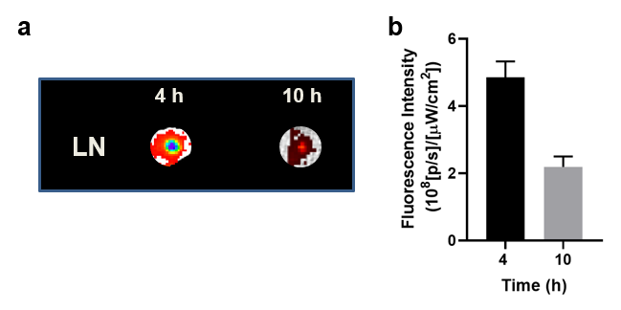
Fig. S1 a) Fluorescence images of LN and b) ROI analysis of fluorescent intensities from the LNs at 4 and 10 h after the administration.

