Supplementary Appendix

Methods

Exposures
A MITT regimen was defined as the concomitant use of two different inhalers to form triple therapy (either ICS/LABA + LAMA or LABA/LAMA + ICS), or the use of three different inhalers in the form of ICS + LAMA + LABA. As these medications can have different overlapping periods, MITT was defined as an overlap in the days of supply of all three components (ICS, LAMA, and LABA) of ≥1 day (e-Figure 1). Patients were considered to be continuous users of a triple therapy component if the gap between two subsequent prescriptions (ie end date of last supply to start date of next supply) was ≤30 days (≤45 days and ≤60 days during sensitivity analysis). Patients were not considered to have initiated triple therapy on a day where one or more inhalers was in a treatment gap of ≤30 days (ie allowable gap observed). Initiation of triple therapy was only identified when a patient had overlapping observable prescriptions. Patients who received a prescription for either FF/UMEC/VI or BDP/FOR/GB were included in the SITT users cohort with further stratification by product for the relevant treatment comparison.

Calculation of proportion of days covered (PDC)
PDC was calculated by dividing the number of days covered by a fixed time interval (ie 6, 12, or 18 months). Patients were considered ‘covered’ for days on which they had a valid prescription for all three components of triple therapy (e-Figure 2). For patients with a subsequent prescription dated before the duration of their existing prescription run out (ie an overlap in the cover of prescriptions), the subsequent prescription date was shifted to the end of the previous prescription days of supply, for the PDC calculation.

e-Table 1 Individual components of MITT regimens
MITT combination | Total  (N=6579)
Beclometasone dipropionate/ formoterol fumarate dihydrate+tiotropium bromide | 1544
Budesonide/formoterol fumarate dihydrate+tiotropium bromide | 580
Fluticasone propionate/salmeterol xinafoate+tiotropium bromide | 549
Fluticasone furoate/vilanterol+umeclidinium bromide | 384
Other | 337
Beclometasone dipropionate/formoterol fumarate dihydrate+umeclidinium bromide | 290
Beclometasone dipropionate/formoterol fumarate dihydrate+glycopyrronium bromide | 267
Budesonide/formoterol fumarate dihydrate+glycopyrronium bromide | 227
Aclidinium bromide+beclometasone dipropionate/formoterol fumarate dihydrate | 216
Fluticasone furoate/vilanterol+tiotropium bromide | 185
Beclometasone dipropionate+umeclidinium bromide/vilanterol trifenatate | 169
Fluticasone furoate/vilanterol+umeclidinium bromide/vilanterol trifenatate | 143
Fluticasone propionate/salmeterol xinafoate+umeclidinium bromide | 132
Beclometasone dipropionate/formoterol fumarate dihydrate+umeclidinium bromide/vilanterol trifenatate | 120
Budesonide/formoterol fumarate dihydrate+umeclidinium bromide | 118
Fluticasone propionate/salmeterol xinafoate+glycopyrronium bromide | 111
Aclidinium bromide+budesonide/formoterol fumarate dihydrate | 96
Aclidinium bromide/formoterol fumarate dihydrate+beclometasone dipropionate/formoterol fumarate dihydrate | 79
Beclometasone dipropionate/formoterol fumarate dihydrate+olodaterol hydrochloride/tiotropium bromide | 77
Beclometasone dipropionate+glycopyrronium bromide/indacaterol maleate | 77
Beclometasone dipropionate+olodaterol hydrochloride/tiotropium bromide | 72
Fluticasone propionate/formoterol fumarate dihydrate+tiotropium bromide | 67
Beclometasone dipropionate/formoterol fumarate dihydrate+glycopyrronium bromide/indacaterol maleate | 64
Aclidinium bromide/formoterol fumarate dihydrate+beclometasone dipropionate | 58
Budesonide/formoterol fumarate dihydrate+umeclidinium bromide/vilanterol trifenatate | 55
Fluticasone propionate/salmeterol xinafoate+umeclidinium bromide/vilanterol trifenatate | 53
Aclidinium bromide+fluticasone propionate/salmeterol xinafoate | 43
Aclidinium bromide/formoterol fumarate dihydrate+budesonide/formoterol fumarate dihydrate | 35
Budesonide/formoterol fumarate dihydrate+olodaterol hydrochloride/tiotropium bromide | 33
Budesonide/formoterol fumarate dihydrate+glycopyrronium bromide/indacaterol maleate | 32
Beclometasone dipropionate/formoterol fumarate dihydrate+salmeterol xinafoate+tiotropium bromide | 32
Fluticasone furoate/vilanterol+glycopyrronium bromide | 25
Fluticasone propionate/salmeterol xinafoate+olodaterol hydrochloride/tiotropium bromide | 24
Beclometasone dipropionate+salmeterol xinafoate+tiotropium bromide | 23
Aclidinium bromide/formoterol fumarate dihydrate+fluticasone propionate/salmeterol xinafoate | 21
Fluticasone propionate/salmeterol xinafoate+glycopyrronium bromide/indacaterol maleate | 21
Beclometasone dipropionate/formoterol fumarate dihydrate+fluticasone propionate/salmeterol xinafoate+tiotropium bromide | 21
Beclometasone dipropionate+budesonide/formoterol fumarate dihydrate+tiotropium bromide | 19
Aclidinium bromide+fluticasone furoate/vilanterol | 17
Beclometasone dipropionate/formoterol fumarate dihydrate+budesonide/formoterol fumarate dihydrate+tiotropium bromide | 14
Beclometasone dipropionate+glycopyrronium bromide/indacaterol maleate+tiotropium bromide | 12
Beclometasone dipropionate/formoterol fumarate dihydrate+glycopyrronium bromide/indacaterol maleate+tiotropium bromide | 12
Fluticasone propionate/formoterol fumarate dihydrate+umeclidinium bromide | 12
Beclometasone dipropionate+tiotropium bromide+umeclidinium bromide/vilanterol trifenatate | 11
Beclometasone dipropionate/formoterol fumarate dihydrate+fluticasone furoate/vilanterol+umeclidinium bromide | 11
Fluticasone furoate/vilanterol+fluticasone propionate/salmeterol xinafoate+umeclidinium bromide | 11
Budesonide+umeclidinium bromide/vilanterol trifenatate | 10
Aclidinium bromide/formoterol fumarate dihydrate+beclometasone dipropionate/formoterol fumarate dihydrate+tiotropium bromide | 10
Beclometasone dipropionate+formoterol fumarate dihydrate+tiotropium bromide | 10
Aclidinium bromide+fluticasone propionate/formoterol fumarate dihydrate | 10
Beclometasone dipropionate/formoterol fumarate dihydrate+tiotropium bromide+umeclidinium bromide/vilanterol trifenatate | 10
Beclometasone dipropionate+fluticasone furoate/vilanterol+umeclidinium bromide | 10
Aclidinium bromide/formoterol fumarate dihydrate+fluticasone furoate/vilanterol | 10
Fluticasone furoate/vilanterol+olodaterol hydrochloride/tiotropium bromide | 10
Notes: MITT combinations are for patients who met the overall inclusion criteria. Some combinations are simplified where products were duplicated in the same regimen. Any combination with <10 patients is combined into ‘other’ to protect patient privacy.
Abbreviations: MITT, multiple-inhaler triple therapy

e-Table 2 Baseline characteristics of the unweighted and weighted SITT and MITT patient cohorts (6-month adherence)
 | Unweighted cohorts |  |  | Weighted cohorts
Characteristics | SITT  (n=2615) | MITT  (n=4538) | SMD  (%) | SITT | MITT | SMD  (%)
Age, mean | 70.27 | 68.39 | −17.71 | 69.14 | 68.89 | −2.35
Male, % | 52.93 | 54.01 | 2.18 | 53.59 | 53.8 | 0.41
Smoking pre-index, %
Current smoker | 48.68 | 50.33 | 3.30 | 49.97 | 49.80 | −0.34
Former smoker | 49.33 | 46.03 | −6.60 | 47.59 | 47.20 | −0.78
Non-smoker | 1.99 | 3.64 | 9.98 | 2.45 | 3.01 | 3.45
BMI, at index, mean (kg/m²) | 27.52 | 27.90 | 5.93 | 27.67 | 27.80 | 1.92
FEV1% predicted in baseline period | 57.90 | 59.20 | 9.09 | 58.62 | 58.81 | 1.37
Number of exacerbations in the 12 months pre-index, mean
Moderate | 0.59 | 0.48 | −12.81 | 0.53 | 0.51 | −2.41
Severe | 0.21 | 0.14 | −13.66 | 0.17 | 0.17 | −0.26
Number of respiratory medicines in 12 months pre-index, mean | 2.15 | 2.35 | 26.95 | 2.24 | 2.28 | 5.44
Selected comorbidities pre-index, %
Current asthma diagnosis | 29.67 | 36.03 | 13.56 | 32.69 | 33.47 | 1.66
Acute myocardial infarction | 12.96 | 10.09 | −9.00 | 11.37 | 10.89 | −1.52
Congestive heart failure | 8.60 | 6.65 | −7.35 | 7.51 | 7.15 | −1.41
Stroke | 11.78 | 10.33 | −4.60 | 10.55 | 10.93 | 1.24
Bronchiectasis | 6.00 | 4.03 | −9.04 | 5.50 | 4.05 | −6.84
Abbreviations: BMI, body mass index; FEV1, forced expiratory volume in 1 second; MITT, multiple-inhaler triple therapy; SITT, single-inhaler triple therapy; SMD, standardized mean difference.

e-Table 3 Baseline characteristics of the unweighted and weighted SITT and MITT patient cohorts (12-month adherence)
 | Unweighted cohorts |  |  | Weighted cohorts
Characteristic | SITT  (n=1242) | MITT  (n=3159) | SMD  (%) | SITT | MITT | SMD  (%)
Age, mean | 70.08 | 68.08 | −18.81 | 68.8 | 68.56 | −2.17
Male, % | 54.67 | 53.34 | −2.67 | 53.58 | 53.47 | −0.23
Smoking pre-index, %
Current smoker | 49.52 | 51.06 | 3.09 | 51.23 | 50.69 | −1.09
Former smoker | 48.79 | 45.36 | −6.87 | 46.81 | 46.30 | −1.01
Non-smoker | 1.69 | 3.58 | 11.80 | 1.96 | 3.01 | 6.75
BMI, at index, mean (kg/m²) | 27.77 | 27.85 | 1.33 | 27.64 | 27.82 | 2.89
FEV1% predicted in baseline period | 57.84 | 58.95 | 7.70 | 58.46 | 58.68 | 1.55
Number of exacerbations in 12 months pre-index, mean
Moderate | 0.61 | 0.47 | −16.59 | 0.52 | 0.50 | −1.48
Severe | 0.20 | 0.14 | −11.93 | 0.16 | 0.16 | −0.58
Number of respiratory medicines in 12 months pre-index, mean | 2.17 | 2.36 | 25.63 | 2.26 | 2.31 | 6.64
Selected comorbidities pre-index, %
Current asthma diagnosis | 27.78 | 35.90 | 17.49 | 32.39 | 33.57 | 2.52
Acute myocardial infarction | 13.04 | 10.29 | −8.59 | 12.21 | 10.71 | −4.70
Congestive heart failure | 8.53 | 6.65 | −7.13 | 7.23 | 7.25 | 0.11
Stroke | 11.19 | 9.75 | −4.71 | 10.25 | 10.22 | −0.12
Bronchiectasis | 6.44 | 4.27 | −9.64 | 5.81 | 4.33 | −6.74
Abbreviations: BMI, body mass index; FEV1, forced expiratory volume in 1 second; MITT, multiple-inhaler triple therapy; SITT, single-inhaler triple therapy; SMD, standardized mean difference.

e-Table 4 Baseline characteristics of the unweighted and weighted SITT and MITT patient cohorts (18-month adherence)
 | Unweighted cohorts |  |  | Weighted cohorts
Characteristic | SITT  (n=394) | MITT  (n=1890) | SMD  (%) | SITT | MITT | SMD  (%)
Age, mean | 70.37 | 68.03 | −22.01 | 68.09 | 68.38 | 2.72
Male, % | 51.78 | 53.97 | 4.39 | 51.41 | 53.41 | 4.17
Smoking pre-index, %
Current smoker | 46.70 | 51.38 | 9.36 | 51.95 | 50.65 | −2.60
Former smoker | 51.02 | 45.56 | −10.93 | 45.51 | 46.43 | 1.83
Non-smoker | 2.28 | 3.07 | 4.86 | 2.54 | 2.93 | 2.39
BMI, at index, mean (kg/m²) | 27.43 | 27.83 | 6.28 | 27.61 | 27.77 | 2.43
FEV1% predicted in baseline period | 57.83 | 58.62 | 5.64 | 58.53 | 58.50 | −0.17
Number of exacerbations in 12 months pre-index, mean
Moderate | 0.61 | 0.49 | −14.60 | 0.53 | 0.51 | −2.92
Severe | 0.17 | 0.13 | −9.94 | 0.14 | 0.14 | −0.86
Number of respiratory medicines in 12 months pre-index, mean | 2.17 | 2.36 | 25.03 | 2.17 | 2.35 | 22.22
Selected comorbidities pre-index, %
Current asthma diagnosis | 26.40 | 34.13 | 16.88 | 26.34 | 33.91 | 16.56
Acute myocardial infarction | 13.45 | 10.11 | −10.39 | 12.51 | 10.19 | −7.30
Congestive heart failure | 8.88 | 6.77 | −7.86 | 6.13 | 7.13 | 4.04
Stroke | 11.68 | 8.99 | −8.81 | 10.87 | 9.30 | −5.24
Bronchiectasis | 5.84 | 4.39 | −6.56 | 4.36 | 4.51 | 0.70
Abbreviations: BMI, body mass index; FEV1, forced expiratory volume in 1 second; MITT, multiple-inhaler triple therapy; SITT, single-inhaler triple therapy; SMD, standardized mean difference.

e-Table 5 Baseline characteristics of the unweighted and weighted FF/UMEC/VI and MITT patient cohorts (6-month adherence)
 | Unweighted cohorts |  |  | Weighted cohorts
Characteristics | FF/UMEC/VI  (n=1319) | MITT  (n=4092) | SMD  (%) | FF/UMEC/VI | MITT | SMD  (%)
Age, mean | 69.86 | 68.52 | −12.65 | 68.90 | 68.75 | −1.37
Male, % | 57.24 | 54.18 | −6.31 | 55.28 | 55.06 | −0.78
Smoking pre-index, %
Current smoker | 49.53 | 50.05 | 1.04 | 50.69 | 50.03 | −1.32
Former smoker | 48.82 | 46.38 | −4.88 | 47.08 | 46.89 | −0.38
Non-smoker | 1.65 | 3.57 | 12.04 | 2.24 | 3.09 | 5.27
BMI, at index, mean (kg/m²) | 27.74 | 27.89 | 2.34 | 27.83 | 27.87 | 0.60
FEV1% predicted in baseline period | 58.49 | 59.28 | 5.53 | 58.71 | 59.08 | 2.57
Number of exacerbations in the 12 months pre-index, mean
Moderate | 0.59 | 0.48 | −12.14 | 0.53 | 0.50 | −3.27
Severe | 0.17 | 0.15 | −5.22 | 0.15 | 0.15 | 0.04
Number of respiratory medicines in 12 months pre-index, mean | 2.11 | 2.34 | 30.3 | 2.24 | 2.29 | 6.61
Selected comorbidities pre-index, %
Current asthma diagnosis | 28.69 | 35.95 | 15.55 | 31.94 | 34.08 | 4.54
Acute myocardial infarction | 14.07 | 9.87 | −12.96 | 11.17 | 10.77 | −1.28
Congestive heart failure | 7.63 | 6.48 | −4.49 | 6.34 | 6.80 | 1.85
Stroke | 11.64 | 10.31 | −4.23 | 10.46 | 10.48 | 0.08
Bronchiectasis | 5.82 | 4.03 | −8.26 | 5.53 | 4.01 | −7.11
Abbreviations: BMI, body mass index; FEV1, forced expiratory volume in 1 second; FF/UMEC/VI, fluticasone furoate, umeclidinium and vilanterol; MITT, multiple-inhaler triple therapy; SMD, standardized mean difference.

e-Table 6 Baseline characteristics of the unweighted and weighted FF/UMEC/VI and MITT patient cohorts (12-month adherence)
 | Unweighted cohorts |  |  | Weighted cohorts
Characteristics | FF/UMEC/VI  (n=622) | MITT  (n=3169) | SMD  (%) | FF/UMEC/VI | MITT | SMD  (%)
Age, mean | 69.73 | 68.09 | −15.49 | 68.55 | 68.34 | −1.98
Male, % | 59.32 | 53.30 | −12.28 | 54.39 | 54.21 | −0.52
Smoking pre-index, %
Current smoker | 49.92 | 51.06 | 2.28 | 51.89 | 50.91 | −1.97
Former smoker | 48.78 | 45.38 | −6.81 | 46.22 | 45.90 | −0.64
Non-smoker | 1.31 | 3.57 | 14.7 | 1.89 | 3.19 | 8.29
BMI, at index, mean (kg/m²) | 27.99 | 27.86 | −2.07 | 27.67 | 27.87 | 3.08
FEV1% predicted in baseline period | 58.61 | 58.97 | 2.51 | 58.41 | 58.89 | 3.39
Number of exacerbations in the 12 months pre-index, mean
Moderate | 0.57 | 0.47 | −11.41 | 0.52 | 0.48 | −4.22
Severe | 0.16 | 0.14 | −4.10 | 0.15 | 0.15 | 0.37
Number of respiratory medicines in 12 months pre-index, mean | 2.16 | 2.36 | 26.69 | 2.27 | 2.33 | 8.03
Selected comorbidities pre-index, %
Current asthma diagnosis | 28.38 | 35.82 | 15.96 | 29.87 | 34.75 | 10.46
Acute myocardial infarction | 13.05 | 10.29 | −8.61 | 12.90 | 10.47 | −7.58
Congestive heart failure | 6.69 | 6.66 | −0.12 | 5.70 | 6.93 | 5.05
Stroke | 11.26 | 9.75 | −4.91 | 11.19 | 10.01 | −3.83
Bronchiectasis | 7.01 | 4.29 | −11.81 | 6.60 | 4.29 | −10.2
Abbreviations: BMI, body mass index; FEV1, forced expiratory volume in 1 second; FF/UMEC/VI, fluticasone furoate, umeclidinium and vilanterol; MITT, multiple-inhaler triple therapy; SMD, standardized mean difference.

e-Table 7 Baseline characteristics of the unweighted and weighted FF/UMEC/VI and MITT patient cohorts (18-month adherence)
 | Unweighted cohorts |  |  | Weighted cohorts
Characteristics | FF/UMEC/VI  (n=156) | MITT  (n=1894) | SMD  (%) | FF/UMEC/VI | MITT | SMD  (%)
Age, mean | 70.3 | 68.03 | −21.16 | 68.08 | 68.18 | 0.87
Male, % | 54.49 | 54.01 | −0.36 | 50.44 | 54.00 | 7.13
Smoking pre-index, %
Current smoker | 49.03 | 51.37 | 4.67 | 58.34 | 51.29 | −14.2
Former smoker | 47.74 | 45.56 | −4.36 | 39.98 | 45.66 | 11.5
Non-smoker | 3.23 | 3.06 | −0.94 | 1.68 | 3.05 | 9.00
BMI, at index, mean (kg/m²) | 28.02 | 27.82 | −3.04 | 27.39 | 27.83 | 7.10
FEV1% predicted in baseline period | 58.54 | 58.62 | 0.62 | 58.57 | 58.62 | 0.39
Number of exacerbations in the 12 months pre-index, mean
Moderate | 0.55 | 0.49 | −8.57 | 0.55 | 0.49 | −6.88
Severe | 0.13 | 0.13 | −0.32 | 0.12 | 0.13 | 2.16
Number of respiratory medicines in 12 months pre-index, mean | 2.23 | 2.36 | 16.93 | 2.25 | 2.35 | 13.67
Selected comorbidities pre-index, %
Current asthma diagnosis | 27.74 | 34.05 | 13.67 | 28.24 | 33.79 | 12.01
Acute myocardial infarction | 15.48 | 10.08 | −16.19 | 14.65 | 10.11 | −13.79
Congestive heart failure | 6.45 | 6.76 | 1.23 | 4.58 | 6.86 | 9.83
Stroke | 10.97 | 8.98 | −6.64 | 13.57 | 9.05 | −14.28
Bronchiectasis | 5.81 | 4.44 | −6.21 | 3.69 | 4.52 | 4.17
Abbreviations: BMI, body mass index; FEV1, forced expiratory volume in 1 second; FF/UMEC/VI, fluticasone furoate, umeclidinium and vilanterol; MITT, multiple-inhaler triple therapy; SMD, standardized mean difference.

e-Table 8 Baseline characteristics of the unweighted and weighted BDP/FOR/GB and MITT patient cohorts (6-month adherence)
 | Unweighted cohorts |  |  | Weighted cohorts
Characteristics | BDP/FOR/GB  (n=1424) | MITT  (n=4566) | SMD  (%) | BDP/FOR/GB | MITT | SMD  (%)
Age, mean | 70.65 | 68.39 | −21.34 | 68.88 | 68.8 | −0.74
Male, % | 48.53 | 53.96 | 10.4 | 52.01 | 52.78 | 1.67
Smoking pre-index, %
Current smoker | 47.88 | 50.31 | 4.86 | 49.77 | 49.76 | −0.02
Former smoker | 49.81 | 46.06 | −7.52 | 47.73 | 46.90 | −1.66
Non-smoker | 2.31 | 3.64 | 7.82 | 2.50 | 3.34 | 4.99
BMI, at index, mean (kg/m²) | 27.31 | 27.90 | 9.23 | 27.66 | 27.79 | 1.91
FEV1% predicted in baseline period | 57.35 | 59.18 | 12.84 | 58.78 | 58.82 | 0.29
Number of exacerbations in the 12 months pre-index, mean
Moderate | 0.59 | 0.48 | −13.25 | 0.52 | 0.50 | −2.10
Severe | 0.25 | 0.14 | −20.49 | 0.18 | 0.17 | −2.98
Number of respiratory medicines in 12 months pre-index, mean | 2.18 | 2.35 | 22.59 | 2.25 | 2.31 | 7.39
Selected comorbidities pre-index, %
Current asthma diagnosis | 30.60 | 36.14 | 11.75 | 33.68 | 34.85 | 2.46
Acute myocardial infarction | 11.91 | 10.10 | −5.81 | 10.80 | 10.45 | −1.12
Congestive heart failure | 9.53 | 6.68 | −10.46 | 8.46 | 7.03 | −5.34
Stroke | 11.91 | 10.34 | −5.01 | 10.18 | 10.93 | 2.44
Bronchiectasis | 6.18 | 4.03 | −9.78 | 5.16 | 4.07 | −5.19
Abbreviations: BDP/FOR/GB, beclomethasone, formoterol and glycopyrronium bromide; BMI, body mass index; FEV1, forced expiratory volume in 1 second; MITT, multiple-inhaler triple therapy; SMD, standardized mean difference.

e-Table 9 Baseline characteristics of the unweighted and weighted BDP/FOR/GB and MITT patient cohorts (12-month adherence)
 | Unweighted cohorts |  |  | Weighted cohorts
Characteristics | BDP/FOR/GB  (n=643) | MITT  (n=3165) | SMD  (%) | BDP/FOR/GB | MITT | SMD  (%)
Age, mean | 70.42 | 68.09 | −21.91 | 68.28 | 68.43 | 1.38
Male, % | 49.77 | 53.30 | 6.45 | 51.39 | 52.55 | 2.48
Smoking pre-index, %
Current smoker | 49.13 | 51.03 | 3.80 | 51.24 | 50.73 | −1.02
Former smoker | 48.81 | 45.37 | −6.89 | 46.58 | 45.94 | −1.29
Non-smoker | 2.07 | 3.60 | 9.26 | 2.18 | 3.33 | 7.04
BMI, at index, mean (kg/m²) | 27.55 | 27.85 | 4.57 | 27.67 | 27.81 | 2.06
FEV1% predicted in baseline period | 57.09 | 58.94 | 12.79 | 58.92 | 58.68 | −1.68
Number of exacerbations in the 12 months pre-index, mean
Moderate | 0.66 | 0.47 | −21.20 | 0.50 | 0.50 | 0.20
Severe | 0.23 | 0.14 | −18.35 | 0.17 | 0.16 | −1.82
Number of respiratory medicines in 12 months pre-index, mean | 2.17 | 2.36 | 24.54 | 2.27 | 2.33 | 8.10
Selected comorbidities pre-index, %
Current asthma diagnosis | 27.19 | 35.96 | 18.94 | 33.26 | 34.59 | 2.81
Acute myocardial infarction | 13.04 | 10.27 | −8.63 | 10.59 | 10.57 | −0.06
Congestive heart failure | 10.33 | 6.64 | −13.30 | 8.11 | 7.10 | −3.80
Stroke | 11.13 | 9.76 | −4.46 | 9.61 | 10.19 | 1.93
Bronchiectasis | 5.88 | 4.30 | −7.21 | 4.62 | 4.38 | −1.17
Abbreviations: BDP/FOR/GB, beclomethasone, formoterol and glycopyrronium bromide; BMI, body mass index; FEV1, forced expiratory volume in 1 second; MITT, multiple-inhaler triple therapy; SMD, standardized mean difference.

e-Table 10 Baseline characteristics of the unweighted and weighted BDP/FOR/GB and MITT patient cohorts (18-month adherence)
 | Unweighted cohorts |  |  | Weighted cohorts
Characteristics | BDP/FOR/GB  (n=241) | MITT  (n=1890) | SMD  (%) | BDP/FOR/GB | MITT | SMD  (%)
Age, mean | 70.42 | 68.03 | −22.58 | 68.05 | 68.26 | 2.00
Male, % | 50.21 | 53.97 | 7.52 | 51.35 | 53.41 | 3.97
Smoking pre-index, %
Current smoker | 45.19 | 51.38 | 12.39 | 49.98 | 50.56 | 1.15
Former smoker | 53.14 | 45.56 | −15.19 | 47.90 | 46.53 | −2.73
Non-smoker | 1.67 | 3.07 | 9.17 | 2.12 | 2.91 | 5.03
BMI, at index, mean (kg/m²) | 27.05 | 27.83 | 12.26 | 27.78 | 27.75 | −0.41
FEV1% predicted in baseline period | 57.37 | 58.62 | 8.72 | 58.53 | 58.50 | −0.19
Number of exacerbations in the 12 months pre-index, mean
Moderate | 0.65 | 0.49 | −17.95 | 0.56 | 0.51 | −5.53
Severe | 0.20 | 0.13 | −15.37 | 0.16 | 0.14 | −5.64
Number of respiratory medicines in 12 months pre-index, mean | 2.13 | 2.36 | 30.05 | 2.22 | 2.34 | 14.97
Selected comorbidities pre-index, %
Current asthma diagnosis | 25.52 | 34.13 | 18.87 | 27.10 | 33.85 | 14.70
Acute myocardial infarction | 12.13 | 10.11 | −6.45 | 9.39 | 10.14 | 2.50
Congestive heart failure | 10.46 | 6.77 | −13.15 | 7.22 | 7.06 | −0.61
Stroke | 12.13 | 8.99 | −10.21 | 9.92 | 9.36 | −1.89
Bronchiectasis | 5.86 | 4.39 | −6.64 | 5.26 | 4.45 | −3.77
Abbreviations: BDP/FOR/GB, beclomethasone, formoterol and glycopyrronium bromide; BMI, body mass index; FEV1, forced expiratory volume in 1 second; MITT, multiple-inhaler triple therapy; SMD, standardized mean difference.

e-Figure 1 Algorithm for MITT identification for a three-inhaler triple therapy regimen.
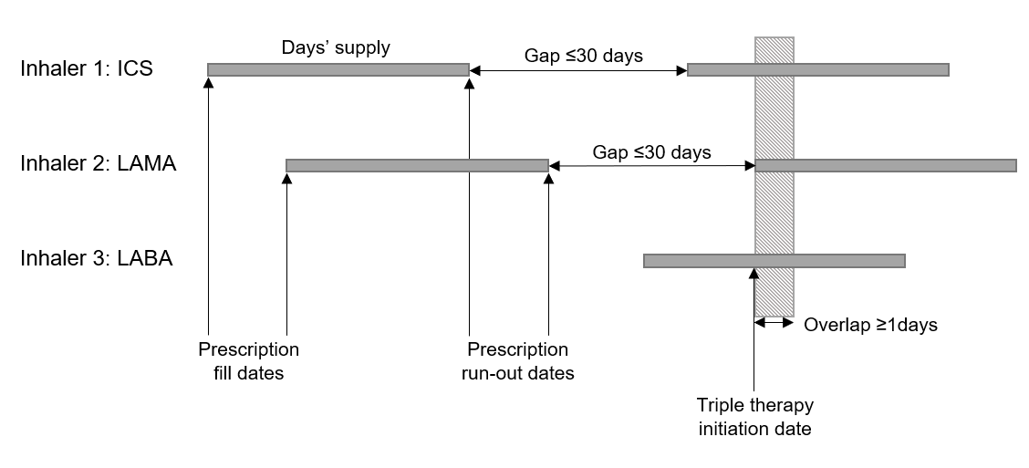
Abbreviations: ICS, inhaled corticosteroid; LABA, long-acting β2-agonist; LAMA, long-acting muscarinic antagonist; MITT, multiple-inhaler triple therapy.

e-Figure 2 PDC calculation by triple therapy type.
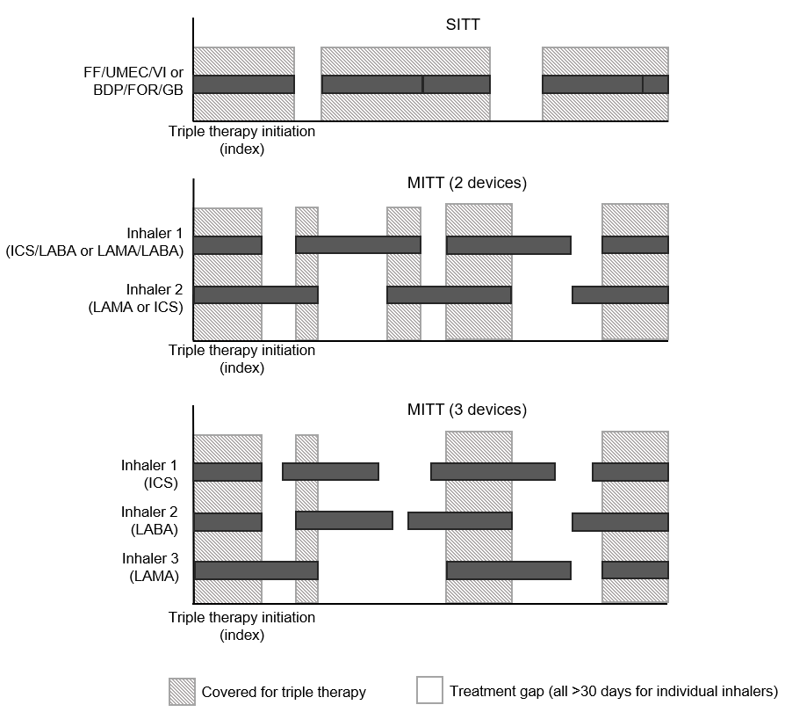

Note: PDC (triple therapy) = days covered by all three components of triple therapy x 100%.
measurement period in days
Abbreviations: BDP/FOR/GB, beclomethasone, formoterol and glycopyrronium bromide; FF/UMEC/VI, fluticasone furoate, umeclidinium and vilanterol; ICS, inhaled corticosteroid; LABA, long-acting β2-agonist; LAMA, long-acting muscarinic antagonist; MITT, multiple-inhaler triple therapy; PDC, proportion of days covered; SITT, single-inhaler triple therapy.

e-Figure 3 Persistence rates of the weighted SITT and MITT cohorts.
- Non-persistence defined as a gap of 45 days*
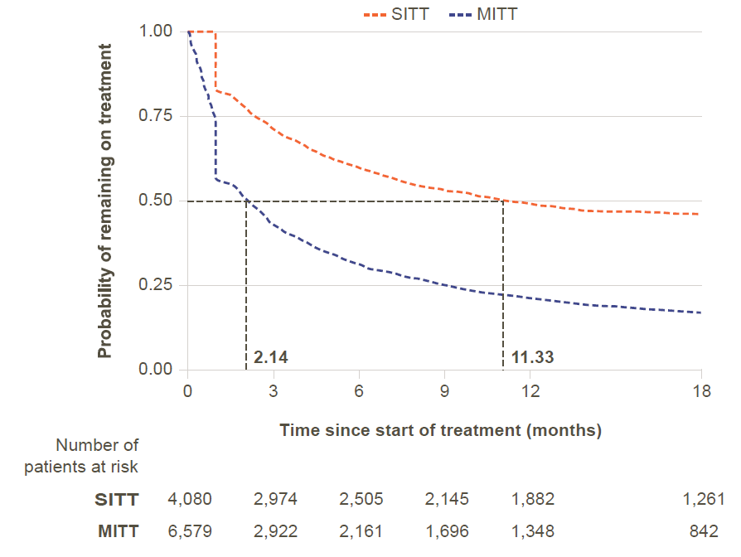

- Non-persistence defined as a gap of 60 days*
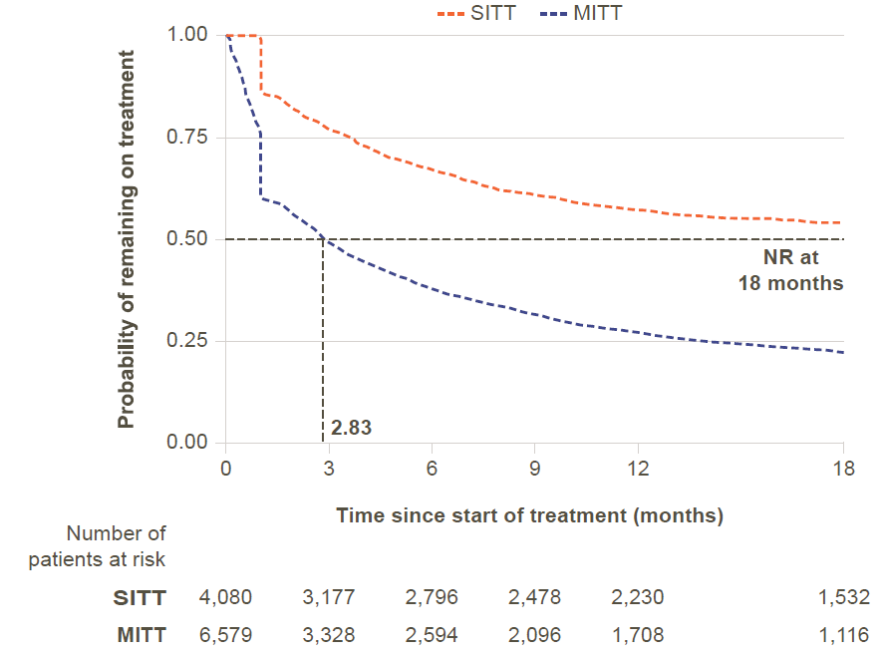
Notes: *For SITT users, non-persistence was defined as a gap of A) 45 or B) 60 days between the end of a SITT prescription duration and the following refill. For MITT users, non-persistence was defined as a gap of A) 45 or B) 60 days between prescriptions in any of the three components of MITT. Patient numbers are from the unweighted cohorts. Median persistence is indicated by the gray dotted lines.
Abbreviations: MITT, multiple-inhaler triple therapy; NR, not reached; SITT, single-inhaler triple therapy.
e-Figure 4 Patient attrition (FF/UMEC/VI versus MITT)
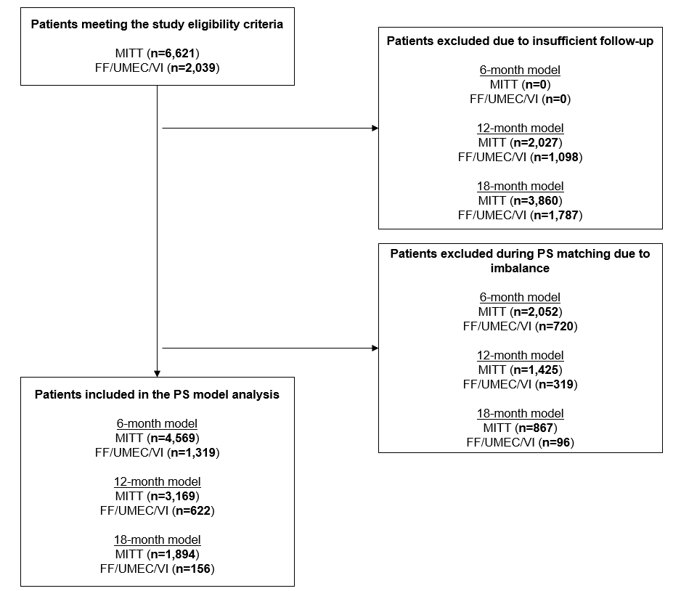
Abbreviations: FF/UMEC/VI, fluticasone furoate, umeclidinium and vilanterol; MITT, multiple-inhaler triple therapy; PS, propensity score.

e-Figure 5 Persistence rates of the weighted FF/UMEC/VI and MITT cohorts.
- Non-persistence defined as a gap of 45 days*
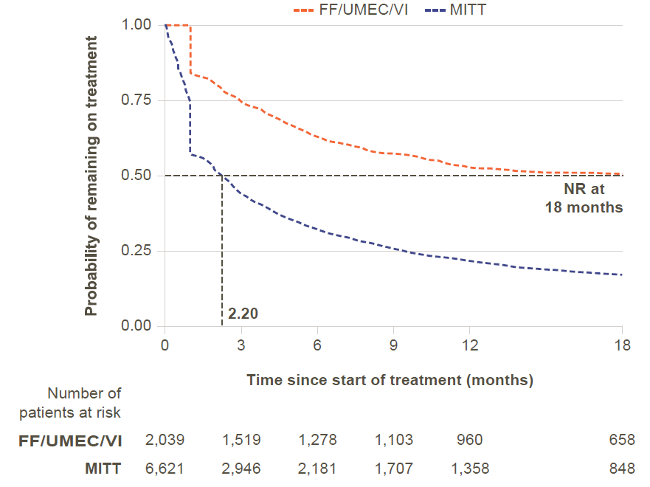

- Non-persistence defined as a gap of 60 days*
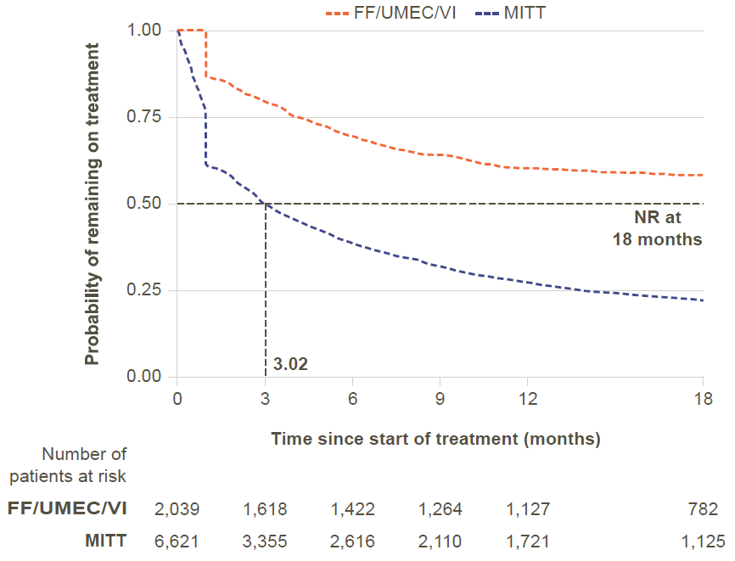
Notes: *For FF/UMEC/VI users, non-persistence was defined as a gap of A) 45 or B) 60 days between the end of an FF/UMEC/VI prescription duration and the following refill. For MITT users, non-persistence was defined as a gap of A) 45 or B) 60 days between prescriptions in any of the three components of MITT. Patient numbers are from the unweighted cohorts. Median persistence is indicated by the gray dotted lines.
Abbreviations: FF/UMEC/VI, fluticasone furoate, umeclidinium and vilanterol; MITT, multiple-inhaler triple therapy; NR, not reached.
e-Figure 6 Patient attrition (BDP/FOR/GB versus MITT)
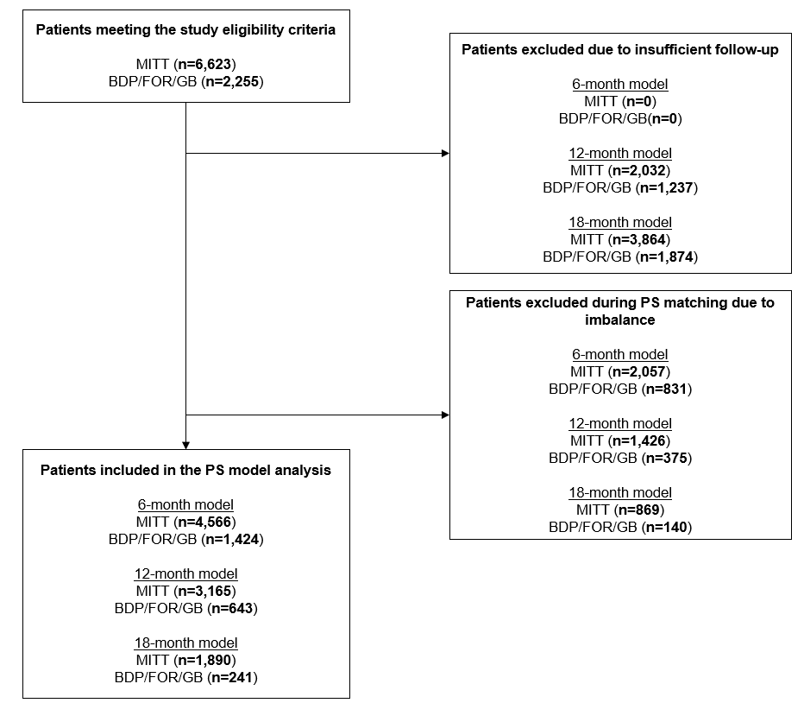
Abbreviations: BDP/FOR/GB, beclomethasone, formoterol and glycopyrronium bromide; MITT, multiple-inhaler triple therapy; PS, propensity score.

e-Figure 7 Persistence rates of the weighted BDP/FOR/GB and MITT cohorts.
- Non-persistence defined as a gap of 45 days*
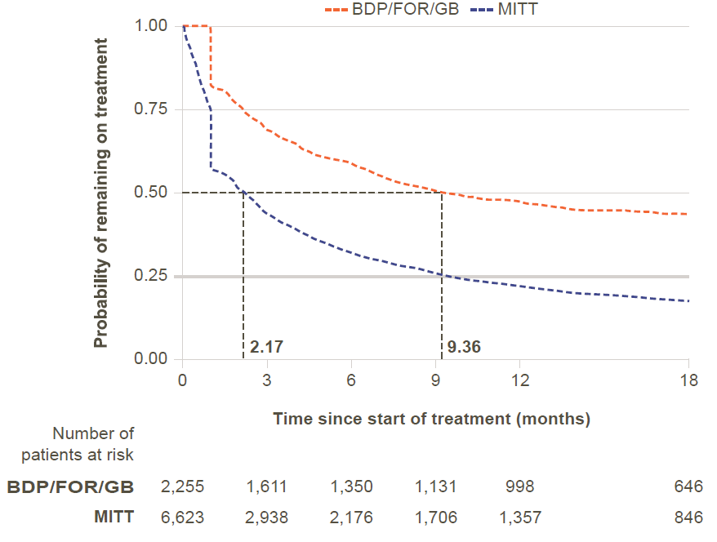

- Non-persistence defined as a gap of 60 days*
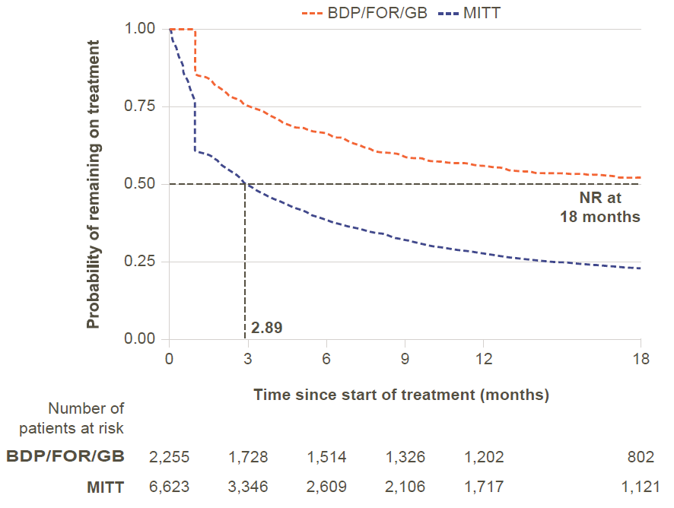

Notes: *For BDP/FOR/GB users, non-persistence was defined as a gap of A) 45 or B) 60 days between the end of a BDP/FOR/GB prescription duration and the following refill. For MITT users, non-persistence was defined as a gap of A) 45 or B) 60 days between prescriptions in any of the three components of MITT. Patient numbers are from the unweighted cohorts. Median persistence is indicated by the gray dotted lines.
Abbreviations: BDP/FOR/GB, beclomethasone, formoterol and glycopyrronium bromide; MITT, multiple-inhaler triple therapy.

