Supplementary Figure 1 Kaplan–Meier curves corresponding to OS and PFS (before PSM). (A) Kaplan–Meier curves for OS; (B) Kaplan–Meier curves for PFS
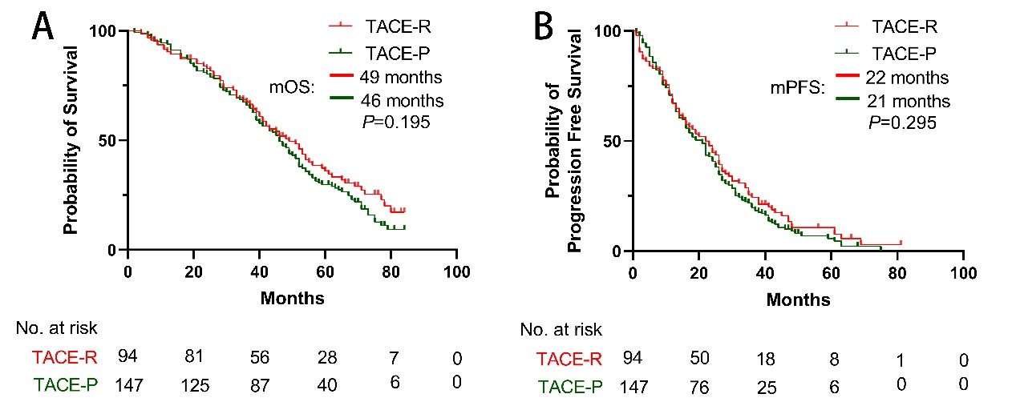
Supplementary Figure 2 Forest plots for subgroup analysis (before PSM). (A) Forest plot for OS; (B) Forest plot for PFS
