Supplementary Materials

Independent association between oxygen desaturation index and cardiovascular disease in non-sleepy sleep-disordered breathing subtype: A Chinese community-based study

Longlong Wang¹ ², Qiong Ou¹ ², Guangliang Shan³, Miaochan Lao², Guo Pei², Yanxia Xu², Jinhuan Huang⁴, Jiaoying Tan¹ ², Weiping Chen¹ ², Bing Lu¹ ²

Figure S1. Type IV intelligent wearable sleep monitoring devices and method of use
(A)
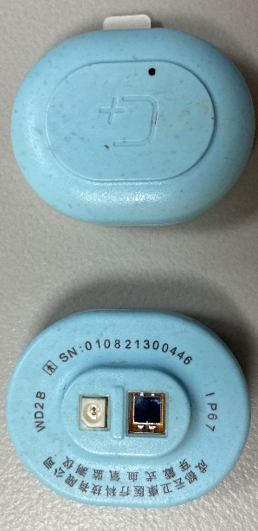
(B)
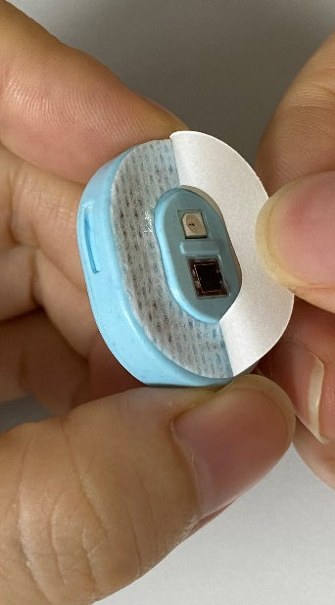
(C)
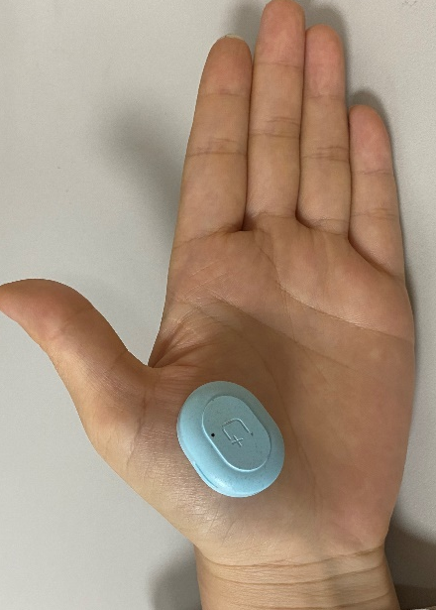
(A) Front and back photos of intelligent wearable sleep monitoring devices
(B) Double-sided adhesive is attached to the side with the photoelectric reflex sensor
(C) The device is tightly adhered to the position of palmar thenar major muscles with double-sided adhesive

Figure S2. Validation of intelligent wearable sleep monitoring devices by comparison against polysomnography
(B)
(A)
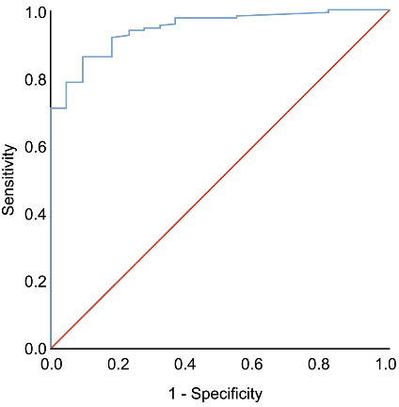
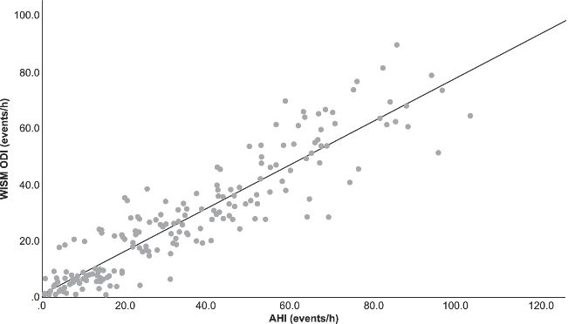
(A) ROC curve of SDB diagnosed by WISM at AHI threshold ≥ 5 times/hour as defined by PSG. (B) AHI and WISM ODI conformance analysis.

Note: Figures (A) and (B) are from the previously published study of our research team; Adapted with permission from Xu Y, Ou Q, Cheng Y, et al. Comparative study of a wearable intelligent sleep monitor and polysomnography monitor for the diagnosis of obstructive sleep apnea. Sleep Breath, 2022.¹

Our research team validated the wearable intelligent sleep monitoring device (WISM) by comparison against polysomnography (PSG) at the Sleep Center of Guangdong Provincial People's Hospital from July 2020 to March 2021. In total, 196 participants completed both PSG and WISM monitoring at the same time. When the ODI by WISM reaches 7.0 events/h, the optimal cut-off value, it has a sensitivity, specificity, and the area under the ROC curve of 86%, 91%, and 0.95, respectively, to predict SDB defined by an apnea-hypopnea index (AHI) ≥5 events/h (Figure (A)). In addition, the ODI had a strong correlation with the AHI from the PSG (R ² =0.843, P < 0.001, Figure (B)).

SDB= sleep-disordered breathing; ROC= receiver-operating characteristic; WISM= wearable intelligent sleep monitor; AHI apnea–hypopnea index; ODI= oxygen desaturation index; PSG= polysomnography

References
[1] Xu Y, Ou Q, Cheng Y, et al. Comparative study of a wearable intelligent sleep monitor and polysomnography monitor for the diagnosis of obstructive sleep apnea [J]. Sleep Breath, 2022. DOI: 10.1007/s11325-022-02599-x.

Figure S3. Flow chart of the study
ESS = Epworth Sleepiness Scale; EDS = excessive daytime sleepiness; CVD = cardiovascular disease.

Table S1: Logistic regression of association between ODI, EDS, and CVD in individuals with SDB.
 | Model 1 | Model 2 | Model 3 | Model 4
EDS | --- | 1.532(0.797,2.944) | 1.077(0.534,2.172) | 1.319(0.629,2.764)
ODI | 1.036(1.019,1.053) | 1.035(1.019,1.052) | 1.024(1.006,1.043) | 1.024(1.005,1.044)
P value for interaction | --- | 0.707 | 0.963 | 0.497
Notes: Model 1 was not adjusted; Model 2 was adjusted for EDS (yes or no); Model 3 was adjusted for age (continuous, years); sex (male or female); BMI (continuous, kg/m²) and EDS (yes or no); Model 4 was adjusted for factors in Model 3 plus neck circumference (continuous, cm), waist circumference (continuous, cm), smoking status (never, former, or current), drinking status (never, former, or current) and diabetes (yes or no). Bold values indicate statistical significance.
Abbreviations: EDS = excessive daytime sleepiness; CVD = cardiovascular disease; ODI= oxygen desaturation index; SDB= sleep-disordered breathing.
Figure S4. Mediation analysis between oxygen desaturation index with CVD in the studied population using EDS (yes or no; A) or ESS score (continuous; B)
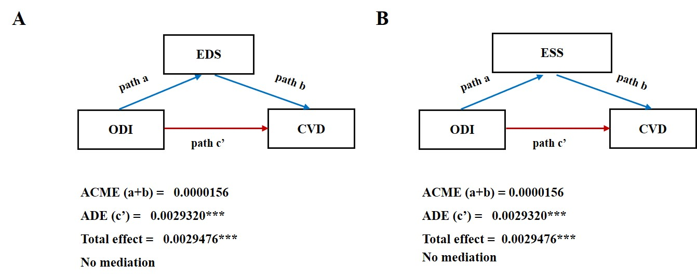
The mediation models are adjusted for: age (continuous, years); sex (male or female); BMI (continuous, kg/m²); neck circumference (continuous, cm); waist circumference (continuous, cm); smoking status (never, former, or current); drinking status (never, former, or current); and diabetes (yes or no). *** indicates statistical significance with P＜0.001.
ESS = Epworth Sleepiness Scale; EDS = excessive daytime sleepiness; CVD = cardiovascular disease; ODI = oxygen desaturation index; ADE = average direct effect; ACME = average causal mediation effect

Figure S5. Mediation analysis between ODI and CVD in non-sleepy SDB patients using TG(A), CHO(B), LDL-C(C), HDL-C(D), PSQI(E), and hsCRP(F)
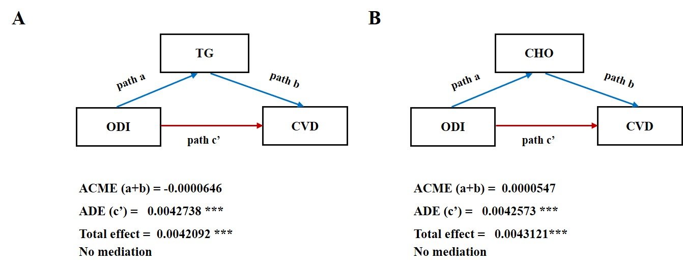
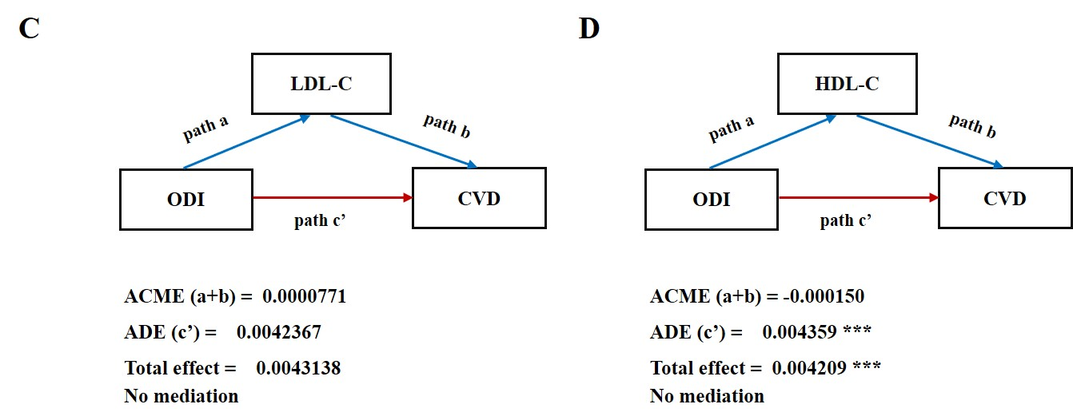
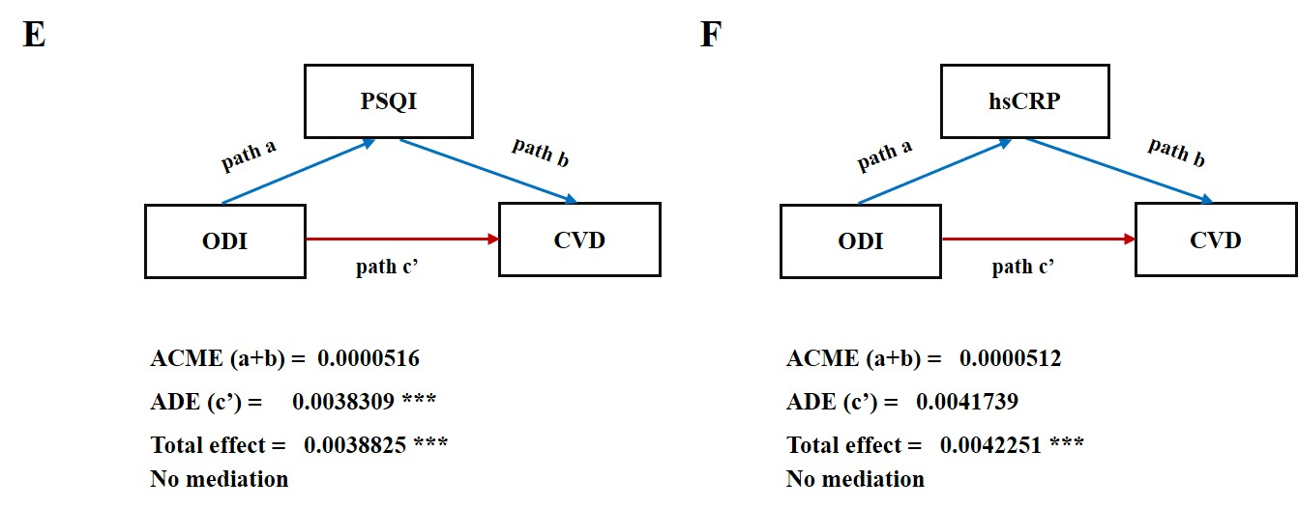
The mediation models are adjusted for: age (continuous, years); sex (male or female); BMI (continuous, kg/m²); neck circumference (continuous, cm); waist circumference (continuous, cm); smoking status (never, former, or current); drinking status (never, former, or current); and diabetes (yes or no). *** indicates statistical significance with P＜0.001.
CVD = cardiovascular disease; ODI = oxygen desaturation index; TG = triglycerides; CHO = total cholesterol; LDL-C = low-density lipoprotein cholesterol; HDL-C = high-density lipoprotein cholesterol; PSQI = Pittsburgh Sleep Quality Index; hsCRP = high-sensitivity C-reactive protein.

