Supplementary materials

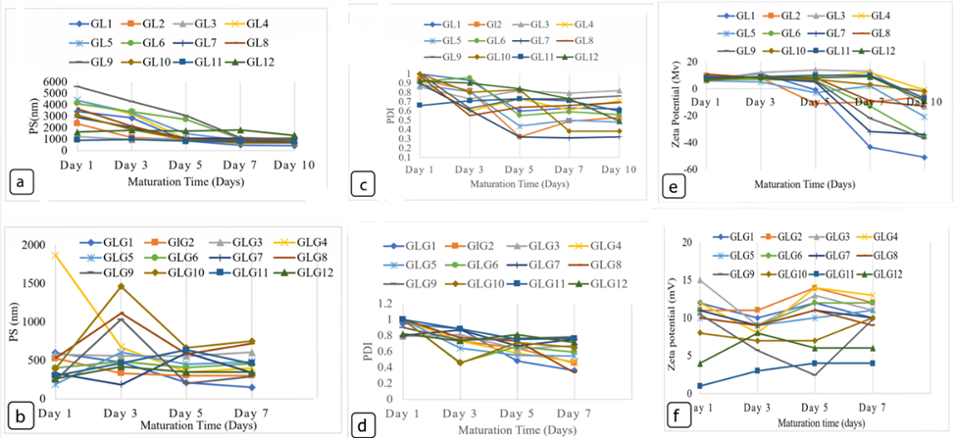

Figure S1: Tracking the particle size (PS), polydispersity index (PDI) and Zeta potential (ZP) of the prepared formulations over a period of 7 to 10-days: a) PS of the glycerol free formulations; GL1 through GL12, b) PS of the glycerol containing formulations; GLG1 through GLG12, c) PDI of GL1 through GL12, d) PDI of GLG1 through GLG12, e) ZP of GL1 through GL12 and f) ZP of GLG1 through GLG12.

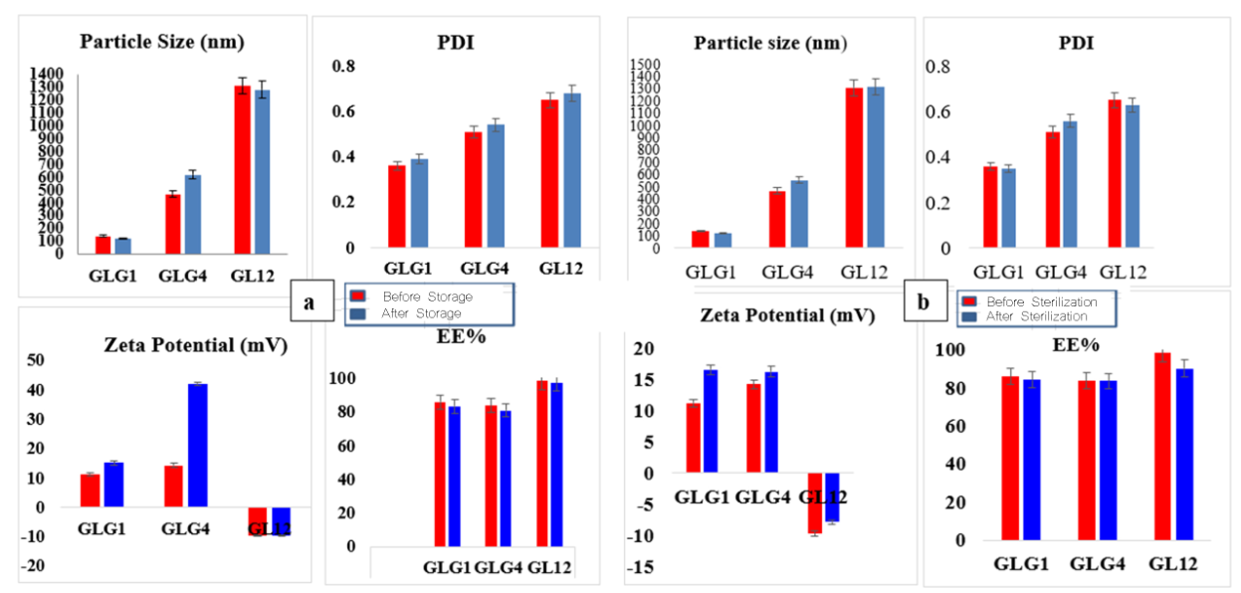

Figure S2: Characterization (PS, PDI, ZP and EE%) of the selected formulations for further investigation: a) before and after storage for 3 months and b) before and after sterilization by gamma irradiation.

