Supplementary material:
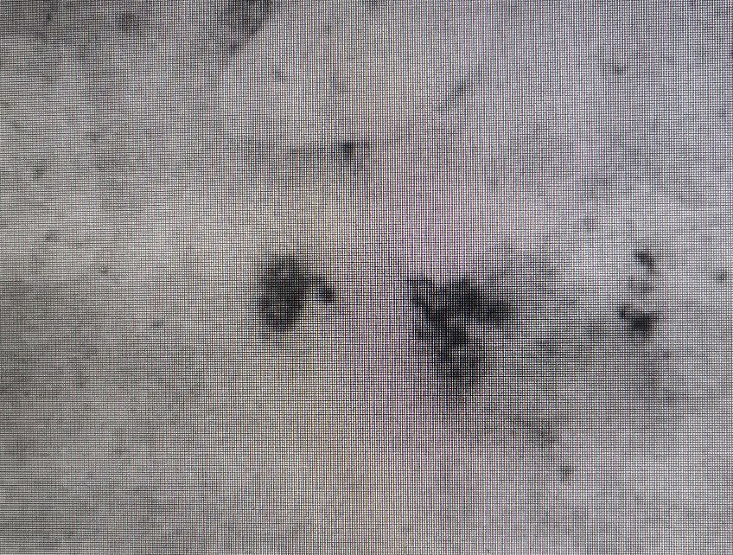
A photograph of sputum cytopathological report.
The sputum smear was stained with silver hexamine and pneumocystis cysts were found.

