Supplementary Materials

Supplementary figures and table are listed as below (legends in small prints):
Supplementary Figure 1. Selection of study population
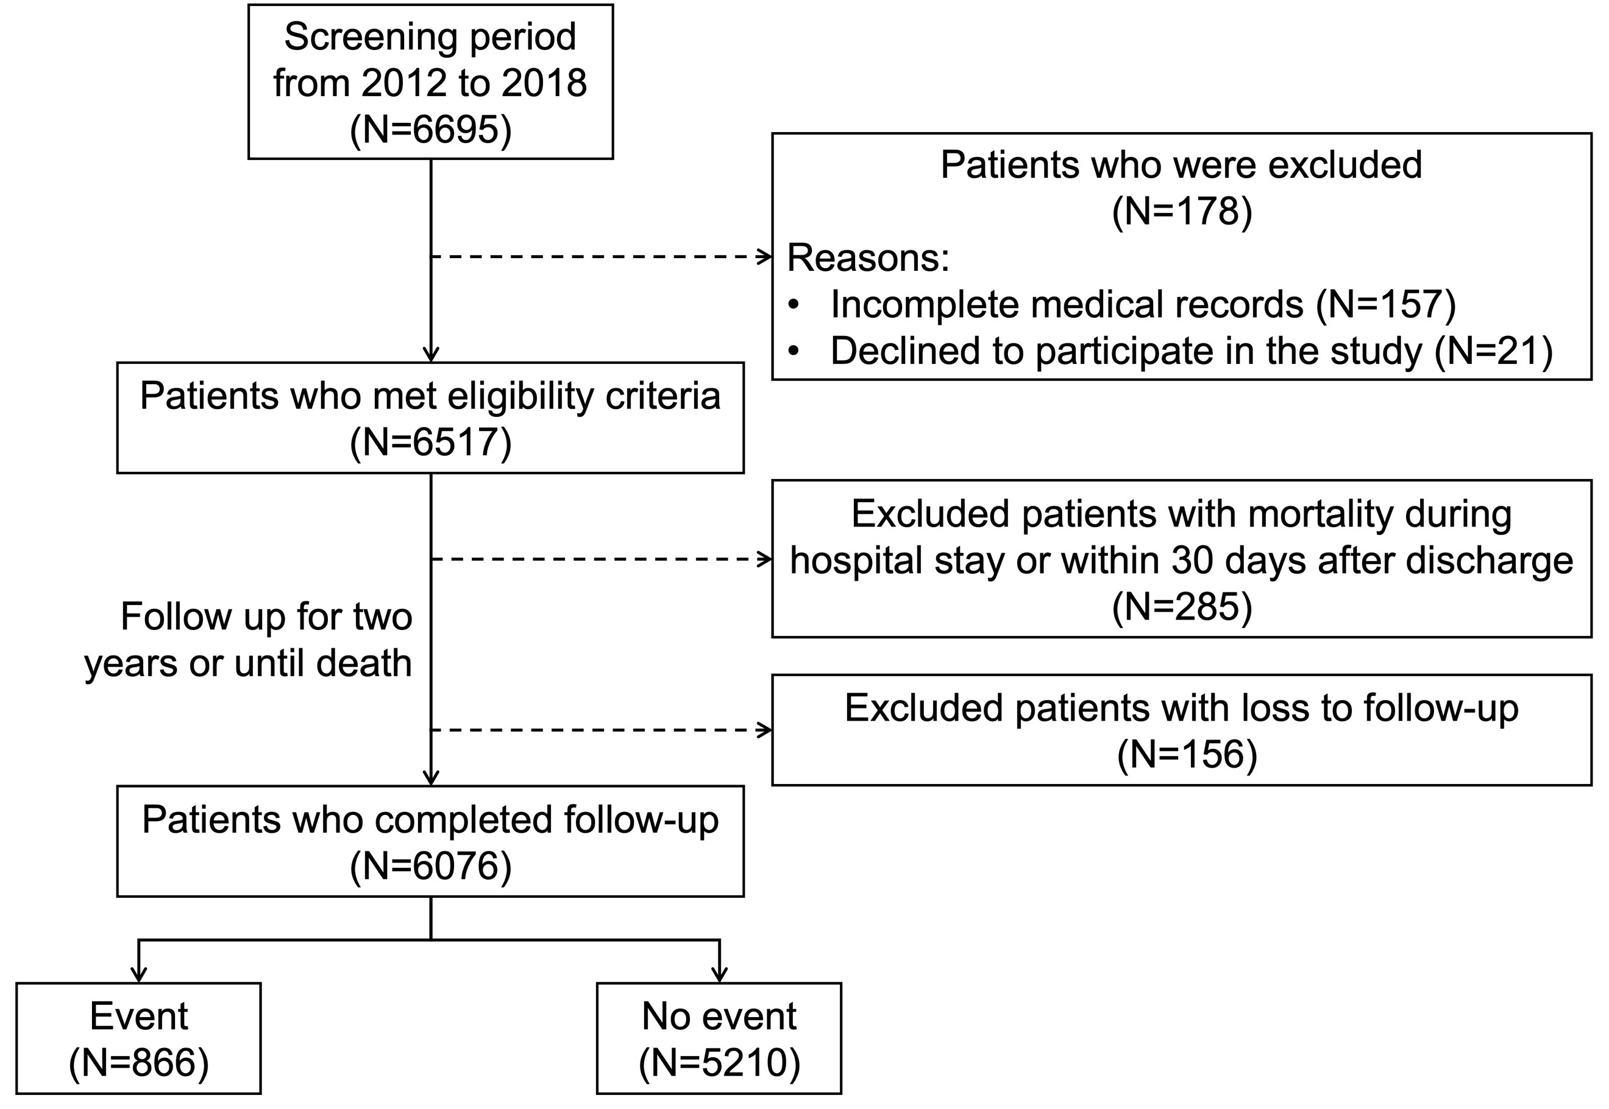

Supplementary Table 1. Reference intervals of biomarkers
Biomarker | Normal values | Unit of measurement
cTnT | <0.03 | ng/mL
WBC | 3.50-9.50 | ×10⁹/L
PLT | 125-350 | ×10⁹/L
Hb (male) | 120-160 | g/L
Hb (female) | 110-150 | g/L
APTT | 25.0-31.3 | s
PT | 10.0-13.0 | s
TT | 14.0-21.0 | s
INR | 0.5-1.20 | -
FIB | 200-400 | mg/dL
D-D | 0-0.80 | mg/dL
CK | 26-140 | U/L
CK-MB | 0-23 | U/L
NT-proBNP | 0-300 | pg/mL
hsCRP | 0-3.0 | mg/L
HbA1c | 4.0-6.0 | %
UA | 155-357 | μmol/L
eGFR | - | ml/min⁻¹·1.73m²
sCr | 44-115 | μmol/L
ALB | 35-55 | g/L
TC, | <5.20 | mmol/L
HDL-C | >1.04 | mmol/L
LDL-C | <3.40 | mmol/L
cTnT, cardiac troponin T; WBC, white blood cell count; PLT, platelet count; Hb, hemoglobin; APTT, activated partial thromboplastin time; PT, prothrombin time; TT, thrombin time; INR, international normalized ratio; FIB, fibrinogen; D-D, D-dimer; CK, creatine kinase; NT-proBNP, N-terminal pro-B-type natriuretic peptide; hsCRP, high sensitivity C-reactive protein; HbA1c, hemoglobin A1c; UA, uric acid; eGFR, estimated glomerular filtration rate; sCr, serum creatinine; ALB, albumin; TC, total cholesterol; HDL-C, high-density lipoprotein cholesterol; LDL-C, low-density lipoprotein cholesterol.

Supplementary Figure 2. Hazard ratios of primary endpoints with individual biomarker levels
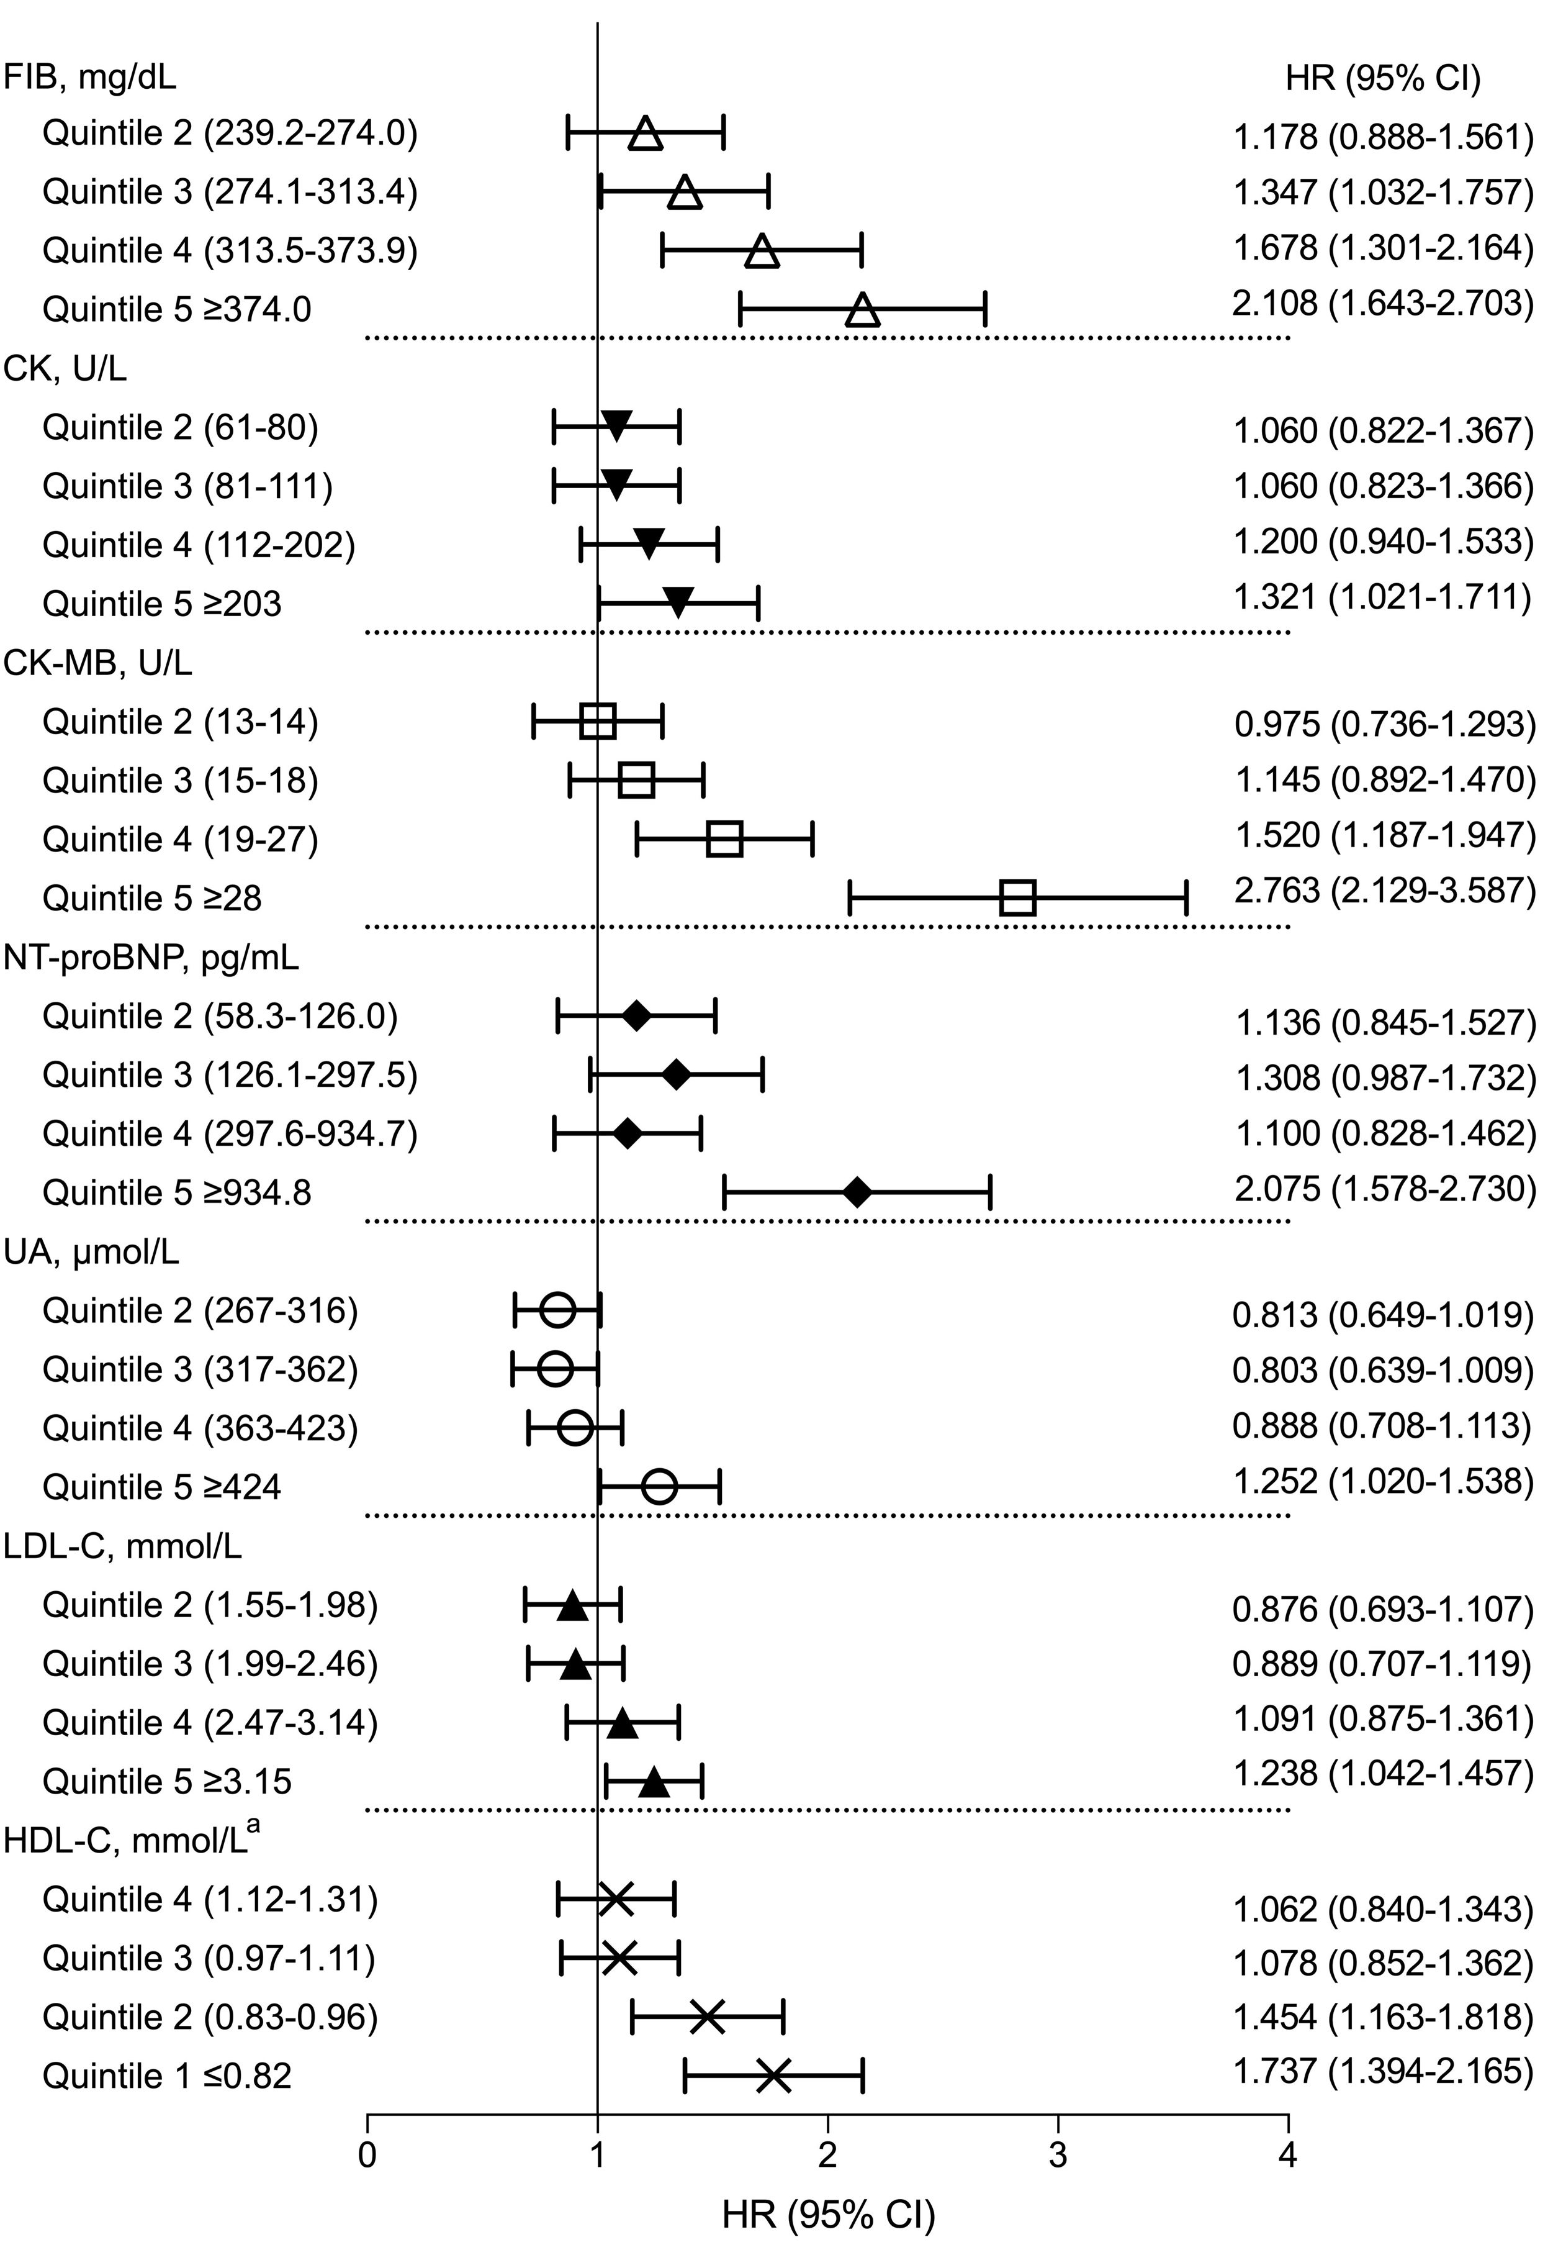
ª HR with 95% CI were calculated with reference to the highest concentration of HDL-C (Quintile 5, ≥1.32 mmol/L).
HRs (95% CI) were adjusted by GRACE scores and cTnT. HR, hazard ratio; CI, confidence interval; FIB, fibrinogen; CK, creatine kinase; NT-proBNP, N-terminal pro-B-type natriuretic peptide; UA, uric acid; LDL-C, low-density lipoprotein cholesterol; HDL-C, high-density lipoprotein cholesterol..

Supplementary Figure 3. Risk reclassification by biomarker scores
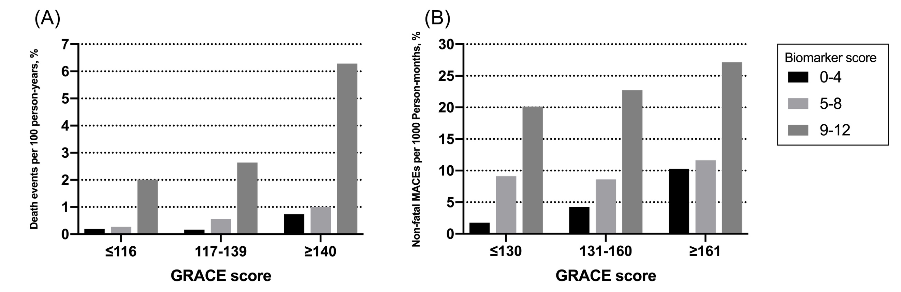
GRACE, Global Registry of Acute Coronary Events .

Supplementary Figure 4. Calibration plots of biomarker scores for all-cause death and non-fatal MACEs
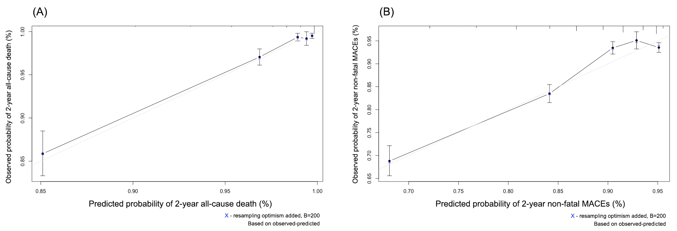
MACE, non-fatal major adverse cardiac events.

