Supplementary Material
Investigation of the "nose-to-brain" pathways in intranasal HupA nanoemulsions and evaluation of their in vivo pharmacokinetics and brain-targeting ability
Yueyao Jiang¹, Yichuan Jiang¹, Zhiying Ding², Qian Yu¹

¹ Department of Pharmacy, China-Japan Union Hospital, Jilin University, Changchun 130033, China; ² Department of Pharmacology, School of Pharmaceutical Sciences, Jilin University, Changchun 130021, China

Correspondence: Qian Yu
Department of Pharmacy, China-Japan Union Hospital, Jilin University, Changchun 130033, China
Tel +86 13664419002
Email yuqian@jlu.edu.cn

Methods

HPLC Method Validation In Vitro and In Vivo
System suitability testing is a crucial part of method validation. System validation parameters, including method selectivity, linearity, precision, accuracy, LOD and LOQ, were set up. Forced degradation study samples (HupA standard solution, blank NE and HupA-NE) were used to evaluate the selectivity of the method. After ultrasonic dissolution, 20 μL of the supernatant was injected into the HPLC system to study whether any interfering peaks coeluted at or near the drug peak. Standard of HupA was diluted with method solution to obtain final HupA standard concentrations of 3.125 µg/mL, 6.25 µg/mL, 12.5 µg/mL, 25 µg/mL, 50 µg/mL, 100 µg/mL. Then, these standards were injected into the HPLC column. Peak area data were plotted against corresponding standard concentrations to construct the standard calibration curve. The linearity was established by calculating the R² value. The precision studies were performed with solutions containing HupA at concentrations of 6.25 µg/mL (low), 25 µg/mL (medium), and 100 µg/mL (high). To determine intra-day and inter-day precision, samples were prepared and analyzed six times on the same day and on six different days. The relative standard deviation (RSD) values were calculated for all concentrations. The accuracy of the method was assessed by a recovery experiment for three different concentrations. HupA standards were added to blank NE. After demulsification using methanol, the recovery was calculated by practical amounts recovered from theoretical values present. The limit of detection (LOD) and limit of quantification (LOQ) were determined when the signal-to-noise ratio (S/N) was 3 and 10, respectively.
Blank samples of heart, liver, spleen, lung, kidney, brain and blood were added to the HupA standards. The blood and vital organs were processed in the same manner according to the “Pharmacokinetics and Targeting Index Analysis”. Then, 20 μL was injected into the HPLC system for the study of selectivity. The concentration gradient of HupA standards was added to the blood and vital organs to obtain final blood and vital organ concentrations of 6.25 ng/mL, 12.5 ng/mL, 25 ng/mL, 50 ng/mL, 100 ng/mL, 200 ng/mL, 400 ng/mL, and 800 ng/mL. Then, these blood and vital organ standards were injected into the HPLC column to construct the standard calibration curve. Samples with concentrations of 200 ng/mL (high), 100 ng/mL (medium), and 6.25 ng/mL (low) were used for the blood and vital organ precision and accuracy.

Results

HPLC Method Validation In Vitro and In Vivo
The HupA peak was well separated from the pharmaceutical excipients of NE (retention time 15.6 min). The selectivity study confirmed that the HPLC method has the capability to form “valid results” that are free from matrix interference (Figure S1). Standard calibration curve reflected good linearity of the assay in the concentration range of 3.125-100 µg/mL (Figure S2). The linear regression of the calibration curve produced an equation of (Y=52149X+202457), with a coefficient of determination (R²) of 0.9997. The intra-day and inter-day precision values are presented in Table S1. The results showed acceptable intra-day and inter-day precision for all concentrations tested. HupA was successfully recovered from all samples at three different concentrations. Table S2 presents the percentage of drug recovered relative to the theoretical values. The recovered values were close to the true values, suggesting the accuracy of the assay. The LOD for HupA was 1.5 ng/mL for a signal-to-noise ratio of 3:1. The LOQ was 5 ng/mL.
The chromatograms presented as Figure S3-S9 were obtained after the treated biological samples were mixed with the HupA standards. The results showed that the chromatographic conditions were suitable. The extraction methods were appropriate. The endogenous substances in biological samples did not interfere with HupA, and the specificity of the analytical method was good. Standard calibration curves reflected good linearity of the assays. The regression equations for each biological sample are shown in Table S3. The results indicated that the plasma and tissue samples of HupA demonstrated a good linear relationship. The RSD values of both inter-day and intra-day precision were acceptable, at less than 15%, demonstrating that the method is precise (Table S4). The accuracy was calculated as the percentage recovery from the three concentrations(Table S5). HupA was successfully recovered from all plasma and tissue samples. The selectivity, linearity, precision, and accuracy of the HPLC method in vivo and vitro are suitable for future use in HPLC analysis.

Table S1 Intra-day and inter-day precision of HupA in vitro (n = 6)
Concentration  （µg/mL） | Intra-day |  | Inter-day
Concentration  （µg/mL） | Mean±SD | RSD（%） | Mean±SD | RSD（%）
6.25 | 6.29±0.10 | 1.61% | 6.25±0.08 | 1.3%
25 | 25.21±0.46 | 1.83% | 25.07±0.22 | 0.88%
100 | 100.06±1.12 | 1.12% | 100.14±0.76 | 0.76%

Table S2 Recovery of HupA in vitro (n = 6)
Concentration  （µg/mL） | Mean（%）±SD | RSD（%）
6.25 | 99.88±0.79 | 1.03
25 | 100.87±0.92 | 1.22
100 | 99.72±0.72 | 0.98

Table S3 Regression equations for HupA standards in plasma and organs
Plasma and organs | Standard calibration curve | Coefficient of determination (R²) | Linear range (ng/mL)
Plasma | y = 62.433x - 208.03 | 0.9995 | 6.25~200
Heart | y = 58.582x + 54.153 | 0.9982 | 6.25~200
Liver | y = 53.934x + 66.476 | 0.9981 | 6.25~400
Spleen | y = 65.688x - 7.6766 | 0.9945 | 6.25~200
Lung | y = 56.13x - 4.179 | 0.9966 | 6.25~800
Kidney | y = 60.878x + 17.857 | 0.9947 | 6.25~800
Brain | y = 22.499x – 5.0678 | 0.9954 | 6.25~200

Table S4 Intra-day and inter-day precision of HupA in vivo (n = 6)
Plasma and organs | Concentration (ng/mL) | intra-day precision |  | inter-day precision
Plasma and organs | Concentration (ng/mL) | Mean±SD | RSD（%） | Mean±SD | RSD（%）
Plasma | 6.25 | 6.28±0.16 | 2.60 | 6.32±0.33 | 5.24
Plasma | 100 | 100.25±4.27 | 4.27 | 103.26±6.17 | 5.98
Plasma | 200 | 201.24±9.76 | 4.85 | 204.27±8.85 | 4.33
Heart | 6.25 | 6.41±0.27 | 4.31 | 6.21±0.50 | 8.07
Heart | 100 | 101.04±4.01 | 3.96 | 105.57±8.29 | 7.85
Heart | 200 | 202.21±5.35 | 2.65 | 201.51±13.81 | 6.85
Liver | 6.25 | 6.31±0.22 | 3.54 | 6.39±0.50 | 7.83
Liver | 100 | 104.02±2.72 | 2.61 | 105.58±9.66 | 9.15
Liver | 200 | 200.63±5.89 | 2.93 | 203.52±10.93 | 5.37
Spleen | 6.25 | 6.38±0.18 | 2.84 | 6.61±0.29 | 4.52
Spleen | 100 | 101.13±4.76 | 4.70 | 101.86±7.91 | 7.77
Spleen | 200 | 202.86±6.01 | 2.96 | 203.24±7.90 | 3.89
Lung | 6.25 | 6.32±0.23 | 3.67 | 6.35±0.54 | 8.51
Lung | 100 | 102.30±6.02 | 5.88 | 103.81±9.11 | 8.78
Lung | 200 | 203.83±7.41 | 3.63 | 198.82±11.01 | 5.54
Kidney | 6.25 | 6.35±0.25 | 4.07 | 6.30±0.51 | 8.08
Kidney | 100 | 101.88±5.63 | 5.53 | 101.51±7.86 | 7.75
Kidney | 200 | 201.44±5.52 | 2.74 | 204.13±7.72 | 3.79
Brain | 6.25 | 6.44±0.27 | 4.18 | 6.15±.39 | 6.47
Brain | 100 | 100.25±3.81 | 3.79 | 106.32±7.62 | 7.17
Brain | 200 | 200.09±7.91 | 3.96 | 205.64±10.75 | 5.53

Table S5 Recovery of HupA in vivo (n = 6)
Plasma and organs | Concentration (ng/mL) | Mean±SD | RSD (%)
Plasma | 6.25 | 93.47±6.12 | 6.55
Plasma | 100 | 94.82±3.57 | 3.77
Plasma | 200 | 95.14±4.06 | 4.27
Heart | 6.25 | 92.87±5.95 | 6.41
Heart | 100 | 90.39±6.49 | 7.19
Heart | 200 | 93.19±4.2 | 4.51
Liver | 6.25 | 90.27±6.39 | 7.03
Liver | 100 | 91.13±6.58 | 7.22
Liver | 200 | 92.11±6.22 | 6.76
Spleen | 6.25 | 90.53±5.10 | 5.63
Spleen | 100 | 90.73±5.18 | 5.71
Spleen | 200 | 93.6±4.26 | 4.55
Lung | 6.25 | 90.93±4.15 | 4.56
Lung | 100 | 89.33±6.70 | 7.51
Lung | 200 | 89.2±4.6 | 5.16
Kidney | 6.25 | 90.82±6.48 | 7.13
Kidney | 100 | 91.99±6.63 | 7.21
Kidney | 200 | 92.51±5.58 | 6.04
Brain | 6.25 | 89.3±6.53 | 7.72
Brain | 100 | 91.93±6.79 | 7.39
Brain | 200 | 92.42±5.95 | 4.05

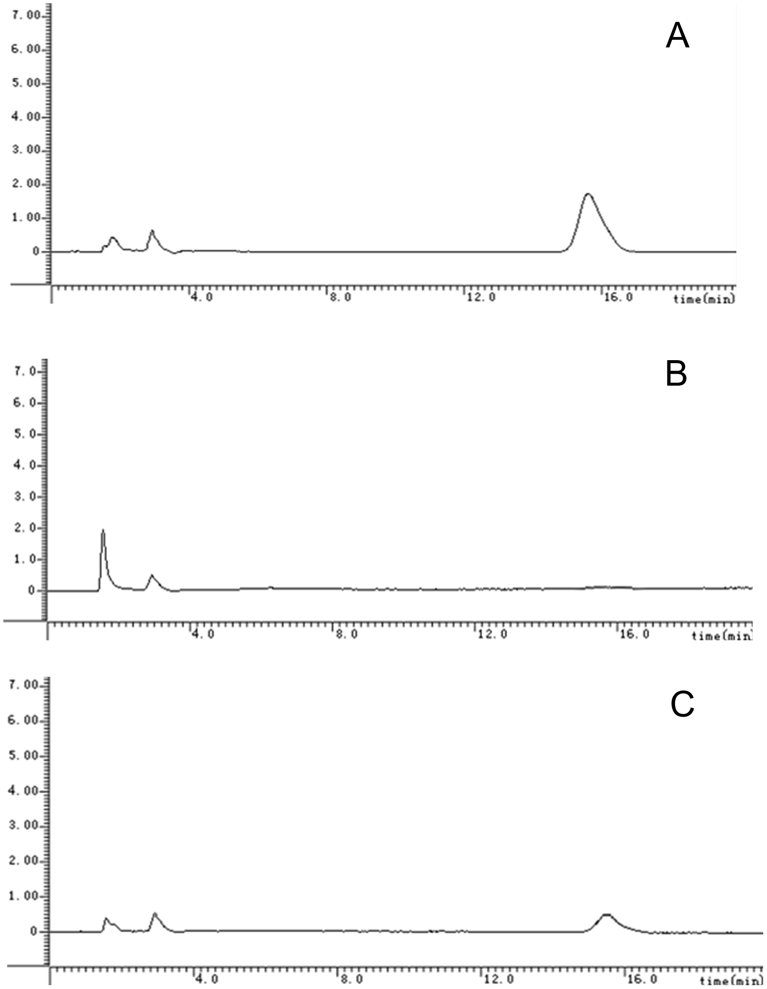
Figure S1 HPLC chromatograms of A. HupA standard solution; B. blank NE; C. HupA-NE
Area

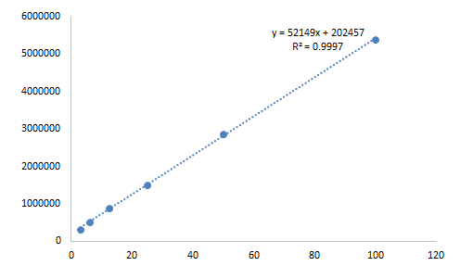
Concentration (ug/mL)

Figure S2 Standard calibration curves for the HupA standard
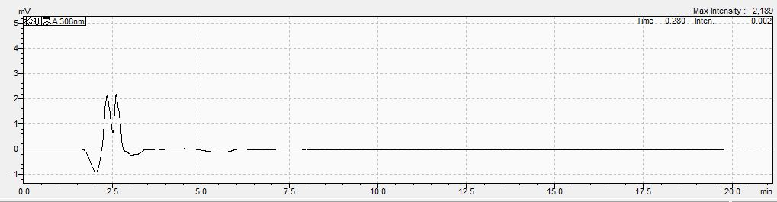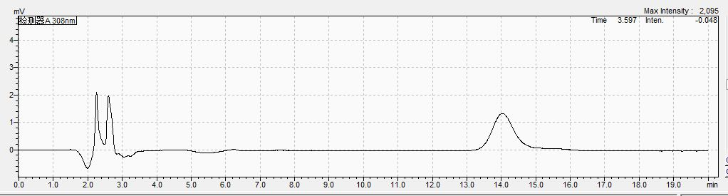
B
A
Figure S3 Chromatogram of HupA standard solution in plasma: A. blank plasma; B. mixture of plasma and HupA standard

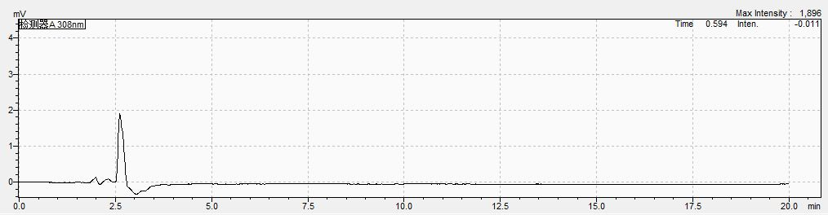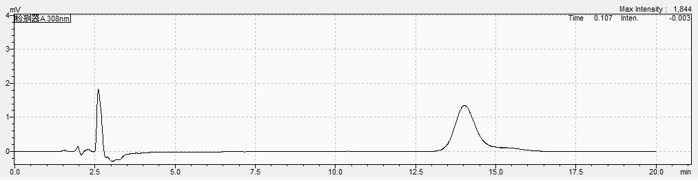
B
A
Figure S4 Chromatogram of HupA standard solution in heart tissue: A. blank heart tissue; B. mixture of heart tissue and HupA standard
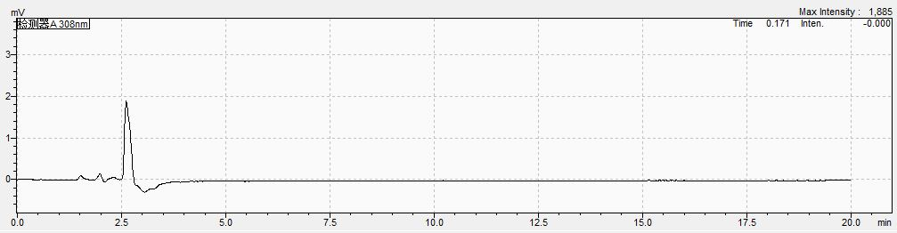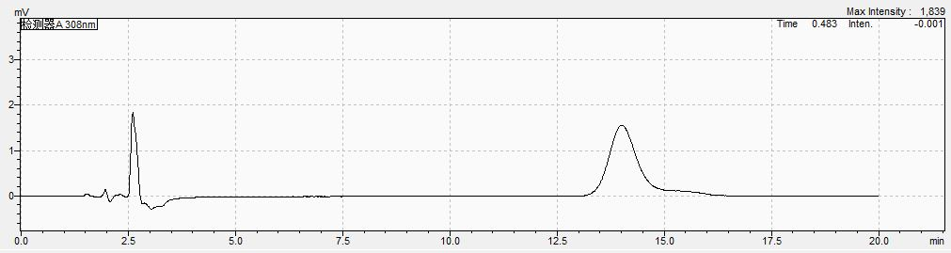
B
A
Figure S5 Chromatogram of HupA standard solution in liver tissue: A. blank liver tissue; B. mixture of liver tissue and HupA standard

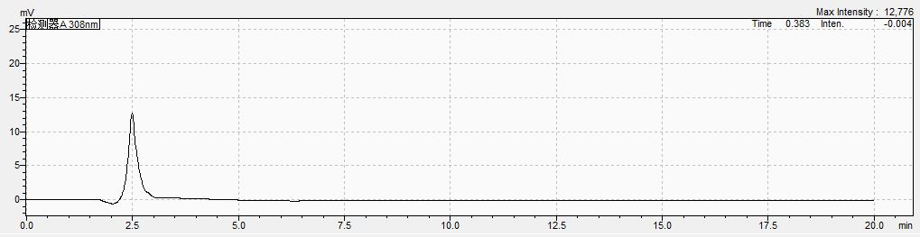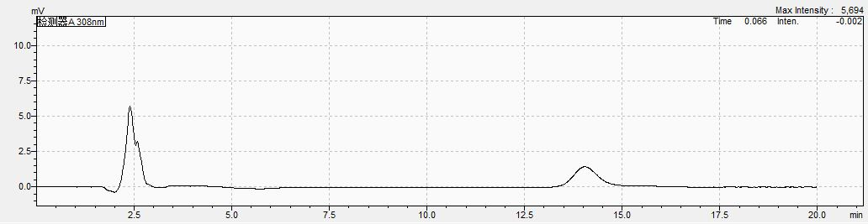
B
A
Figure S6 Chromatogram of HupA standard solution in spleen tissue: A. blank spleen tissue; B. mixture of spleen tissue and HupA standard

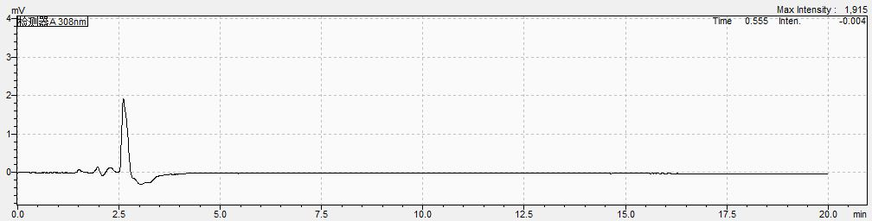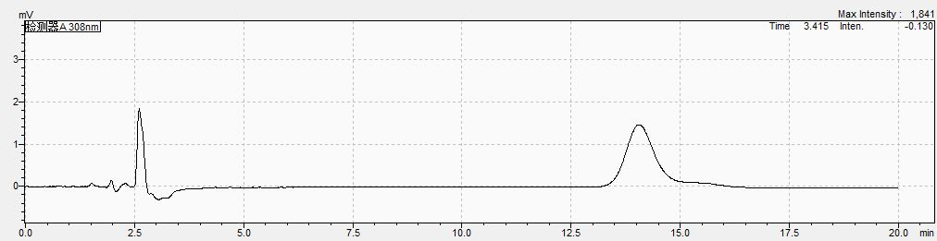
B
A
A
Figure S7 Chromatogram of HupA standard solution in lung tissue: A. blank lung tissue; B. mixture of lung tissue and HupA standard

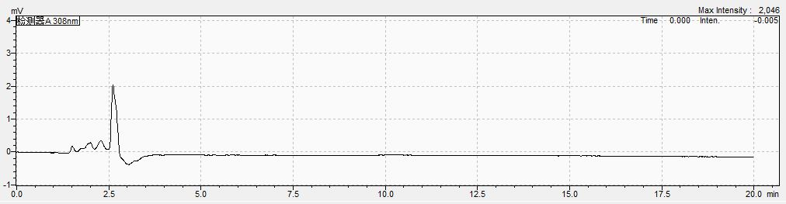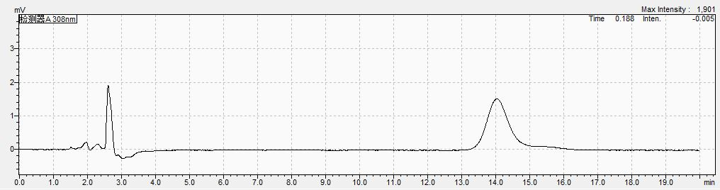
B
A
Figure S8 Chromatogram of HupA standard solution in kidney tissue: A. blank kidney tissue; B. mixture of kidney tissue and HupA standard

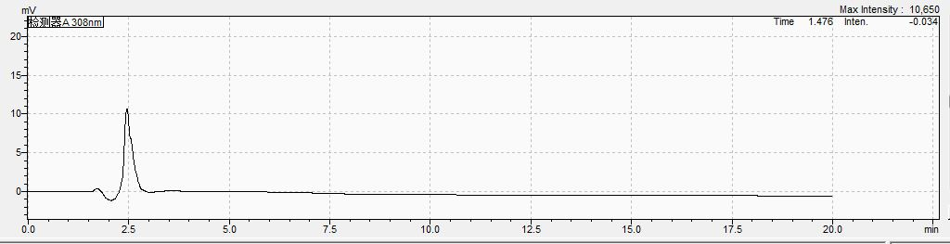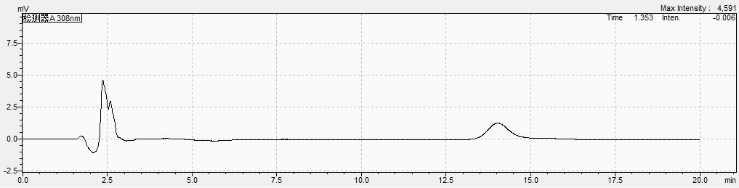
B
A
Figure S9 Chromatogram of HupA standard solution in brain tissue: A. Blank brain tissue; B. mixture of brain tissue and HupA standard

