Supplementary data

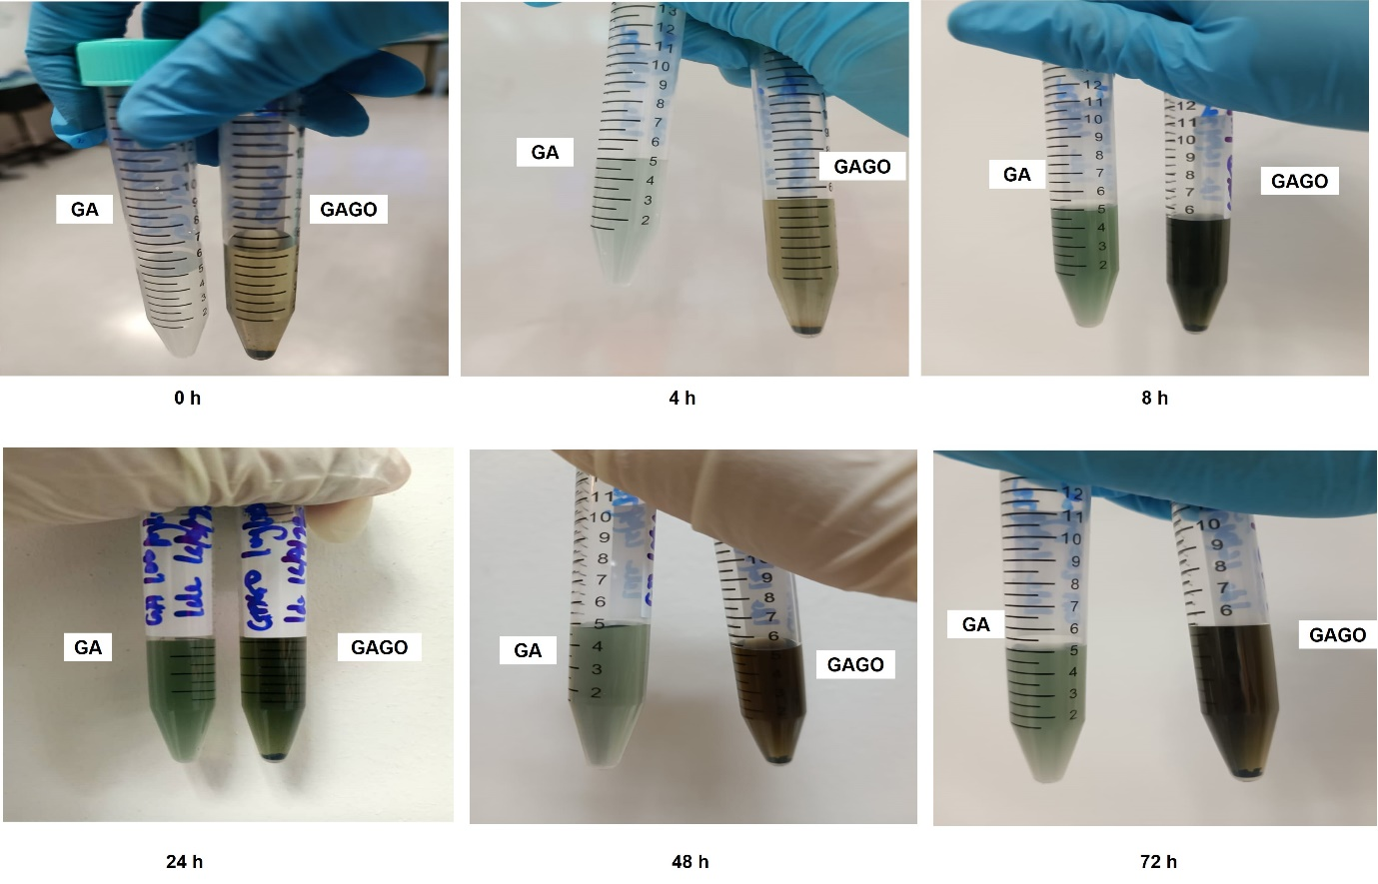
Figure S1: Stability of GA and GAGO in PBS, pH 7.4 following incubation for 72 h in a shaking incubator operating at 120 rpm, 37 °C. GA was shown to be unstable as early as 4h, in which was observed by the change in colour of the GA solution, compared to GAGO.

Figure S2: Time kill study of (A) MRSA, (B) MSSA, (C) MRSA-pvl+, and (D) MRSA-pvl- following exposure to GA, GO, and GAGO for 0–24 h at 150 µg/mL. MRSA, MSSA, MRSA-pvl+, and MRSA-pvl- treated with distilled water served as negative control (CTRL), while CFX acts as the positive control. Data represent mean ± SD (n = 3).

