Supplementary Table 1. Pearson correlation matrix for sleep, circadian variables, and FAs in Shift Workers
Working Status |  | 1 | 2 | 3 | 4 | 5 | 6 | 7 | 8 | 9 | 10 | 11 | 12 | 13 | 14 | 15 | 16 | 17 | 18 | 19 | 20 | 21
Shift Workers | 1. Mesor | 1
 | 2. Acrophase | 0.061 | 1
 | 3. F_statistics | 0.126 | 0.048 | 1
 | 4. M10 | .862** | 0.065 | .409** | 1
 | 5. L5 | 0.245 | -0.024 | -.578** | -0.042 | 1
 | 6. Interdaily stability | 0.117 | 0.034 | .847** | .411** | -.723** | 1
 | 7. Interdaily variability | -0.106 | -0.005 | -.329* | -.266* | 0.057 | -0.142 | 1
 | 8. Relative Amplitude | 0.027 | 0.043 | .694** | .337** | -.907** | .820** | -0.163 | 1
 | 9. PSQI | 0.102 | -0.195 | -0.103 | 0.064 | 0.146 | -0.122 | -0.144 | -0.208 | 1
 | 10. ESS | 0.094 | -0.036 | -0.028 | 0.076 | 0.106 | -0.056 | -0.219 | -0.161 | .483** | 1
 | 11. ISI  DTI Variables | -0.006 | 0.078 | -0.039 | -0.024 | 0.122 | -0.150 | -0.145 | -0.189 | .741** | .431** | 1
 | 12. FAs of the Right Cingulum | .386** | -0.131 | -0.085 | .328* | 0.021 | 0.055 | -0.072 | 0.059 | .261* | 0.186 | 0.130 | 1
 | 13. FAs of the Left Cingulum | 0.046 | -0.172 | -0.122 | 0.044 | -0.136 | 0.055 | 0.140 | 0.122 | 0.049 | 0.049 | -0.019 | .599** | 1
 | Actigraphic Variables
 | 14. TST | -.310* | 0.002 | 0.083 | -0.182 | -0.115 | -0.101 | -.275* | 0.030 | 0.009 | 0.076 | 0.080 | -0.060 | -0.007 | 1
 | 15. SOL | -0.149 | 0.008 | 0.118 | -0.018 | -0.214 | 0.045 | -0.019 | 0.164 | -0.053 | -0.195 | -0.028 | -0.189 | -0.162 | -0.071 | 1
 | 16. SE | -0.054 | 0.040 | 0.110 | -0.069 | -0.138 | 0.123 | -0.085 | 0.120 | 0.037 | .337** | 0.109 | 0.191 | 0.188 | .366** | -.705** | 1
 | 17. WASO | 0.220 | 0.136 | -0.168 | 0.105 | .282* | -0.214 | 0.152 | -.293* | 0.071 | -0.095 | -0.050 | -0.007 | -0.057 | 0.104 | 0.046 | -.295* | 1
 | Sleep Diary Variables
 | 18. TST | 0.015 | 0.149 | 0.151 | 0.153 | -0.063 | 0.107 | -0.211 | 0.199 | -0.251 | -.321* | -0.147 | 0.010 | 0.005 | .492** | -0.038 | 0.101 | 0.055 | 1
 | 19. SE | 0.019 | 0.168 | -0.032 | -0.004 | -0.072 | 0.111 | 0.246 | 0.125 | -.262* | -0.215 | -0.235 | 0.108 | 0.080 | 0.031 | -.279* | .268* | 0.090 | .364** | 1
 | 20. WASO | 0.251 | 0.017 | -0.091 | 0.249 | .354** | -0.201 | -0.229 | -.272* | 0.222 | 0.174 | 0.195 | -0.080 | -0.202 | -0.102 | 0.153 | -.275* | 0.099 | -0.144 | -.654** | 1
 | 21. SOL | -0.152 | -0.222 | 0.064 | -0.073 | 0.060 | -0.006 | -0.107 | -0.093 | .306* | 0.165 | 0.221 | -0.056 | 0.001 | 0.081 | 0.017 | -0.022 | -0.089 | -0.091 | -.574** | .458** | 1

**. Correlation is significant at the 0.01 level (2- tailed).
*. Correlation is significant at the 0.05 level (2- tailed).
Abbreviations: M10, most active 10-h period; L5, least active 5-h period; PSQI, Pittsburgh Sleep Quality Index; ESS, Epworth Sleepiness Scale; ISI, Insomnia Severity Index; DTI, diffusion tensor imaging; FA, Fractional Anisotropy; TST, total sleep time; SOL, sleep onset latency; SE, sleep efficiency; WASO, wake time after sleep onset

Supplementary Table 2. Pearson correlation matrix for sleep, circadian variables, and FAs in Non-shift workers
Working Status |  | 1 | 2 | 3 | 4 | 5 | 6 | 7 | 8 | 9 | 10 | 11 | 12 | 13 | 14 | 15 | 16 | 17 | 18 | 19 | 20 | 21
Non_Shift | 1. Mesor | 1
Workers | 2. Acrophase | -0.035 | 1
 | 3. F_statistics | 0.287 | 0.182 | 1
 | 4. M10 | .905** | -0.058 | 0.314 | 1
 | 5. L5 | 0.256 | 0.185 | -0.076 | 0.080 | 1
 | 6. Interdaily stability | .473** | -0.360 | 0.258 | .536** | -.388* | 1
 | 7. Interdaily variability | -0.180 | -0.124 | -.646** | -0.216 | -0.141 | 0.056 | 1
 | 8. Relative Amplitude | 0.123 | -0.177 | 0.141 | 0.294 | -.903** | .553** | 0.091 | 1
 | 9. PSQI | 0.133 | -0.146 | 0.052 | 0.100 | -0.125 | -0.007 | -0.039 | 0.158 | 1
 | 10. ESS | 0.119 | -0.033 | -0.005 | 0.122 | -0.035 | -0.208 | -0.169 | 0.069 | .470** | 1
 | 11. ISI  DTI Variables | 0.129 | -0.187 | 0.091 | 0.078 | -0.266 | 0.209 | -0.031 | 0.288 | .722** | .416* | 1
 | 12. FAs of the Right Cingulum | 0.257 | 0.063 | 0.195 | 0.247 | 0.343 | -0.026 | -0.092 | -0.307 | -0.257 | -0.219 | -0.349 | 1
 | 13. FAs of the Left Cingulum | .386* | -0.234 | 0.100 | .438* | 0.359 | 0.095 | -0.013 | -0.223 | -0.061 | 0.016 | -0.191 | .725** | 1
 | Actigraphic Variables
 | 14. TST | -.480** | 0.250 | 0.319 | -0.355 | -0.326 | -0.227 | -0.039 | 0.115 | -0.182 | -0.132 | -0.162 | 0.015 | -0.096 | 1
 | 15. SOL | -.428* | 0.252 | 0.171 | -.416* | 0.097 | -0.314 | -0.005 | -0.281 | -0.219 | -0.235 | -.363* | 0.230 | 0.040 | 0.345 | 1
 | 16. SE | 0.084 | -0.130 | -0.104 | 0.180 | -.458* | 0.347 | 0.154 | .479** | 0.072 | -0.076 | 0.100 | -0.122 | -0.164 | 0.190 | -.487** | 1
 | 17. WASO | 0.045 | 0.091 | 0.161 | -0.056 | .541** | -0.307 | -0.160 | -.532** | -0.239 | 0.182 | -0.151 | 0.179 | 0.197 | 0.061 | 0.071 | -.664** | 1
 | Sleep Diary Variables
 | 18. TST | -0.307 | 0.132 | 0.054 | -0.210 | -0.212 | -0.033 | -0.047 | 0.137 | -.386* | -0.001 | -0.312 | -0.183 | -0.145 | .389* | 0.158 | -0.182 | 0.138 | 1
 | 19. SE | 0.090 | -0.300 | -0.343 | 0.066 | 0.218 | 0.201 | 0.209 | -0.151 | -0.284 | -.387* | -0.312 | 0.037 | 0.119 | -.398* | -0.174 | 0.064 | -0.104 | 0.121 | 1
 | 20. WASO | 0.056 | 0.189 | .519** | 0.052 | -0.220 | -0.006 | -0.337 | 0.198 | 0.286 | 0.280 | .396* | 0.046 | -0.084 | .384* | -0.024 | 0.085 | 0.135 | -0.166 | -.847** | 1
 | 21. SOL | -0.028 | 0.252 | 0.171 | -0.013 | 0.064 | -0.201 | -0.064 | -0.037 | 0.353 | .362* | 0.217 | 0.112 | 0.048 | -0.037 | 0.244 | -0.330 | 0.208 | -0.214 | -.516** | .451* | 1

**. Correlation is significant at the 0.01 level (2- tailed).
*. Correlation is significant at the 0.05 level (2- tailed).
Abbreviations: M10, most active 10-h period; L5, least active 5-h period; PSQI, Pittsburgh Sleep Quality Index; ESS, Epworth Sleepiness Scale; ISI, Insomnia Severity Index; DTI, diffusion tensor imaging; FA, Fractional Anisotropy; TST, total sleep time; SOL, sleep onset latency; SE, sleep efficiency; WASO, wake time after sleep onset

Supplementary Figure 1. Flowchart of study participants selection
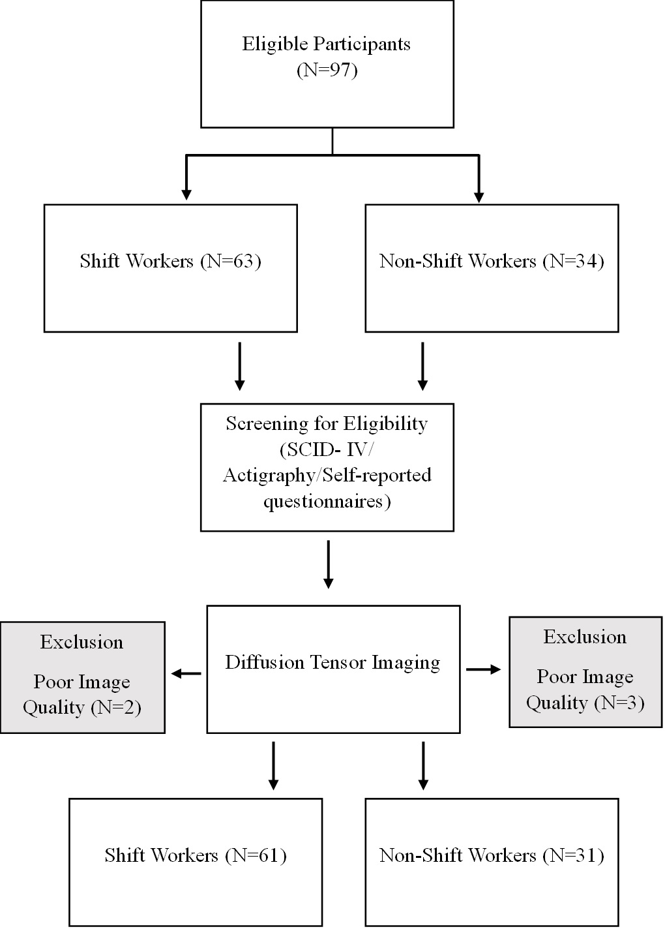

This flowchart showed process of how subjects were selected, showing inclusion and exclusion criteria. Initially, 97 participants were recruited among them 63 participants were shift workers and 34 participants were non-shift workers. SCID-IV, Actigraphy and self-reported questionnaire were conducted for screening for eligibility. Diffusion Tenson Imaging were performed after the screening. During this process 2 shift workers and 3 non-shift workers were excluded due to poor image quality. As a result, 61 shift workers and 31 non-shift workers were used. Abbreviation: SCID-IV, (structured clinical interview for DSM-IV)

