Appendix 1. Questionnaire
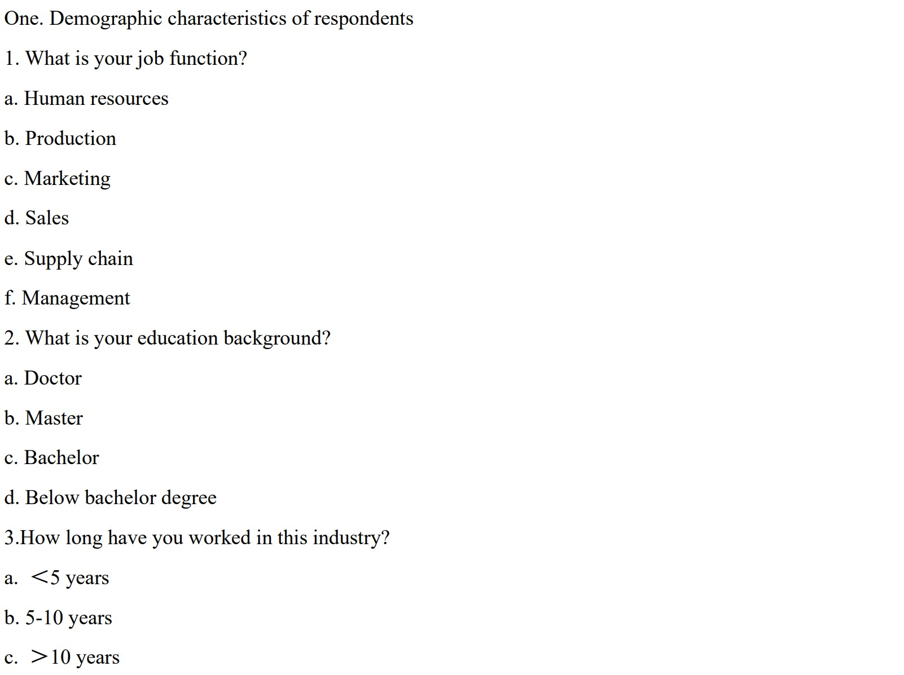
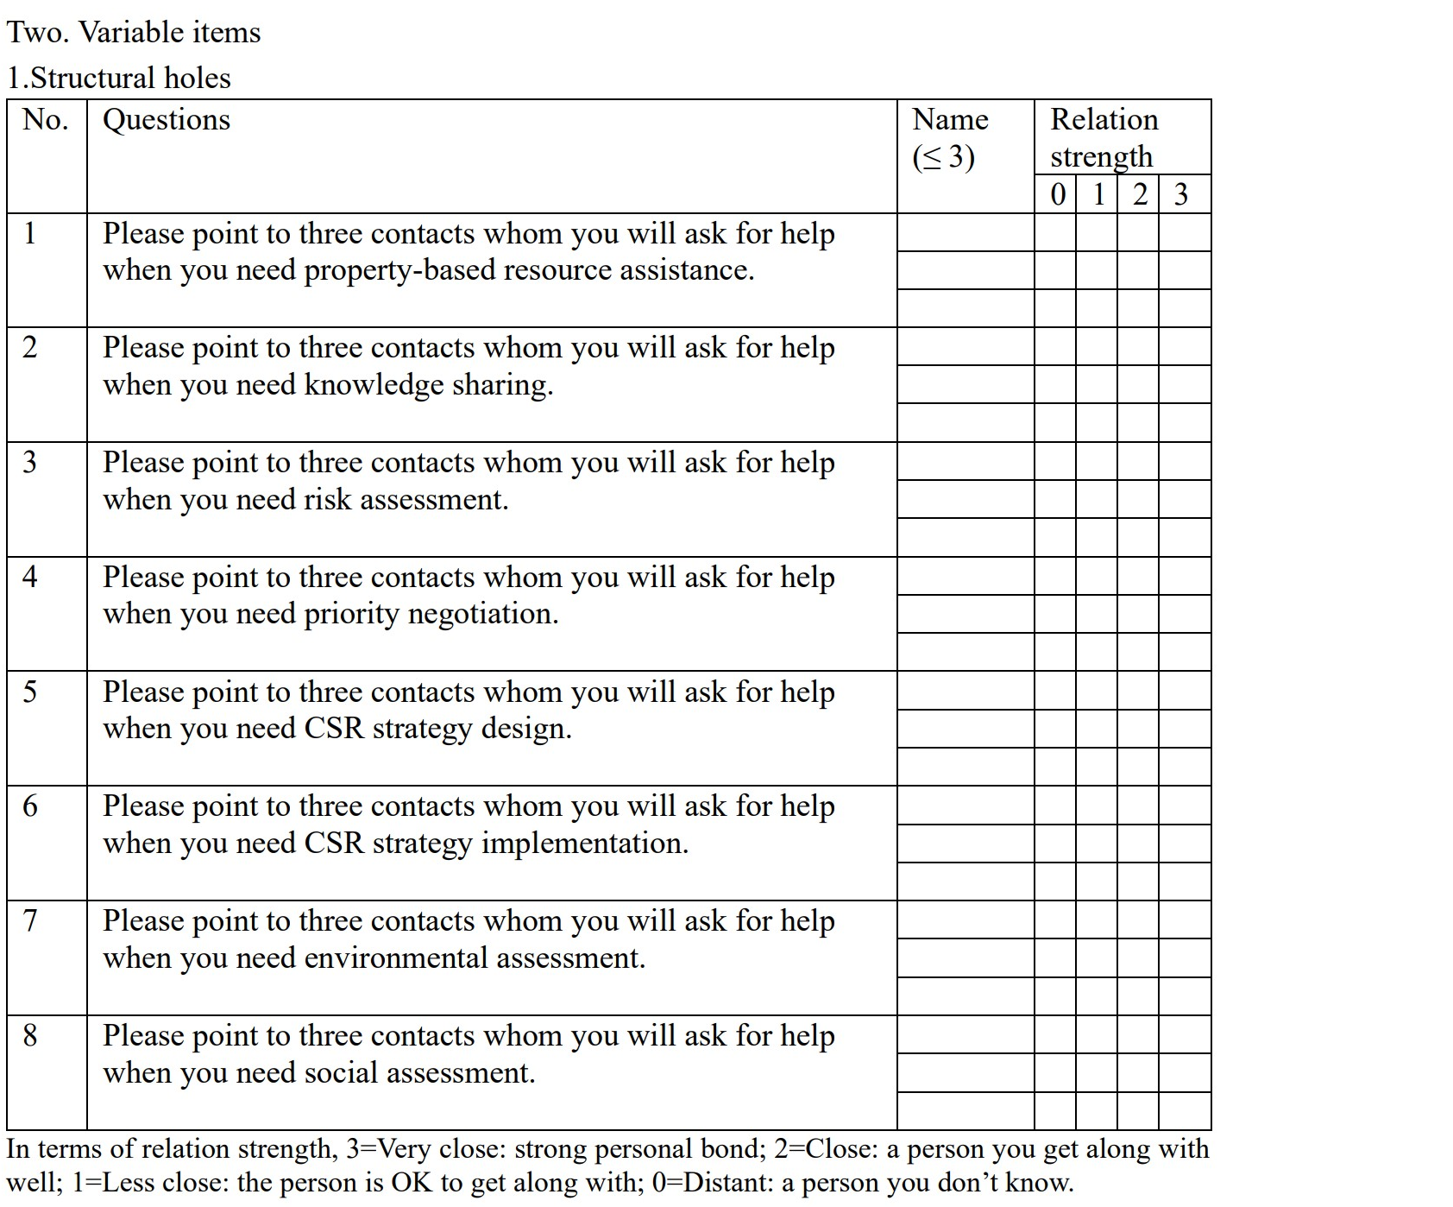
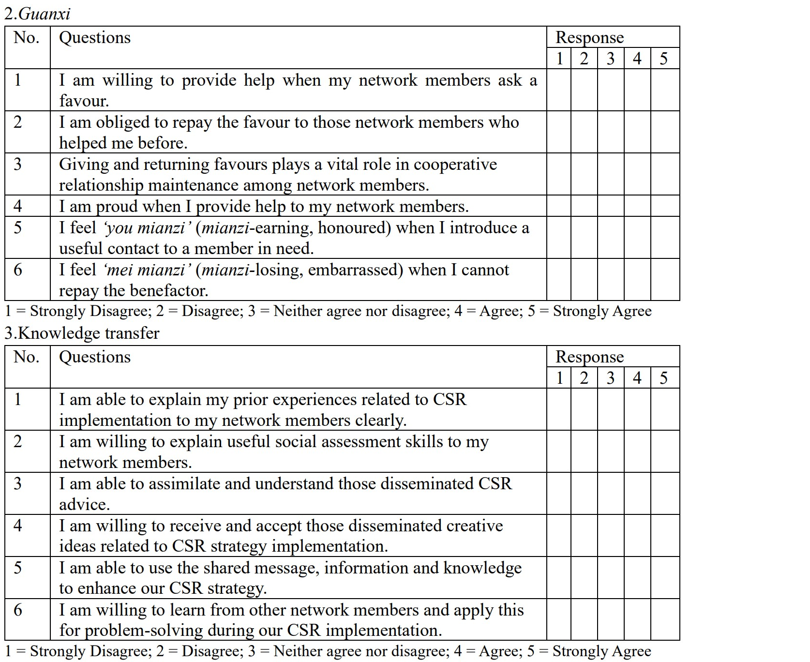
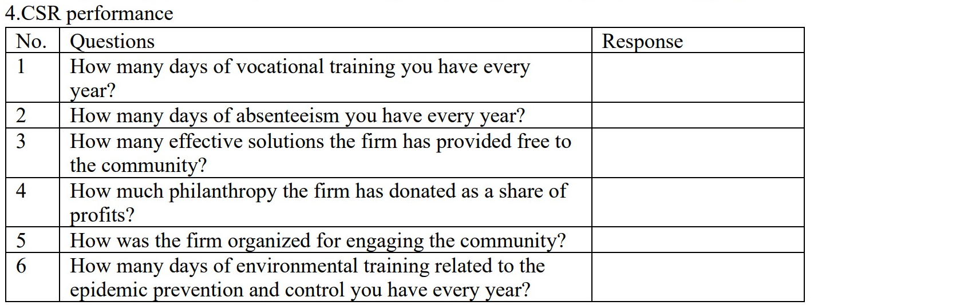
Appendix 2. Interview protocol
1. Would you like to introduce your network members who are otherwise disconnected to know each other when they are in need in the epidemic prevention and control period?
1a. If the answer is yes, can you please tell me why you choose to do so.
1b. If the answer is no, can you please tell me why you refuse to do so.
2. How do you regard renqing?
3. How do you regard renqing giving? Is it important to you?
4. How do you regard renqing returning? Is it important to you?
5. Do you believe that introducing a proper contact to another who is in need implies a big favour giving?
5a. If the answer is yes, can you please explain it in more detail.
5b. If the answer is no, can you please explain it in more detail.
6. When you receive help from someone, do you think you have the obligation to return this favour at some later time?
6a. If the answer is yes, can you please explain it in more detail.
6b. If the answer is no, can you please explain it in more detail.
7. Do you believe that renqing giving and returning is important to maintain guanxi between you and other stakeholders in the epidemic prevention and control period?
7a. If the answer is yes, can you please explain it in more detail.
7b. If the answer is no, can you please explain it in more detail.
8. How do you regard mianzi?
9. How do you regard mianzi earning? Is it important to you?
10. How do you regard mianzi giving? Is it important to you?
11. Do you believe that introducing a proper contact to another who is in need implies giving them mianzi?
11a. If the answer is yes, can you please explain it in more detail.
11b. If the answer is no, can you please explain it in more detail.
12. When you introduce a proper contact to another who is in need, do you feel ‘you mianzi’ (honoured, mianzi earning)?
12a. If the answer is yes, can you please explain it in more detail.
12b. If the answer is no, can you please explain it in more detail.
13. When your request to know a new contact is refused, do you feel ‘mei mianzi’ (embarrassed, mianzi losing)?
13a. If the answer is yes, can you please explain it in more detail.
13b. If the answer is no, can you please explain it in more detail.
14. Do you believe that mianzi earning and giving is important to maintain guanxi between you and other stakeholders in the epidemic prevention and control period?
14a. If the answer is yes, can you please explain it in more detail.
14b. If the answer is no, can you please explain it in more detail.
15. When you are introduced to know diverse professionals beyond the reach of your original personal contacts, do you think you have more opportunities to communicate with each other in the epidemic prevention and control period?
15a. If the answer is yes, can you please explain it in more detail.
15b. If the answer is no, can you please explain it in more detail.
16. When you are introduced to know diverse professionals beyond the reach of your original personal contacts, do you think you have more opportunities to learn from each other in the epidemic prevention and control period?
16a. If the answer is yes, can you please explain it in more detail.
16b. If the answer is no, can you please explain it in more detail.
17. As you have more opportunities to communicate with and learn from diverse professionals, do you think you can understand others’ ideas without spending too much effort in the epidemic prevention and control period?
17a. If the answer is yes, can you please explain it in more detail.
17b. If the answer is no, can you please explain it in more detail.
18. As you have shared and exchanged more information and resources with your network members, do you think what you have done help increase the attachment of employees towards the firm?
18a. If the answer is yes, can you please explain it in more detail.
18b. If the answer is no, can you please explain it in more detail.
19. As you have shared and exchanged more information and resources with your network members, do you think what you have done help increase the satisfaction of local communities?
19a. If the answer is yes, can you please explain it in more detail.
19b. If the answer is no, can you please explain it in more detail.
20. As you have shared and exchanged more information and resources with your network members, do you think what you have done help prevent and control the epidemic in Wuhan?
20a. If the answer is yes, can you please explain it in more detail.
20b. If the answer is no, can you please explain it in more detail.

