Supplementary materials

Supplementary figures

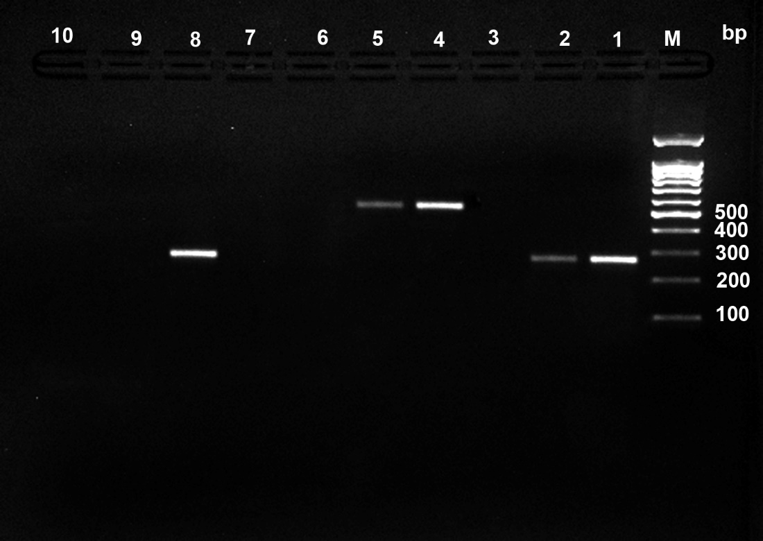
can=278bp
fnbB = 523bp
fnbA=269bp

Figure S1: PCR results of adhesion virulence genes profiling of S. aureus. Agarose (1.5%) gel electrophoresis of S. aureus PCR products of adhesion virulence factor genes. M = 100 bp molecular weight marker; Lane 1 &2: fnbA (269 bp) positive samples; Lane 3: fnbA negative control; Lane 4 &5: fnbB (523 bp) positive samples; Lane 6; fnbB negative samples; Lane 7: fnbB negative control; lane 8: can (278 bp) positive samples; Lane 9: can negative sample and Lane 10: can negative control.

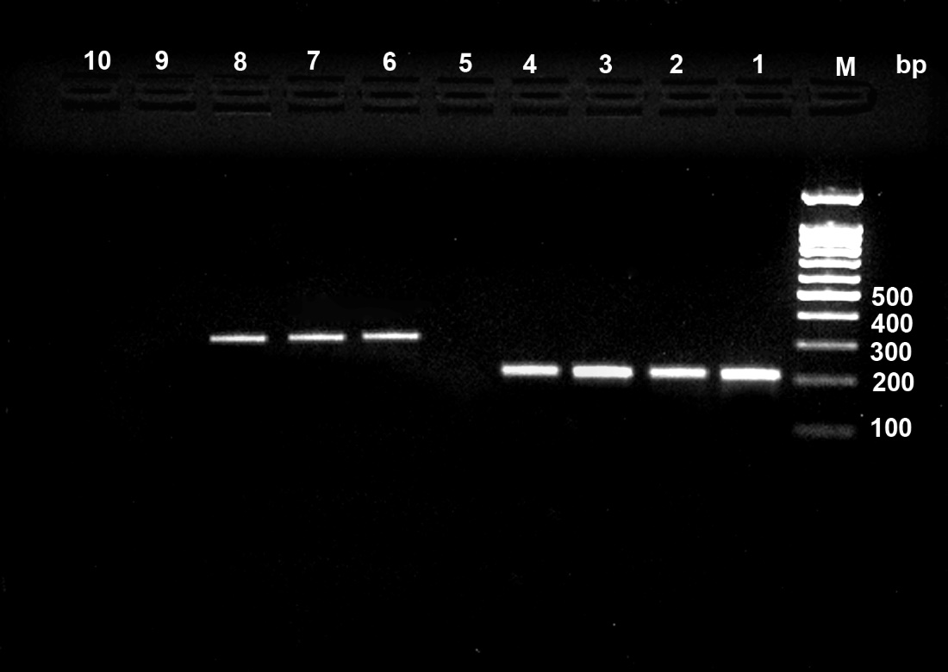
hla=210 bp
hlb=310 bp
Figure S2: PCR results of hemolysin virulence genes profiling of S. aureus. Agarose (1.5%) gel electrophoresis of S. aureus PCR products of hemolysines virulence factor genes. M = 100 bp molecular weight marker; Lane 1, 2, 3&4: hla (210 bp) positive samples; Lane 5: negative control for hla gene ; Lane 6,7&8 hlb (310 bp) positive samples ; Lane 9: hlb negative samples and Lane 10 negative control for hlb gene.

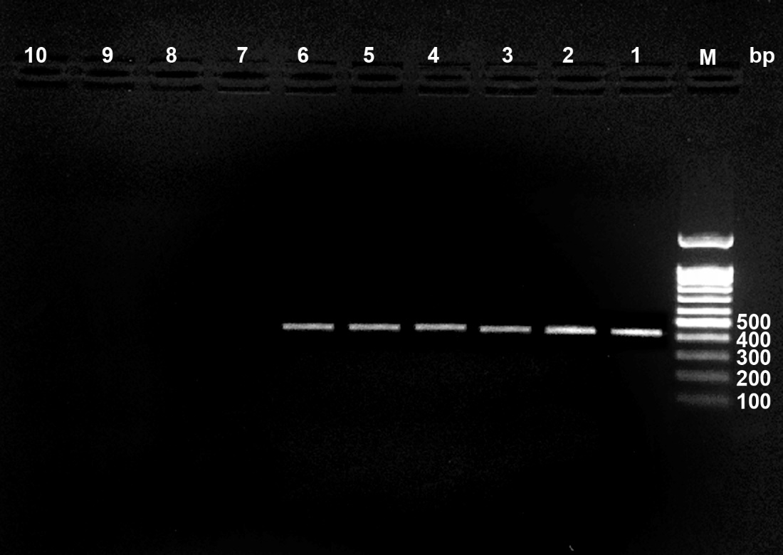
pvl=433 bp

Figure S3: PCR results of Panton-Valentine leukocidin virulence genes profiling of S. aureus. Agarose (1.5%) gel electrophoresis of S. aureus PCR products of pvl virulence factor gene. M = 100 bp molecular weight marker; Lane 1, 2, 3, 4, 5&6: pvl (433bp) positive samples; Lane 7, 8 & 9: pvl negative samples and Lane 10: negative control.

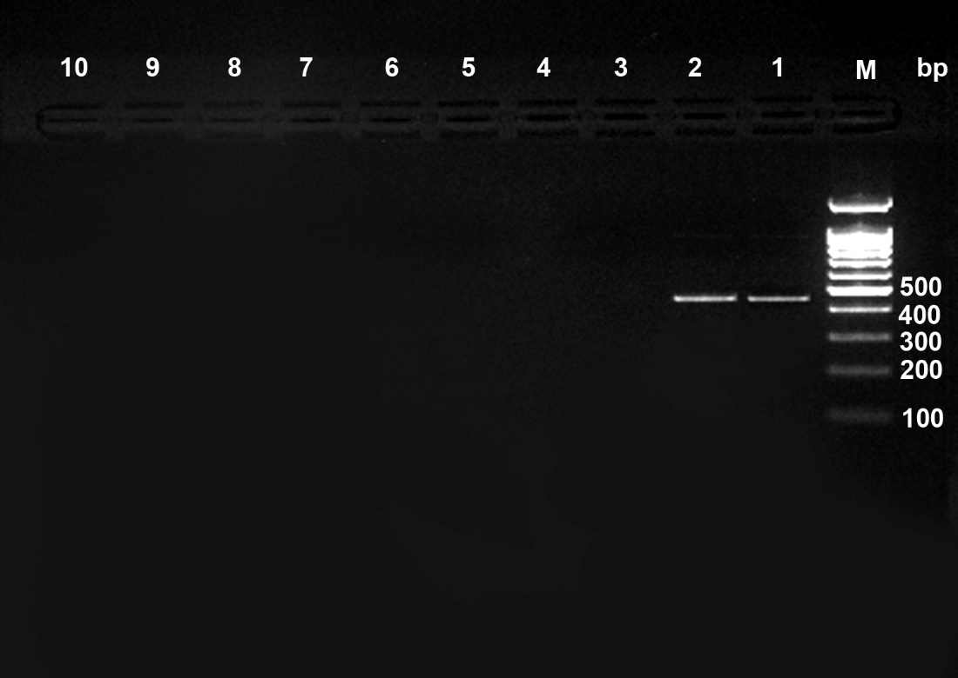
seb=477 bp

Figure S4: PCR results of enterotoxin virulence gene profiling of S. aureus. Agarose (1.5%) gel electrophoresis of S. aureus PCR products of seb virulence factor gene. M = 100 bp molecular weight marker; Lane 1& 2: seb (477 bp) positive samples; Lane 3, 4, 5, 6, 7, 8 & 9: seb negative samples and Lane 10: negative control.

Figure S5: Susceptibility patterns of S. aureus samples.

Supplementary Tables
Table S1: The list of primers used during the study
Target gene | Sequence | Annealing temperature | Product length | GenBank accession no.
Pvl | F:5’-ATCATTAGGTAAAATGTCTGGACATGATCCA-3’  R:5’-GCATCAACTGTATTGGATAGCAAAAGC-3’ | 55˚c | 433 | AB006796
fnbA | F:5’-TTAACTTGGGATAATGGTTTAGTTT-3’  R:5’-GCTGATGAATCCGTTTCTTCTATTG-3’ | 50˚c | 269 | LC073763.1
fnbB |  | 55˚c | 523 | X62992.1
  F:5’-GTAACAGCTAATGGTCGAATTGATACT-3’
  R:5’-CAAGTTCGATAGGAGTACTATGTTC-3’
Can |  | 55˚c | 278 | M81736.1
  F:5’- CGGGAGATATGCTACCAGAAGATA-3’
  R:5’-ATAGCCTTGTGGAATTGTTACATCA-3’
Hla |  | 55˚c | 210 | KR063697.1
  F:5’- CTGATTACTATCCAAGAAATTCGATTG -3’
  R:5’-CTTTCCAGCCTACTTTTTTATCAGT -3’
Hlb |  | 60˚c | 310 | X13404.1
  F:5’-GTGCACTTACTGACAATAGTGC-3’
  R:5’-GTTGATGAGTAGCTACCTTCAGT-3’
sea |  | 55˚c | 121 | M18970.1
  F:5’-TTGGAAACGGTTAAAACGAA -3’
  R:5’-GAACCTTCCCATCAAAAACA -3’
seb |  | 55˚c | 477 | M11118.1
  F:5’-TCGCATCAAACTGACAAACG -3’
  R:5’-GCAGGTACTCTATAAGTGCC -3’
sec |  | 55˚c | 257 | AB084256.1
  F:5’-GACATAAAAGCTAGGAATTT -3’
  R:5’-AAATCGGATTAACATTATCC -3’

- Abbreviations:
hla = Hemolysine a; hlb= Hemolysine b; seb = staphylococcal enterotoxin b; sea= staphylococcal enterotoxin a; sec=staphylococcal enterotoxin c,; pvl= Pantone Valentine leucocidin; can = collagen binding protein ; fnbA = fibronectin binding proteins A ; fnbB= fibronectin binding proteins B.

