Long-circulation and brain targeted isoliquiritigenin micelle nanoparticles: formation, characterization, tissue distribution, pharmacokinetics and effects for ischemic stroke
Weitong Song¹, Lu Bai¹, Yuya Yang¹, Yongchao Wang², Pingxiang Xu^{1,3}, Yuming Zhao¹, Xuelin Zhou^{1,3}, Xiaorong Li^{1,3}, Ming Xue^{1,3*}

¹ Department of Pharmacology, School of Basic Medical Sciences, Capital Medical University, Beijing, China; ² CAS Key Laboratory for Biomedical Effects of Nanomaterials and Nanosafety, CAS Center for Excellence in Nanoscience, National Center for Nanoscience and Technology of China, Beijing, China; ³ Beijing Laboratory for Biomedical Detection Technology and Instrument, Beijing, China

*Corresponding author: Ming Xue
Department of Pharmacology, School of Basic Medical Sciences, Capital Medical University, Youanmen, Beijing 100069, China.
Tel.: +8610-83950416
Fax: +8610-83911520
E-mail: xuem@ccmu.edu.cn

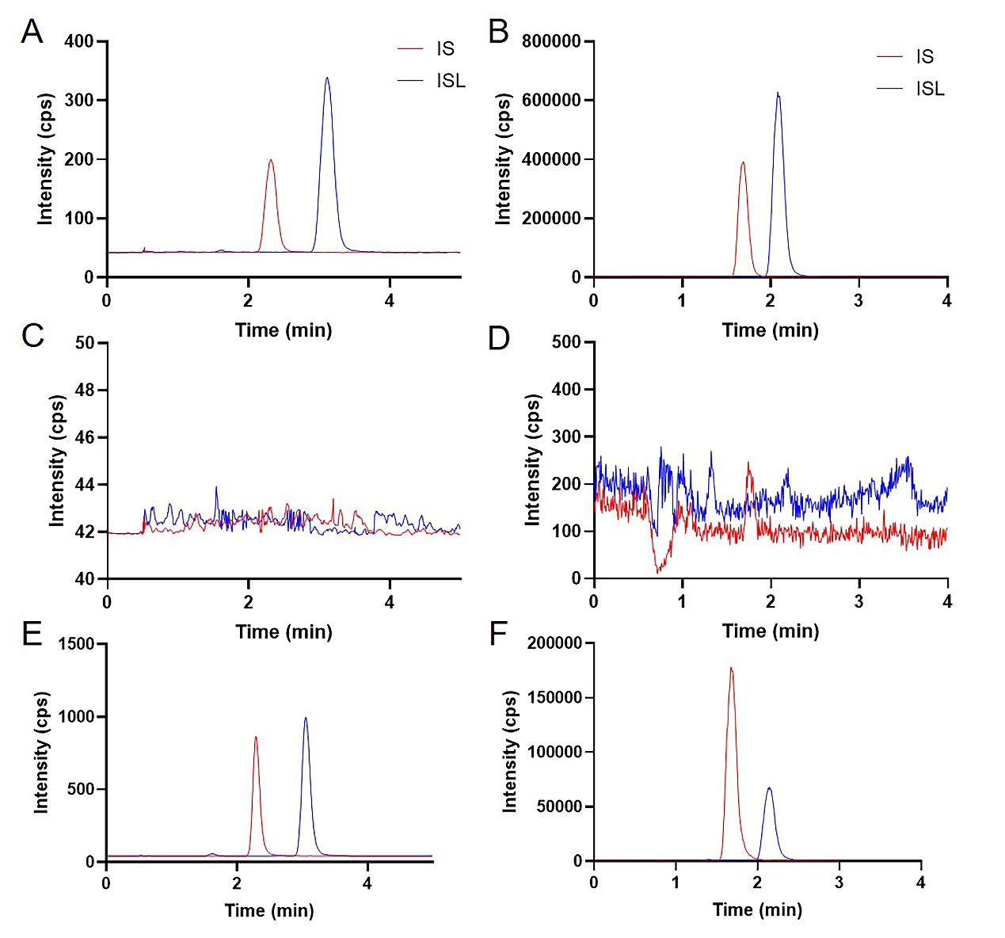
Figure S1 Representative UPLC-MS/MS chromatograms for ISL and IS. (A) Blank plasma spiked with ISL (500 ng/mL) and IS; (B) blank mouse mixed tissue homogenate spiked with ISL (1 μg/mL) and IS; (C) blank rat plasma; (D) blank mouse mixed tissue homogenate; (E) rat plasma sample 10 min after administration of ISL-M; (F) mouse mixed tissue homogenate 10 min after administration of ISL-M.

Table S1 The parameters of the standard curve and the lower limit of quantification of UPLC-MS/MS method.
Matrix | Standard Curve Line | Range | R² | LLOQ (ng/mL)
Plasma | y = 0.004391x + 0.004727 | 5-2000 ng/mL | 0.9998 | 5
Plasma | y = 3.867x + 0.7097 | 2-100 μg/mL | 0.9999 | 2000
Tissue | y = 0.001869x - 0.007118 | 5-1000 ng/mL | 0.9990 | 5
Abbreviations: UPLC-MS/MS, ultra-performance liquid chromatography tandem mass spectrometry; LLOQ, lower limit of quantitation.

Table S2 Accuracy and precision of the assays for ISL in rat plasma and mice tissue homogenate.
Matrix | Spiked | Intra-day |  |  | Inter-day
Matrix | Spiked | Measured | Precision RSD (%) | Accuracy RE (%) | Measured | Precision RSD (%) | Accuracy RE (%)
Plasma (ng/mL) | 5 | 5.22 ± 0.72 | 13.78 | 4.35 | 5.33 ± 0.38 | 7.09 | 6.66
Plasma (ng/mL) | 100 | 103.80 ± 7.80 | 7.51 | 3.80 | 107.32 ± 5.81 | 5.41 | 7.32
Plasma (ng/mL) | 2000 | 2045.12 ± 109.81 | 5.37 | 2.26 | 2045.44 ± 68.46 | 3.35 | 2.27
Plasma (μg/mL) | 2 | 2.13 ± 0.15 | 7.24 | 6.28 | 2.04 ± 0.10 | 4.73 | 2.10
Plasma (μg/mL) | 10 | 9.52 ± 0.56 | 5.84 | -4.84 | 9.80 ± 0.40 | 4.07 | -2.00
Plasma (μg/mL) | 100 | 95.11 ± 2.47 | 2.60 | -4.89 | 95.16 ± 2.06 | 2.16 | -4.84
Tissue (ng/mL) | 5 | 5.22 ± 0.62 | 11.95 | 4.31 | 5.09 ± 0.26 | 5.08 | 1.71
Tissue (ng/mL) | 100 | 95.52 ± 9.90 | 10.37 | -4.48 | 97.63 ± 2.71 | 2.78 | -2.37
Tissue (ng/mL) | 1000 | 934.26 ± 39.89 | 4.27 | -6.57 | 973.96 ± 32.61 | 3.35 | -2.60
Notes: The results were expressed as the mean ± SD, n = 4.
Abbreviations: RSD, relative standard deviation; RE, relative error.

Table S3 Recovery and matrix effect of ISL in rat plasma and mice tissue homogenate.
Matrix | Spiked | Recovery | RSD (%) | Matrix effect | RSD (%)
Plasma (ng/mL) | 5 | 88.08 ± 4.54 | 5.16 | 96.95 ± 8.38 | 8.64
Plasma (ng/mL) | 100 | 93.20 ± 4.90 | 5.26 | 99.82 ± 5.31 | 5.32
Plasma (ng/mL) | 2000 | 99.35 ± 3.01 | 3.03 | 92.99 ± 4.48 | 4.81
Plasma (μg/mL) | 2 | 99.35 ± 3.01 | 3.03 | 92.99 ± 4.48 | 4.81
Plasma (μg/mL) | 10 | 96.48 ± 5.64 | 5.84 | 86.31 ± 2.89 | 3.35
Plasma (μg/mL) | 100 | 97.22 ± 7.24 | 7.44 | 90.94 ± 3.59 | 3.95
Tissue (ng/mL) | 5 | 104.73 ± 8.07 | 7.71 | 99.89 ± 7.39 | 7.40
Tissue (ng/mL) | 100 | 96.10 ± 8.78 | 9.14 | 107.82 ± 4.21 | 3.90
Tissue (ng/mL) | 1000 | 102.87 ± 5.43 | 5.28 | 98.39 ± 2.53 | 2.57
Notes: The results were expressed as the mean ± SD, n = 4.

