Supplementary Table 1. Baseline characteristics of study population. (Including phosphate > 6.0 mg/dl)
 | Total | Phosphate  (< 2.8 mg/dl) | Phosphate  (2.8-3.2 mg/dl) | Phosphate  (3.3-3.7 mg/dl) | Phosphate  (3.8-4.4 mg/dl) | Phosphate  (≥ 4.5 mg/dl) | p trend
n | 15,686 | 2,406 | 3,585 | 4,411 | 3,855 | 1,429
Male, n (%) | 7,514 (47.9) | 1,367 (56.8) | 1,906 (53.2) | 2,101 (47.6) | 1,524 (39.5) | 616 (43.1) | <0.001
Age (years), median (IQR) | 70.0 [60.0-79.0] | 72.0 [62.0-80.0] | 71.0 [61.0-79.0] | 69.0 [60.0-78.0] | 67.0 [59.0-77.0] | 70.0 [60.0-79.0] | <0.001
Surgical department, n (%) | 5,228 (33.3) | 677 (28.1) | 1,341 (37.4) | 1,563 (35.4) | 1,319 (34.2) | 328 (23.0) | <0.001
Height (cm), median (IQR) | 160.0 [153.0- 167.0] | 161.1 [154.0-168.0] | 160.0 [153.4-167.6] | 160.0 [152.8-167.0] | 158.0 [152.0-165.0] | 158.6 [151.8-166.0] | <0.001
Weight (kg), median (IQR) | 60.4 [53.0-69.1] | 60.5 [53.0-70.0] | 60.6 [53.1-70.0] | 60.5 [53.0-69.0] | 60.6 [53.0-69.0] | 59.5 [51.1-68.0] | 0.021
BMI, (kg/m²), median (IQR) | 23.8 [21.5-26.4] | 23.6 [21.2-26.0] | 23.8 [21.4-26.2] | 23.9 [21.6-26.4] | 24.1 [21.8-26.8] | 23.7 [20.9-26.4] | <0.001
HOD (days), median (IQR) | 5.0 [2.0-9.0] | 6.0 [3.0-11.0] | 5.0 [3.0-11.0] | 5.0 [2.0-9.0] | 4.0 [2.0-8.0] | 5.0 [3.0-11.0] | <0.001
Pulse (/min), median (IQR) | 80.0 [70.0-91.0] | 85.0 [74.0-98.0] | 80.0 [71.0-91.0] | 78.0 [69.0-89.0] | 77.0 [68.0-87.0] | 81.0 [70.0-95.0] | <0.001
SBP (mmHg), median (IQR) | 135.0 [120.0-150.0] | 135.0 [119.0-152.0] | 136.0 [121.0-151.0] | 135.0 [121.0-149.0] | 134.0 [120.0-147.0] | 132.0 [115.0-148.0] | 0.038
DBP (mmHg), median (IQR) | 79.0 [70.0-88.0] | 78.0 [69.0-88.0] | 79.5 [71.0-89.0] | 79.0 [70.0-88.0] | 79.0 [71.0-87.0] | 77.0 [68.0-87.0] | <0.001
Phosphate (mg/dl), median (IQR) | 3.5 [3.0-3.9] | 2.4 [2.1-2.6] | 3.0 [2.9-3.1] | 3.5 [3.4-3.6] | 4.0 [3.9-4.2] | 4.9 [4.6-5.4] | <0.001
Calcium (mg/dl), median (IQR) | 8.9 [8.5-9.2] | 8.6 [8.2-9.0] | 8.8 [8.4-9.1] | 8.9 [8.5-9.2] | 9.0 [8.7-9.3] | 8.9 [8.4-9.3] | <0.001
BUN (mg/dl), median (IQR) | 16.9 [13.1-22.8] | 16.0 [12.2-21.4] | 16.1 [12.5-20.7] | 16.6 [13.0-21.7] | 17.2 [13.5-22.8] | 25.9 [17.1-48.4] | <0.001
Creatinine (mg/dl), median (IQR) | 0.9 [0.7-1.1] | 0.9 [0.7-1.1] | 0.8 [0.7-1.0] | 0.8 [0.7-1.0] | 0.8 [0.7-1.1] | 1.1 [0.8-2.5] | <0.001
Uric Acid (mg/dl), median (IQR) | 4.8 [3.7-6.1] | 4.3 [3.2-5.6] | 4.6 [3.5-5.8] | 4.8 [3.8-5.9] | 5.0 [3.9-6.1] | 6.1 [4.6-8.2] | <0.001
Cholesterol (mg/dl), median (IQR) | 153.0 [125.0-184.0] | 140.0 [114.0-171.0] | 151.0 [125.0-181.0] | 157.0 [130.0-188.0] | 161.0 [131.0-192.0] | 150.0 [120.0-185.0] | <0.001
Glucose (mg/dl), median (IQR) | 125.0 [105.0-159.0] | 134.0 [111.0-171.0] | 126.0 [107.0-160.0] | 122.0 [104.0-152.0] | 119.0 [102.0-149.0] | 131.0 [105.0-188.2] | 0.111
ALP (IU/L), median (IQR) | 76.0 [61.0-99.0] | 80.0 [63.0-108.0] | 76.0 [61.0-99.0] | 75.0 [61.0-96.0] | 75.0 [61.0-95.0] | 81.0 [64.0-107.0] | <0.001
AST (IU/L), median (IQR) | 25.0 [20.0-35.0] | 27.0 [20.0-41.0] | 25.0 [20.0-35.0] | 25.0 [20.0-34.0] | 25.0 [20.0-33.0] | 28.0 [20.0-43.0] | 0.109
ALT (IU/L), median (IQR) | 19.0 [13.0-28.0] | 19.0 [13.0-30.0] | 18.0 [13.0-28.0] | 18.0 [13.0-27.0] | 19.0 [13.0-28.0] | 20.0 [13.0-32.0] | 0.685
Bilirubin (mg/dl), median (IQR) | 0.6 [0.4-0.8] | 0.6 [0.4-1.0] | 0.6 [0.4-0.8] | 0.6 [0.4-0.8] | 0.5 [0.4-0.7] | 0.5 [0.4-0.8] | <0.001
Protein (g/dl), median (IQR) | 6.8 [6.3-7.2] | 6.6 [6.1-7.1] | 6.7 [6.3-7.2] | 6.8 [6.4-7.2] | 6.9 [6.4-7.3] | 6.8 [6.3-7.3] | <0.001
Albumin (g/dl), median (IQR) | 4.0 [3.6-4.3] | 3.8 [3.3-4.2] | 4.0 [3.6-4.3] | 4.1 [3.7-4.4] | 4.1 [3.8-4.4] | 3.9 [3.5-4.3] | <0.001
Hemoglobin (g/dl), median (IQR) | 12.5 [11.0-13.9] | 12.3 [10.5-13.8] | 12.6 [11.1-14.0] | 12.6 [11.3-14.0] | 12.6 [11.3-13.8] | 12.0 [10.2-13.6] | 0.924
HCT (%), median (IQR) | 37.4 [33.1-41.1] | 36.4 [31.6-40.5] | 37.6 [33.1-41.3] | 37.7 [33.8-41.4] | 37.6 [33.8-41.1] | 36.3 [31.0-40.4] | 0.032
RDW (%), median (IQR) | 12.9 [12.3-14.0] | 13.1 [12.4-14.5] | 12.9 [12.3-14.0] | 12.9 [12.3-13.8] | 12.8 [12.3-13.7] | 13.3 [12.5-14.6] | <0.001
History of fall, n (%) | 691 (4.5) | 91 (3.8) | 148 (4.2) | 208 (4.8) | 182 (4.8) | 62 (4.5) | 0.099
Fall risk score, median (IQR) | 4.0 [2.0-7.0] | 4.0 [2.0-7.0] | 4.0 [2.0-6.0] | 4.0 [2.0-7.0] | 4.0 [2.0-7.0] | 5.0 [3.0-7.0] | 0.042

Note: Data were provided median (IQR) or N (%)
Abbreviations: BMI = body mass index; SBP = systolic blood pressure; DBP = diastolic blood pressure; BUN = blood urea nitrogen; ALP = alkaline phosphatase; AST = aspartate aminotransferase; ALT = alanine aminotransferase, HCT = hematocrit; RDW = red cell distribution width

Supplementary Figure 1. Pearson correlation between phosphate level and other clinical parameters
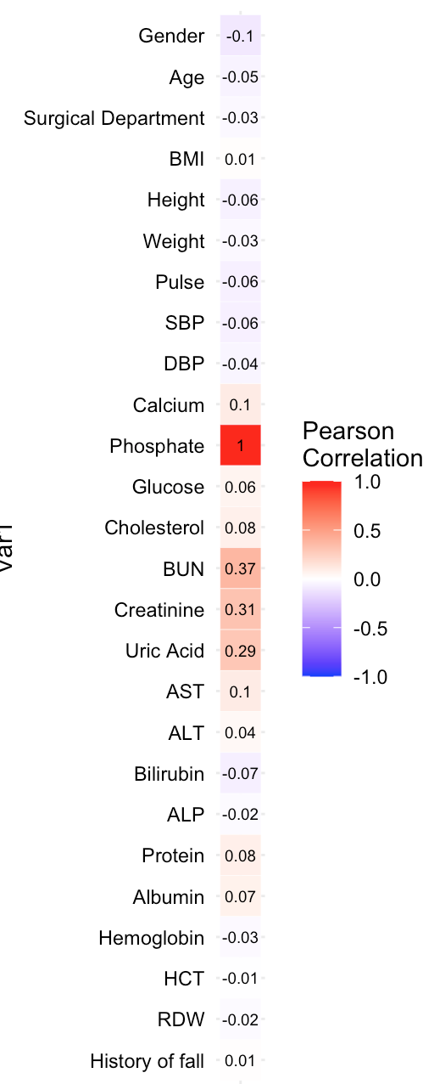
Abbreviations: BMI, body mass index; BUN, blood urea nitrogen; SBP, systolic blood pressure; DBP, diastolic blood pressure; AST, aspartate aminotransferase; ALT, alanine aminotransferase; ALP, alkaline phosphatase; HCT, hematocrit; RDW, red cell distribution width
Supplementary Figure 2. Distribution of serum phosphate among all admitted subjects
