Sleep restriction reduces cognitive but not physical motivation

Supplementary Information

Computational Models of Effort Discounting
In order to compare our results with those of previous effort discounting studies, we modelled participants’ choices to three commonly applied effort discounting functions, which capture different ways in which effort devalues reward. These data reaffirm the differential impact of sleep restriction on cognitive motivation

Analysis

To model participants’ behaviour, we used linear, parabolic and hyperbolic effort discounting functions, which respectively capture linear, concave, and convex patterns of discounting behaviour ¹.

$Linear: {SV}_{t}=R_{t}-k ⋅E_{t}$
$$Parabolic: {SV}_{t}=R_{t}-k ⋅{E_{t}}^{2}$$
$$Hyperbolic: {SV}_{t}=\frac{R_{t}}{1+k ⋅E_{t}}$$
where SV represents the subjective value of the baseline or offer on trial t; R represents the reward available (1, 2, 4, 6, 8, 10 credits); E is the effort required to obtain that reward (1 to 6 streams for cognitive effort; % MVC in the physical domain); and k is a subject-specific discounting parameter that scales the effect of effort on subjective value. Thus, a higher k value reflects a steeper effort discounting function, and a greater sensitivity to effort costs. Quantifying both the shape and gradient of this function provides a sensitive measure of motivated behaviour ¹⁻³.

We computed the probability of an individual choosing the high-effort/high-reward offer over the baseline option using a softmax function, and maximum likelihood estimation:
$$Pr\left(i\right)=\frac{e^{β ∙ {SV}_{i}}}{e^{β ∙ {SV}_{b}}+ e^{β ∙{ SV}_{i} }}$$
where Pr(i) is the probability of choosing the offer, i, with a subjective value, SV_{i} relative to the baseline option, b, with subjective value, SV_{b}, and $β$ is the inverse temperature parameter, which indicates choice stochasticity. We fit a single $β$ parameter for the fully rested and sleep restricted conditions.

We fit participants’ choices to each of these three effort discounting functions for each task (cognitive, physical) across both Sleep Conditions (fully rested, sleep restriction). Thus, our model space comprised 81 (3⁴) models. For each participant, we fit choices for each of the four conditions (two domains x two sleep conditions) simultaneously, and the best model was determined using the Bayesian Information Criterion (BIC) ⁴.

Results

Cognitive effort task. When participants were fully rested, cognitive effort discounting was best described by a linear function, which is consistent with previous data ^{3,5}. However, when sleep restricted, cognitive effort discounting was instead better captured by a concave (parabolic) pattern. This indicates a qualitative difference in the way in which sleep restriction modulated the devaluation of reward by cognitive effort (Figure S1A).

Physical effort task. In contrast, physical effort discounting followed a parabolic pattern in both sleep conditions, which is again consistent with previous findings ^{2,6,7}. We compared the gradient of the physical effort discounting functions (i.e., the k-values) between the Sleep Conditions with a non-parametric Wilcoxon signed-rank test, which demonstrated no significant differences in k-values when fully rested vs sleep restricted (Figure S1B; Z=0.37, p = 0.710).

Posterior predictive checks indicated a good fit between our best fitting model and participants’ choices (Figure S2). Overall, these data reaffirm our main findings by showing that sleep restriction resulted in a qualitative difference in cognitive effort discounting relative to the fully rested condition, while sparing effort discounting in the physical domain.

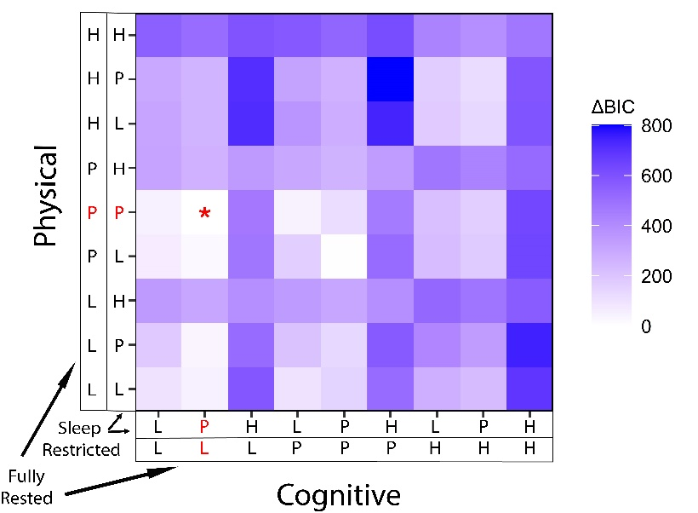  B  A | 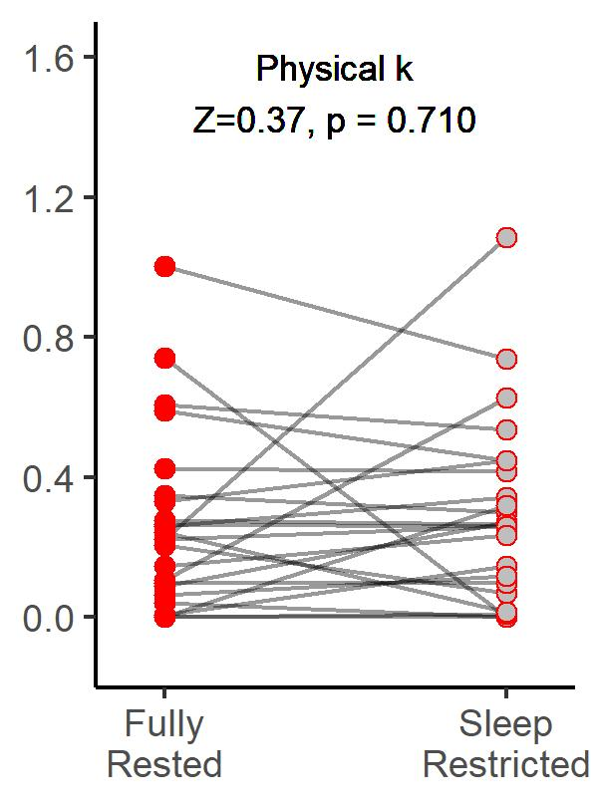

Figure S1. (A) Comparison of hyperbolic (H), parabolic (P), and linear (L) effort discounting functions. (A) Model comparison revealed that the model LPPP best captured participants choices (highlighted with a red asterisk). Hence, the shape of cognitive effort discounting function changed from linear when fully rested to parabolic under sleep restriction. The shape of physical effort discounting was best captured by a parabolic function in both conditions. (B) Physical effort discounting parameter, estimated using parabolic function, did not significantly differ under sleep restriction compared to the fully rested condition.

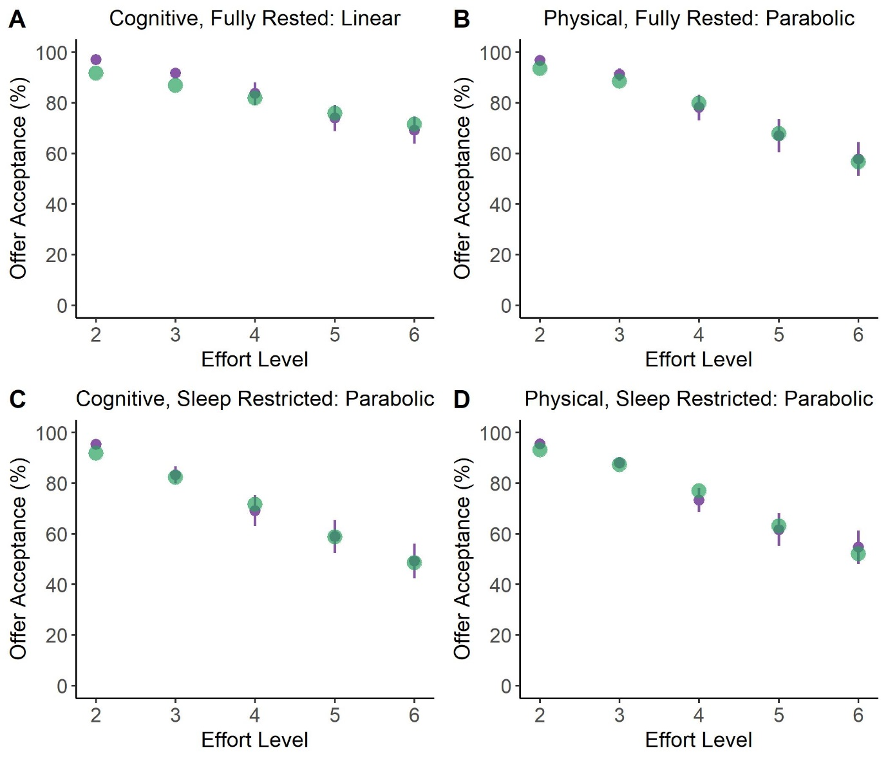
Figure S2. Computationally modelled choices closely matched actual participants’ decisions. Purple circles reflect the observed group average (error bars indicate standard error), green circles indicate the group average based on modelled participants’ choices. Cognitive effort discounting pattern changed from linear in the fully rested condition (A) to parabolic in the sleep restricted condition (C). Physical effort discounting was best captured by a parabolic function both in the fully rested condition (B) and the sleep restricted condition (D).

References

1. Chong TT-J, Apps MAJ, Giehl K, Hall S, Clifton CH, Husain M. Computational modelling reveals distinct patterns of cognitive and physical motivation in elite athletes. Scientific Reports. Aug 2018;811888. doi:10.1038/s41598-018-30220-3
2. Chong TT-J, Apps M, Giehl K, Sillence A, Grima LL, Husain M. Neurocomputational mechanisms underlying valuation of effort costs. PLoS Biology. 2017;15(2):e1002598. doi:doi: 10.1371/journal.pbio.1002598
3. McGuigan S, Zhou SH, Brosnan MB, Thyagarajan D, Bellgrove MA, Chong TT-J. Dopamine restores cognitive motivation in Parkinson's disease. Article. Brain. Mar 2019;142:719-732. doi:10.1093/brain/awy341
4. Schwarz G. Estimating the Dimension of a Model. The Annals of Statistics. 1978;6(2):461-464.
5. Atkins KJ, Andrews SC, Stout JC, Chong TT-J. Dissociable Motivational Deficits in Pre-manifest Huntington’s Disease. Cell Rep Med. 2020;1(9):100152-100152. doi:10.1016/j.xcrm.2020.100152
6. Hartmann MN, Hager OM, Tobler PN, Kaiser S. Parabolic discounting of monetary rewards by physical effort. Article. Behav Processes. Nov 2013;100:192-196. doi:10.1016/j.beproc.2013.09.014
7. Klein-Flugge MC, Kennerley SW, Saraiva AC, Penny WD, Bestmann S. Behavioral Modeling of Human Choices Reveals Dissociable Effects of Physical Effort and Temporal Delay on Reward Devaluation. Article. Plos Computational Biology. Mar 2015;11(3):31. UNSP e1004116. doi:10.1371/journal.pcbi.1004116

