APPENDIX: Implementing multiple imputation for missing data in longitudinal studies when models are not feasible: An example using the random hot deck approach
This appendix describes the methods used for simulating missing data in The Childhood Health, Activity, and Motor Performance School Study Denmark (CHAMPS-DK) dataset, and the results of both random hot deck imputation and common model-based imputation approaches using the MICE package [1] in R for Statistical Computing [2] (which are easily accessible to applied epidemiologists) on the simulated data.
The objectives of our simulations were (1) to assess variability between imputed datasets, which is a requisite for multiple imputation, and (2) to assess accuracy of the imputed datasets compared to a gold standard that reflects real-world data. As our objective is to assess the agreement of imputation with the gold standard data set, a comparison to data that might be used in a “complete case analysis” is not appropriate because there are no imputed data to be compared.
We created our gold standard dataset by restricting the observed CHAMPS-DK data to those records with complete data on activity frequency and sport across a particular 26-week time period (10% of total weeks). Due to a large proportion of entries missing sport counts, these records still required simulation of sport counts that were treated as equivalent to observed values.
We then created a synthetic dataset by simulating missing data for activity frequency, sport, and sport count data within the gold standard dataset, as described below. We imputed the missing values in the synthetic dataset using the random hot deck imputation outlined in our main paper and common model-based approaches with and without a specific constraint (see below) to create five imputed datasets for each approach. We compared distributions of the imputed values across the five datasets to assess the randomness of imputation, and calculated agreement between the imputed datasets from each approach and the gold standard dataset to assess the accuracy of imputation. In general, we used default arguments in MICE for our model-based approaches. We did not use a hierarchical model that would account for repeated measures on participants because such models require specific expertise in modelling missing data that many epidemiologists would not have access to.

Methods
The data used for simulations were from The Childhood Health, Activity, and Motor Performance School Study Denmark (CHAMPS-DK). Most missing data within each week were missing monotonically due to the method of data collection, which is described further in our main paper. For example, if parents did not provide a response for their child’s activity frequency, they were never asked about the types of sports they did. Both frequency and sport information were required to determine sport counts.
We subsetted the CHAMPS-DK dataset to a specific 26 consecutive week period (10% of total weeks) with data for 1,391 individuals followed over 26 consecutive weeks, for a total of 35,303 entries (person-weeks). This is referred to as the time-restricted dataset.
Among these individuals in the time-restricted dataset, 809 had complete frequency and sport data across all 26 weeks. These were included in what we refer to as the base dataset, for a total of 21,034 entries (person-weeks). Sport counts were missing in 2,042 (9.7%) entries in the base dataset, corresponding to 302 (37.3%) individuals. These data were replaced with simulated values to create the gold standard dataset. To mimic the missingness observed in real life, we created a model to predict the pattern of missingness in the time-restricted dataset. We applied this predictive model to the gold standard dataset, resulting in a synthetic dataset with 2,689 (12.7%) incomplete entries. A flow diagram of the entire process is outlined in Figure S1.

Figure S1. Flow diagram for the datasets used in simulating missing data. (*) The base dataset contained missing sport counts for 9.7% of entries. These sport counts were simulated using different logic than the imputation method to create the gold standard dataset, and treated as equivalent to observed values.

Simulating sport counts
All 809 individuals in the base dataset had complete information for frequency and sport over the 26-week period, but some had missing data on the number of times the child participated in each sport (sport counts). This only occurred when a child participated in more than one sport in a week, and more than one session for at least one of their sports. In these cases, their activity frequency would be greater than the number of sports. Consider a child with an activity frequency of 4 because they played football (code 1) three times and handball (code 2) once. Parents might answer 1112, providing one sport for each activity session, with no missing sport count data. However, other parents might answer 12 without specifying how many sessions of each sport were played, resulting in missing sport counts. All cases where a child participated in more than one sport and had an activity frequency greater than the number of sports were missing sport counts in this subset of data, representing 10% of entries. The other entries (90%) had observed sport counts because the children either didn’t do any activity, only did one sport, or did the same number of sports as their activity frequency.
We simulated sport counts for our gold standard dataset, intentionally using different logic from our imputation approach to evaluate the robustness of our imputation and avoid overly optimistic results. While our imputation approach only considered the relative proportion of sports done in nearby weeks within individuals, our simulation approach employed a between individual approach.
More specifically, we calculated the average frequency for each sport across weeks where individuals only played that specific sport (Table S1). This represented the typical number of sessions for each sport.

Table S1. Mean frequencies for each sport among individuals only playing a single sport in a week. The numeric code for each sport used in the SMS data collection is given in parentheses.
Sport | Mean frequency
Football (Soccer) (1) | 2.2
Handball (2) | 2.6
Basketball (3) | 2.0
Volleyball (4) | 1.9
Artistic gymnastics (5) | 1.4
Rhythmic gymnastics (6) | 1.9
Swimming (7) | 1.5
Horseback riding (8) | 2.3
Dance (9) | 1.2
Other (10) | 1.7

For each week that was missing sport counts (10% of weeks), we calculated sampling probabilities for each sport the child played by dividing its average frequency by the sum of the average frequencies for all sports played that week. For example, the sampling probabilities for a child with an activity frequency of 4 who played football (code 1, mean frequency 2.2) and handball (code 2. mean frequency 2.6) would be 2.2/(2.2+2. 6) = 45.8% and 2. 6/(2.2+2.6) = 54.2% respectively. Since each sport that was played had to have a sport count of at least 1, we sampled excess sport counts (2 counts in this example) with replacement. Although these sport counts were simulated, we considered them as “true” or “observed” values in our gold standard dataset.

Synthetic dataset
The missing data in the time-restricted dataset were monotonic within each week, so an entry could either have 1) no missing data, 2) missing sport count, 3) missing sport and sport count, or 4) missing frequency, sport, and sport count. We aimed to create missingness patterns from the gold standard dataset that mimicked the missingness patterns in the time-restricted dataset. In the time-restricted dataset, we created a four-level missingness indicator to reflect the patterns above. We then used multinomial logistic regression to create a missingness model with sex (male or female), grade (3 to 7), school (13 schools total), and week as predictor variables. We applied this model to each of the records in the gold standard dataset and simulated missing entries based on the predicted probabilities for each of the records. We then evaluated the degree to which the synthetic dataset reflected real data by comparing the distribution of missingness patterns between the synthetic dataset and the time-restricted dataset.

Imputed datasets
We imputed the missing values in the synthetic dataset using the random hot deck approach outlined in the “Methods” section of our article and common model-based approaches with and without constraints for a total of five imputed datasets per approach.
For the random hot deck approach, for each missing variable, (1) we identified relevant covariates, (2) generated a preliminary (potential) donor pool of complete records that matched the observed covariates in the missing record, (3) created a final (actual) donor pool with increased uncertainty compared to the preliminary donor pool using the Approximate Bayesian Bootstrap method, (4) generated sampling probabilities based on the final donor pool, and (5) sampled to obtain the value for the first imputed dataset. We then repeated steps 3-5 for each additional imputed dataset obtained.
For frequency, we matched on pain within individuals using nearby weeks to create our donor pool, sampled with equal probability, and calculated the difference between the individual’s frequency and their gender-specific median class frequency from the sampled week. We then summed this difference with the gender-specific median class frequency in the missing week to derive an imputed frequency for that week. For sport, we matched on frequency within individuals using nearby weeks to create our donor pool, sampled with equal probability, and imputed the sports from the sampled week. For sport count, we included all nearby weeks within individuals where sports from the missing week were played in our donor pool, and derived sampling probabilities by dividing the total counts for each sport in nearby weeks by the total frequency that all of the sports in the missing week were played in nearby weeks. We sampled each missing sport count with these probabilities.
For the model-based approach, we used a common model that would be accessible to applied epidemiologists without access to resources for more advanced techniques. We used MICE including the following variables: unique identifier for each individual, calendar week, sex, grade, school, pain, activity frequency, and sport count. Our first approach used default settings where there are no constraints on the sum of sport counts and does not account for within participant correlation. Our second approach applied passive imputation [3] with the constraint that the sum of the sport counts is equal to the activity frequency. In addition, when the MICE model with our one constraint imputed values greater than 8 (the maximum response for this variable) for activity frequency, we conducted a sensitivity analysis where we truncated the activity frequency to the maximum value of 8 to create a fair comparison.

Assessment of variability
To assess variability between imputed datasets, we visually compared the distribution of activity frequency across the gold standard dataset and imputed datasets. We also compared the number of entries where each sport was played (binary sport variable yes/no, equivalent to sport count > 0) across datasets, as well as the mean sport counts for each sport across all weeks.

Assessment of agreement
Frequency: We assessed agreement with the gold standard dataset by calculating weighted Cohen’s kappas for frequency across each of the imputed datasets. Primary calculations were performed only on imputed entries and the equivalent entries in the gold standard dataset, excluding non-imputed entries which would overestimate agreement.
Sport: We assessed agreement with the gold standard dataset by calculating unweighted Cohen’s kappas for each of ten binary sport variables (sport done: yes/no) across each of the imputed datasets. Primary calculations were performed only on imputed entries and the equivalent entries in the gold standard dataset, both overall and by missingness pattern (frequency data missing, frequency data available). To further assess differences between the simulated gold standard and imputed datasets, we calculated the average number of incorrect imputations for sport across imputed datasets. An incorrect imputation occurred when a sport that was played was not imputed, or when a sport that was not played was imputed. For example, if an imputed dataset entry had sports 1 and 2 but the gold standard dataset entry had sports 1 and 3, there would be 2 incorrect sports because sport 2 was not imputed even though it was played and sport 3 was imputed even though it was not played. We calculated the average number of incorrect sports overall and by missingness pattern (frequency data missing, frequency data available). Although accuracy is not the objective of multiple imputation in general, our objective is focused on complex dependencies amongst variables and the impact on generating imputations. For completeness, we also calculated the sensitivity and specificity of imputation for each of the ten sports. Sensitivity was calculated as the probability of imputing a specific sport given that it was actually done (i.e. observed in the gold standard dataset), while specificity was calculated as the probability of not imputing a specific sport given that it was actually not done (i.e. not observed in the gold standard dataset).
Sport Count: We assessed agreement with the gold standard dataset by calculating weighted Cohen’s kappas for each of ten sport count variables across each of the imputed datasets. Primary calculations were performed only on imputed entries and the equivalent entries in the gold standard dataset, both overall and by missingness pattern (frequency and sport data missing, frequency data available but sport data missing, frequency and sport data available).

Results
The distributions of missingness for the time-restricted dataset and the synthetic dataset were very similar (Table S2).

Table S2. Baseline characteristics for the time-restricted dataset and synthetic dataset. The time-restricted dataset included 1,391 individuals followed over a 26-week period. The synthetic dataset included the 809 individuals with complete frequency and sport data over the 26-week period, and represents the gold standard dataset with simulated missing data.
 | Time-restricted dataset (n=1,391) | Synthetic dataset (n=809)
Sex (% female) | 52.5% | 52.8%
Grade (age)
3-4 (7-10) | 40.3% | 39.9%
5-6 (9-12) | 45.4% | 45.9%
7 (11-13) | 14.3% | 14.2%
Missingness pattern
No missing variables | 87.3% | 87.2%
Missing frequency, sport, and sport counts | 2.2% | 2.1%
Missing sport and sport counts | 0.9% | 0.9%
Missing sport counts | 9.7% | 9.9%

Frequency
Variability: Figure S2 displays the number of observations for each activity frequency in the gold standard dataset and five imputed datasets for random hot deck (left), a common model-based imputation without any constraints (middle) and with our one constraint (right). These results are restricted to missing entries in the synthetic dataset (2% of dataset). Due to the randomness of the imputation method, each imputed dataset had a slightly different activity frequency distribution.

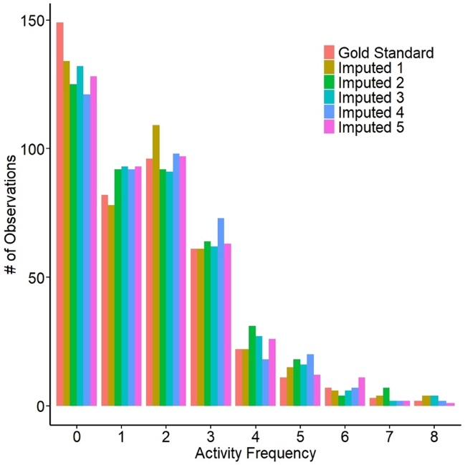 | 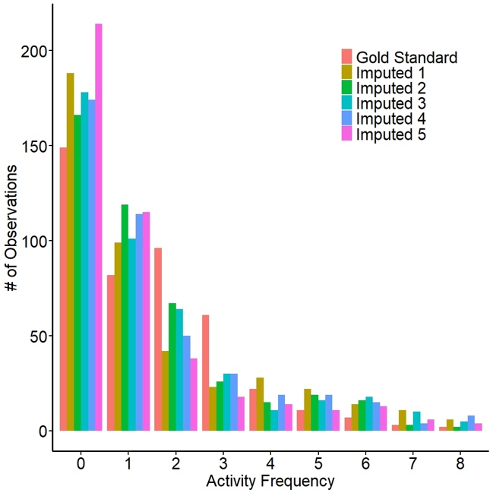 | 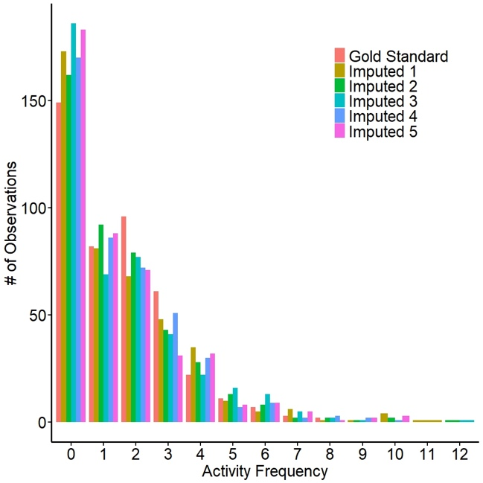

Figure S2. Number of observations for each activity frequency in the gold standard dataset and five imputed datasets, restricted to imputed values or values that were selected to be missing in the gold standard dataset (2% of dataset, N=433). The left panel used random hot deck, the middle panel used MICE model without constraints, and the right panel used MICE model with the constraint that activity frequency must equal the sum of the sport counts.

Agreement: When comparing all entries in the gold standard to the imputed datasets, the weighted Cohen’s kappa for frequency using the random hot deck approach ranged between 0.98 to 1.00. This is an overestimate due to the large amount of non-imputed data for this variable (98% of entries). When restricted to missing entries in the synthetic dataset, the average weighted Cohen’s kappa for frequency using random hot deck approach was 0.67 (range: 0.65-0.71), demonstrating moderate agreement [4]. For the common model-based context restricted to missing entries in the synthetic dataset, the average weighted Cohen’s kappa frequency was 0.02 (range: -0.05-0.10), demonstrating no agreement [4]. For the constrained model-based approach, the average weighted Cohen’s kappa for frequency was 0.00 (range: -0.06 to 0.09), demonstrating no agreement. These results did not change in our sensitivity analyses where we changed the value for imputed total activity if it exceeded 8 to the maximum value of 8 in the gold standard data. In a separate sensitivity analysis, we restricted the range of activity frequency to 0-5 activities; the Kappas remained at 0.02 (-0.04 to 0.06) for the unconstrained model and 0.00 (0.04 to 0.07) for the constrained model.
The contingency tables below show the agreement between the gold standard frequency and the imputed frequency using the unconstrained MICE model (Table S3) and the constrained MICE model where frequency greater than 8 were truncated to the maximum value in the gold standard data (Table S4). If imputation were perfect, each cell along the diagonal would contain a number greater than 0, and every other cell would be 0. In tables S3 and S4, there are 0 counts along the diagonal when gold standard frequency ranged between 5-8.

Table S3: Agreement between gold standard frequency and frequency imputed using the unconstrained MICE model. For this data set, kappa was equal to 0.07
 | Imputed Frequency: Unconstrained MICE model
 |  | 0 | 1 | 2 | 3 | 4 | 5 | 6 | 7 | 8
Gold  Standard  Frequency | 0 | 72 | 36 | 14 | 5 | 7 | 5 | 4 | 4 | 2
Gold  Standard  Frequency | 1 | 35 | 20 | 4 | 4 | 6 | 6 | 4 | 3 | 0
Gold  Standard  Frequency | 2 | 39 | 19 | 19 | 6 | 3 | 4 | 4 | 1 | 1
Gold  Standard  Frequency | 3 | 24 | 12 | 2 | 4 | 8 | 5 | 2 | 1 | 3
Gold  Standard  Frequency | 4 | 11 | 7 | 1 | 0 | 1 | 2 | 0 | 0 | 0
Gold  Standard  Frequency | 5 | 3 | 3 | 0 | 3 | 2 | 0 | 0 | 0 | 0
Gold  Standard  Frequency | 6 | 2 | 0 | 1 | 1 | 1 | 0 | 0 | 2 | 0
Gold  Standard  Frequency | 7 | 0 | 2 | 1 | 0 | 0 | 0 | 0 | 0 | 0
Gold  Standard  Frequency | 8 | 2 | 0 | 0 | 0 | 0 | 0 | 0 | 0 | 0

Table S4: Agreement between gold standard frequency and frequency imputed using the constrained MICE model where frequency must equal the sum of the sport counts, and imputed values greater than 8 were changed to the maximum value of 8 in the gold standard data. For this imputed data set, kappa was equal to 0.03.
 | Imputed Frequency: Unconstrained MICE model
 |  | 0 | 1 | 2 | 3 | 4 | 5 | 6 | 7 | 8
Gold  Standard  Frequency | 0 | 62 | 28 | 23 | 18 | 14 | 1 | 2 | 0 | 1
Gold  Standard  Frequency | 1 | 30 | 18 | 9 | 12 | 3 | 4 | 0 | 2 | 4
Gold  Standard  Frequency | 2 | 39 | 19 | 15 | 10 | 7 | 3 | 1 | 2 | 0
Gold  Standard  Frequency | 3 | 24 | 8 | 11 | 6 | 7 | 1 | 1 | 1 | 2
Gold  Standard  Frequency | 4 | 10 | 4 | 2 | 2 | 2 | 0 | 1 | 1 | 0
Gold  Standard  Frequency | 5 | 5 | 3 | 3 | 0 | 0 | 0 | 0 | 0 | 0
Gold  Standard  Frequency | 6 | 2 | 0 | 2 | 0 | 2 | 1 | 0 | 0 | 0
Gold  Standard  Frequency | 7 | 0 | 0 | 3 | 0 | 0 | 0 | 0 | 0 | 0
Gold  Standard  Frequency | 8 | 1 | 1 | 0 | 0 | 0 | 0 | 0 | 0 | 0

As a comparison, the contingency Table S5 shows the same results when we used the random hot deck approach.

Table S5: Agreement between gold standard frequency and frequency imputed using the Random Hot Deck method. For this data set, kappa was equal to 0.65.
 |  | 0 | 1 | 2 | 3 | 4 | 5 | 6 | 7 | 8
Gold  Standard  Frequency | 0 | 100 | 24 | 18 | 5 | 2 | 0 | 0 | 0 | 0
Gold  Standard  Frequency | 1 | 25 | 28 | 24 | 3 | 0 | 0 | 1 | 1 | 0
Gold  Standard  Frequency | 2 | 4 | 20 | 44 | 19 | 7 | 1 | 0 | 1 | 0
Gold  Standard  Frequency | 3 | 5 | 4 | 12 | 24 | 8 | 6 | 0 | 0 | 2
Gold  Standard  Frequency | 4 | 0 | 1 | 4 | 8 | 3 | 3 | 0 | 1 | 2
Gold  Standard  Frequency | 5 | 0 | 1 | 3 | 2 | 1 | 1 | 3 | 0 | 0
Gold  Standard  Frequency | 6 | 0 | 0 | 2 | 0 | 1 | 2 | 2 | 0 | 0
Gold  Standard  Frequency | 7 | 0 | 0 | 0 | 0 | 0 | 2 | 0 | 1 | 0
Gold  Standard  Frequency | 8 | 0 | 0 | 2 | 0 | 0 | 0 | 0 | 0 | 0

Sport
Variability: Figure S3 displays the number of entries where each sport was done in the gold standard and imputed datasets, restricted to missing entries in the synthetic dataset (3% of dataset) for random hot deck (left), and common model-based imputation without constraints (middle) and with our one constraint (right). As with activity frequency, there was variation between the imputed datasets due to the randomness of the imputation method.

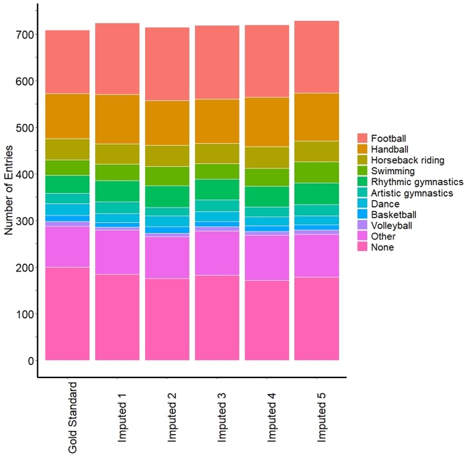 | 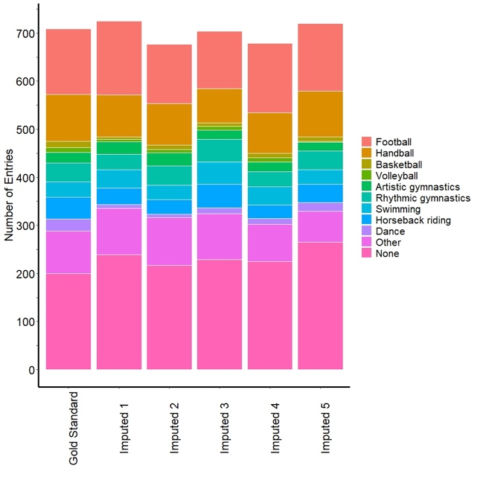 | 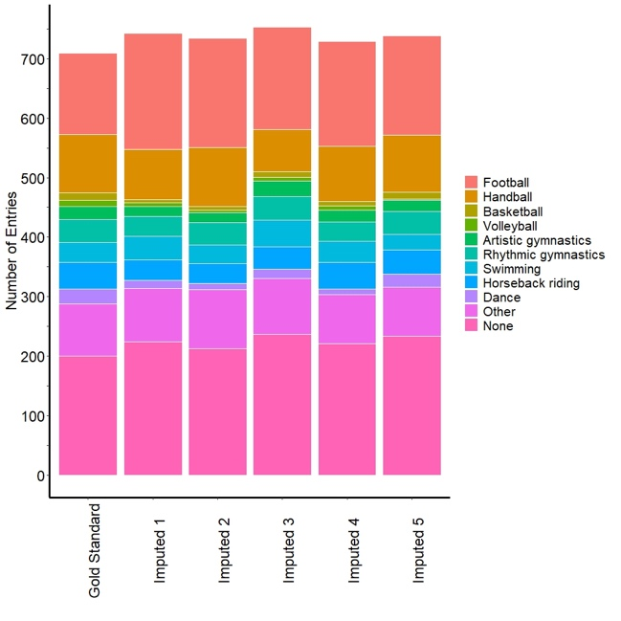

Figure S3. Mosaic plot for the number of observations where each sport was played in the gold standard dataset and five imputed datasets, restricted to records that were imputed (3% of dataset, N=615). The left panel used random hot deck, the middle panel used MICE model without constraints, and the right panel used MICE model with the constraint that total activity must equal sum of activities.

Agreement: When comparing all entries in the gold standard and imputed datasets, the unweighted Cohen’s kappa for each of the binary sport variables ranged between 0.98 to 1.00. This is an overestimate due to the large amount of non-imputed data for these variables (97% of entries).
When restricted to missing entries in the synthetic dataset, the average kappa for the random hot deck approach ranged from 0.59 to 0.85 depending on the sport (Figure 4, main text), demonstrating moderate-to-strong agreement [4]. For the common model-based context without constraints, the average kappa ranged from -0.02 to 0.05 depending on the sport, demonstrating no agreement [4]. For the constrained model-based approach, the average kappa ranged from 0.00 to 0.11, demonstrating no agreement.
As expected, kappas were much higher for entries when frequency data were available compared to when frequency data were missing. This can be attributed to the additional information that frequency provides about sport. Kappas were generally lower for sports that were done less frequently, as is expected for sports with lower prevalence [5]. For the random hot deck approach, 71% of entries were imputed correctly (imputing each sport that was played or not imputing no sports that were not played) compared to 21% of entries for the common model-based method and 24% of entries for the constrained model-based method.
When frequency data were available, 85% of entries with missing sports were imputed correctly by the random hot deck approach compared to 21% with the common model-based approach and 38% with the constrained model-based method. When frequency data were missing, 65% of entries were imputed correctly with random hot deck approach due to the reduced information, compared to 21% with the common model-based approach and 18% with the constrained model-based method. For the ten sports, overall sensitivity with the random hot deck approach ranged from 0.60 to 0.92 (Figure S4) compared to 0.07 to 0.81 for the common model-based approach and 0.07 to 0.63 for the constrained model-based approach (data not shown). Sensitivity tended to be lower for sports done less frequently, and when frequency data were missing.

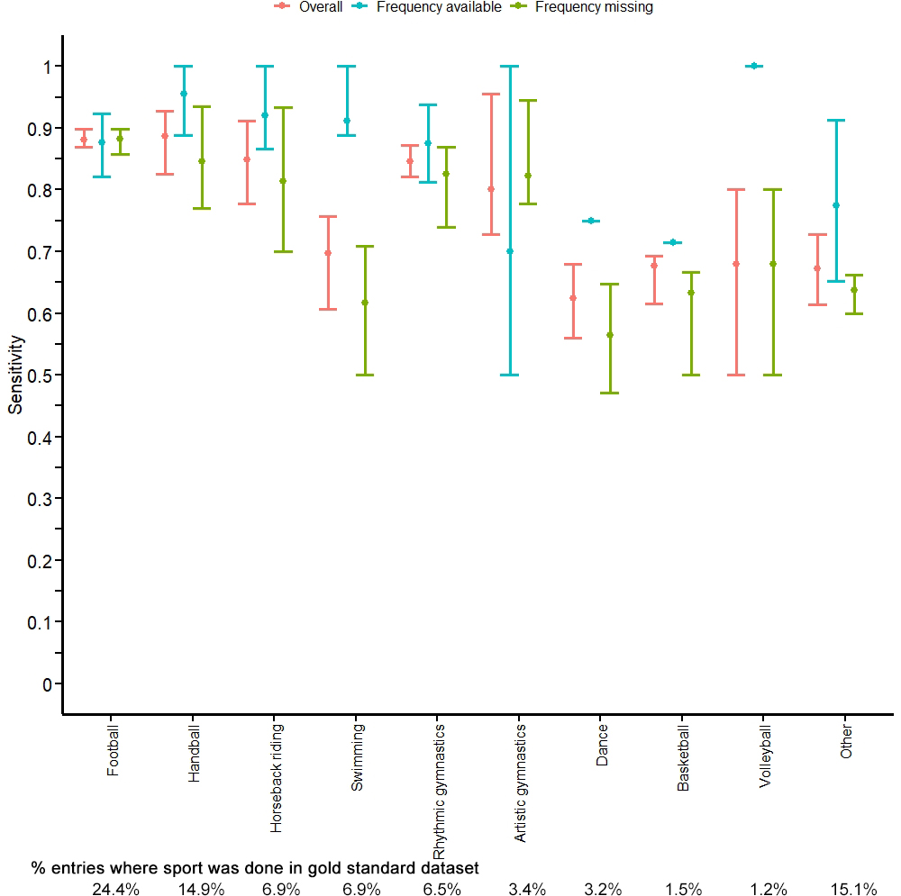

Figure S4. Sensitivity of imputed entries for each sport by missingness pattern. Sensitivity refers to the probability of correctly imputing a sport given that it was actually done. “Overall” is a weighted average of the two missingness patterns. Circles represent the average sensitivity across 5 imputed datasets, while error bars represent the minimum and maximum sensitivity between the 5 imputed datasets. The percentage of entries where each sport was done in the gold standard dataset is shown below the plot.

Overall specificity ranged from 0.92 to 1.00 for the random hot deck approach (Figure S5), compared to 0.79 to 0.99 for the common model-based approach and 0.74 to 0.99 for the constrained model-based approach (data not shown). Specificity tended to be lower for sports done more frequently, and when both frequency and sport were missing.

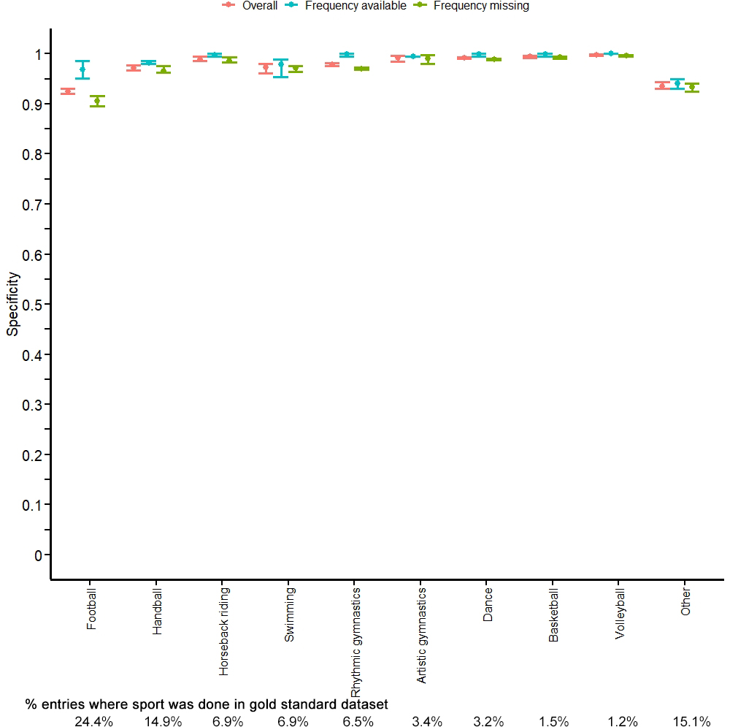

Figure S5. Specificity of imputed entries for each sport by missingness pattern. Specificity refers to the probability of not imputing a sport given that it was actually not done. “Overall” is a weighted average of the two missingness patterns. Circles represent the average specificity across 5 imputed datasets, while error bars represent the minimum and maximum specificity between the 5 imputed datasets. The percentage of entries where each sport was done in the gold standard dataset is shown below the plot.

Sport Counts
Variability: Figure S6 displays the mean sport count for each sport where that sport was done (sport count > 0) for the gold standard and imputed datasets, restricted to missing entries in the synthetic dataset (13% of the dataset) for random hot deck (left), and a common model-based imputation without constraints (middle) and with our one constraint (right). As above, the mean sport counts differed randomly between imputed datasets. As mentioned in the main text, the variability for the random hot deck approach is much less than we observed for Frequency and Sport because of the constraints in the data. This occurred because a week with missing data on some sport counts might still have observed data for other sport counts. For example, a participant with Frequency=3 who listed Basketball and Football as sports would only require imputing one of the sport counts and not all three sport counts. This constraint reduces the variability in our imputed data sets compared to the variables Frequency and Sport.

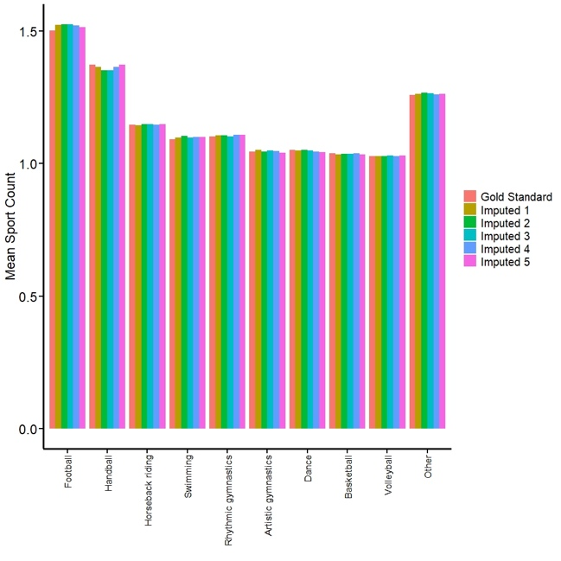 | 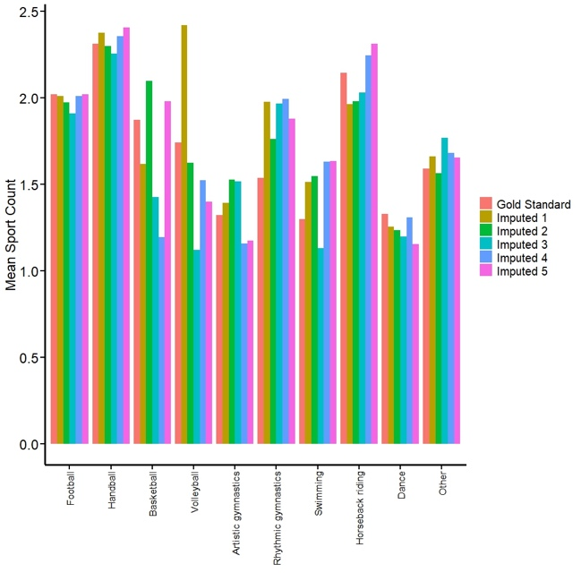 | 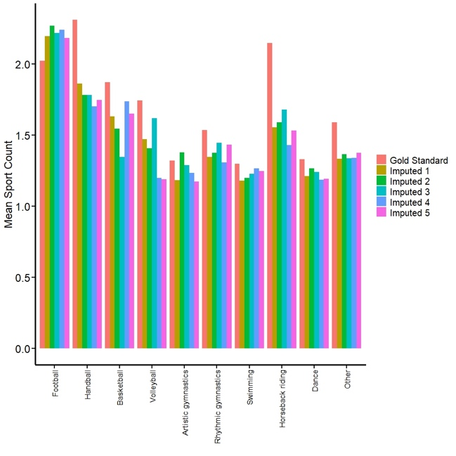
Figure S6. Mean sport count across entries where each sport was played (sport count > 0) in the gold standard dataset and five imputed datasets, restricted to records that were imputed (13% of dataset, N=2,689). The left panel used random hot deck, the middle panel used MICE model without constraints, and the right panel used MICE model with the constraint that total activity must equal sum of activities.

Agreement: When comparing all entries in the gold standard and imputed datasets, the weighted Cohen’s kappa for each of the sport count variables ranged between 0.98 to 1.00. This is an overestimate due to the large amount of non-imputed data for these variables (87% of entries). When restricted to missing entries in the synthetic dataset, the average kappa for the random hot deck approach ranged from 0.87 to 0.97 depending on the sport, demonstrating strong-to-almost perfect agreement [4] (Figure 7, main text). For the common model-based context, the average kappa ranged from 0.55 to 0.71 depending on the sport, demonstrating weak to moderate agreement [4], while the average kappa ranged from -0.01 to 0.33 for the constrained model-based approach, demonstrating no to minimal agreement.
Kappas were highest for entries when frequency and sport data were available, followed by when frequency was available but sport missing, followed by when frequency, sport, and sport count were all missing. This can be attributed to the additional information that frequency and sport provide about sport count. Kappas were generally lower for sports that were done less frequently, as is expected for sports with lower prevalence [5]. Kappas below 0.4 only occurred in the random hot deck approach for sports with low prevalence when each of frequency, sport, and sport count were missing.

References

1. Van Buuren, S., Groothuis-Oudshoorn, K. Multivariate imputation by chained equations. J Stat Softw. 2011;45:1–67.
2. R Core Team. R: A language and environment for statistical computing [Internet]. Vienna, Austria: R Foundation for Statistical Computing; 2021. Available from: http://www.R-project.org
3. Van Buuren, S. Flexible imputation of missing data. CRC Press; 2018.
4. McHugh ML. Interrater reliability: the kappa statistic. Biochem Medica. 2012;22:276–82.
5. Byrt T, Bishop J, Carlin JB. Bias, prevalence and kappa. J Clin Epidemiol. 1993;46:423–9.

