Supplementary Materials
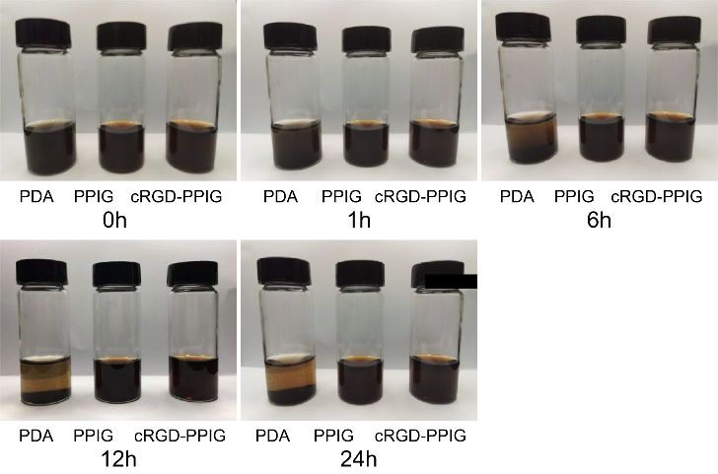
Supplementary Figure S1. Dispersion stability of PDA NPs, PPIG NPs, and cRGD-PPIG NPs in PBS at different time points
Supplementary Figure S2. Expression of integrin alpha V beta 3 (α_{v}β3) in GES-1 and MKN45 cells using confocal laser scanning microscopy
Supplementary Figure S3. Average relative T1-weighted MRI signal intensities of the lymph nodes (LNs) over 4 h after injection of cRGD-PPIG or PPIG NPs (general linear model repeated measures) (n = 3)
Supplementary Figure S4. Average relative fluorescence intensity of lymph nodes (LNs) over 4 h after injection of cRGD-PPIG NPs or PPIG NPs (general linear model repeated measures) (n = 3)
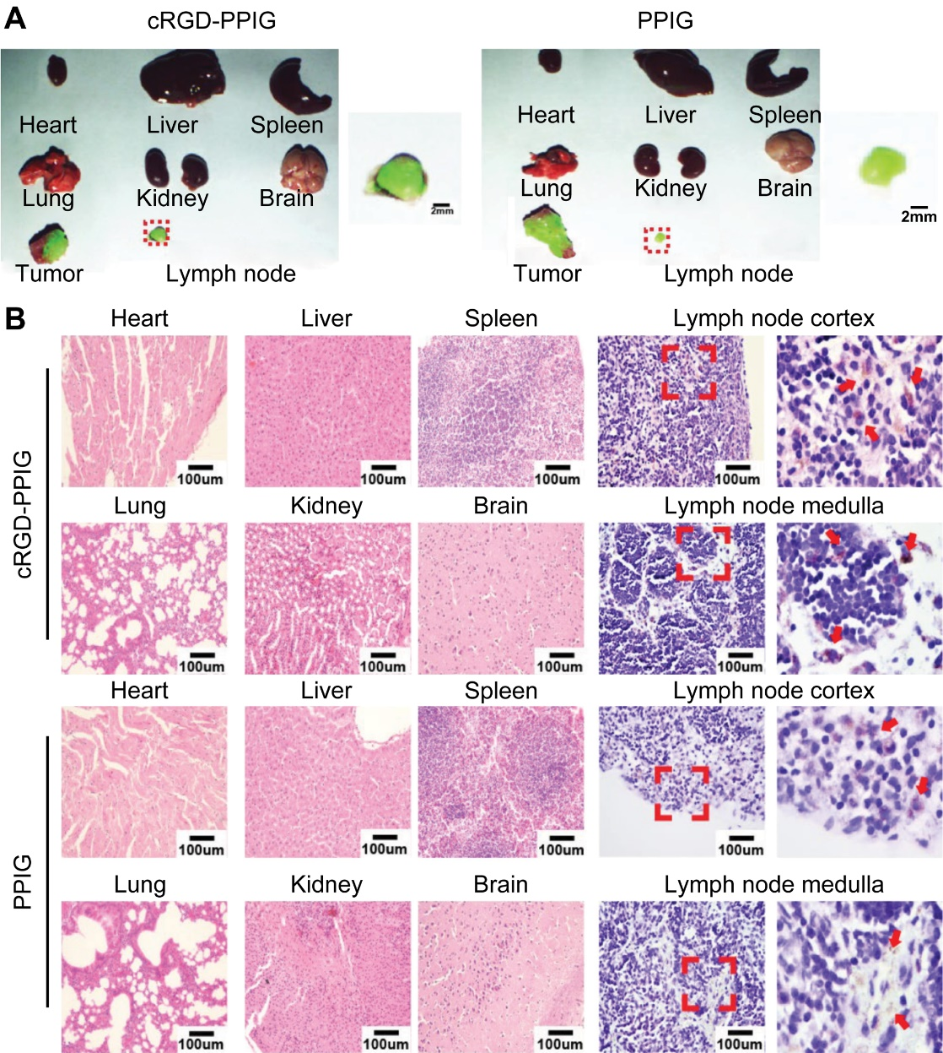
Supplementary Figure S5. In vivo biodistribution and biosafety of cRGD-PPIG NPs in mice
Supplementary Figure S6. Blood biochemistry indices, including alanine transaminase (ALT), aspartate transaminase (AST), blood urea nitrogen (BUN), and creatinine (CREA), after footpad injection of PPIG or cRGD-PPIG NPs in rats

