Supplementary Material

Table S1. Means, standard deviations, skewness, and kurtosis.
Item | M | SD | Skewness | kurtosis
GAD1 | 1.10 | 0.53 | 1.24 | 3.78
GAD2 | 0.89 | 0.62 | 0.52 | 1.35
GAD3 | 1.04 | 0.58 | 0.78 | 2.43
GAD4 | 1.03 | 0.63 | 0.82 | 2.01
GAD5 | 0.61 | 0.60 | 0.60 | 0.49
GAD6 | 1.08 | 0.57 | 0.99 | 2.92
GAD7 | 0.70 | 0.63 | 0.65 | 1.00
PHQ1 | 1.09 | 0.55 | 1.08 | 3.37
PHQ2 | 0.98 | 0.50 | 0.81 | 4.41
PHQ3 | 1.19 | 0.69 | 0.83 | 1.07
PHQ4 | 1.30 | 0.60 | 1.48 | 1.67
PHQ5 | 1.15 | 0.63 | 0.93 | 1.78
PHQ6 | 0.81 | 0.61 | 0.48 | 1.16
PHQ7 | 0.85 | 0.60 | 0.55 | 1.67
PHQ8 | 0.66 | 0.63 | 0.73 | 1.06
PHQ9 | 0.39 | 0.56 | 1.24 | 1.53
ISI1 | 1.07 | 0.86 | 0.79 | 0.75
ISI2 | 1.08 | 0.91 | 0.76 | 0.46
ISI3 | 1.28 | 0.97 | 0.70 | 0.19
ISI4 | 1.43 | 0.97 | 0.68 | 0.21
ISI5 | 1.21 | 0.86 | 0.91 | 1.21
ISI6 | 1.02 | 0.85 | 0.92 | 1.22
ISI7 | 1.15 | 0.91 | 0.94 | 1.04

Note: GAD1: Nervousness; GAD2: Uncontrollable worry; GAD3: Excessive worry; GAD4: Trouble relaxing; GAD5: Restlessness; GAD6: Irritability; GAD7: Feeling afraid; PHQ1: Anhedonia; PHQ2: Sad Mood; PHQ3: Sleep; PHQ4: Fatigue; PHQ5: Appetite; PHQ6: Guilt; PHQ7: Concentration; PHQ8: Motor; PHQ9: Suicide ideation; ISI1: Severity of sleep onset; ISI2: Sleep maintenance; ISI3: Early morning wakening problems; ISI4: Sleep dissatisfaction; ISI5: Noticeability of sleep problems by others; ISI6: Distress caused by the sleep difficulties; ISI7: Interference with daytime functioning.
Table S2. Correlation matrix of the GAD-7, PHQ-9 and ISI items.
 | GAD1 | GAD2 | GAD3 | GAD4 | GAD5 | GAD6 | GAD7 | PHQ1 | PHQ2 | PHQ3 | PHQ4 | PHQ5 | PHQ6 | PHQ7 | PHQ8 | PHQ9 | ISI1 | ISI2 | ISI3 | ISI4 | ISI5 | ISI6 | ISI7
GAD1
GAD2 | 0.22
GAD3 | 0.18 | 0.26
GAD4 | 0.18 | 0.15 | 0.24
GAD5 | 0 | 0.11 | 0 | 0.11
GAD6 | 0.09 | 0.002 | 0.04 | 0.11 | 0.07
GAD7 | 0.03 | 0.09 | 0.07 | 0.03 | 0.30 | 0.09
PHQ1 | 0.01 | 0 | 0.06 | 0 | 0.03 | 0.14 | 0.02
PHQ2 | 0.04 | 0.08 | 0.02 | 0.04 | 0.02 | 0.12 | 0.07 | 0.19
PHQ3 | 0.02 | 0 | 0 | 0.06 | 0 | 0 | 0 | 0 | 0.02
PHQ4 | 0.09 | 0 | 0 | 0.03 | -0.05 | 0.10 | -0.002 | 0.21 | 0.07 | 0.19
PHQ5 | 0.03 | 0 | 0 | 0.04 | 0.01 | 0.06 | 0.03 | 0 | 0 | 0.05 | 0.27
PHQ6 | 0 | 0.06 | 0.05 | 0 | 0 | 0.03 | 0.03 | 0 | 0.13 | 0 | 0.02 | 0
PHQ7 | 0 | 0.01 | 0.02 | 0 | 0.07 | 0 | 0 | 0.06 | 0 | 0 | 0 | 0.05 | 0.13
PHQ8 | 0 | 0.06 | 0.02 | 0 | 0.11 | 0 | 0.07 | 0.01 | 0 | 0 | 0 | 0 | 0.12 | 0.33
PHQ9 | 0 | 0 | 0 | 0 | 0.09 | 0 | 0.14 | 0.01 | 0.06 | 0 | -0.05 | 0 | 0.22 | 0.05 | 0.21
ISI1 | 0 | 0.003 | 0 | 0 | 0.001 | 0 | 0.01 | 0 | 0 | 0.16 | 0 | 0 | 0 | 0 | 0 | 0
ISI2 | 0 | 0 | 0 | 0.03 | 0.01 | 0 | 0 | 0 | 0 | 0.10 | 0 | 0.02 | 0 | 0 | 0 | 0 | 0.24
ISI3 | 0.002 | 0 | 0 | 0 | 0 | 0 | 0 | 0 | 0 | 0 | 0 | 0 | 0 | 0.03 | 0.02 | 0 | 0 | 0.22
ISI4 | 0 | 0 | 0 | 0 | 0 | 0 | 0 | 0 | -0.01 | 0.15 | 0 | 0 | 0 | 0 | 0 | -0.03 | 0.18 | 0.21 | 0.20
ISI5 | 0.01 | 0 | 0.01 | 0.01 | 0 | 0.01 | 0 | 0.003 | 0 | 0 | 0.05 | 0.02 | 0 | 0 | 0 | 0 | 0.09 | 0.04 | 0.05 | 0.11
ISI6 | 0 | 0.02 | 0 | 0 | 0.04 | 0 | 0.05 | 0 | 0 | 0 | 0 | 0 | 0.03 | 0 | 0.05 | 0.02 | 0.02 | 0.07 | 0.02 | 0 | 0.37
ISI7 | 0 | 0 | 0 | 0 | 0 | 0.01 | 0 | 0.003 | 0 | 0.05 | 0 | 0 | 0 | 0.02 | 0.02 | 0 | 0.06 | 0.10 | 0.04 | 0.27 | 0.31 | 0.30
Note: GAD1: Nervousness; GAD2: Uncontrollable worry; GAD3: Excessive worry; GAD4: Trouble relaxing; GAD5: Restlessness; GAD6: Irritability; GAD7: Feeling afraid; PHQ1: Anhedonia; PHQ2: Sad Mood; PHQ3: Sleep; PHQ4: Fatigue; PHQ5: Appetite; PHQ6: Guilt; PHQ7: Concentration; PHQ8: Motor; PHQ9: Suicide ideation; ISI1: Severity of sleep onset; ISI2: Sleep maintenance; ISI3: Early morning wakening problems; ISI4: Sleep dissatisfaction; ISI5: Noticeability of sleep problems by others; ISI6: Distress caused by the sleep difficulties; ISI7: Interference with daytime functioning
Figure S1. Visual representation of the network after controlling for age, gender, and having experiences of caring for COVID-19 patients.
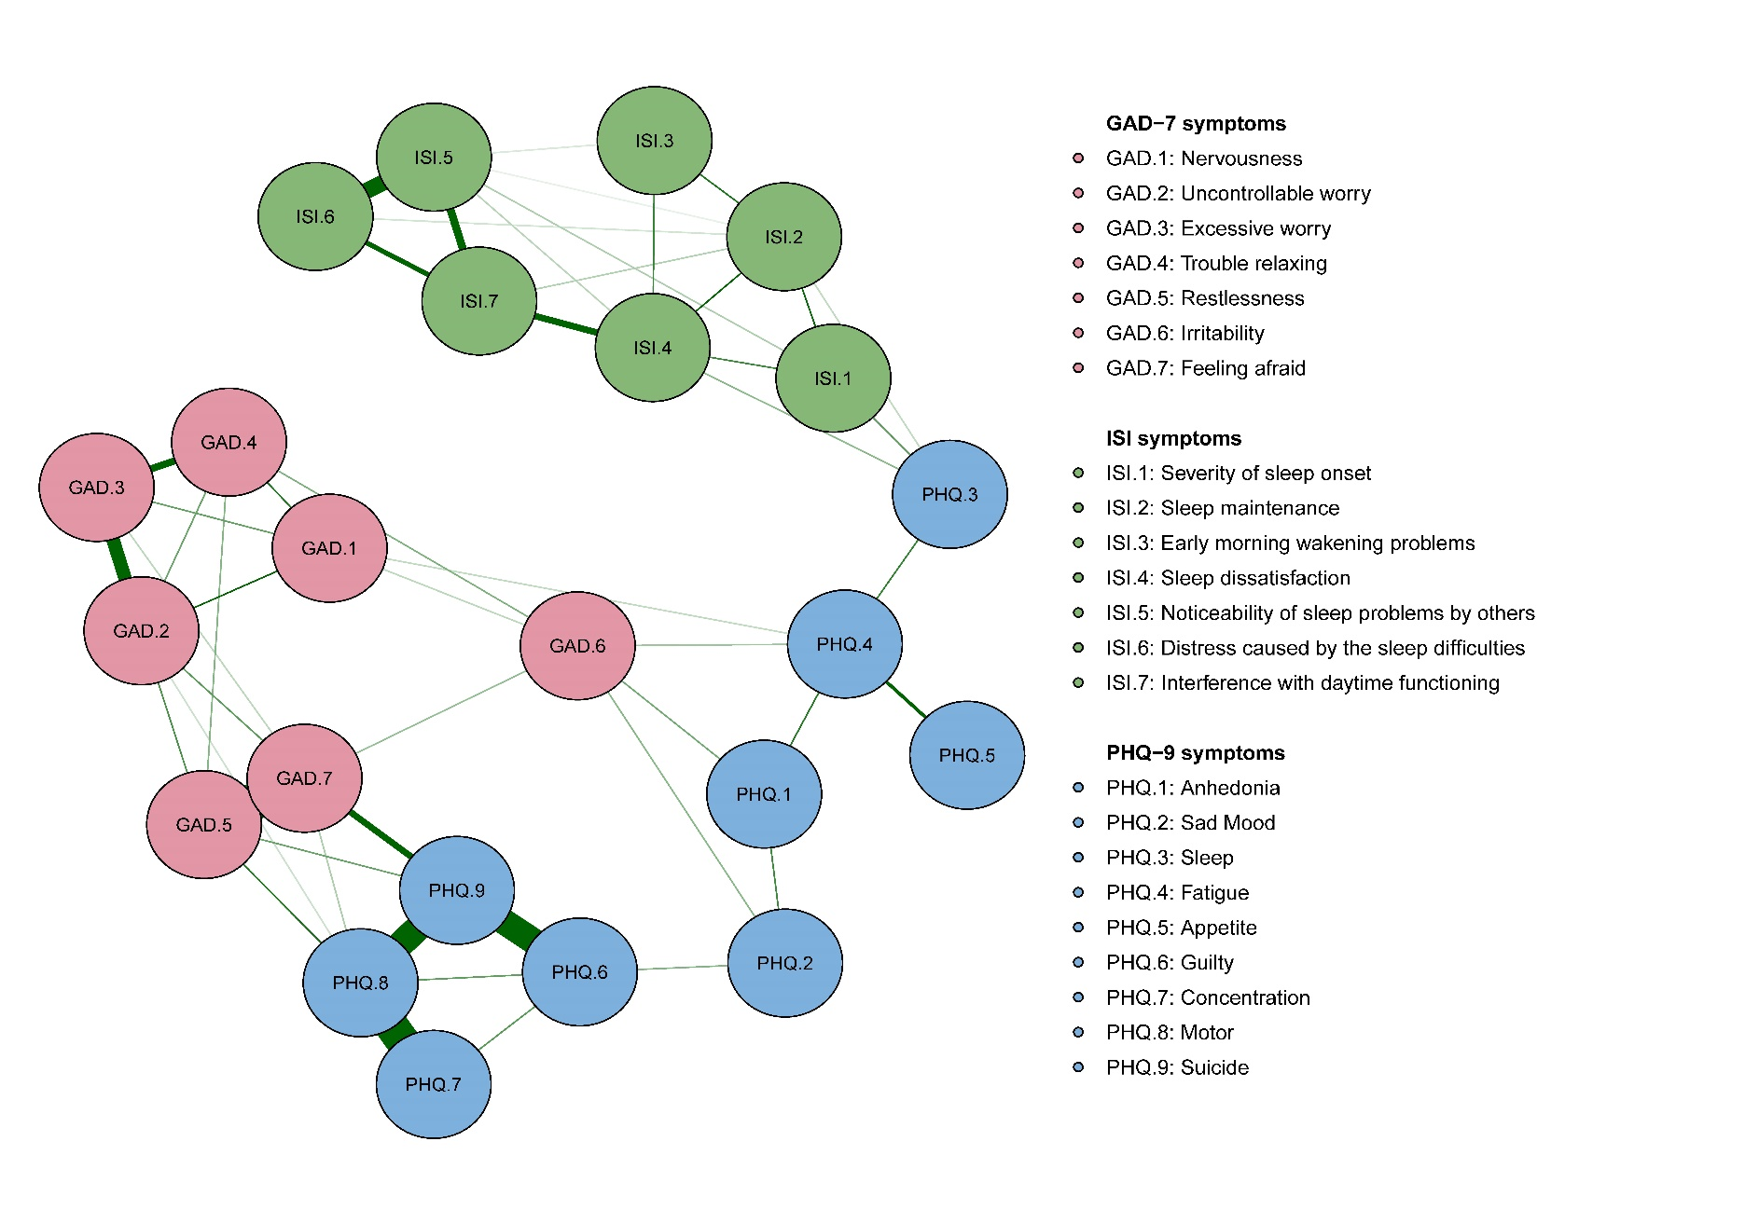

Figure S2. Estimated network model for the association between depression, anxiety and insomnia in females and males.
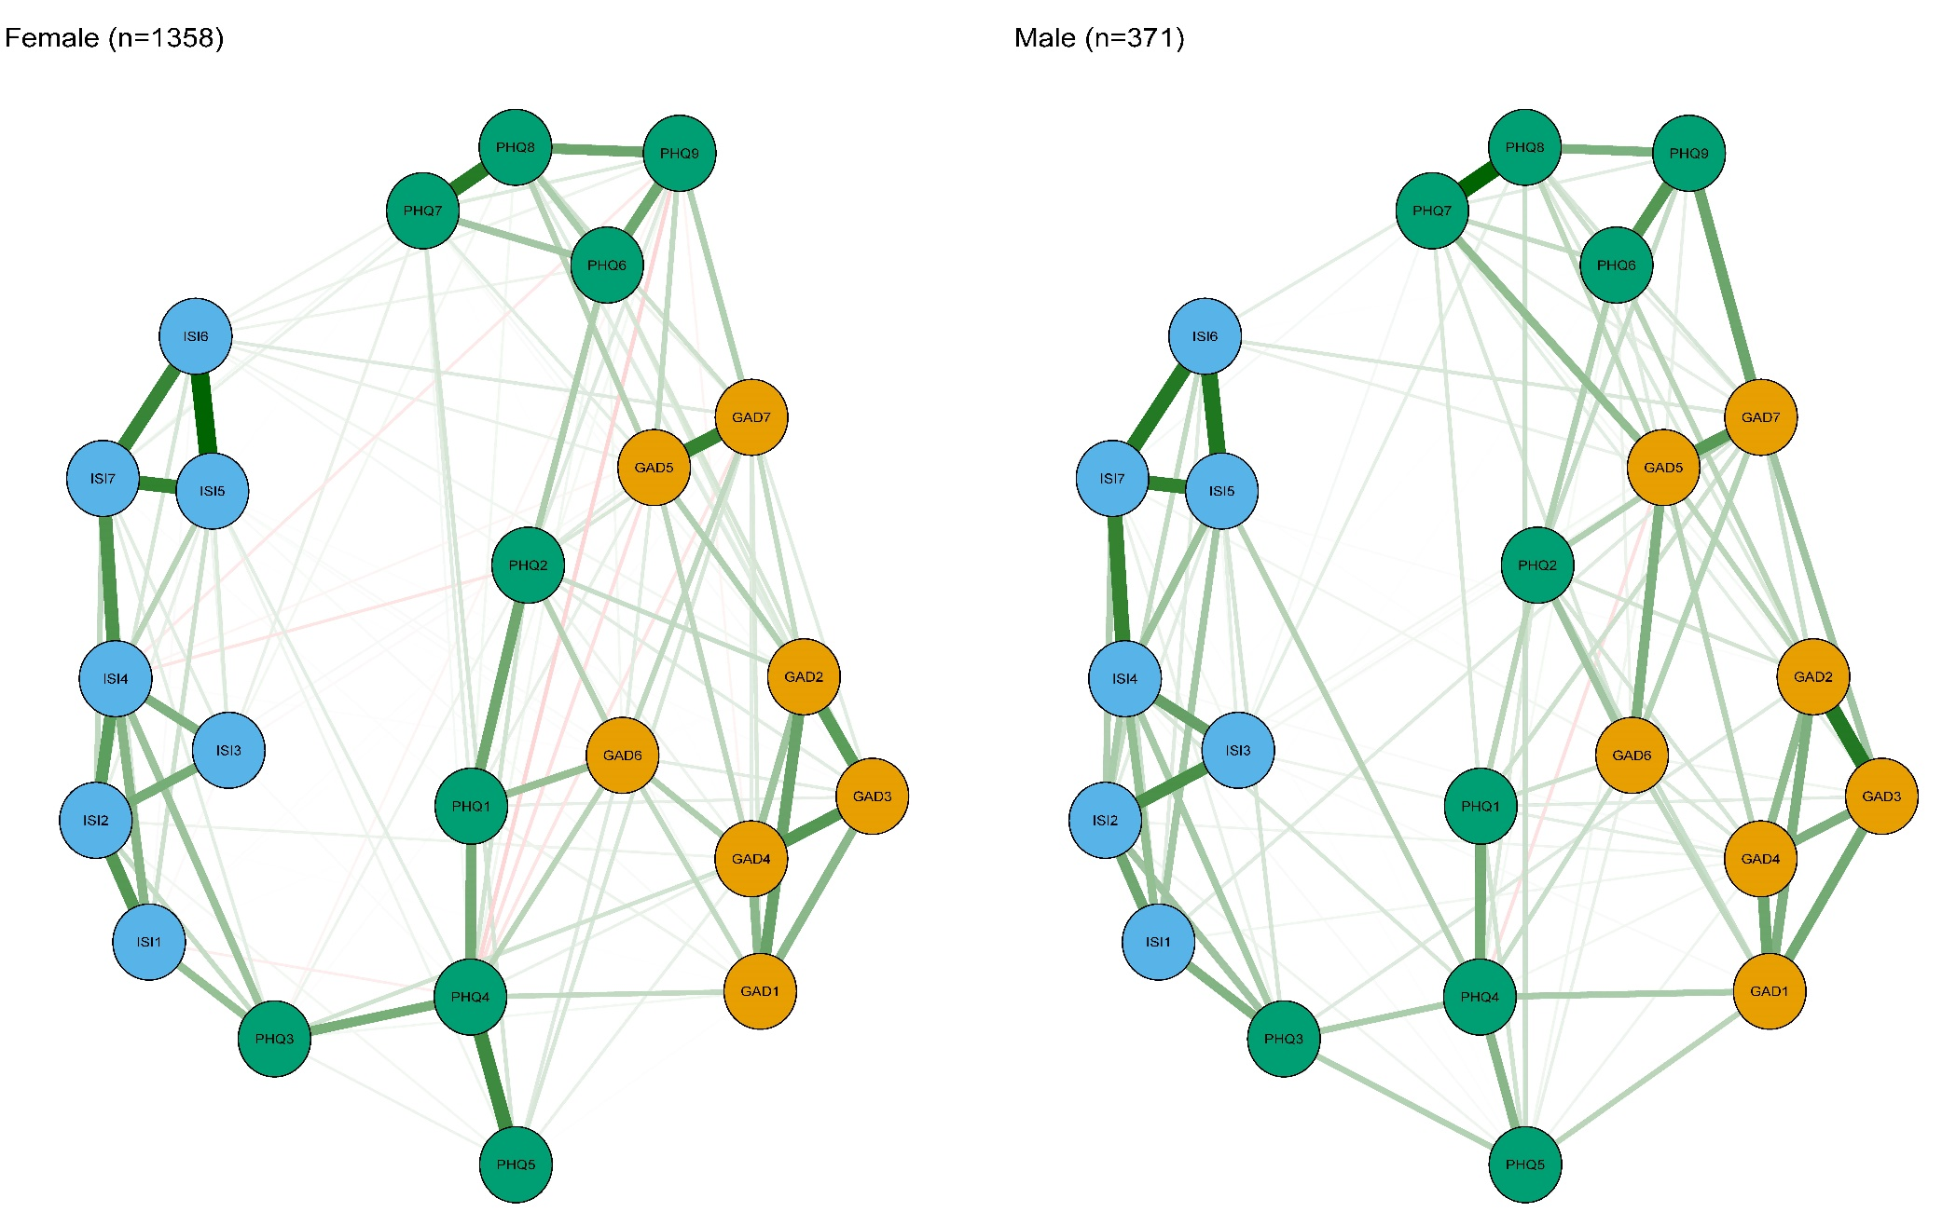

Figure S3. Comparison of network properties between females and males.
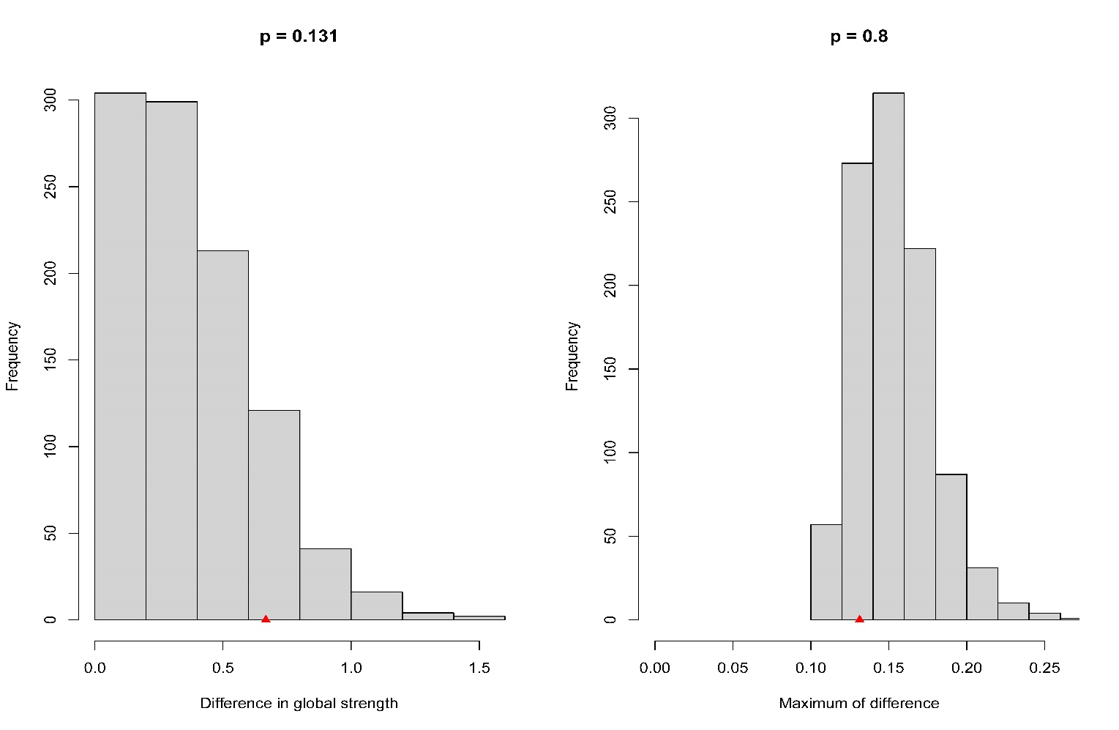

Figure S3. Right Panel: A plot of bootstrap value of the difference in network global strength. The difference was not significant (network strength among male participants: 10.98; among female participants: 10.31; S: 0.67, p=0.131) (The red triangle in figure indicated the S score). Invariance in edge weights was tested using the permutation test, generating sets of p values for each edge-edge comparison. Holm-Bonferroni corrected p values were all >0.05 indicating absence of significant differences.
Left Panel: A plot of bootstrap value of the maximum difference in any of the edge weights (1000 permutations). The difference was not significant (M=0.13, p=0.8) (The red triangle in figure indicated the M score).
Figure S4. Estimated network model for the association between depression, anxiety and insomnia in those with experiences of caring for COVID-19 patients.
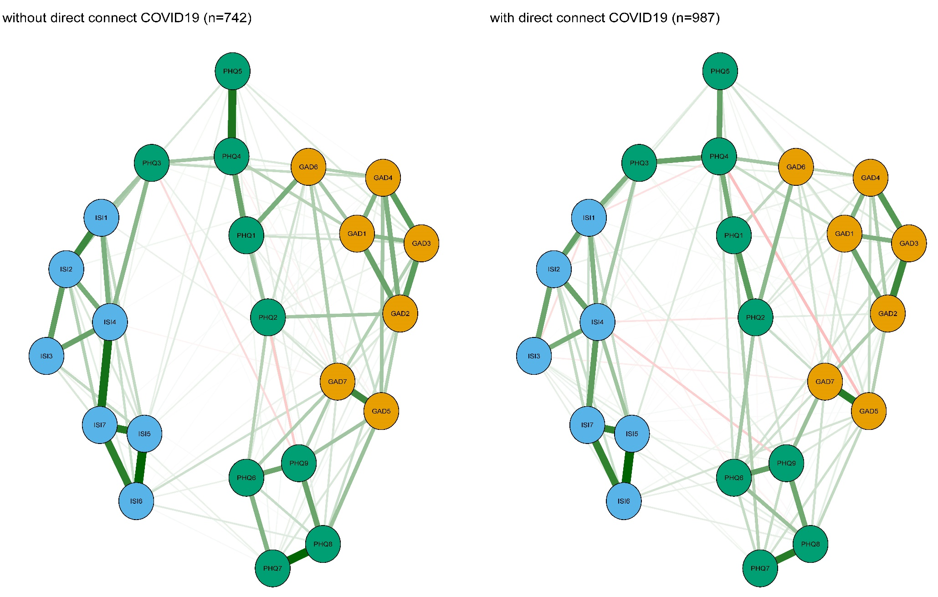
Figure S5. Comparison of network properties between with and without experiences of caring for COVID-19 patients.
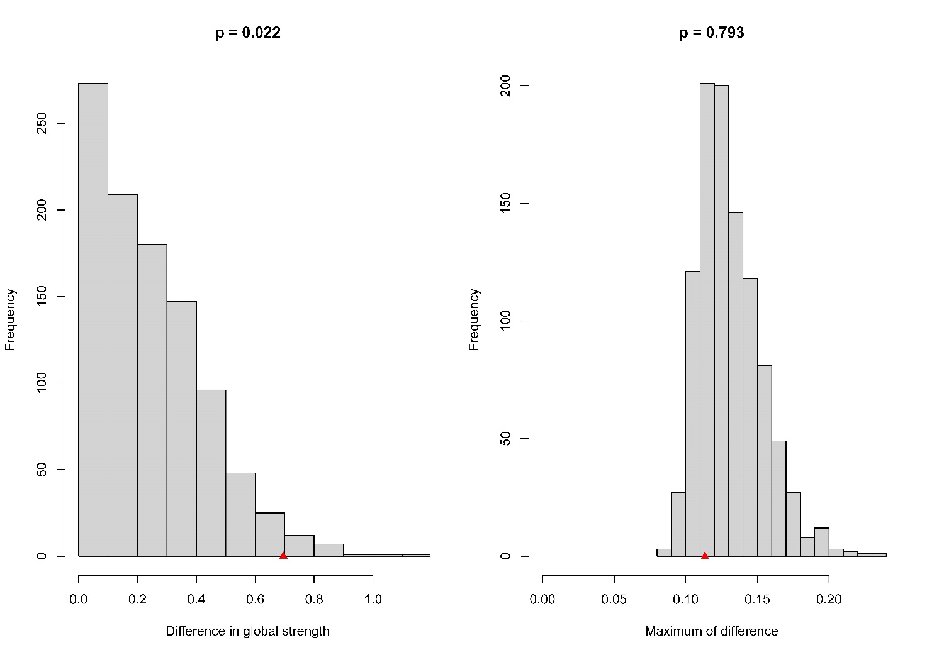
Figure S5. Right Panel: A plot of bootstrap value of the difference in network global strength. The difference was significant (network strength among who without experiences caring for COVID-19 patients: 10.63; among who with experiences caring for COVID-19 patients: 11.32; S: 0.67, p=0.022) (The red triangle in figure indicated the S score). Invariance in edge weights was tested using the permutation test, generating sets of p values for each edge-edge comparison. Holm-Bonferroni corrected p values were all >0.05 indicating absence of significant differences.
Left Panel: A plot of bootstrap value of the maximum difference in any of the edge weights (1000 permutations). The difference was not significant (M=0.11, p=0.793) (The red triangle in figure indicated the M score).

