LIST OF FIGURES

Figure 1a) I START-END tool/cognitive aid FRONT
Figure 1b) I START-END tool/cognitive aid BACK

Figure 2
STUDY FLOW CHART

Figure 3
STUDY PARTICIPANT TRAINING LEVELS

Figure 4
TECHNICAL SKILLS CHECKLIST SCORES

Figure 5
ANESTHETISTS’ NON-TECHNICAL SKILLS (ANTS) SCORES

Figure 1a)

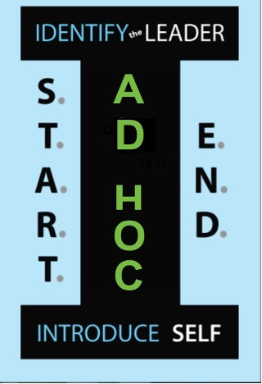

I START-END tool/cognitive aid FRONT
(This 2 x 3.5 inch laminated card was provided to each study participant after they completed the
first simulation scenario).
Figure 1b)

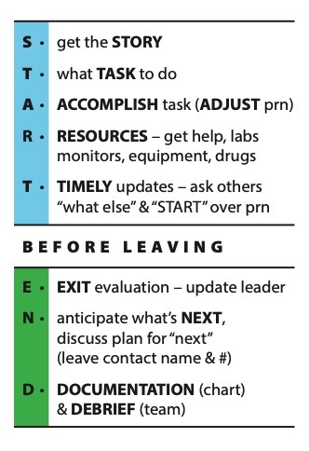

I START-END tool/cognitive aid BACK
(This is the reverse side of the laminated card provided to the study participants. Participants were encouraged to use the card as an aide-memoire, in their clinical work and subsequent simulations).
Figure 2
STUDY FLOW CHART
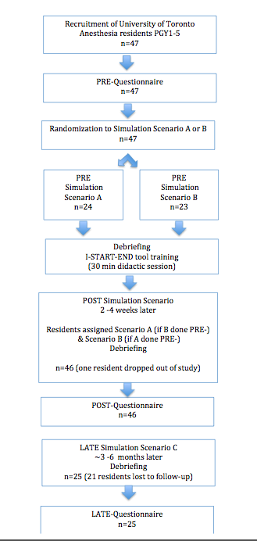

The study had 47 resident participants enrolled. These residents completed a standardized simulation scenario PRE-I START-END tool training.
I START-END tool training was provided to all 47 participants, after completion of the first simulation.
Two-four weeks later, 46 residents, referred to as POST-I START-END group, completed a second different simulation (note one resident did not continue in the study).
Three to six months later, 25 residents, referred to as LATE-I START-END group, completed a third simulation (21 residents did not return to complete the study).

Figure 3
PARTICIPANT TRAINING LEVELS

PGY1 | 10
PGY2 | 16
PGY3 | 5
PGY4 | 8
PGY5 | 8
Total | 47
This figure provides the level of training of the 47 resident participants in the study, at the time of enrollment.

Figure 4
ANESTHETISTS’ NON-TECHNICAL SKILLS (ANTS):
Intraclass correlation for inter-rater reliability was 0.61.

ANT SKILLS ASSESSMENT | Pre- I START-END tool training | Post- I START-END tool training | Late- I START-END tool training
Decision-making | 2.88 (SD 0.73) | 3.18 (SD 0.83) | 3.03 (SD 1.03)
Task Management | 2.94 (SD 0.69) | 3.09 (SD 0.67) | 3.13 (SD 0.9)
Situational Awareness | 3 (SD 0.78) | 3.15 (SD 0.82) | 3.03 (SD 1.03)
Teamwork | 3.12 (SD 0.77) | 3.29 (SD 0.52) | 3.27 (SD 0.74)

There was no significant difference measured in the ANTS scores in the Pre-, Post- and Late-
I START-END tool training groups.

Figure 5
TECHNICAL SKILLS CHECKLIST SCORES
Intraclass correlation for inter-rater reliability was 0.79
Pre-  I START-END tool training | 6.44 (SD 0.87)
Post - I START- END tool training | 5.67 (SD 1.67)
Late- I START- END tool training | 8.5 (SD 1.93)

The technical skills scores improved significantly between the Pre- and Late- I START-END tool training groups.

SUMMARY OF APPENDICES

List of existing teamwork tools reviewed

Explanation of the I START-END tool elements

Pre-, Post-, and Late- questionnaires

Data and graphs of questionnaire results

Comments from questionnaires

Simulation scenario descriptions A, B, and C

Action items/ technical skill scoring for scenarios

ANTS scoring framework

Mayo High Performance Teamwork Scale

APPENDIX A
List of existing teamwork tools reviewed;

TOPS Improving safety culture on adult medical units through multidisciplinary teamwork and communication interventions: the TOPS ProjectArticle (PDF Available) in Quality and Safety in Health Care 19(4):346-50 · August 2010 with 386 Reads DOI: 10.1136/qshc.2008.031252 · Source: PubMed Mary A Blegen

MOSES Multidisciplinary Obstetric Simulated Emergency Scenarios (MOSES): Promoting Patient Safety in Obstetrics with Teamwork-Focused Inter professional Simulations Article in Journal of Continuing Education in the Health Professions 29(2):98-104 · December 2009 with 550 Reads DOI: 10.1002/chp.20018 · Source: PubMed Della Freeth UK Freeth D, Ayida G, Berridge EJ, Sadler C, Strachan A. MOSES: Multidisciplinary Obstetric Simulated Emergency Scenarios. J Interprof Care. 2006;20(5):552-4.

GITT The Geriatric Interdisciplinary Team Training ProgramArticle· Literature Review (PDF Available) in Gerontology & Geriatrics Education 24(2):3-12 · February 2003 with 197 Reads DOI: 10.1300/J021v24n02_02 · Source: PubMed Terry Fulmer USA

MedTeams Reducing errors in emergency medicine through team performance: The MedTeams project
Simon R. Morey JC, Rice MM, Rogers L, Jay GD, Salisbury M.: National Patient Safety Foundation. Reducing errors in emergency medicine through team performance: The MedTeams project. Enhancing Patient Safety and Reducing Errors in Health Care, Scheffler AL, Zipperer L, editors. 1998; 142-146.

Team STEPPS Clancy CM, Tornberg DN. TeamSTEPPS: assuring optimal teamwork in clinical settings. Am J Med Qual. 2007;22(3):214-7.

SCRIPT Structuring communication relationships for interprofessional teamwork (SCRIPT): a cluster randomized controlled trial Authors and affiliations Merrick Zwarenstein Scott Reeves SEPT 2007

MORE Milne JK, Lalonde AB. Patient safety in women’s health-care: professional colleges can make a difference. The Society of Obstetricians and Gynaecologists of Canada MORE(OB) program. Best Pract Res Clin Obstet Gynaecol. 2007;21(4):565-79

SBAR Whittington J, Nagamine J. SBAR: application and critical success factors of implementation. Institute for Healthcare Improvement; 2006 [cited 2010 May 28th]; Available from: http:// www.managedcare.com

MTT, Life Wings/DOM , TOMS Team Oriented Medical Simulation
Medical Team Training Programs in Health Care David P. Baker, Sigrid Gustafson, J. Mathew Beaubien, Eduardo Salas, and Paul Barach.

STICC (Situation, Task, Intent, Concern, Calibrate)
Crit Care. 2011; 15(6): 314.Published online 2011 Dec 8. doi: 10.1186/cc10360

TADMUS – Tactical Decision Making Under Stress
Morrison JG, Kelly RT, Moore RA, Hutchins SG.
APPENDIX B
“I START-END” COMMUNICATION TOOL

I
IDENTIFY the leader (ensures they know you arrived) and INTRODUCE self by specialty and experience level.
This automatically informs the leader of how to effectively delegate tasks, leading to more efficient and safe patient care (also important for documentation by nursing). An added benefit is that others will now know who is in charge and also who you are. It may prompt them to introduce themselves also.

S
“Getting the STORY” is essential. Context is what creates meaning and understanding and impacts directly on patient care planning.

T
TASK assignment (what would you like me to do?)
The resident becomes a vital part of the team by actively participating in the care of the patient as per the leader.

A
ACCOMPLISH OR ADJUST the task
Every individual on the team has a unique skill set depending on prior experience, training, and judgment.
When a task is assigned – it creates an opening for dialog.
For this reason, closed loop communication is essential - the task is either performed as requested or adjustments may be necessary, depending on the skill set of the individual team member.

R
As the emergency scenario is evolving, other RESOURCES (special drugs, other monitors, equipment, scans, specialists etc.) will be needed. Proactively thinking to organize these things will expedite patient care.

T
TIMELY UPDATES.
A regular summation of what individuals on the team have done so far and what their viewpoint of the patient’s status and course to date is.
(What do you think is happening?)
This update will usually be initiated by the leader but can be requested by anyone on the team, including NURSING and may be performed as often as is necessary (such as a significant change in the patient’s vital signs, assistance required to perform a task or treat a complication).
The update process is essential given that the patient status is continuously evolving patient status; a regular review by the WHOLE team ensures “we are all on the same page” (leading to situational awareness and shared mental models).

Depending on the update it may necessitate START’ing again. For example – “lets review the story, what task do we need to do next, do we need any other resources’ and so on...

Once the patient is stabilized, definitive care is passed on to another team (e.g. ICU)
END process is required BEFORE leaving the Ad Hoc event

E
Exit Evaluation. Each team member directly addresses the leader summarizing/updating the patient care delivered so far and informs the leader that they are leaving

N
Before leaving, the team member gives their opinion of what might happen NEXT and clarification is made as to who will do what i.e. who is in charge going forward and be responsible to make NEXT happen, and when.

D
Documentation
Documentation of facts is critical and provides a record of what has transpired. Also contact information for all those who have participated is necessary for follow-up as per “next” above.

Debriefing the experience with the group concludes the interaction. What went well – what could be improved – what is the process to ensure the improvement will actually occur.

APPENDIX C
QUESTIONNAIRES

(i) PRE NEEDS ASSESSMENT QUESTIONNAIRE

This questionnaire is part of a research project about performance of emergency teams.

Please take the few minutes (<5 mins) to complete this questionnaire Your honesty is appreciated.
All responses will be handled so your anonymity will be preserved.

Thank you in advance for your participation.
- – never
- – rarely
- – sometimes
- – often
- – always

- Team performance in emergency situations can influence patient outcome.

Never | Rarely | Sometimes | Often | Always

- Working on a team with people I don’t know is challenging.

Never | Rarely | Sometimes | Often | Always

- The leader on the team is the most important factor in how well the team functions.

Never | Rarely | Sometimes | Often | Always

- I am asked to perform tasks I am unsure of how to do.

Never | Rarely | Sometimes | Often | Always

- I don’t know the “story” of the patient I am caring for.

Never | Rarely | Sometimes | Often | Always

- The emergency scenario feels chaotic and out of control.

Never | Rarely | Sometimes | Often | Always

- I feel peripheral to the overall management of the patient.

Never | Rarely | Sometimes | Often | Always

- I feel isolated in my role on the team.

Never | Rarely | Sometimes | Often | Always

- It is easy for me to ask for help with tasks on this team.

Never | Rarely | Sometimes | Often | Always

- It is difficult to “be heard” /express my opinion in this setting.

Never | Rarely | Sometimes | Often | Always

- I leave the emergency scenario as soon as the airway is secured and the patient is otherwise stable.

Never | Rarely | Sometimes | Often | Always

- I communicate my patient care interventions to the leader.

Never | Rarely | Sometimes | Often | Always

- I give regular updates of the patient’s status to the team from my viewpoint.

Never | Rarely | Sometimes | Often | Always

- I participate in the debriefing process.

Never | Rarely | Sometimes | Often | Always

- I document my interventions on the chart, including what needs to be done next.

Never | Rarely | Sometimes | Often | Always

(ii) POST & LATE ASSESSMENT QUESTIONNAIRE

This questionnaire is part of a research project about performance of emergency teams. Please take the few minutes (<5 mins) to complete this questionnaire.
All responses will be handled so your anonymity will be preserved. Thank you in advance for your participation.

  - The tool gave me have an organized approach to emergency scenarios.

Never | Rarely | Sometimes | Often | Always

  - The tool gave me confidence integrating into the emergency team.

Never | Rarely | Sometimes | Often | Always

  - Using the tool provided me with information to take better care of the patient.

Never | Rarely | Sometimes | Often | Always

  - The tool facilitated communication with other team members.

Never | Rarely | Sometimes | Often | Always

  - The tool helped me to speak up about patient concerns.

Never | Rarely | Sometimes | Often | Always

  - The tool made me aware of what “else” was happening to the patient.

Never | Rarely | Sometimes | Often | Always

  - The tool helped me anticipate resources needed for care of the patient.

Never | Rarely | Sometimes | Often | Always

  - The tool prompted me to debrief before leaving.

Never | Rarely | Sometimes | Often | Always

  - The tool was a reminder to document my interventions on the chart.

Never | Rarely | Sometimes | Often | Always

  - I will continue to use the tool in Ad Hoc emergency scenarios.

Never | Rarely | Sometimes | Often | Always

  - The tool may be useful in other clinical settings.

Never | Rarely | Sometimes | Often | Always

APPENDIX D
QUESTIONAIRE DATA

PRE

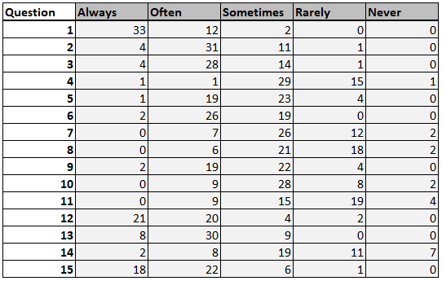
Graphs
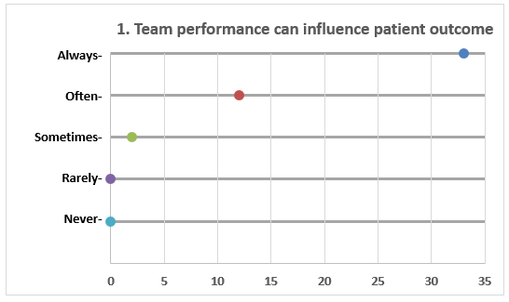
# = respondents
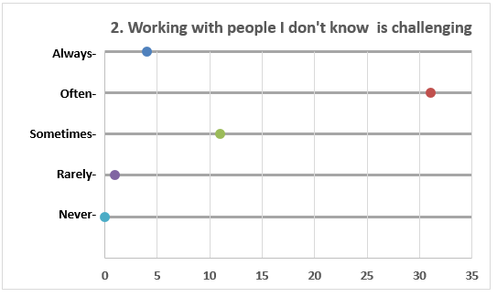
# = respondents
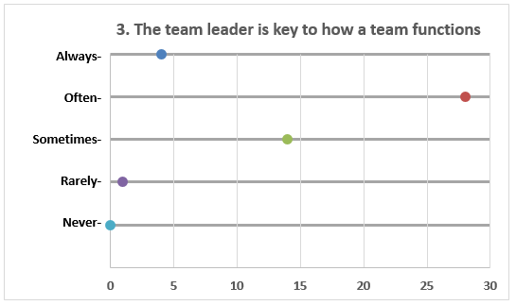
# = respondents
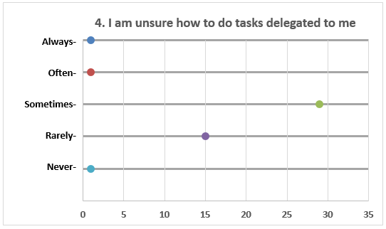
# = respondents
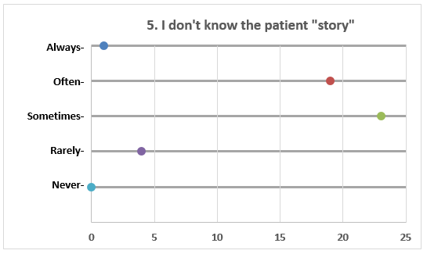
# = respondents
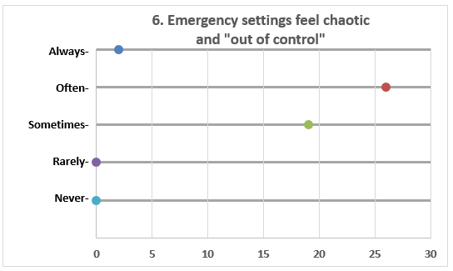
# = respondents
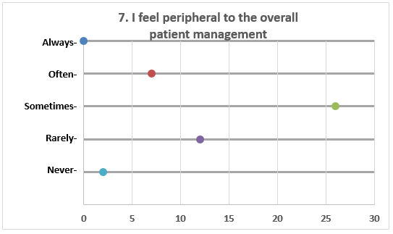
# = respondents
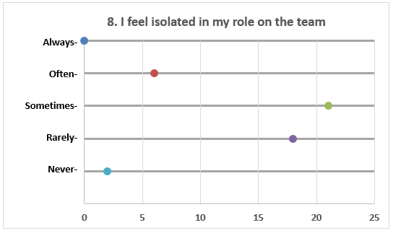
# = respondents
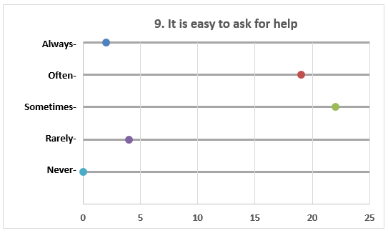
# = respondents
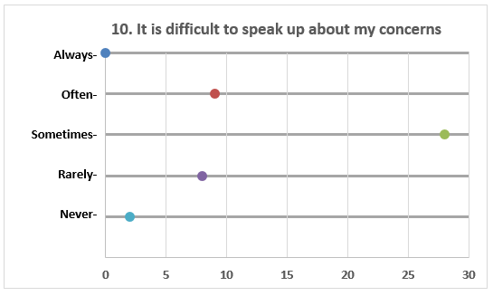
# = respondents
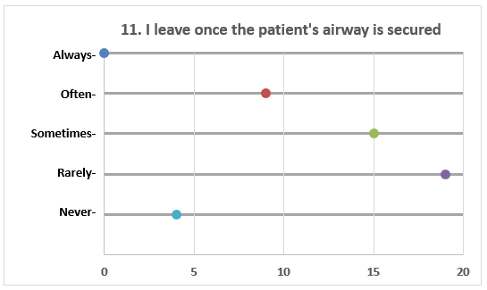
# = respondents
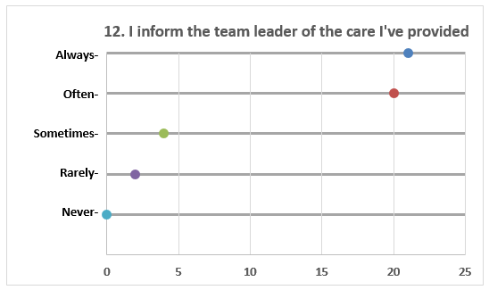
# = respondents
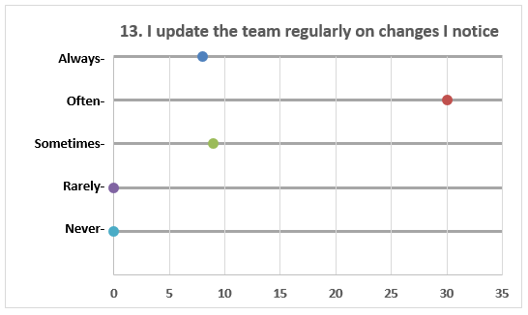
# = respondents
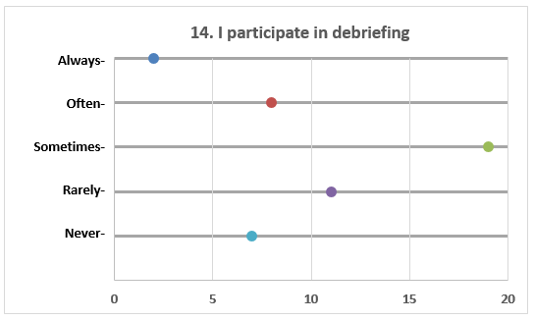
# = respondents
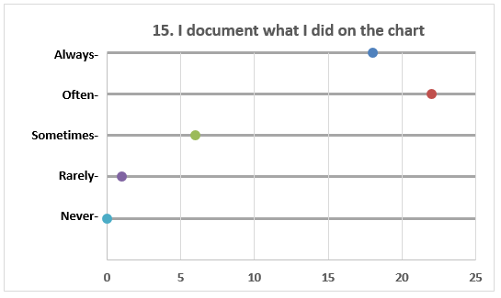
# = respondents

POST
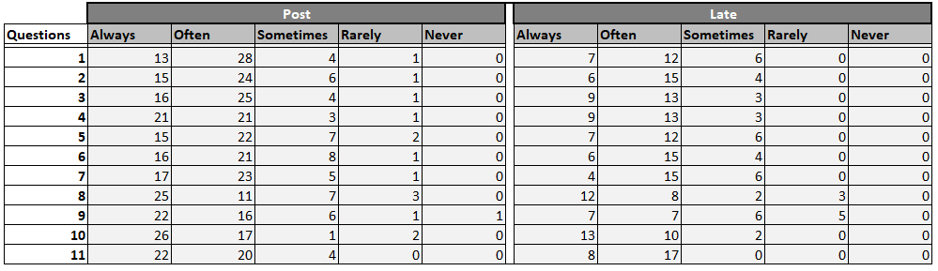
Graphs
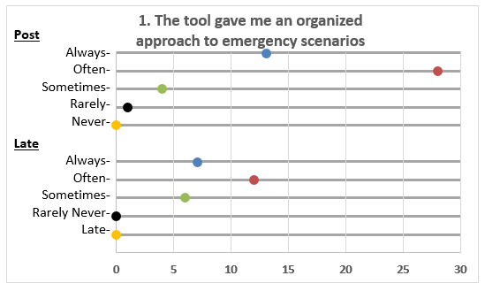
# = respondents
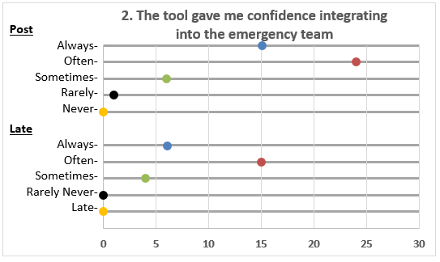
# = respondents
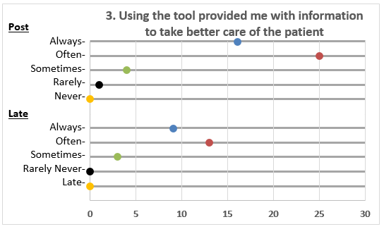
# = respondents
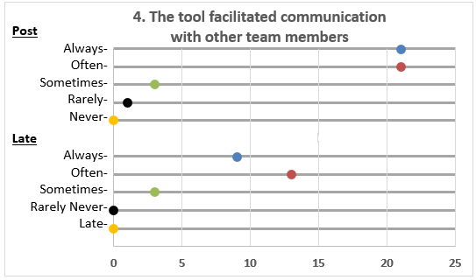
# = respondents
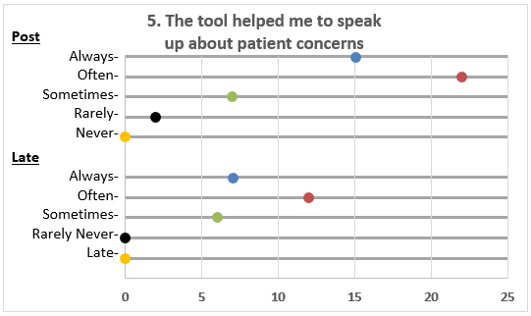
# = respondents
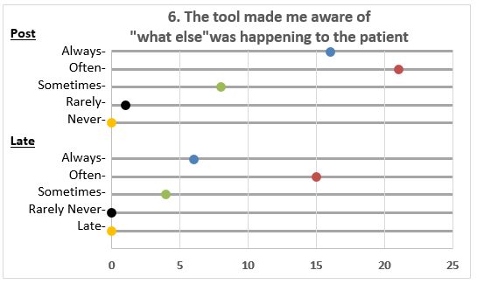
# = respondents
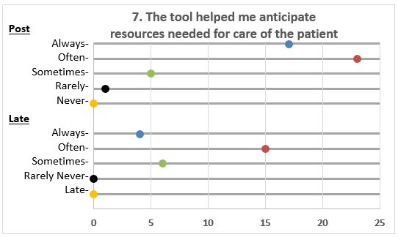
# = respondents
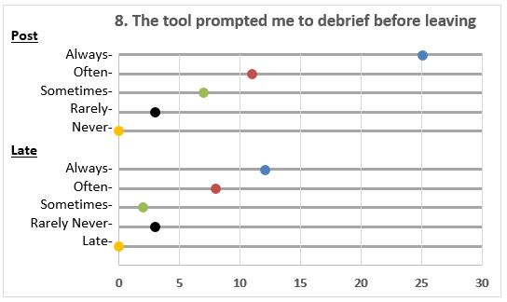
# = respondents
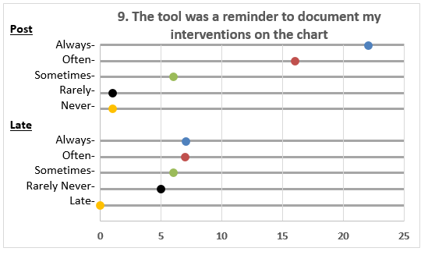
# = respondents
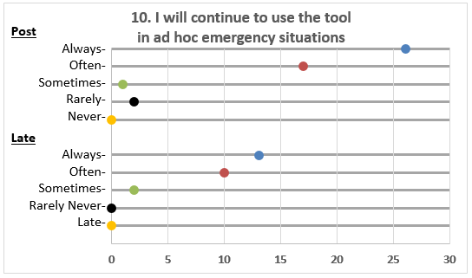
# = respondents
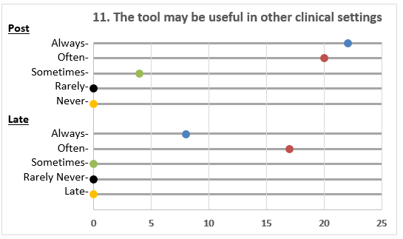
# = respondents

APPENDIX E
RESIDENTS’ COMMENTS:

POST
- really useful tool, better if colleagues from other services utilized same system
- most useful is introduce self and ask who leader is
- helped identify clear opportunities to minimize miscommunication between team members to ensure safe patient care
- great tool, easy to remember mnemonic, applicable and useful-grateful for “cheat card aid” I can carry around
- enjoyed sim scenarios and structure of I START-END useful for grounding me in a tense situation
- too long – I forgot what the acronym stood for
- with the tool, I had an organized approach to the simulation, it helped me stay calm – gather relevant information, prioritize tasks. I will use this tool in the future.
- “ART” part helps to organize thoughts and plan steps for going forward
- excellent communication simulation exercise-structured approach makes critical situations go more smoothly – idea should be spread to increase insight in real practice settings
- great learning form scenarios – keeps me organized – need more practice with it in real life situations – to remember all the specified items
- study tool and debrief very useful
- “I” and “END” part most useful - struggle more to apply “START” part. Debrief useful
- really useful tool- better if colleagues from other services utilized the same system
- most useful – introduce self and ask who leader is
- helped identify clear opportunities to minimize mis-communication between teams to ensure safe patient care
- great tool, easy to remember mnemonic, applicable and useful in many settings
- grateful for cheat sheet (cognitive aide) – small size makes it easy to carry around and refer to (attached it to my ID lanyard)
- enjoyed sim scenarios and structure of I START-END useful for grounding me in a tense situation
- I like the tool and will use it in my practice
- more “hands-on” training after teaching the tool in a didactic session would be helpful
- best aspect of this tool is at the beginning – establishing people’s competency level and the “END” part – latter not usually done well – the tool reminds us
- good framework when in an unfamiliar situation
- tool definitely gives a good framework for creating a team with people you haven’t met before- great training in code blues etc
- realistic scenarios
- I believe the tool helped me communicate more effectively with team mambers – especially in emergency scenarios it prompted me to communicate with the others on the team (sometimes difficult in stressful situations). It facilitated better patient care and teamwork
- great learning about team dynamics- very useful practical learning – will definitely use, it reminds us to put a conscious effort on the team side of things
- good idea, very practical, straightforward, user friendly,
- 100% practical
- easy to apply
- easy to apply
- excellent idea
- could be used for other settings
- makes sense
- experience was excellent. It was great to have an opportunity to practice non-technical aspects of the care we provide. I have often been put into scenarios such as the ones presented in the simulations. It was great to receive training and feedback. The framework will help me handle these situations better.
- The tool is a great cognitive aide to remind the team and leader to work together in difficult settings outside the OR
- In practice, we mostly focus on the medical management of patients and interventions. Critical mistakes can happen due to lack of communication (such as poor handovers and misunderstandings of who was supposed to do what). The tool aims to rectify these challenges and I think it will be be a great help in practice.

LATE
- Very useful for being effective in a team setting – we are taught technical skills but not teamwork, managerial and leadership skills – the tool helps fill this gap
- It is good to have the tool handy by my badge. It reminds me to give timely updates, check the chart for more info, and leave my contact information before I leave the room
- It is a great idea to have a structured approach to communicating in emergency situations.

APPENDIX F
SCENARIO DESCRIPTIONS

Scenarios A & B interchanged randomly between PRE and POST simulations Scenario C used for all participants for LATE simulation

SCENARIO A –
SETTING: CARDIOLOGY CATHETERIZATION LAB BACKGROUND:
Non-communicative cardiologist attempting a cardiac catheterization procedure for urgent STEMI, having difficulty with groin access
Patient restless, says “I feel like I can’t breathe” Anesthesia called stat to intubate patient.
On arrival of anesthesia resident, cardiologist says “good, anesthesia is here” and he turns to the anesthesia resident & says “just intubate the patient – we’re struggling here”
The only nurse in the room is assisting the cardiologist – rather passive, indifferent to the anesthesia resident – DOES NOT ENGAGE, unless specifically addressed.

Status of Patient:
HR 100 SR with ST elevation & VPBs BP 170/100
SaO2 93 with nasal prong oxygen flowing at 4 lpm
Patient alert, cooperative, complaining of shortness of breath and says “my mouth feels strange”

Cardiologist responds: “He’s just moving around too much to be able to do this. Just put him to sleep with something”

WHEN RESIDENT ASKS FOR HISTORY
Cardiologist states the patient is well known to him. The patient has a grade 4 ischemic cardiomyopathy.
Over breakfast today, he developed chest pain – we’ve been at it for 45 mins…

Patient improves – less restless & SaO2 improves to 95% with oxygen mask but says “my ears feel plugged – like ringing or something”.
Cardiologist is preoccupied, non-responsive – still struggling with access (does not accept help, if asked)
He says, “We’re fine” IF HE WOULD JUST STOP MOVING and asks for more local anesthetic for the groin on the other side, which the nurse draws up & hands up without double-checking (this lidocaine is double the usual concentration – resulting in the patient experiencing local anesthetic toxicity).

AFTER 2ND SIDE local injection –
Patient says – “I can’t really feel my tongue - I feel weird – like I’m going to pass out” Then - Patient unresponsive, but snoring/obstructed? VS unchanged
Cardiologist says - “great, now we’ve got access” –Is he OK? – (directed at anesthesia)- “What did you give him?”

Nurse will assist with airway management, giving IV meds (as per anesthesia resident) Give drugs as per resident – probably midazolam IV
After request for 2nd dose of versed –nurses report IV is interstitial
Wait for the anesthesia resident to ask for you to start another - when asked, IV inserted easily Nurse administers more drugs as per resident

Patient stable … successful stenting, patient wakes up –cardiac and neuro exams normal
OR calls – anesthesia resident needed to return to OR to start emergency operative procedure. Nurse (& cardiology) eager to move patient back to floor to do next case. They say...
“We’ll take him back to his room– no need for you to stay –– thanks for offering- we do this all the time – he’s fine now – the ward is just around the corner…”

SCENARIO B –
SETTING: INTERNAL MEDICINE/CARDIOLOGY WARD BACKGROUND:
Student nurse is covering for lunch break and notes the cardiac rhythm monitor alarming at the nursing station. The rhythm worries her and there is no one around to check with, so she calls a CODE BLUE.

Opening Scene:
Junior medical resident is rounding on the ward and is first to arrive. He notes the student nurse at the bedside is looking up the ACLS protocol on her smartphone – she asks the resident about drug vs. shock treatment. The resident is unsure. Crash cart has arrived. Code Blue team en route.
At patient bedside, vitals show HR 180, wide complex polymorphic tachycardia BP 95/50, Sao2 95 with oxygen face mask at 6L/min
ANESTHESIA RESIDENT ARRIVES (as part of CODE BLUE team)
Junior Medicine resident admits to inexperience - I’m on my first week on ward medicine – this patient just came in this morning – he is not on my team, I don’t know his history ...so, I’m really glad you’re here…I was thinking you could just intubate and I could defibrillate”
Student nurse says she thinks this patient was admitted earlier today for pacemaker insertion –no other information
Patient is responsive but limited English.
Patient unable to give clear description of symptoms – but says this is “always happening” and they will be fixing it today with a “electrical box”.

IV access (in situ) EKG machine en route.
Patient chart/computer not in room.
Nurse says should I go look for it or find an EKG machine first?
Med resident says “what about some adenosine or maybe amiodarone - refers to his smartphone– not sure of the doses…”
ECG strip provided –
Chart arrives – grade 4 cardiomyopathy for ICD insertion
Phone rings– nurse “they are asking us to premed him for the cath lab” Med res asks what to do next–drugs or shock? (VS same)

SCENARIO C –
SETTING: TRAUMA ROOM IN EMERGENCY DEPARTMENT BACKGROUND:
25 year old male on motorcycle, hit guard rail at high speed, thrown off and found unconscious, tachycardic & hypotensive on roadside. Intubated by EMS. Large bore IV x 1 started in field.
No past medical history available. C spine collar on and patient on backboard.

On arrival of patient in trauma room, patient very agitated and sedated by Trauma Team Leader Midazolam 2mg & Fentanyl 200 ug IV) and paralyzed (rocuronium 50mg IV) after ETT checked –

ETT re-taped by RT (and slipped down right mainstem bronchus, in the process - unrecognized)
Patient is being ventilated with increasing oxygen requirement.
Patient has been in trauma room about 40 mins – anesthesia resident arrives after this time.

RT has left (– called stat to Obstetrics floor for difficult intubation).
Primary survey done – and FAST completed negative (general surgery has come & gone) CXR & leg films done (and available if asked for)

Scenario starts with resuscitation ongoing… VS HR 135, BP 87/55, Sao2 90 (poor trace)
TTL, nurse & orthopedic resident all very busy when anesthesia resident arrives

APPENDIX G
TECHNICAL SKILLS CHECKLIST SCORING

SCENARIO A - CATH LAB
- Recycle BP
- Check LOC
- Verbalize differential/working diagnosis
- Airway assessment
- Ensures adequate IV access
- Prepares oxygen
- Prepares suction
- Prepares intubation equipment
- Appropriate seizure management

SCENARIO B - WARD
- LOC
- Pulse check
- States rhythm
- Recycle BP
- 12 lead EKG
- Applies oxygen
- Ensures IV access
- Consults cardiology
- Applies pads from crash cart
- Appropriate ACLS management (tachycardia with a pulse - stable)

SCENARIO C - TRAUMA ROOM
- Scans VS – alerts team aloud of poor sat & low BP
- Confirms patient receiving 100% oxygen or states aloud “let’s increase to 100% O2”
- Checks re stage of trauma survey- primary or secondary surveys competed?- and asks about identified injuries
- Cycles BP and continually reassesses BP
- Assesses airway, breathing (listens with stethoscope)
- Ensures adequate IV access (for example “how many IV”s do we have, are they running OK?
- Opens IVs fully to give fluid bolus
- Orders blood
- Discusses with TTL/& orthopedics re need to go to OR urgently
- Reviews chest X ray
- Recognizes endo-bronchial intubation (without prompting) and pulls ETT back

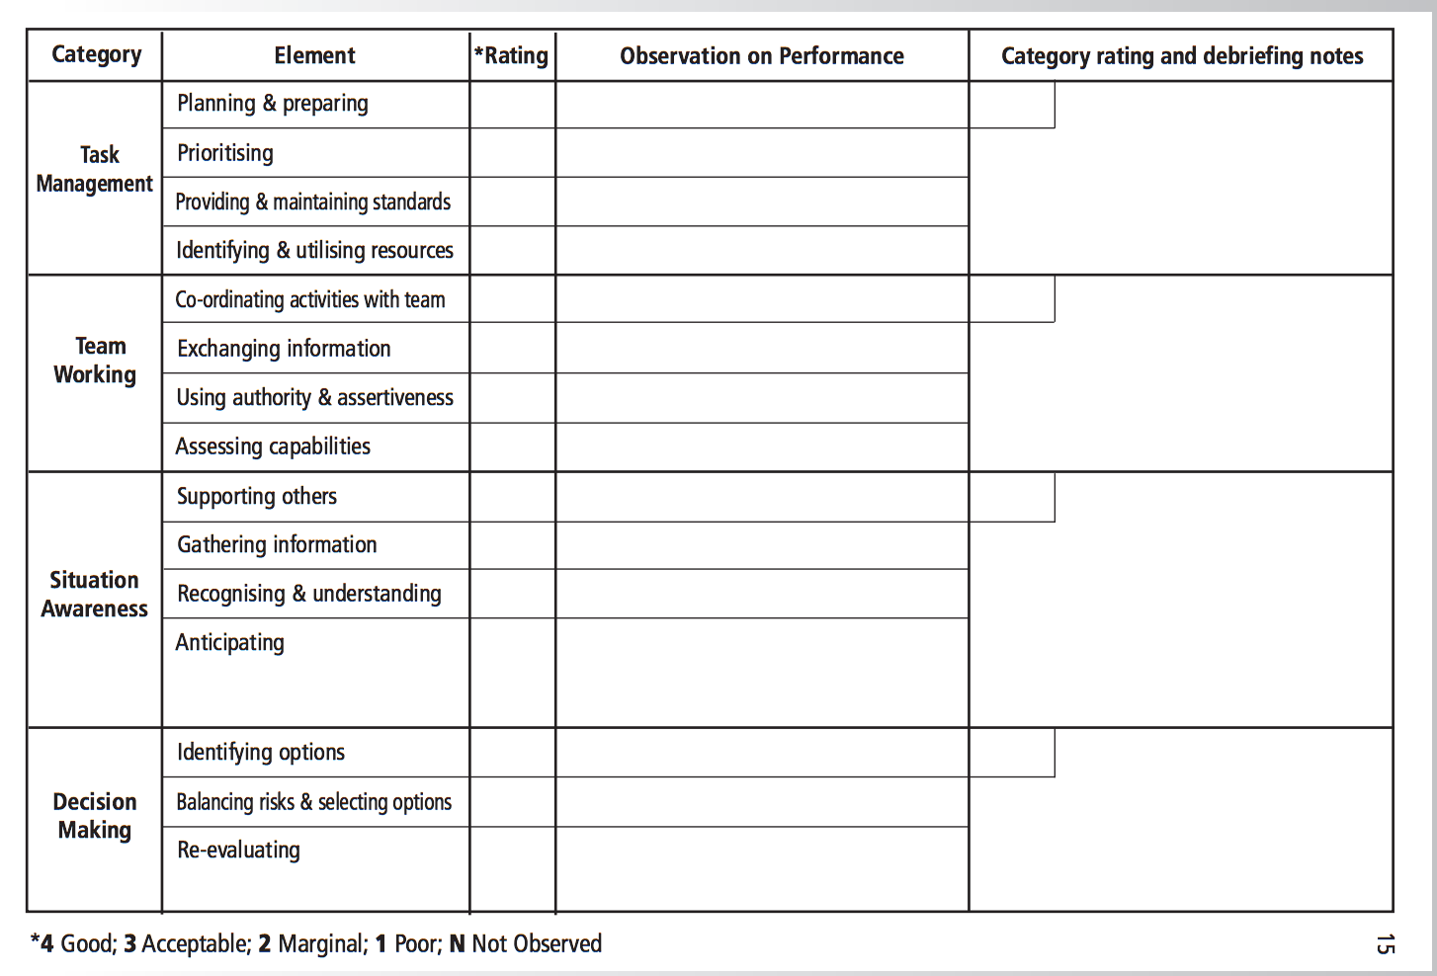
APPENDIX H
ANESTHETISTS NON-TECHNICAL SKILLS (ANTS) SCORING

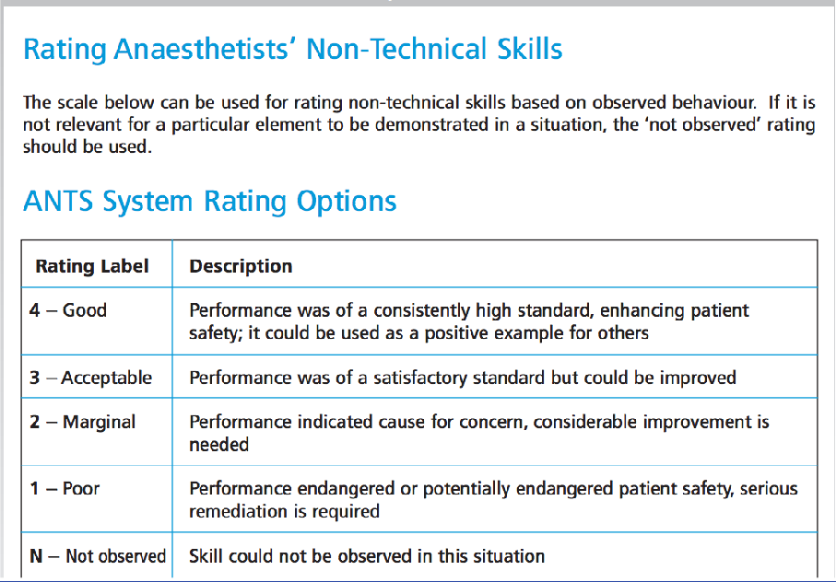

APPENDIX I
MAYO HIGH PERFORMANCE TEAM SCORE – plus DEBRIEFING
