Supporting Information
Figure S1: Backbone r.m.s.d. of the TRY1-TRY1 dimer equilibration.

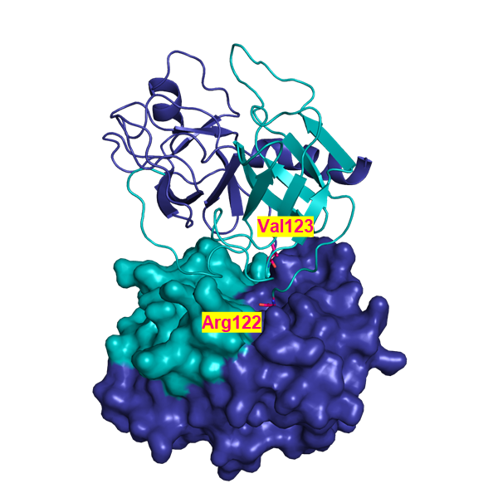
Figure S2: Model of the TRY1 homodimer. TRY1– Arg122 is colored cyan and Val123 is colored in dark-blue. The TRY1 – TRY1 complex shows one monomer in cartoon representation and one in surface representation.

Figure S3: Arg122 – Val123 distance in TRY1 during MDS.

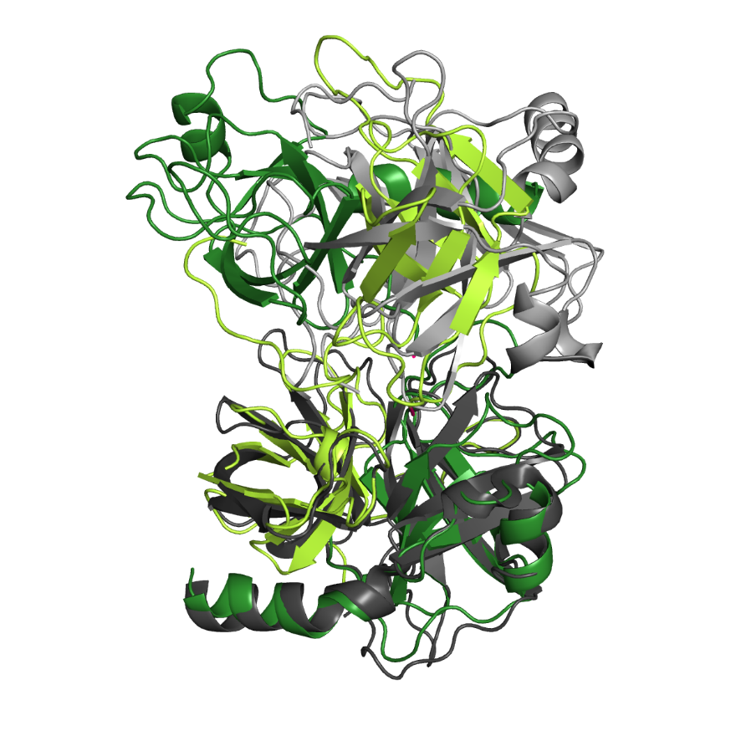
Figure S4: Superposition of the TRY2 – TRY2 and α-CT dimer. The lower chains were superimposed and TRY2 is shown in green and the α-CT dimer is shown in gray. Data from Blevins et al.³²

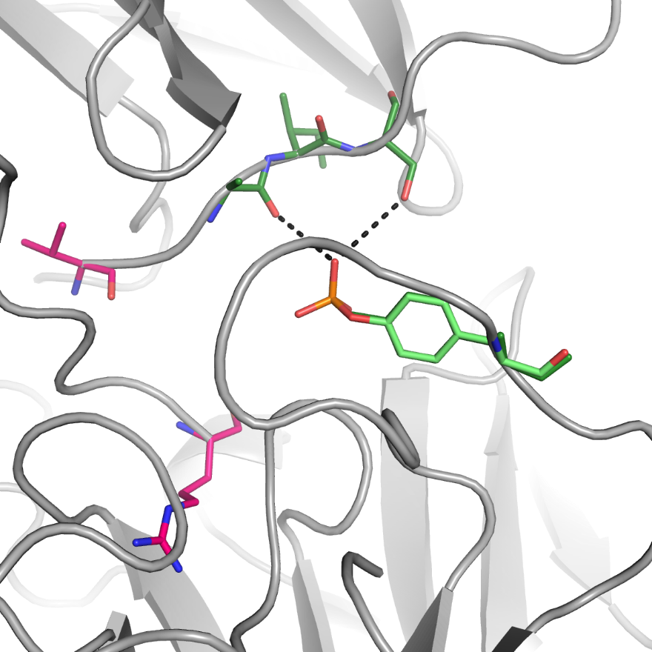
Figure S5: Influence of Tyr154 sulfation. Arg122 and Val123 are highlighted in pink. The sulfate moiety was modeled into the TRY2 structure with the sulfated tyrosine and interacting residues shown in light and dark green, respectively.

