Supplementary Figures
Figure S1. FTIR images of HNTs, PVA, menthol, propranolol HCl and F6, (optimized formulation) were obtained through OMNIC software ver 7.3 (ThermoFisher Scientific, USA)
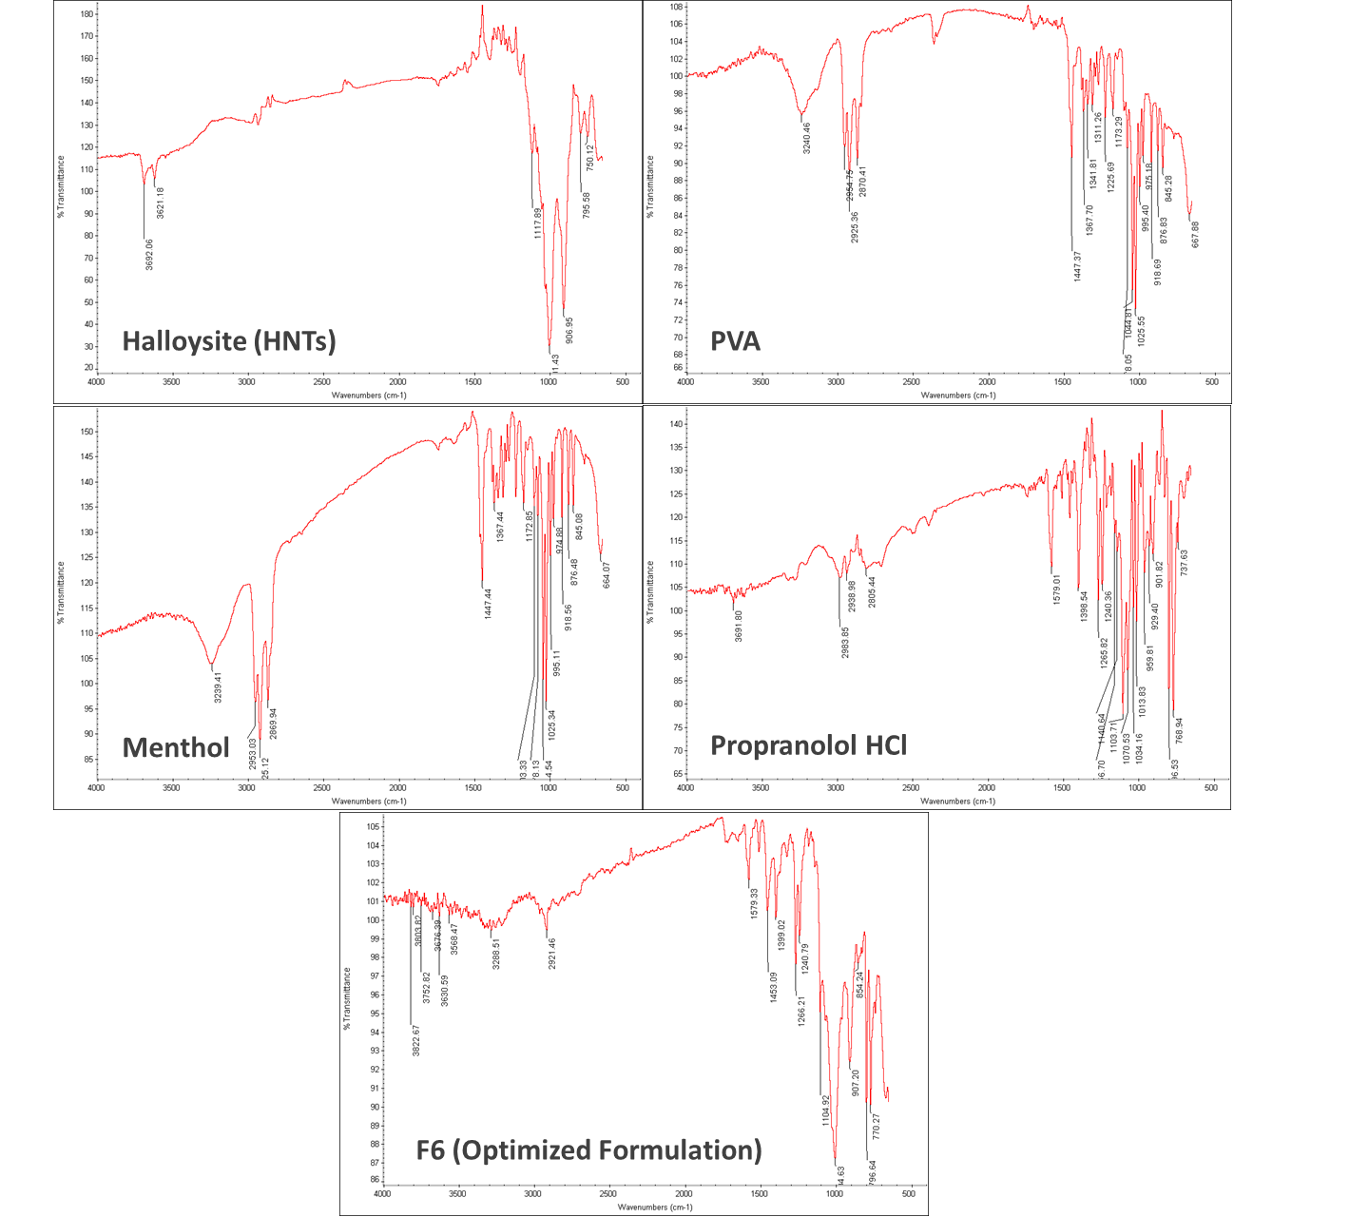
Figure S2. DSC images of HNTs, PVA, PVA-HNTs, propranolol HCl and F6, (optimized formulation) obtained through TRIOS software (TA Instruments, USA)

