Supplement

Tables

Tab. S1: Patient characteristics

 | Vespid stings (n = 170) | Bee stings (n = 25)

Sex
Male All ages | 87 (51.2%) | 10 (40.0%)
< 18 years old | 9 (5.3%) | 3 (12.0%)
Female All ages | 83 (48.8%) | 15 (60.0%)
< 18 years old | 2 (1.2%) | 6 (24.0%)

Age (years)
Median | 46.4 | 36.9
Average | 46.0 | 31.5
Maximum | 74.6 | 61.6
Minimum | 10.1 | 5.6

Tab. S2: Concomitant diseases and comorbidities

 | Vespid stings (n = 170) | Bee stings (n = 25)
Chronic obstructive pulmonary disease (COPD) and/or bronchial asthma | 17 (10.0%) | 1 (4.0%)
Cardiovascular diseases (without arterial hypertension) | 13 (7.6%) | 2 (8.0%)
Arterial hypertension | 36 (21.2%) | 1 (4.0%)
Psychiatric diseases | 3 (1.8%) | 1 (4.0%)
Atopic dermatitis | 4 (2.4%) | 2 (8.0%)
Allergic rhinitis | 36 (21.2%) | 5 (20.0%)
Rheumatic diseases | 1 (0.6%) | 0 (0.0%)
Mastocytosis* | 12 (7.1%) | 0 (0.0%)
Active malignancies | 1 (0.6%)** | 0 (0.0%)
* No differentiation between cutaneous and systemic mastocytosis.
** Malignant melanoma

Tab. S3: Medications prescribed

 | Vespid stings  (n = 170) | Bee stings  (n = 25)
Antihistamines
H₁-blockers | 7 (4.1%) | 1 (4.0%)
Antihypertensives
Beta-blockers | 6 (3.5%) | 0 (0.0%)
Angiotensin-converting enzyme (ACE)-inhibitors | 12 (7.1%) | 0 (0.0%)
Other anti-hypertensive medications | 21 (12.4%) | 0 (0.0%)
Glucocorticoids
Inhaled glucocorticoids | 8 (4.7%) | 1 (4.0%)
Prednisolone equivalents | 0 (0.0%) | 0 (0.0%)
Psychotropic drugs | 3 (1.7%) | 1 (4.0%)

Figures
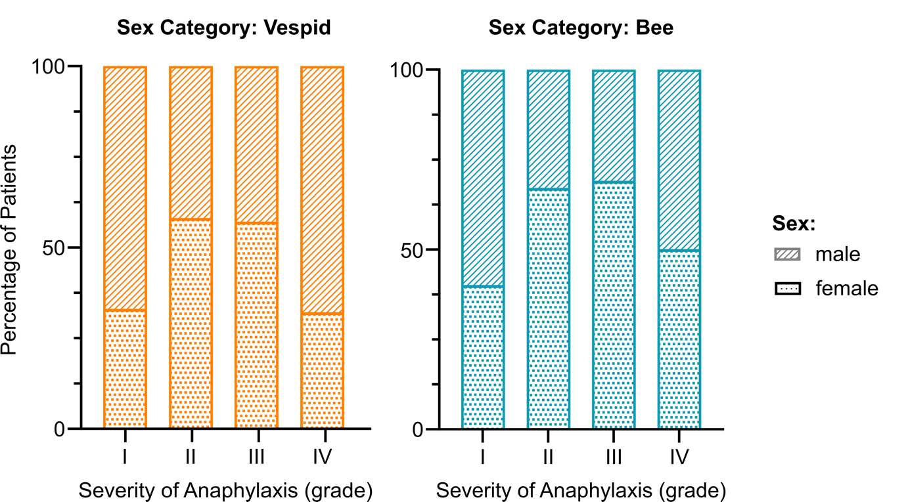
Fig. S1: The severity of anaphylaxis in males versus females. Values on the x-axis are severities of anaphylaxis graded I – IV according to Mueller¹. The percentages of male and female patients are as indicated on the y-axis. Results are shown for both vespid (left, n=169) and bee (right, n=25) venom allergies.

References
1. Mueller HL. Diagnosis and Treatment of Insect Sensitivity. J Asthma Res. 1966;3(4):331-333.

