Supplementary materials

Moderate Intensity Ultrasound-Triggered On-demand Analgesia for Postoperative Pain Management

 | Size | Size distribution | Potential | Loading Efficiency
DMSN-bupi-PFP | 485 nm | 220.2-712.4 nm | -41.14mV | 91%

Table S1. Basic characteristic of DMSN-bupi-PFP.

Figure S1. UV-Vis spectrum of levobupivacaine.

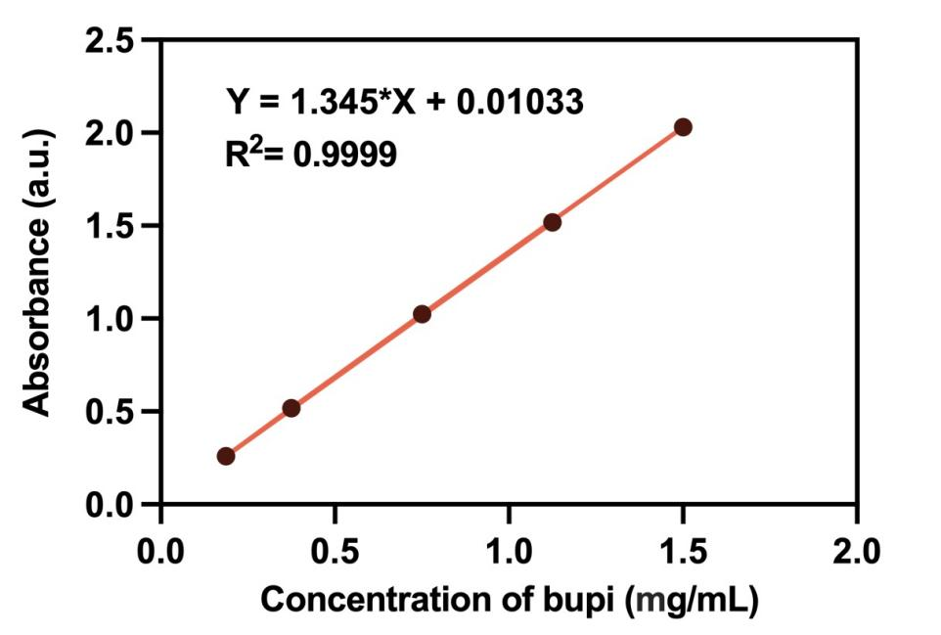
Figure S2. Standard curve of levobupivacaine.
Figure S3. Absorption curve of levobupivacaine, DMSN-PFP, and DMSN-bupi-PFP.

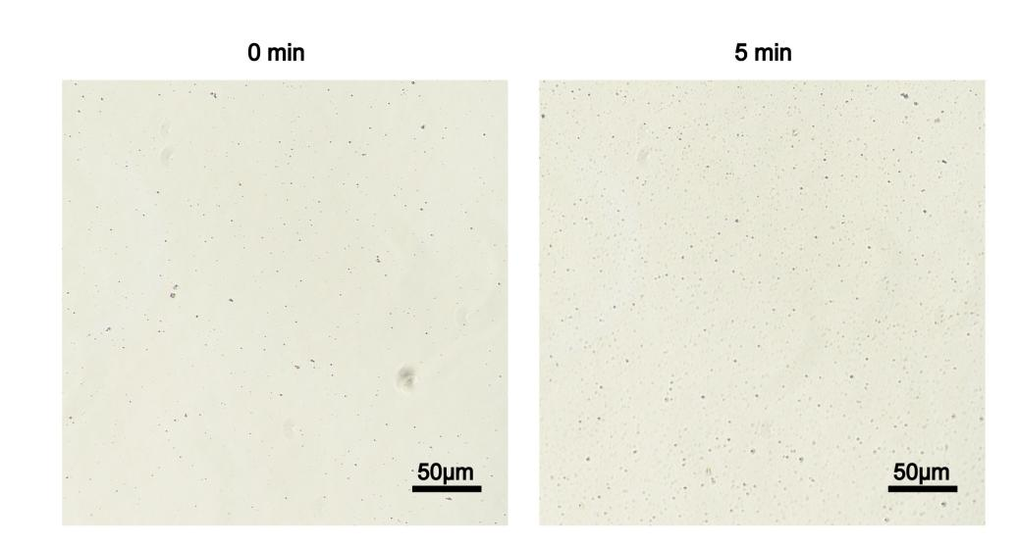
Figure S4. Photograph of DMSN-bupi (A) before and (B) after ultrasound treatment.

