SUPPLEMENTARY MATERIAL
Stability of LNPs in serum conditions
To assess the stability of LNPs in serum conditions, LNP4 was incubated with bovine serum albumin (BSA). BSA solution was prepared in PBS pH 7.4 at 3µM¹. Next, LNPs were incubated with BSA or PBS 7.4 1:9 (v/v) for 1, 3 and 12 at 37 °C. Samples were centrifuged (7800 rpm, 30 min, 20 °C) using 100 kDa centrifugal filters (Amicon) and washed three times with PBS to remove the unbounded BSA². The filtrate was collected to measure BSA concentration using nanodrop. Size and zeta potential of LNPs after filtration were determined by the DLS in 1, 3 and 12h.
Measurements of cardiomyocyte contractility and morphology
To assess contractility and morphology after LNP4 treatment, cardiomyocyte cells were isolated according to the previously described method ³. Briefly, hearts were surgically removed and retrogradely perfused for 12 minutes with Ca²⁺ free modified Tyrode's solution containing collagenase type 2 (1 mg/mL). The ventricular chambers were separated and submitted to mechanical digestion. Ca²⁺ extracellular was gradually added to reach 500 mM. Afterward, the cells were centrifuged and maintained in Tyrode’s solution. A bright-field microscope comprising an incubator (model ChamlideIC-CU: 109, Live Cell Instrument, Nowan-gu, Korea) was used to maintain controlled adult myocytes temperature (37°C) and humidity (60%) levels. Cells were electrically stimulated by platinum electrodes (1Hz,3Hz or 5Hz, 30V) with a 5 ms duration pulse. A high-speed digital CMOS camera (SILICON VIDEO 642M, EPIX, Inc) was used to capture the cellular images at 200 fps, 640x200 pixel resolution, pixel size of 0.25 μm/pixel with a depth of 8 bits. Contraction images were acquired from the cell baseline of each animal and also acutely stimulated with isoproterenol (10⁻⁷ M). The data from cellular contractility was obtained according to the protocol previously described⁴. To acquire the cellular contractility parameters, the images were processed and analyzed by CONTRACTIONWAVE software⁵. Cell morphometry was performed measuring the myocyte area, length, and width on acquired images using ImageJ software.
Histological analysis
The heart was harvested from mice, fixed in 10% buffered formalin for 48h and then processed for paraffin inclusion. Histological sections (um thickness) were stained with hematoxylin and eosin (H&E). Tissue toxicity and inflammatory scoring were assessed based on the following criteria: score 0 = normal tissue (absence of inflammation), score 1 = the inflammatory cells and tissue damage are present in less than 25% of the field of view, score 2 = inflammation and tissue damage involved in 25–50% of the field of view, score 3 = inflammation and tissue damage involved in 50–75% of the field of view, and score 4 = inflammation and tissue damage involved in more than 75% of the field of view ⁶.
Hematological and biochemical parameters
Blood samples were collected from vena cava, 7 days after LNP4 or PBS injection, into EDTA eppendorf tubes to assess hematological parameters via Automated Hematology Analyzer (Nihon Kohden Corporation, Japan). For liver toxicity studies, blood was centrifuged (10.000 rpm, 5 min, 4 °C), and plasma samples from mice treated with LNPs or PBS were collected to assess liver enzyme levels aspartate aminotransferase (AST) and alanine aminotransferase (ALT) using K048 and K049 colorimetric activity assay (Bioclin-Quibasa, Brazil), respectively. Briefly, inactivated plasma was mixed with kit reagents and incubated according to the manufacturer’s recommendations for 4h followed by plate reading at 505 nm (HTS Synergy, Biotek). AST and ALT values were calculated using the absorbance values obtained from the calibration curve prepared and the results were expressed in U/L.
Western blotting Antibodies
Primary antibodies used for Western blotting experiments: SERCA2 (cat. no. sc-376235, RRID: AB_10989947, 1:2000, Santa Cruz Biotechnology), pAKT(Ser473) (cat. no. 4060, RRID: AB_2315049, 1:1000, Cell Signaling), AKT (cat. no. sc-1619, RRID: AB_671713, 1:1000, Santa Cruz Biotechnology), pERK1/2 (cat. no. 4370, RRID: AB_2315112, 1:1000, Cell Signaling), ERK1/2 (cat. no. 9102L, RRID: AB_330744, 1:1000, Cell Signaling) and GAPDH (cat. no. sc-32233, RRID: AB_627679, 1:3,000; Santa Cruz Biotechnology).

Figure S1. The size, zeta potential and amount of BSA adsorbed in LNP4. (A) The average size of LNP4 before and after incubation of BSA 0,3 µM for 1, 3 and 12 h. (B) Zeta potential of LNP4 before and after incubation of BSA 0,3 MM for 1, 3 and 12 h. (C) Percentage for BSA adsorbed on LNP4 surface after 1, 3 and 12 h of incubation at 37 °C. Data are expressed as mean ± SEM. *p< 0.05, ** p< 0.01. Statistics analysis was performed by Brown-Forsythe and Welch ANOVA with multiple comparisons, followed by Tukey post-hoc test.
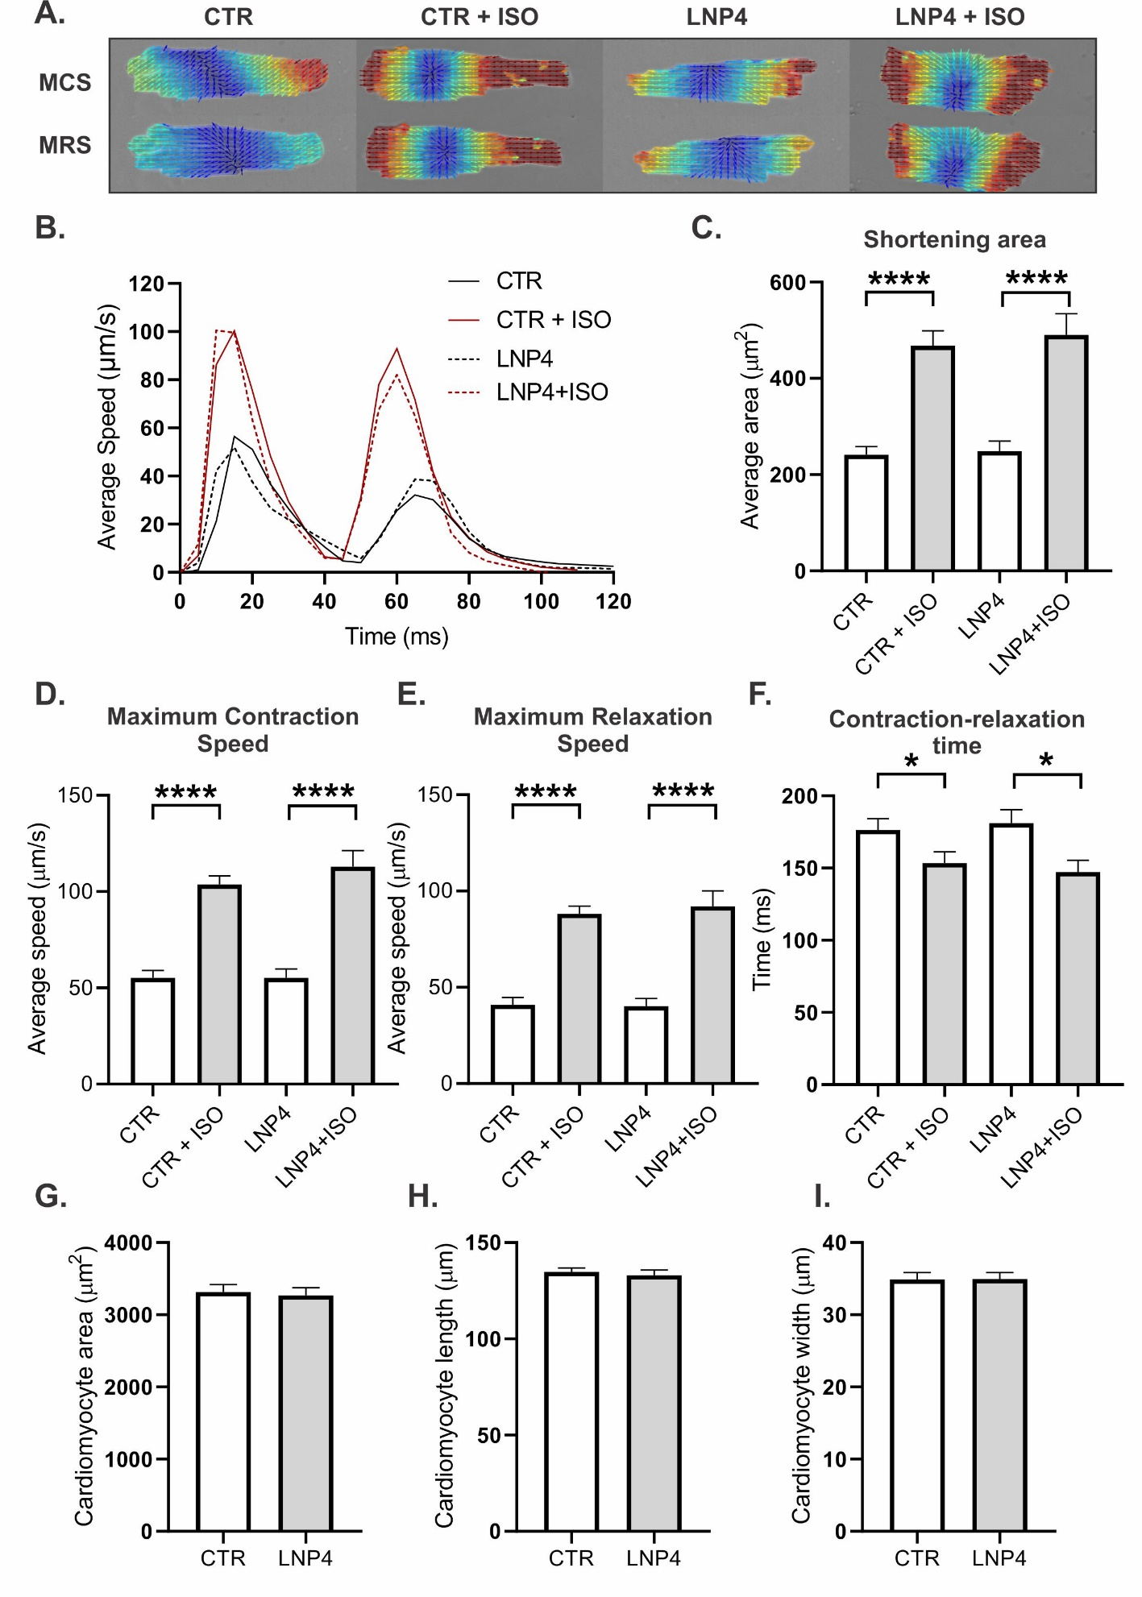
Figure S2. LNP4 does not have an influence on the contractility function at the cellular level even after isoproterenol-induced stress. (A) Isolated ventricular cardiomyocyte morphology and cell displacement speed displayed in magnitude and vector fields during maximum contraction speed (MCS) and maximum relaxation speed (MRS) from the heart of mice treated with either control or LNP4 formulation and incubated or not with isoproterenol and control group. (B) Contraction-relaxation cycle of baseline groups and treated with isoprenaline. (C) Myocyte baseline and isoprenaline-stimulated (10⁻⁷ M) values of shortening area, (D) maximum contraction speed (E), maximum relaxation speed, and (F) contraction-relaxation time. (G) Quantitative morphological analysis of cardiomyocyte area, (H) length, (I), and width. Data are expressed as mean ± SEM from an average of 30 cells from each experimental group. *p<0.05, ****p<0.0001 stressed versus unstressed corresponded group and Oneway ANOVA, followed by Tukey post hoc test.
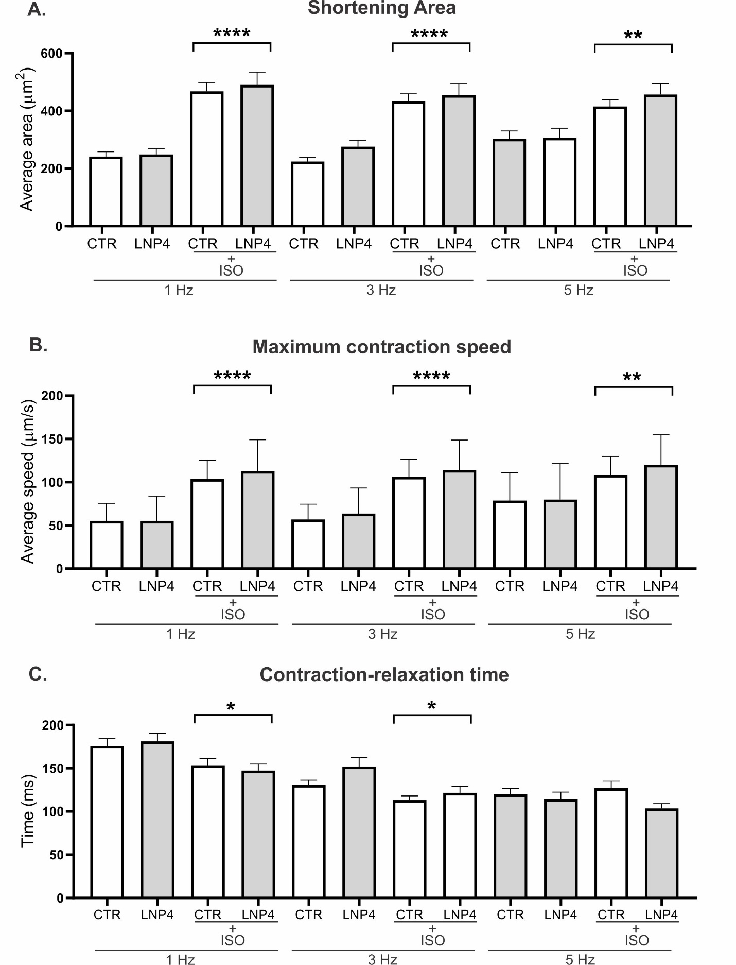
Figure S3. LNP4 does not influence contractility function at the cellular level even after isoproterenol-induced stress and progressive increase in the frequency of cell contraction. Bar graph showing the contractility parameters of cardiac myocytes stimulated with isoproterenol at different rates pacing for (A) shortening area (B) maximum contraction speed (C) contraction-relaxation time. Data were plotted as mean ± SEM. *p<0.05, **p<0.01, ****p<0.0001 stressed versus unstressed corresponded group, and Oneway ANOVA, followed by Tukey post hoc test.
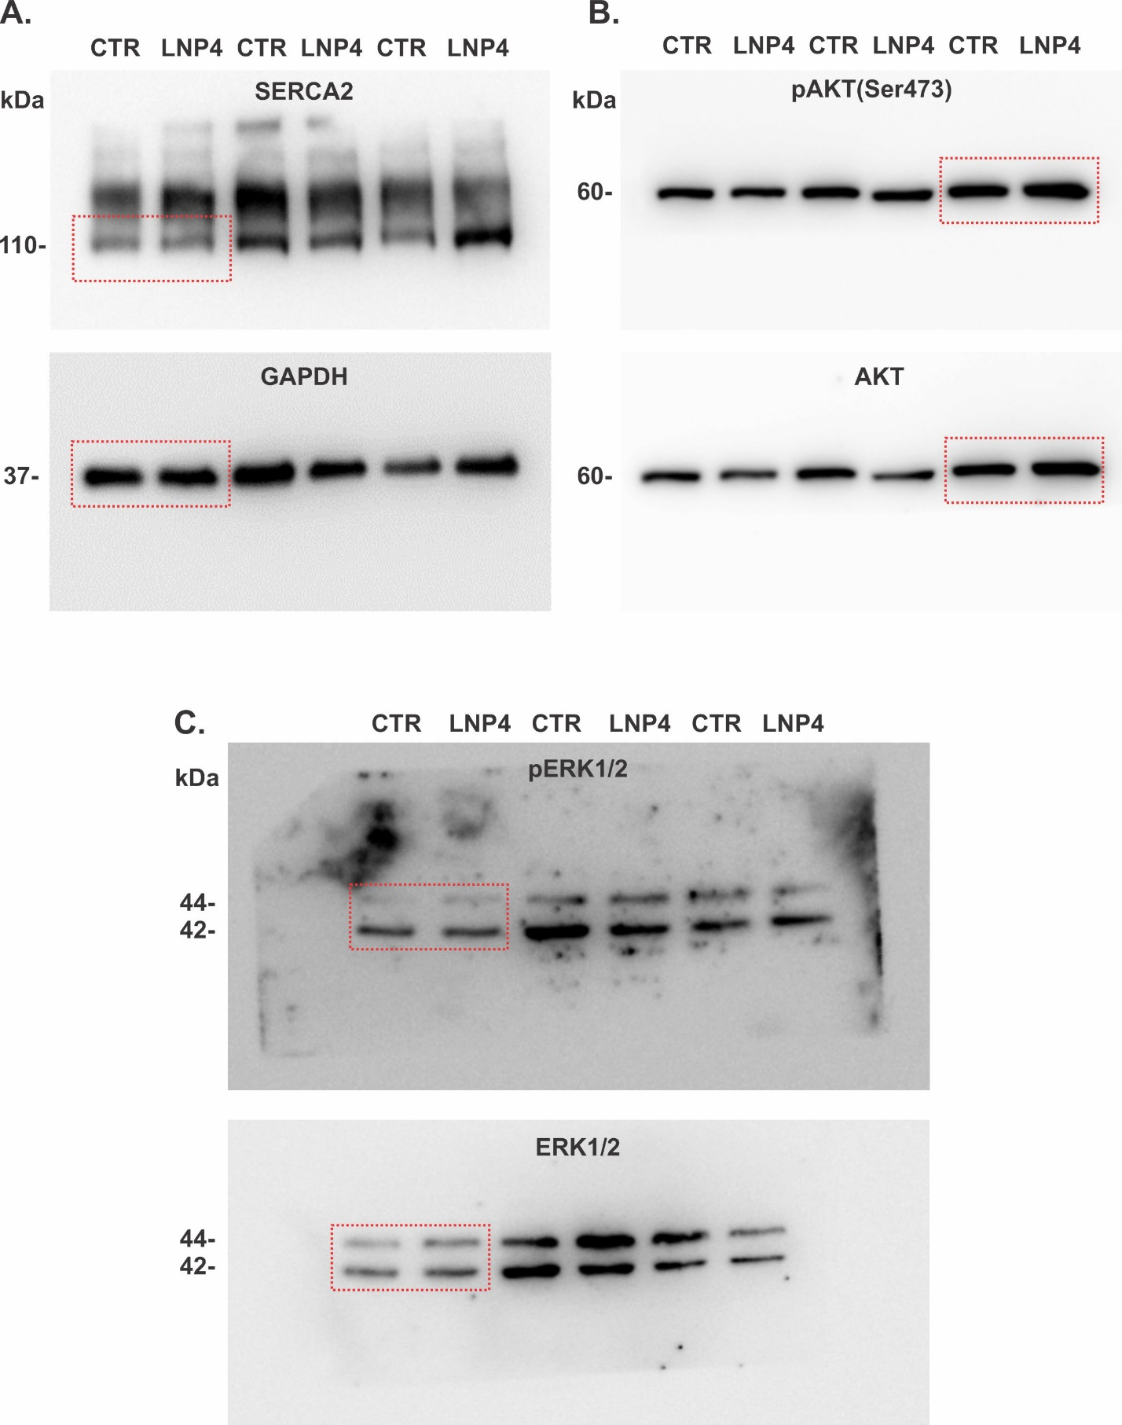
Figure S4. Western blot images and their representative bands (red dashed square) in Figure 7A-C.
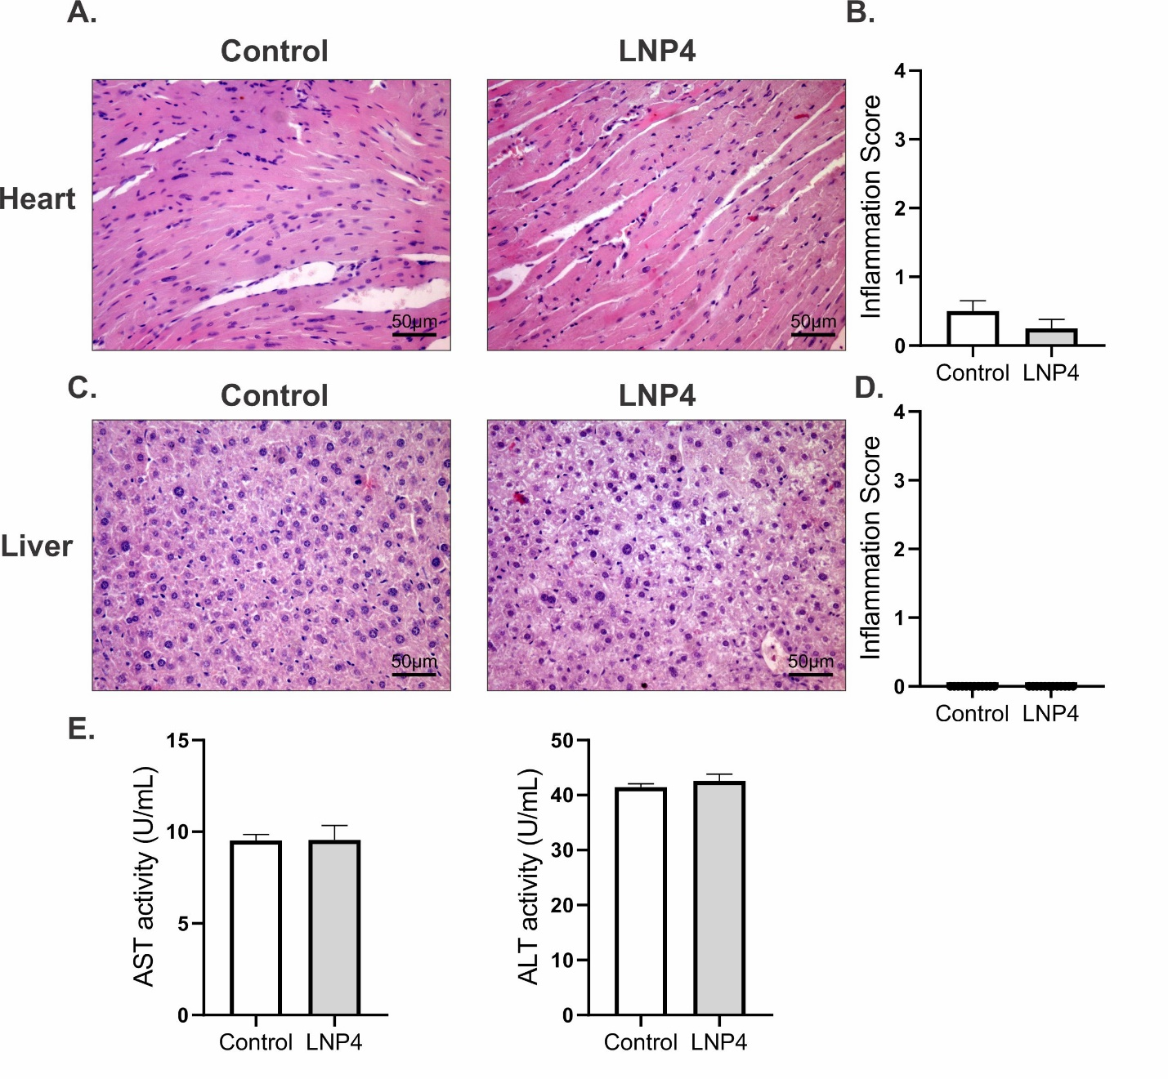
Figure S5. Evaluation of tissue and systemic toxicity following LNP4 injection. (A,C) Representative images of H&E staining of heart and liver from mice treated with LNP4 or PBS (Control) at × 400 magnification. (A) Heart section with normal heart architecture without any necrosis or infiltration of leukocytes for both LNP4 and PBS (Control) groups. (B) Scoring for inflammatory changes in the heart. (C) Liver section showing normal hepatic architecture, without any necrosis or infiltration of leukocytes for both LNP4 and PBS (Control) groups. (D) Scoring for inflammatory changes in the liver. (E) Measures of AST or ALT from serum 7 days following injection. Data were plotted as mean ± SEM. Statistics were performed by t-test.
Table S1: Influence of LNP on hematological parameters 7 days post injection in mice

Group | RBC  (10⁶/µL) | WBC  (10⁹/L) | Platelet count  (10⁹/L) | Lymphocytes  (10⁶/µL)
CTR | 7.98±0.67 | 10.05±3.89 | 577.5±4.95 | 4.18±3.14
LNP4 | 8.05±0.85 | 7.35±2.95 | 671.0±156.7 | 3.65±1.94
Abbreviations: LNP: ionizable lipid-nanoparticles; CTR: control; RBC: red blood cell; WBC: white blood cell. The results are expressed mean ± std. deviation for 4 animals and analyzed by one-way ANOVA followed by Welch’s t post hoc test.

References

1. Yu M, Ding Z, Jiang F, et al. Analysis of binding interaction between pegylated puerarin and bovine serum albumin by spectroscopic methods and dynamic light scattering. Spectrochimica Acta Part A: Molecular and Biomolecular Spectroscopy. 2011;83(1):453-460. doi:10.1016/j.saa.2011.08.065
2. Wang W, Huang Z, Li Y, et al. Impact of particle size and pH on protein corona formation of solid lipid nanoparticles: A proof-of-concept study. Acta Pharmaceutica Sinica B. 2021;11(4):1030-1046. doi:10.1016/j.apsb.2020.10.023
3. Guatimosim S, Sobie EA, Dos J, et al. Molecular identification of a TTX-sensitive Ca(2+) current. 2001;21201:1327-1339.
4. Scalzo S, Mendonça CATF, Kushmerick C, Agero U, Guatimosim S. Microscopy-based cellular contractility assay for adult, neonatal, and hiPSC cardiomyocytes. STAR Protocols. 2022;3(1):101144. doi:10.1016/j.xpro.2022.101144
5. Scalzo S, Afonso MQL, da Fonseca NJ, et al. Dense optical flow software to quantify cellular contractility. Cell Reports Methods. 2021;1(4):100044. doi:10.1016/j.crmeth.2021.100044
6. Ranneh Y, Akim AMd, Hamid HAb, et al. Induction of Chronic Subclinical Systemic Inflammation in Sprague–Dawley Rats Stimulated by Intermittent Bolus Injection of Lipopolysaccharide. Archivum Immunologiae et Therapiae Experimentalis. 2019;67(6):385-400. doi:10.1007/s00005-019-00553-6

