Figure S1. The web-based calculator for predicting the probability of post-hepatectomy liver failure
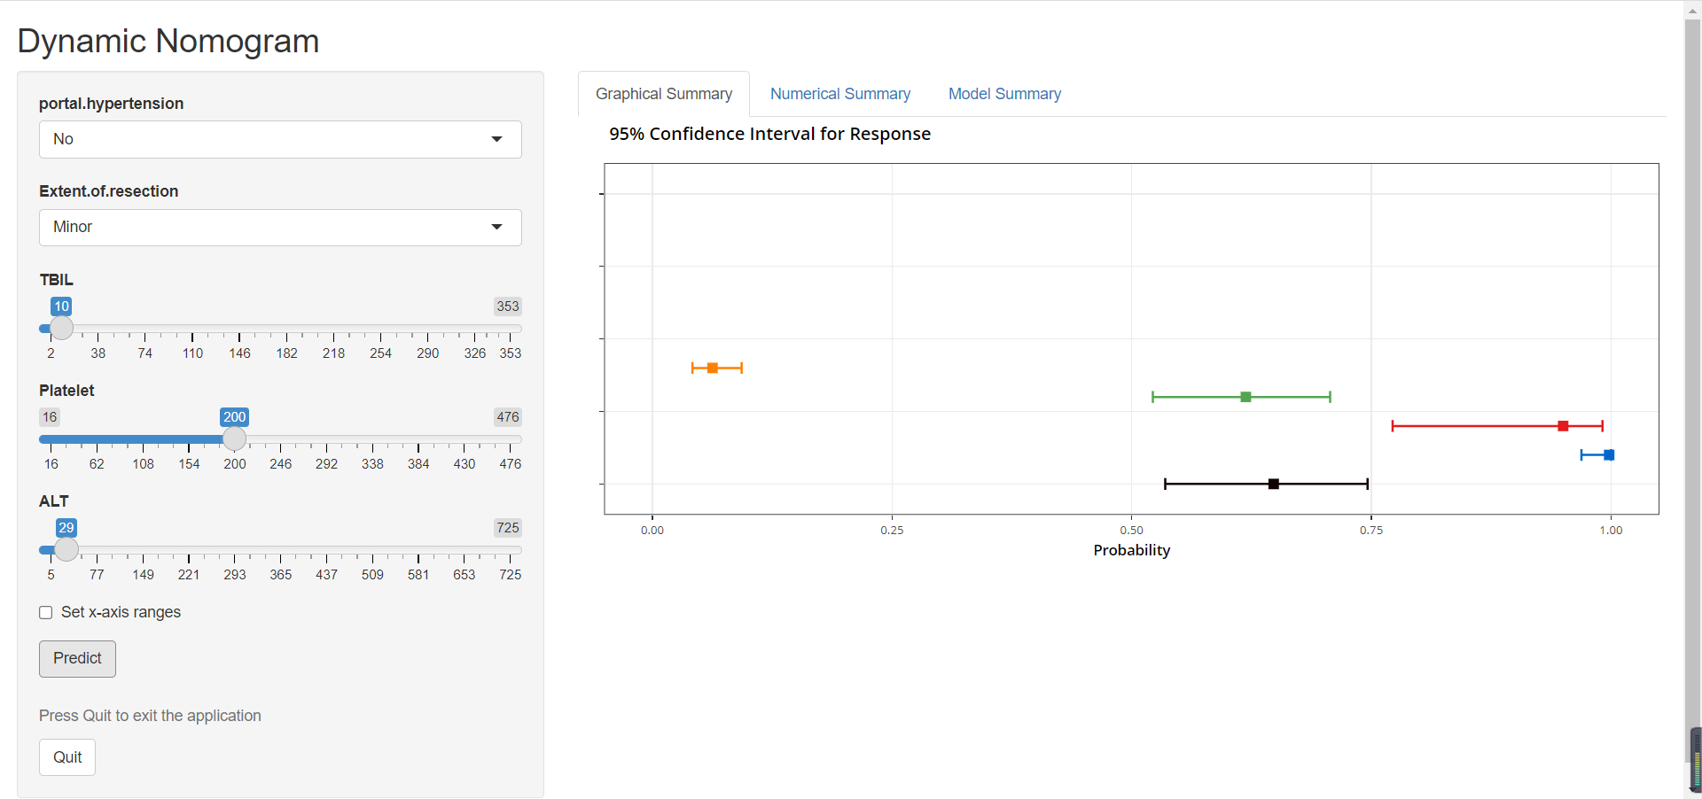
Figure S2. The web-based calculator for predicting the probability of post-hepatectomy liver failure class B+C.

