SUPPLEMENTAL MATERIAL

Modified Citrus Pectin Alleviates Cerebral Ischemia/Reperfusion Injury by Inhibiting NLRP3 Inflammasome Activation via TLR4/NF-ĸB Signaling Pathway in Microglia

Yu Cui, Nan-Nan Zhang, Dan Wang, Wei-Hong Meng, Hui-Sheng Chen

Supplemental Tables

Supplemental Figures

Supplemental Tables
Table 1. ARRIVE guideline checklist.
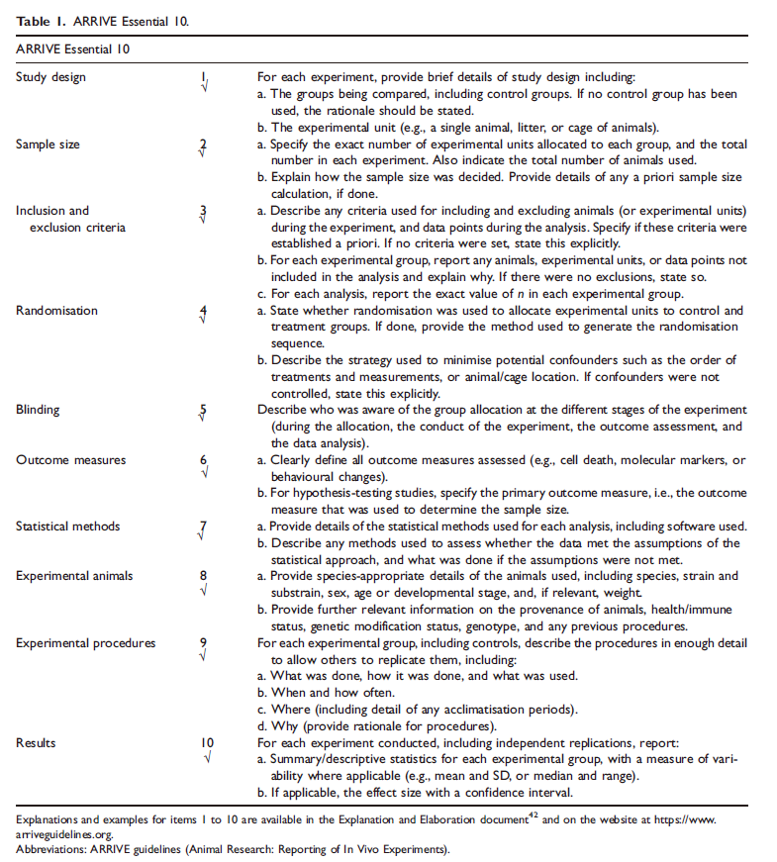
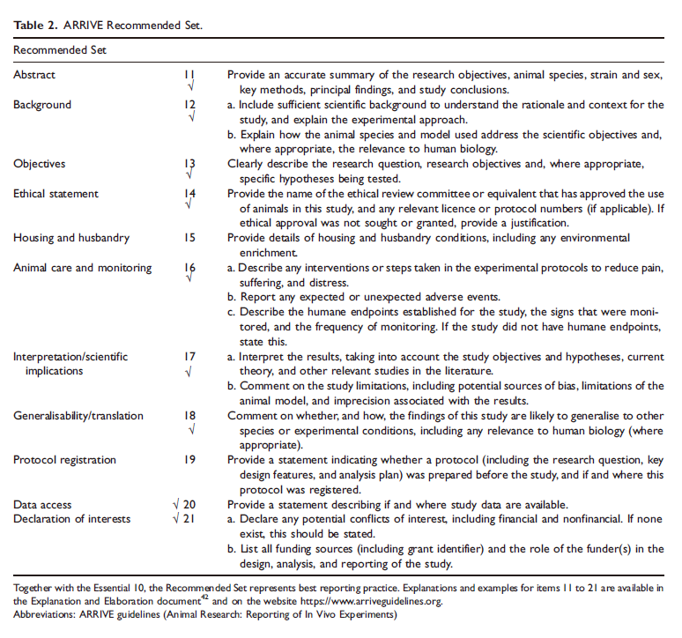

Table 2 The number of C57BL/6J mice used in the animal experiment.
Groups | Sham  +  Vehicle | MCAO/R  +  Vehicle | MCAO/R  +  MCP 200 mg/kg/d | MCAO/R  +  MCP 400 mg/kg/d | MCAO/R  +  MCP 800 mg/kg/d
Mice in each group | 9 | 18 | 18 | 18 | 18
Failed to establish model | 0 | 3 | 2 | 5 | 2
Dead | 0 | 6 | 7 | 4 | 7
Neurological deficit scoring | 9 | 9 | 9 | 9 | 9
Infarction size (TTC staining)  Brain water content | 3 | 3 | 3 | 3 | 3
Immunohistochemistry | 3 | 3 | 3 | 3 | 3
Western blot assays | 3 | 3 | 3 | 3 | 3
MCAO/R indicates middle cerebral artery occlusion/reperfusion; MCP, modified citrus pectin; TTC, 2,3,5-triphenyltetrazolium chloride.

Table 3. Numerical data for MCP pretreatment with 7 days showing effects of MCP on neurological deficit scoring and infarction size of C57BL/6J mice at 1 day after MCAO/R operation in the preliminary study.
Group | Number of animals | Neurological deficit scoring | Infarction size
MCAO/R + Vehicle | 1 | 3 | 54.83%
MCAO/R + 200 mg/kg/d MCP | 1 | 2 | 34.34%
MCAO/R + 400 mg/kg/d MCP | 1 | 2 | 32.22%
MCAO/R + 800 mg/kg/d MCP | 1 | 1 | 12.02%
MCAO/R indicates middle cerebral artery occlusion/reperfusion; MCP, modified citrus pectin.
Table 4. Numerical data for MCP treatment with 7 days showing effects of MCP on neurological deficit scoring of C57BL/6J mice at 7 day after MCAO/R operation in the preliminary study.
Group | Number of animals | Neurological deficit scoring
Group | Number of animals | Day 1 | Day 3 | Day 5 | Day 7
MCAO/R + Vehicle | 3 | 2.83 | 2.33 | 2.17 | 1.67
MCAO/R + 200 mg/kg/d MCP | 3 | 2.67 | 2.33 | 2.17 | 1.50
MCAO/R + 400 mg/kg/d MCP | 3 | 2.50 | 2.33 | 1.83 | 1.17
MCAO/R + 800 mg/kg/d MCP | 3 | 2.50 | 2.00 | 1.17 | 0.67
MCAO/R indicates middle cerebral artery occlusion/reperfusion; MCP, modified citrus pectin.
Table 5. Numerical data for selection of optimal concentration for MCP in both HT-22 and BV-2 cells through CCK-8 assays in the preliminary study.
Group | HT-22 cells |  | BV-2 cells
Group | Number of cells | Cell viability | Number of cells | Cell viability
OGD/R | 5 | 100%±0.00% | 5 | 100%±0.00%
OGD/R + 0.1 g/L MCP | 5 | 104.38%±14.32% | 5 | 102.72%±28.81%
OGD/R + 0.2 g/L MCP | 5 | 105.04%±11.97% | 5 | 106.30%±23.87%
OGD/R + 0.5 g/L MCP | 5 | 114.97%±24.64% | 5 | 101.29%±14.52%
OGD/R + 1 g/L MCP | 5 | 113.47%±11.19% | 5 | 112.94%±20.87%*
OGD/R + 2 g/L MCP | 5 | 121.11%±19.33% | 5 | 125.86%±37.86%*
OGD/R + 5 g/L MCP | 5 | 119.73%±9.86% | 5 | 130.93%±26.06%*
OGD/R + 10 g/L MCP | 5 | 122.49%±23.05% | 5 | 133.25%±31.08%*
OGD/R indicates oxygen-glucose deprivation/reperfusion; MCP, modified citrus pectin.*, compared with OGD/R group, the change of cell viability showed significant difference with P value < 0.05.
Table 6. Numerical data for selection of optimal time for OGD in both HT-22 and BV-2 cells through CCK-8 assays in the preliminary study.
Group | HT-22 cells |  | BV-2 cells
Group | Number of cells | Cell viability | Number of cells | Cell viability
OGD 0h | 5 | 100%±0.00% | 5 | 100%±0.00%
OGD 2h | 5 | 101.78%±16.25% | 5 | 99.58%±20.53%
OGD 4h | 5 | 90.58%±14.31% | 5 | 84.67%±18.55%
OGD 6h | 5 | 85.37%±9.21%* | 5 | 70.40%±14.79%*
OGD 8h | 5 | 69.23%±11.55%* | 5 | 62.96%±7.30%*
OGD indicates oxygen-glucose deprivation. *, compared with OGD 0h group, the change of cell viability showed significant difference with P value < 0.05.

Table 7. Numerical data for MCP pretreatment with 7 days showing effects of MCP on neurological deficit scoring, brain water content and infarction size of C57BL/6J mice at 1 day after MCAO/R operation.
Group | Neurological deficit scoring | Brain water content | Infarction size
Number of animals per group | 9 | 3 | 3
Sham + Vehicle | 0.00±0.00 | 78.87%±0.71% | 0.00%±0.00%
MCAO/R + Vehicle | 2.67±0.50 | 83.90%±0.46% | 62.76%±12.18%
MCAO/R + 200 mg/kg/d MCP | 2.56±0.53 | 81.94%±1.05% | 40.35%±1.56%
MCAO/R + 400 mg/kg/d MCP | 1.89±0.33 | 81.69%±1.04% | 29.89%±8.47%
MCAO/R + 800 mg/kg/d MCP | 1.11±0.60 | 80.97%±0.94% | 20.45%±5.94%
MCAO/R indicates middle cerebral artery occlusion/reperfusion; MCP, modified citrus pectin.
Table 8. Numerical data for MCP pretreatment with 7 days showing effects of MCP on TUNEL and FJB positive cells counts per mm² of C57BL/6J mice at 1 day after MCAO/R operation.
Group | Number of animals | TUNEL⁺ cells counts | FJB⁺ cells counts
Sham + Vehicle | 3 | 59±21 | 0±0
MCAO/R + Vehicle | 3 | 795±96 | 1100±228
MCAO/R + 200 mg/kg/d MCP | 3 | 516±70 | 571±89
MCAO/R + 400 mg/kg/d MCP | 3 | 365±57 | 352±55
MCAO/R + 800 mg/kg/d MCP | 3 | 247±36 | 142±21
MCAO/R indicates middle cerebral artery occlusion/reperfusion; MCP, modified citrus pectin; TUNEL, Terminal-deoxynucleotidyl Transferase Mediated Nick End Labeling; FJB, Fluoro-Jade B.
Table 9. Numerical data for MCP attenuated neuronal cell viability, injury, and apoptosis in OGD/R model.
Group | Number of cells | Cell viability | LDH activity | Cell apoptosis
Control | 5 | 100%±0.00% | 80.661±4.892 | 3.38%±0.45%
OGD/R | 5 | 80.75%±8.20% | 310.413±6.942 | 14.34%±2.72%
OGD/R + 1 g/L MCP | 5 | 87.30%±13.88% | 275.702±3.967 | 10.06%±1.21%
OGD/R + 2 g/L MCP | 5 | 92.91%±11.98% | 239.339±2.496 | 7.45%±0.26%
OGD/R + 4 g/L MCP | 5 | 94.09%±16.55% | 161.653±4.545 | 7.15%±0.22%
OGD/R indicates oxygen-glucose deprivation/reperfusion; MCP, modified citrus pectin.
Table 10. Numerical data for MCP attenuated neuronal cell viability, injury, and apoptosis in OGD/R model and supernatant .
Group | Number of cells | Cell viability | LDH activity | Cell apoptosis
Control | 5 | 100%±0.00% | 85.289±2.624 | 6.71%±0.06%
OGD/R | 5 | 49.91%±5.19% | 422.810±4.472 | 29.10%±1.94%
OGD/R + 1 g/L MCP | 5 | 56.57%±9.69% | 416.198±3.188 | 22.16%±3.44%
OGD/R + 2 g/L MCP | 5 | 64.08%±11.92% | 384.463±4.472 | 18.32%±0.41%
OGD/R + 4 g/L MCP | 5 | 77.41%±17.05% | 338.843±3.188 | 15.59%±0.27%
OGD/R indicates oxygen-glucose deprivation/reperfusion; MCP, modified citrus pectin.
Table 11. Numerical data for MCP treatment reduced the co-expression of NLRP3 and Iba1 in C57BL/6J mice at 1 day after MCAO/R operation.
Group | Number of animals | NLRP3⁺ and Iba1⁺ cells counts per mm²
Sham + Vehicle | 3 | 18±8
MCAO/R + Vehicle | 3 | 87±16
MCAO/R + 200 mg/kg/d MCP | 3 | 73±16
MCAO/R + 400 mg/kg/d MCP | 3 | 64±16
MCAO/R + 800 mg/kg/d MCP | 3 | 32±8
MCAO/R indicates middle cerebral artery occlusion/reperfusion; MCP, modified citrus pectin; NLRP3, NOD-like receptor 3.

Table 12. Numerical data for effects of MCP on NLRP3, cleaved-caspase-1/caspase-1, and IL-1β after MCAO/R injury.
Group | Number of animals | NLRP3 | Cleaved-caspase-1 | Caspase-1 | IL-1β
Sham + Vehicle | 3 | 1.00±0.00 | 1.00±0.00 | 1.00±0.00 | 1.00±0.00
MCAO/R + Vehicle | 3 | 5.77±1.12 | 6.98±1.91 | 1.06±0.23 | 3.10±0.58
MCAO/R + 200 mg/kg/d MCP | 3 | 3.90±1.09 | 5.12±1.11 | 1.10±0.06 | 2.67±0.69
MCAO/R + 400 mg/kg/d MCP | 3 | 2.66±0.40 | 2.95±0.34 | 1.05±0.05 | 1.82±0.23
MCAO/R + 800 mg/kg/d MCP | 3 | 1.60±0.38 | 1.49±0.92 | 1.04±0.12 | 1.44±0.40
MCAO/R indicates middle cerebral artery occlusion/reperfusion; MCP, modified citrus pectin; NLRP3, NOD-like receptor 3.
Table 13. Numerical data for effects of MCP on NLRP3, cleaved-caspase-1/caspase-1, and IL-1β in BV-2 cells after OGD/R.
Group | Number of cells | NLRP3 | Cleaved-caspase-1 | Caspase-1 | IL-1β
Control | 5 | 1.00±0.00 | 1.00±0.00 | 1.00±0.00 | 1.00±0.00
OGD/R | 5 | 4.26±0.33 | 4.49±1.07 | 0.96±0.09 | 4.83±0.87
OGD/R + 1 g/L MCP | 5 | 3.42±0.26 | 3.36±0.49 | 1.03±0.01 | 3.12±0.74
OGD/R + 2 g/L MCP | 5 | 2.36±0.53 | 2.34±0.45 | 1.03±0.02 | 2.46±0.54
OGD/R + 4 g/L MCP | 5 | 1.46±0.29 | 1.59±0.25 | 1.04±0.04 | 1.23±0.35
OGD/R indicates oxygen-glucose deprivation/reperfusion; MCP, modified citrus pectin; NLRP3, NOD-like receptor 3.
Table 14. Numerical data for MCP treatment reduced the co-expression of galectin-3 and Iba1 in C57BL/6J mice at 1 day after MCAO/R operation.
Group | Number of animals | Galectin-3⁺ and Iba1⁺ cells counts per mm²
Sham + Vehicle | 3 | 0±0
MCAO/R + Vehicle | 3 | 110±14
MCAO/R + 200 mg/kg/d MCP | 3 | 82±14
MCAO/R + 400 mg/kg/d MCP | 3 | 55±14
MCAO/R + 800 mg/kg/d MCP | 3 | 46±8
MCAO/R indicates middle cerebral artery occlusion/reperfusion; MCP, modified citrus pectin.
Table 15. Numerical data for effects of MCP on TLR4, NF-κB p65, and galectin-3 in cerebral cortex after MCAO/R injury.
Group | Number of animals | Galectin-3 | TLR4 | NF-κB
Sham + Vehicle | 3 | 1.00±0.00 | 1.00±0.00 | 1.00±0.00
MCAO/R + Vehicle | 3 | 5.64±0.59 | 5.76±1.43 | 1.96±0.19
MCAO/R + 200 mg/kg/d MCP | 3 | 3.70±0.66 | 4.88±1.48 | 1.61±0.44
MCAO/R + 400 mg/kg/d MCP | 3 | 2.48±0.40 | 3.31±0.95 | 1.26±0.25
MCAO/R + 800 mg/kg/d MCP | 3 | 1.45±0.20 | 1.73±0.67 | 1.09±0.05
MCAO/R indicates middle cerebral artery occlusion/reperfusion; MCP, modified citrus pectin.
Table 16. Numerical data for effects of MCP on TLR4, NF-κB p65, and galectin-3 in BV-2 cells after OGD/R injury.
Group | Number of cells | Galectin-3 | TLR4 | NF-κB
Control | 5 | 1.00±0.00 | 1.00±0.00 | 1.00±0.00
OGD/R | 5 | 5.68±0.24 | 5.76±1.98 | 2.36±0.43
OGD/R + 1 g/L MCP | 5 | 3.78±0.84 | 4.36±1.21 | 2.08±0.36
OGD/R + 2 g/L MCP | 5 | 2.33±0.16 | 3.35±0.98 | 1.60±0.23
OGD/R + 4 g/L MCP | 5 | 1.34±0.25 | 2.20±0.81 | 1.19±0.16
OGD/R indicates oxygen-glucose deprivation/reperfusion; MCP, modified citrus pectin.

Supplemental Figures

