Supplementary Data

Identification of drug combination therapies for SARS-CoV-2: A molecular dynamics simulations approach

Heba Abdel-Halim^{1†●}, Malak Hajar^{1†}, Luma Hasouneh^{1†}, Suzanne M. A Abdelmalek^{2†*}

Affiliations:
¹ Department of Medicinal Chemistry, Faculty of Pharmacy and Medical Sciences, University of Petra, Amman, Jordan. ● Dr Abdel-Halim passed away on 14th July 2022.
² Department of Pharmacology and Biomedical Sciences, Faculty of Pharmacy and Medical Sciences, University of Petra, Amman, Jordan.

†These authors contributed equally to this work.

*Correspondence: Suzanne M. A Abdelmalek
ORCID 0000-0001-5401-6532
Department of Pharmacology and Biomedical Sciences
Faculty of Pharmacy and Medical Sciences
University of Petra
P.O. Box 961343, Amman 11196, Jordan
Tel +962-6-5799555 Ext. (8310)
Fax +962-65715570
E mail sabdelmalek@uop.edu.jo

Supplementary data
Binding results of docked compounds in the different identified SARS-CoV-2 main protease (Mpro) binding sites, contact frequency analysis, and hydrogen bond interactions reported during the 100ns long MD simulations.
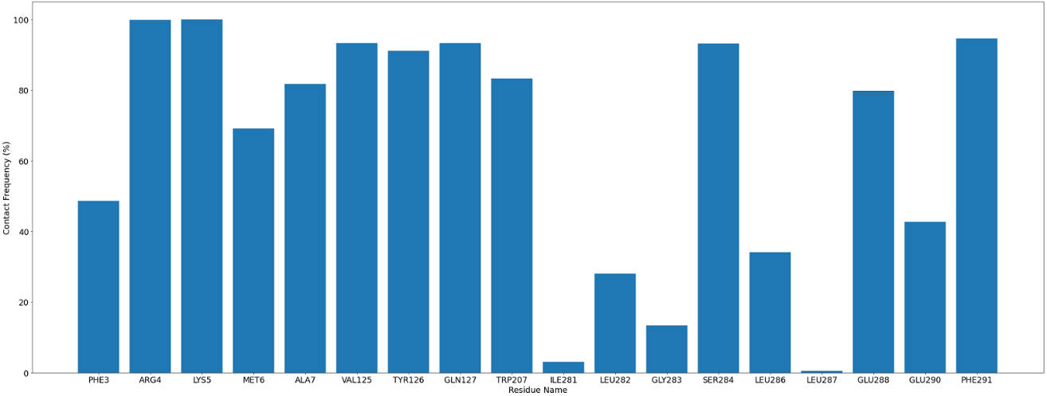
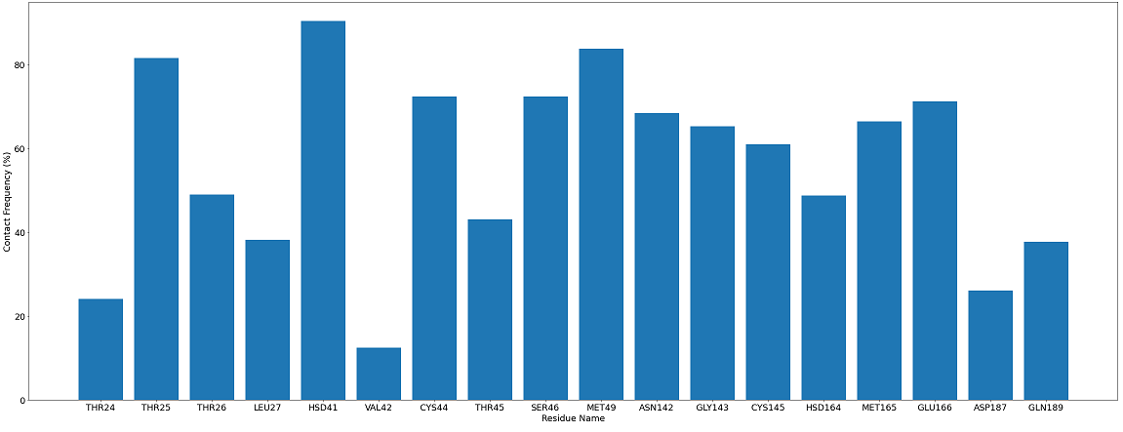

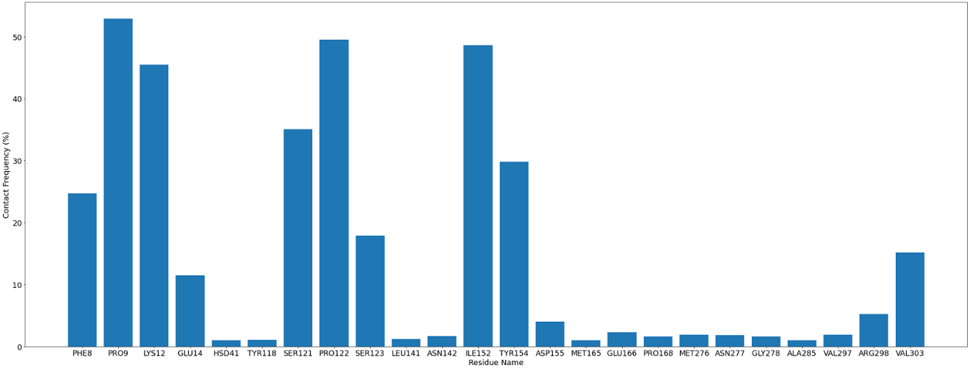
Figure 1S Contact frequency analysis during the 100-ns-long MD simulations for residues belonging to the binding sites defined A: carvedilol in Binding Site 3, B: cefixime in Binding Site 1, and C: favipiravir in In-between Dimer Binding Site of SARS-CoV-2 main protease receptor M^{pro}.
B
A
C

Table 1S Binding results of different compounds in the different identified SARS-CoV-2 main protease (M^{pro}) binding sites.
Docked Compound | Clinical Indication/Use | Chemical Class | Docking Results
Docked Compound | Clinical Indication/Use | Chemical Class | Binding Site 1 | Binding Site 2 | Binding Site 3  (Crystal Site) | Binding Site 4 | In-between Dimer  Binding Site
Abacavir | Anti-HIV | NRTI | ✓ | ✓ | ✓
Abemaciclib | Antitumor | Kinase Inhibitor | ✓
Acadesine | Anti-Ischemic | Imidazole Ribonucleoside | ✓ | ✓ | ✓ |  | ✓
Acalabrutinib | Anticancer | Tyrosine Kinase Inhibitor | ✓
Acebutolol | Antihypertensive | Beta Blocker | ✓ | ✓ | ✓ |  | ✓
Acecarbromal | Hypnotic/Sedative | Ureide | ✓ | ✓ | ✓ |  | ✓
Aceclofenac* | Anti-Inflammatory/ Analgesic | NSAID | ✓ | ✓ | ✓ |  | ✓
Acemetacin* | Anti-Inflammatory/ Analgesic | NSAID | ✓ | ✓ | ✓ |  | ✓
Acenocoumarol | Anticoagulant | Vitamin K Antagonist | ✓ | ✓ | ✓ |  | ✓
Acetaminosalol | Anti-Inflammatory / Analgesic | Salicylate | ✓ | ✓ | ✓ |  | ✓
Acetanilide | Analgesic / Antipyretic | Hydrogen Peroxide Inhibitor | ✓ | ✓ | ✓ |  | ✓
Acetohydroxamic Acid | UTI | Urease Inhibitor | ✓ | ✓ | ✓ |  | ✓
Acetophenazine | Antipsychotic | Phenothiazine | ✓ | ✓ | ✓ |  | ✓
Aspirin* | Anti-Inflammatory / Anti-Platelet | NSAID | ✓ | ✓ | ✓ |  | ✓
Aciclovir | Herpes Treatment | Nucleoside Analog Anti-Viral | ✓ | ✓ | ✓ |  | ✓
Aclarubicin | Anti Cancer (Investigational) | Anthracycline Drug | ✓ | ✓ | ✓ |  | ✓
Acrivastine | Allergies / Hay Fever | Antihistamine | ✓ | ✓ | ✓ |  | ✓
Adefovir Dipivoxil | Hepatitis B | Reverse Transcriptase Inhibitors | ✓ | ✓ | ✓ |  | ✓
Adicillin | Antibiotic | Beta Lactam Antibiotic |  | ✓
Adinazolam | Anxiolytic / Anticonvulsant | Benzodiazepine Derivative | ✓ | ✓ | ✓ |  | ✓
Afatinib | Anticancer | Tyrosine Kinase Inhibitor | ✓
Afloqualone | Muscle Relaxant | Beta Blocker |  | ✓
Ajmaline | Antiarrhythmic | Sodium Channel Blocker |  |  | ✓ |  | ✓
Alacepril* | Antihypertensive | ACE Inhibitor |  |  | ✓ |  | ✓
Alexidine | Antimicrobial | Biguanide |  |  | ✓ |  | ✓
Alfuzosin | Benign Prostatic Hyperplasia | Alpha-Adrenergic Blocker |  |  | ✓ |  | ✓
Aliskiren | Antihypertensive | Direct Renin Inhibitor |  |  | ✓ |  | ✓
Alizapride | Antiemetic | Dopamine Antagonist |  |  | ✓ |  | ✓
Alkofanone | Antidiarrheal Agent | Dihydrochalcone |  |  | ✓ |  | ✓
Allobarbital | Sedative / Hypnotic | Barbiturate |  |  | ✓ |  | ✓
Alloclamide | Cough Suppressant | Benzamide |  |  | ✓ |  | ✓
Allopurinol | Gout | Xanthine Oxidase Enzyme Inhibitor |  |  | ✓ |  | ✓
Almecillin | Antibiotic | Beta Lactam |  | ✓
Alminoprofen* | Anti-Inflammatory / Analgesic | NSAID |  |  | ✓ |  | ✓
Alprazolam | Anxiolytc | Benzodiazepine |  |  | ✓ |  | ✓
Alprenolol | Antihypertensive | Beta Blocker |  |  | ✓ |  | ✓
Altretamine | Antineoplastic | Alkylating Agent |  |  | ✓ |  | ✓
Amantadine | Antiviral | Adamantanes |  |  | ✓ |  | ✓
Amenamevir | Antiviral | Oxadiazolephenyl derivative | ✓
Amifampridine | Lambert-Eaton Myasthenic Syndrome | Potassium Channel Blocker | ✓
Amikacin | Antibiotic | Aminoglycoside |  |  | ✓ |  | ✓
Amiodarone | Anti-Arrhythmic | Potassium Channel Blocker |  |  | ✓ |  | ✓
Amitriptyline | Antidepressant | Tricyclic Antidepressant‎ |  |  | ✓ |  | ✓
Amitriptylinoxide | Antidepressant | Tricyclic Antidepressant‎ |  |  | ✓ |  | ✓
Apixaban* | Anticoagulant | Factor Xa Inhibitors | ✓
Azaribine | Allergy / Common Cold | Antihistamine | ✓ | ✓ | ✓ |  | ✓
Azilsartan Medoxomil* | Antihypertensive | ARB | ✓
Baricitinib* | Anti-Inflammatory | Jak1/Jak2 Inhibitor | ✓
Benzathine Benzylpenicillin | Antibiotic | Beta Lactam | ✓
Betrixaban* | Anticoagulant | Factor Xa Inhibitors | ✓
Bictegravir | Anti-HIV | Integrase Inhibitor | ✓
Bilastine | Rhinoconjunctivitis | Antihistamine | ✓
Brigatinib | Lung Cancer | Kinase Inhibitors | ✓
Carbasalate Calcium* | Analgesic, Antipyretic & Anti-Inflammatory | NSAID | ✓
Carvedilol | Atrial Fibrillation | Alpha and Beta Blockers |  | ✓ | ✓ |  | ✓
Cefathiamidine | Antibiotic | Cephalosporin | ✓
Celiprolol | Antihypertensive | Beta Blocker |  |  |  | ✓
Cefixime | Antibiotic | Cephalosporin | ✓
Cerivastatin* | Cholesterol Lowering Agent | Statin |  |  |  | ✓
Chloramphenicol | Antibiotic | Protein Synthesis Inhibitor | ✓
Elvitegravir | Anti-HIV | Integrase Inhibitors | ✓
Enasidenib | Acute Myeloid Leukemia | IDH2 Inhibitors | ✓
Etimicin | Wide Variety Of Bacterial Infections | Aminoglycosides | ✓
Evogliptin | Antidiabetic | Dipeptidyl Peptidase-4 (Dpp-4) Inhibitor | ✓
Favipiravir* | Antiviral | Purine nucleic acid analog |  |  |  | ✓
Fluorouracil | Anticancer | Antimetabolites | ✓ | ✓ | ✓ |  | ✓
Forodesine | Anticancer | Purine Nucleoside Phosphorylase (PNP) Inhibitor | ✓
Icotinib | Antineoplastic | Epidermal Growth Factor Receptor (EGFR) Inhibitor | ✓
Imrecoxib | Knee Osteoarthritis (Investigational) | Cox-2 Inhibitor | ✓
Letermovir | Antiviral | DNA Terminase Complex Inhibitors | ✓
Levdobutamine | Heart Failure / Atrial Fibrillation | Β1-Adrenergic Agonist | ✓ | ✓ | ✓ |  | ✓
Levornidazole | Antibiotic | Nitroimidazole | ✓
Neratinib | Anticancer | Kinase Inhibitors | ✓
Nicardipine | Antihypertensive | Calcium Channel Blocker | ✓ | ✓ | ✓ |  | ✓
Niraparib | Ovarian Cancer | Poly (ADP-Ribose) Polymerase (PARP) Inhibitors | ✓
Olmutinib | Anticancer | Epidermal Growth Factor Receptor (EGFR) Inhibitor | ✓
Pecilocin | Antibiotic | Lincosamides |  | ✓
Perfosfamide | Anticancer | Alkylating Agent |  | ✓
Polmacoxib* | Osteoarthritis | NSAIDs | ✓
Pyronaridine | Antimalarial / Anticancer | Nitroimidazole | ✓
Radotinib | Anticancer | Kinase Inhibitor | ✓
Ribociclib | Anticancer | Selective Cyclin-Dependent Kinase Inhibitor | ✓
Rosoxacin | UTI | Quinolones | ✓ | ✓ | ✓ |  | ✓
Rucaparib | Anticancer | Poly (ADP-Ribose) Polymerase (PARP) Inhibitors | ✓
Sulfadiasulfone | Antibacterial | Sulfonamides | ✓ | ✓ | ✓ |  | ✓
Tivozanib | Renal Cell Carcinoma | Kinase Inhibitor | ✓
Triaziquone | Anticancer | Alkylating Agent | ✓
Xantinol | Cholesterol Lowering Agent | Vasodilator | ✓
Zabofloxacin | MDR Infection (Investigational) | Fluroquinolones | ✓
* Drugs reported in the American Society of Health-System Pharmacists (ASHP) report.¹
Italic names are for compounds under investigation

Table 2S Hydrogen bond interactions reported during the 100ns long MD simulations for carvedilol and Binding Site 3 residues of SARS-CoV-2 main protease receptor M^{pro}.
Donor | Acceptor | Occupancy
Glu166-Main-N | Carvedilol-Side-O2 | 29.33%
Carvedilol-Side-N5 | Thr25-Side-OG1 | 4.60%
Carvedilol-Side-N5 | Cys44-Main-O | 1.30%
Ser46-Side-OG | Carvedilol-Side-O3 | 1.40%
Gln189-Side-Ne2 | Carvedilol-Side-O3 | 0.90%
Carvedilol-Side-N5 | Thr26-Main-O | 0.40%
Gly143-Main-N | Carvedilol-Side-O1 | 0.40%
Carvedilol-Side-O2 | Glu166-Side-OE1 | 0.30%
Thr25-Side-Og1 | Carvedilol-Side-O4 | 0.30%
Gln189-Side-NE2 | Carvedilol-Side-O4 | 0.30%
Asn142-Side-ND2 | Carvedilol-Side-N6 | 0.30%
Asn142-Side-ND2 | Carvedilol-Side-O2 | 0.30%
Carvedilol-Side-N5 | Thr24-Main-O | 0.20%
Ser46-Main-N | Carvedilol-Side-O2 | 0.20%
Ser46-Side-OG | Carvedilol-Side-O4 | 0.20%
Carvedilol-Side-O2 | Gln189-Side-OE1 | 0.20%
Asn142-Side-ND2 | Carvedilol-Side-C17 | 0.10%
Carvedilol-Side-N5 | Ser46-Side-OG | 0.10%
Hsd41-Side-ND1 | Carvedilol-Side-C21 | 0.10%
Asn142-Side-ND2 | Carvedilol-Side-O3 | 0.10%
Ser46-Side-OG | Carvedilol-Side-N6 | 0.10%
Thr24-Side-OG1 | Carvedilol-Side-O1 | 0.10%

Table 3S Hydrogen bond interactions reported during the 100ns long MD simulations for cefixime and Binding Site 1 residues of SARS-CoV-2 main protease receptor M^{pro}.
Donor | Acceptor | Occupancy
Lys5-Side-NZ | Cefixime-Side-O9 | 66.93%
Lys5-Main-N | Cefixime-Side-O3 | 39.98%
Trp207-Side-NE1 | Cefixime-Side-O5 | 23.35%
Cefixime-Side-N14 | Lys5-Main-O | 22.34%
Cefixime-Side-N14 | Val125-Main-O | 5.31%
Lys5-Main-N | Cefixime-Side-O6 | 2.51%
Arg4-Side-NH2 | Cefixime-Side-O6 | 2.40%
Cefixime-Side-O8 | Glu290-Side-OE1 | 2.00%
Ser284-Side-OG | Cefixime-Side-O5 | 1.70%
Lys5-Main-N | Cefixime-Side-O8 | 1.40%
Gln127-Side-NE2 | Cefixime-Side-O9 | 0.50%
Arg4-Side-Ne | Cefixime-Side-O3 | 0.30%
Lys5-Main-N | Cefixime-Side-O9 | 0.20%
Gln127-Side-NE2 | Cefixime-Side-O6 | 0.20%
Lys5-Side-NZ | Cefixime-Side-N12 | 0.10%
Arg4-Side-NE | Cefixime-Side-O6 | 0.10%
Lys5-Main-N | Cefixime-Side-O7 | 0.10%
Gln127-Main-N | Cefixime-Side-O6 | 0.10%
Trp207-Side-NE1 | Cefixime-Side-O4 | 0.10%

Table 4S. Hydrogen bond interactions reported during the 100-ns-long MD simulations for favipiravir and In-between Dimer site residues of SARS-CoV-2 main protease receptor M^{pro}.
Donor | Acceptor | Occupancy
Lys12-Side-Nz | Favipiravir-Side-O2 | 6.20%
Favipiravir-Side-N1 | Val303-Side-OT1 | 1.40%
Lys12-Side-Nz | Favipiravir-Side-N2 | 1.20%
Favipiravir-Side-N1 | Val303-Side-OT2 | 1.00%
Favipiravir-Side-N3 | Glu14-Side-OE1 | 1.00%
Favipiravir-Side-N1 | Pro122-Main-O | 0.60%
Favipiravir-Side-N1 | Glu166-Side-OE2 | 0.50%
Ser123-Side-OG | Favipiravir-Side-N2 | 0.40%
Gly278-Main-N | Favipiravir-Side-O1 | 0.30%
Favipiravir-Side-N1 | Ser121-Side-OG | 0.30%
Favipiravir-Side-N3 | Pro9-Main-O | 0.20%
Favipiravir-Side-N3 | Pro122-Main-O | 0.20%
Gly143-Main-N | Favipiravir-Side-O2 | 0.20%
Favipiravir-Side-N3 | Tyr154-Main-O | 0.10%
Favipiravir-Side-N1 | Cys300-Main-O | 0.10%
Arg298-Side-NH2 | Favipiravir-Side-O2 | 0.10%
Arg298-Side-NE | Favipiravir-Side-N2 | 0.10%
Arg298-Side-NE | Favipiravir-Side-O2 | 0.10%
Asn142-Side-ND2 | Favipiravir-Side-F1 | 0.10%
Favipiravir-Side-N1 | Hsd41-Side-NE2 | 0.10%
Favipiravir-Side-N1 | Glu166-Side-OE1 | 0.10%
Favipiravir-Side-N1 | Glu166-Main-O | 0.10%
Favipiravir-Side-N1 | Asn238-Side-OD1 | 0.10%
Favipiravir-Side-N3 | Ala285-Main-O | 0.10%
Favipiravir-Side-N1 | Leu272-Main-O | 0.10%
Supplementary data references

1. American Society of Health-System Pharmacists (ASHP). Assessment of Evidence for COVID-19-Related Treatments: Updated 8/19/2021. 2021.

