Tackling Microbial Resistance with Isatin-Decorated Thiazole Derivatives: Design, Synthesis, and in vitro Evaluation of Antimicrobial and Antibiofilm activity
Refaie M. Kassab, Sami A. Al-Hussain, Nooran S. Elleboudy, Amgad Albohy, Magdi E. A. Zaki, Khaled AM Abouzid, Zeinab A. Muhammad

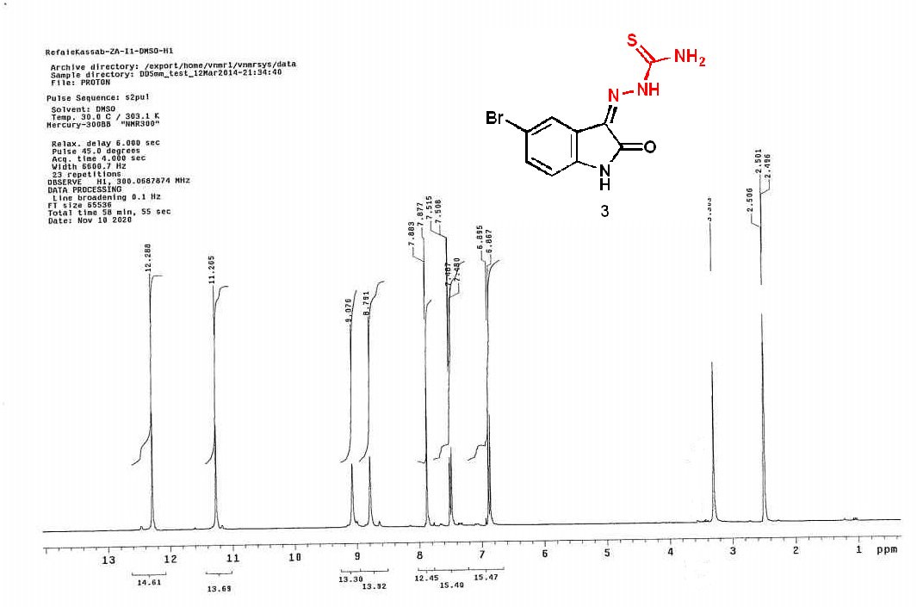
¹H NMR spectrum compound 3
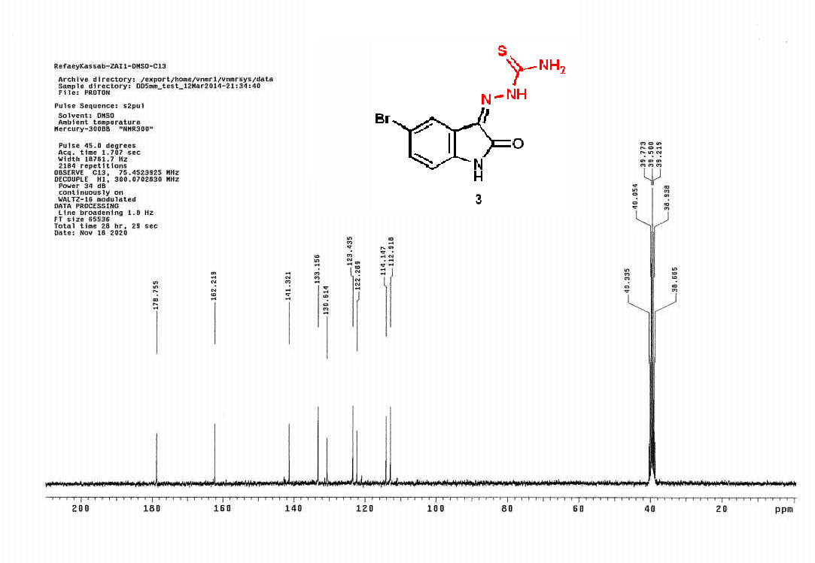
¹H NMR spectrum compound 3
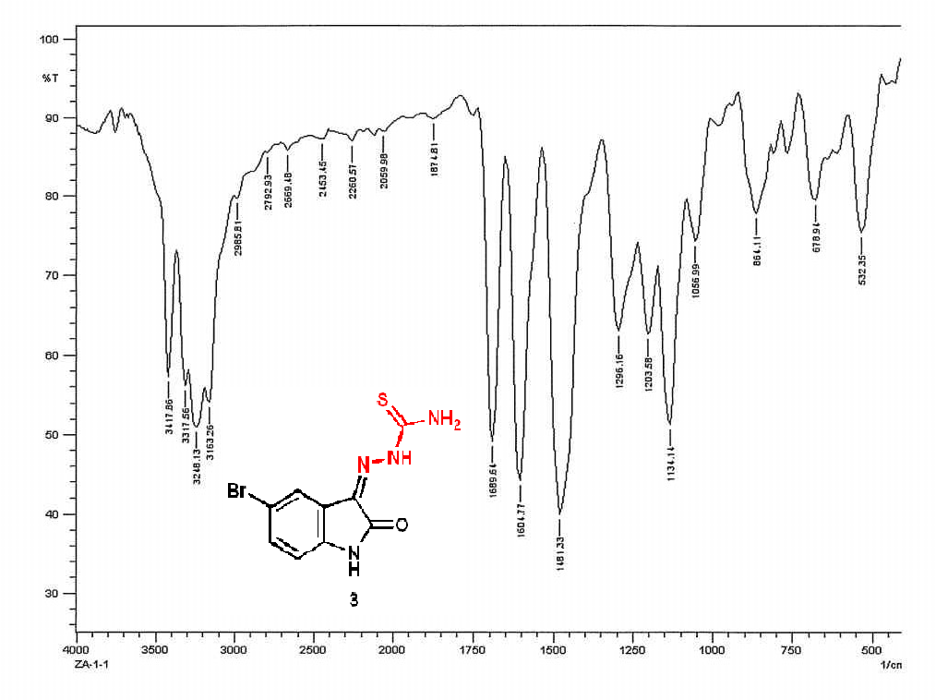
IR spectrum compound 3
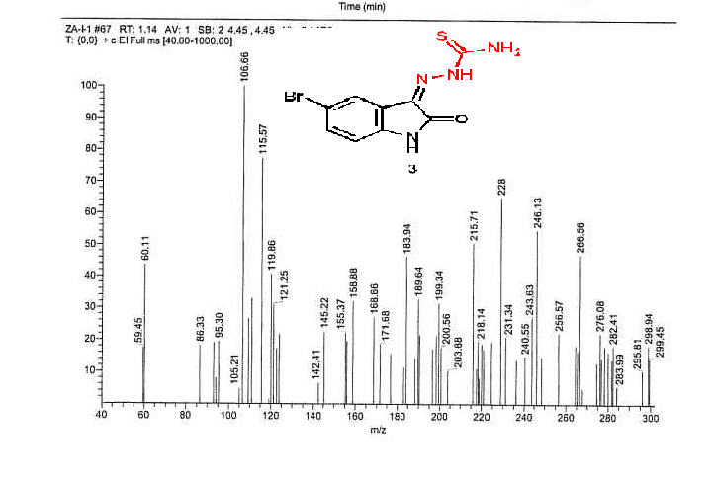
Mass spectrum compound 3

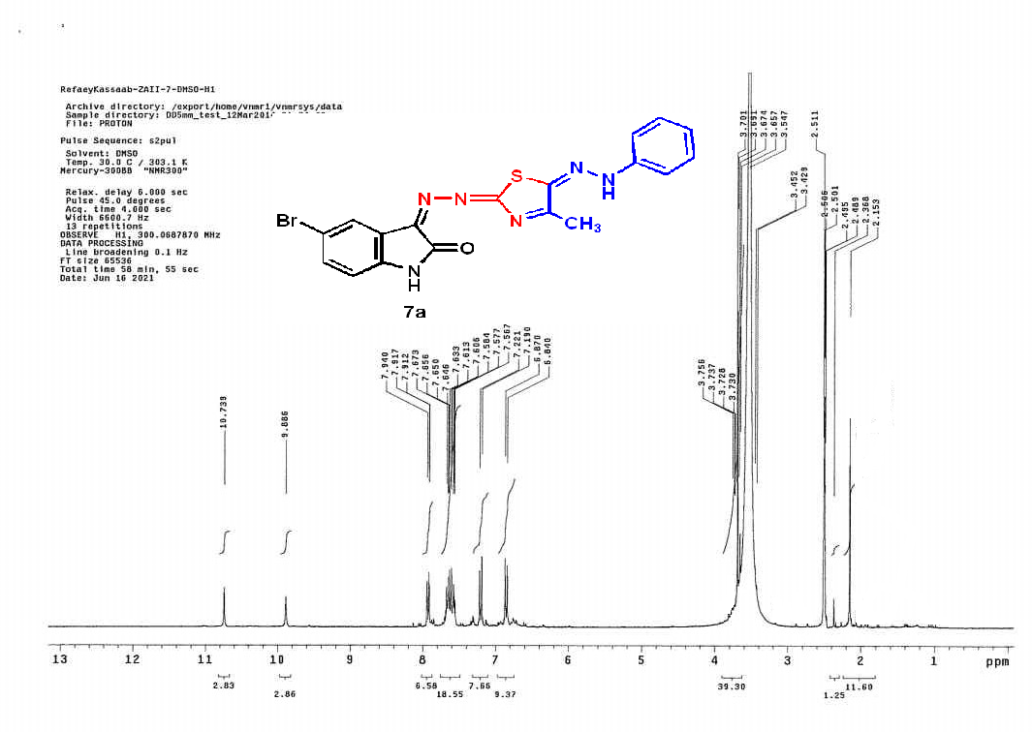
¹H NMR spectrum compound 7a
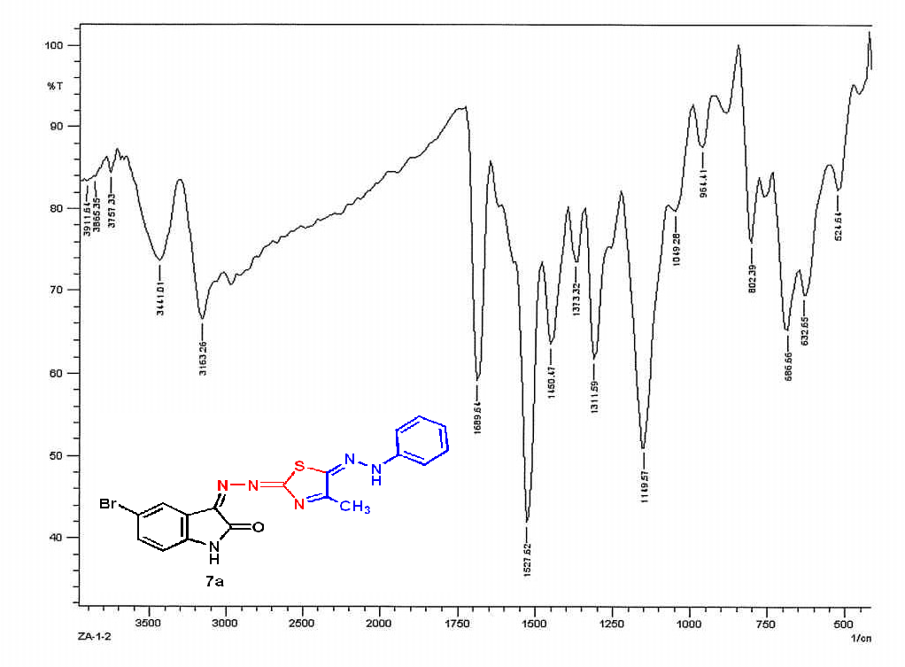
IR spectrum compound 7a
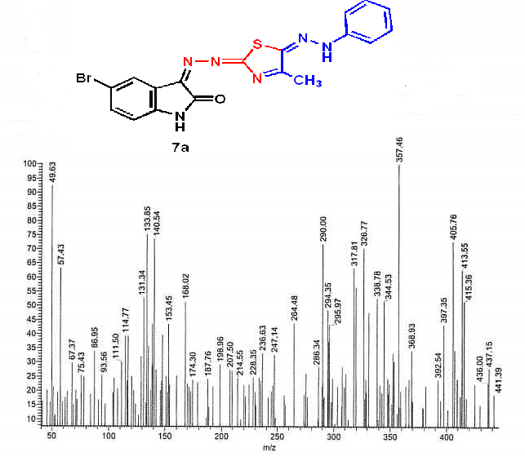
Mass spectrum compound 7a
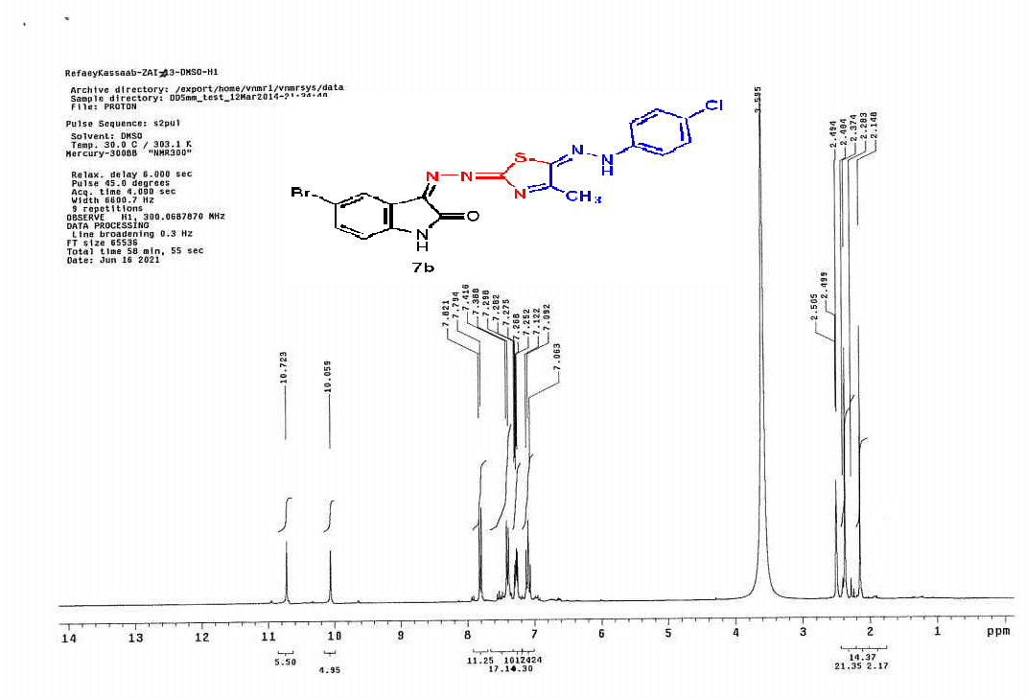
¹H NMR spectrum compound 7b
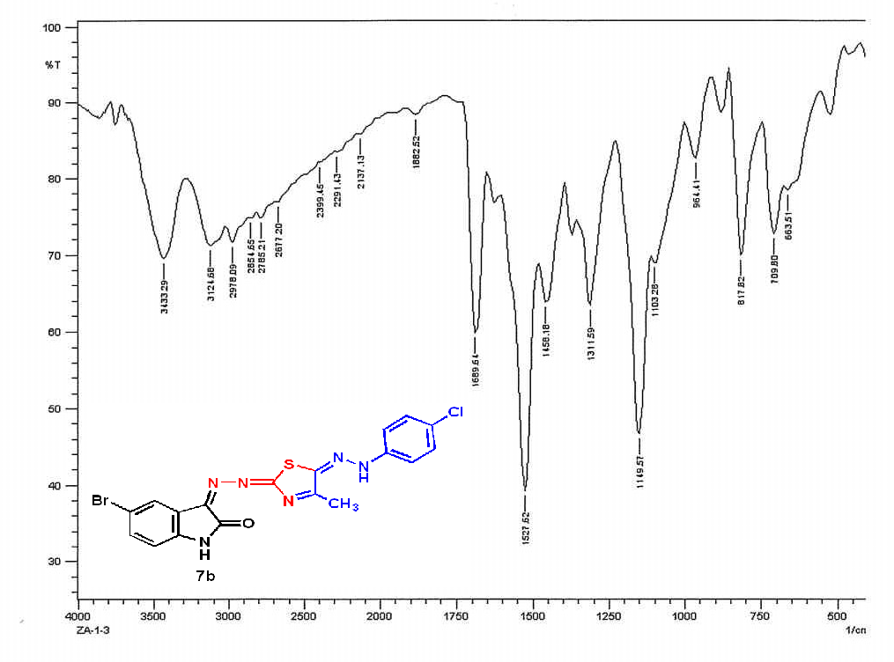
IR spectrum compound 7b
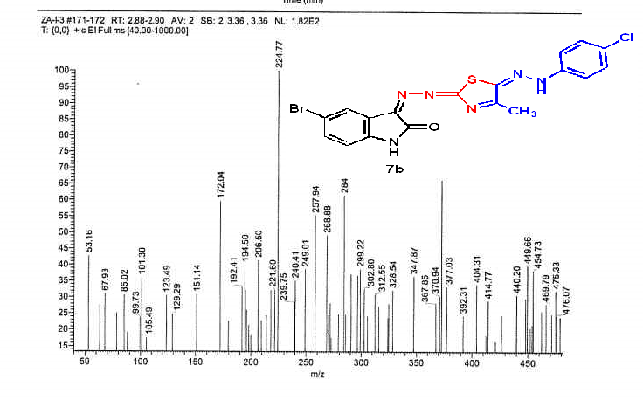
Mass spectrum compound 7b
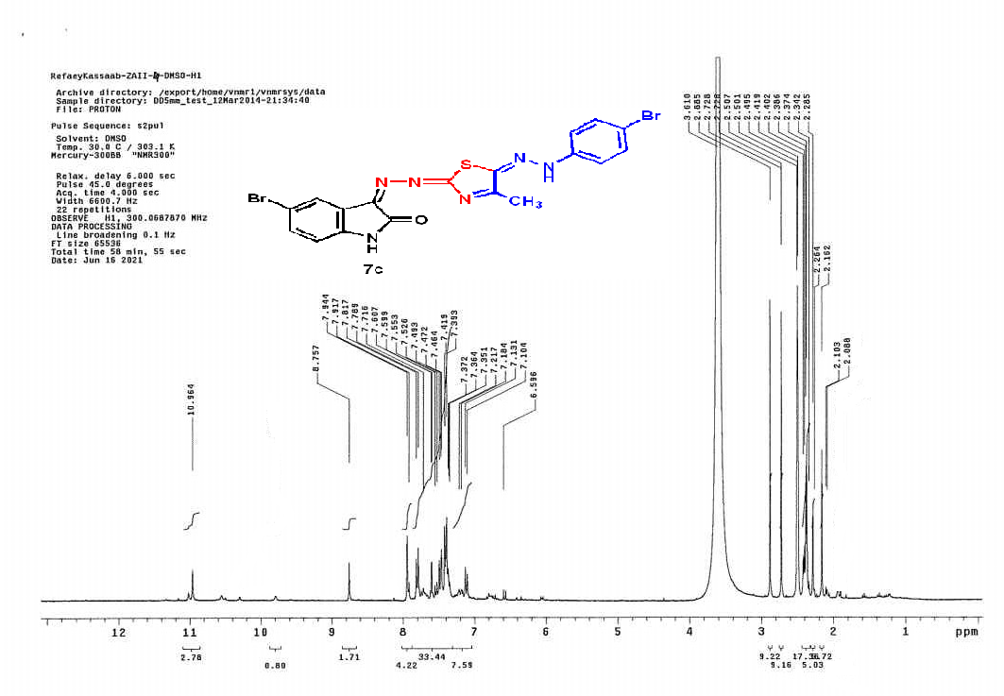
¹H NMR spectrum compound 7c
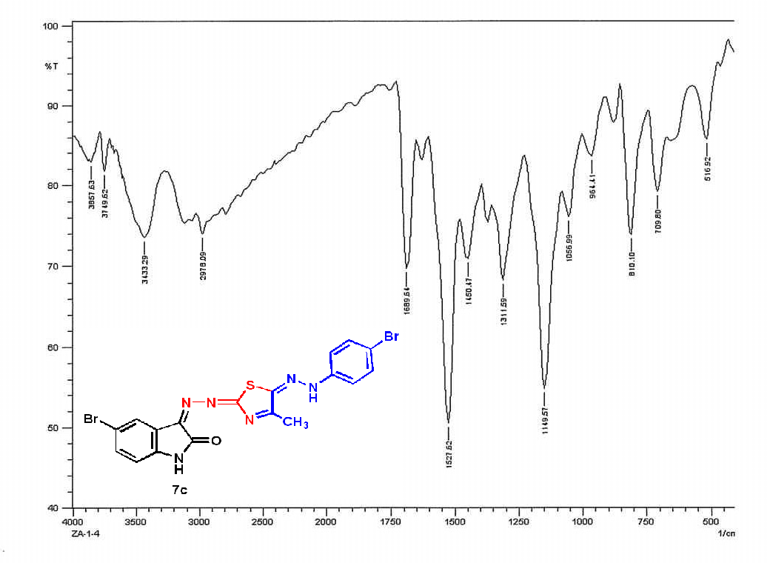
IR spectrum compound 7c

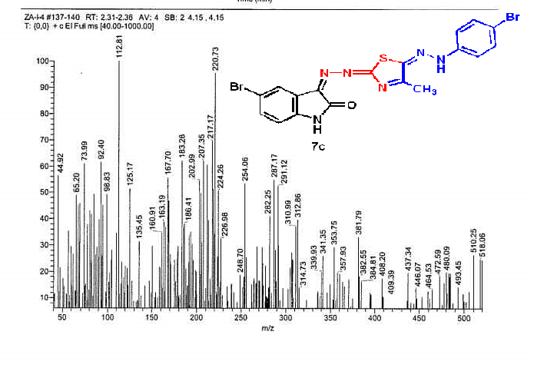
Mass spectrum compound 7c
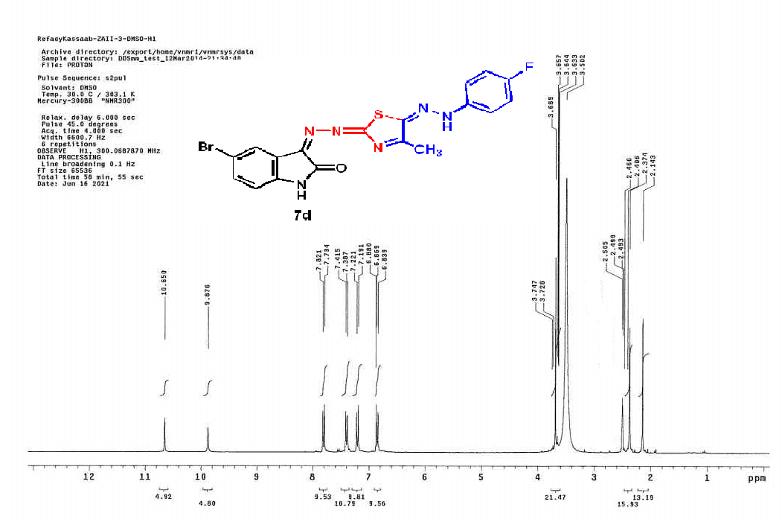
¹H NMR spectrum compound 7d

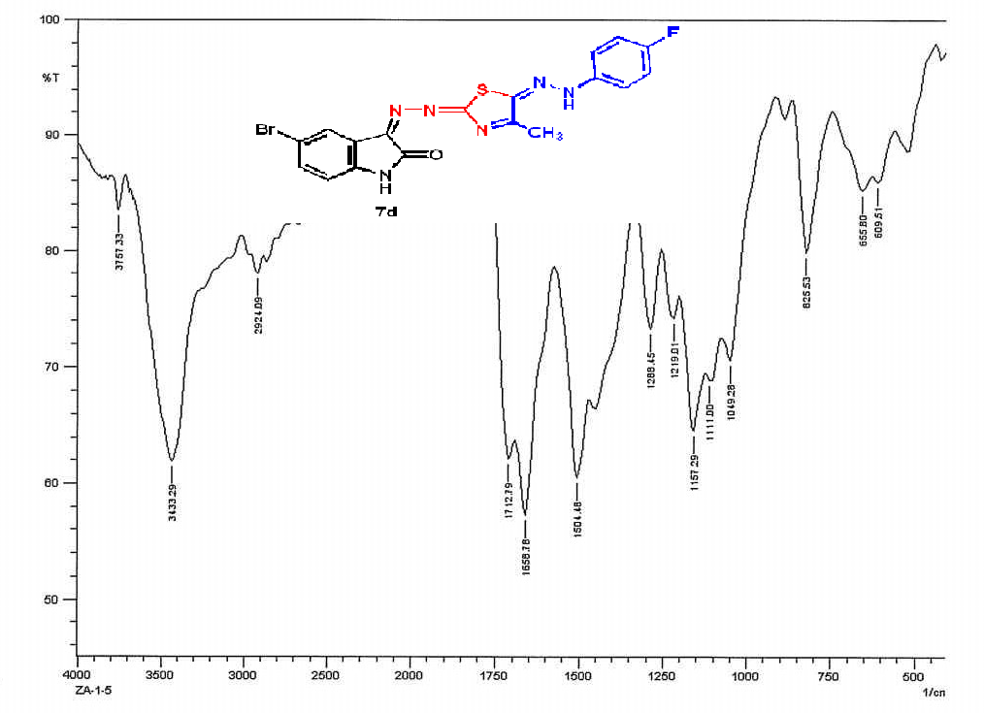
IR spectrum compound 7d

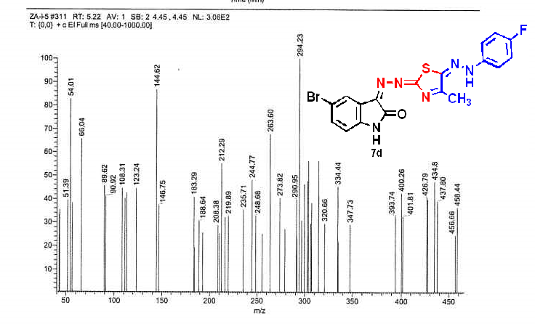
Mass spectrum compound 7d
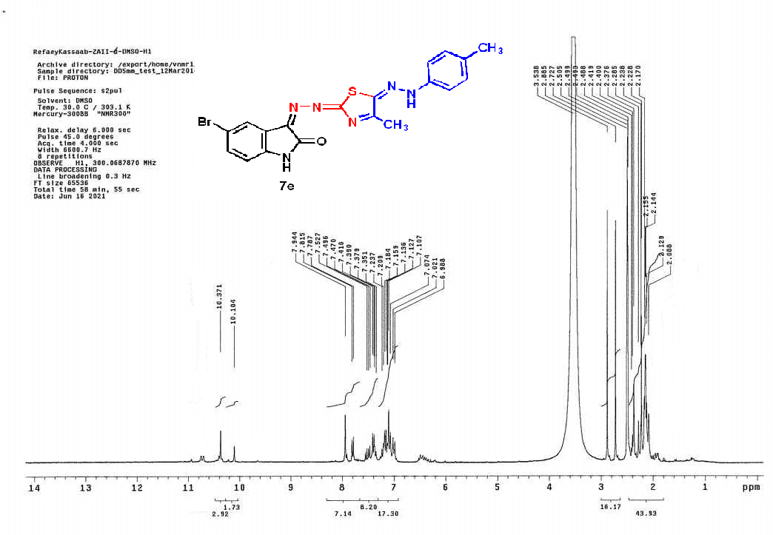
¹H NMR spectrum compound 7e
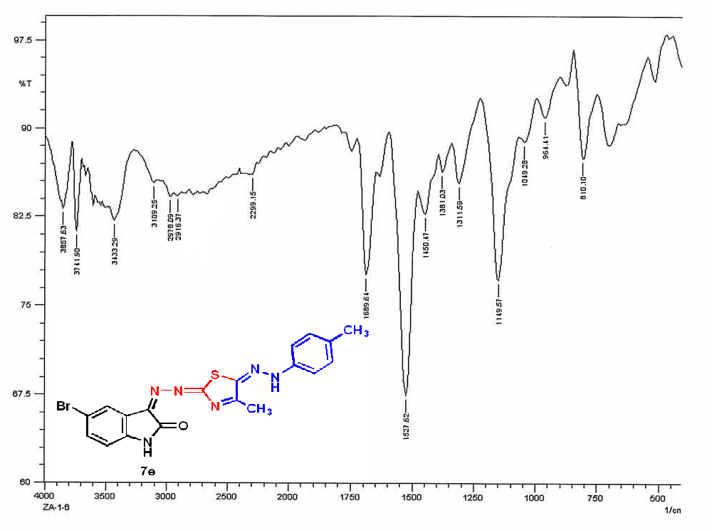
IR spectrum compound 7e

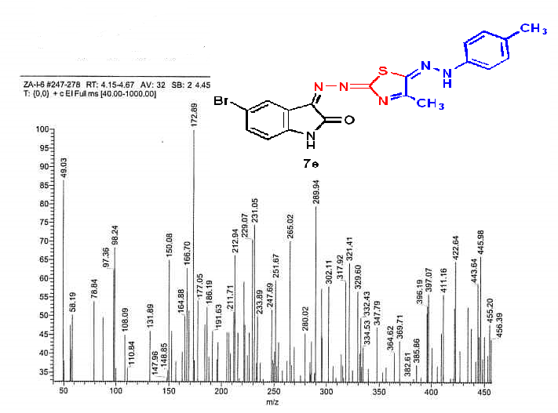
Mass spectrum compound 7e
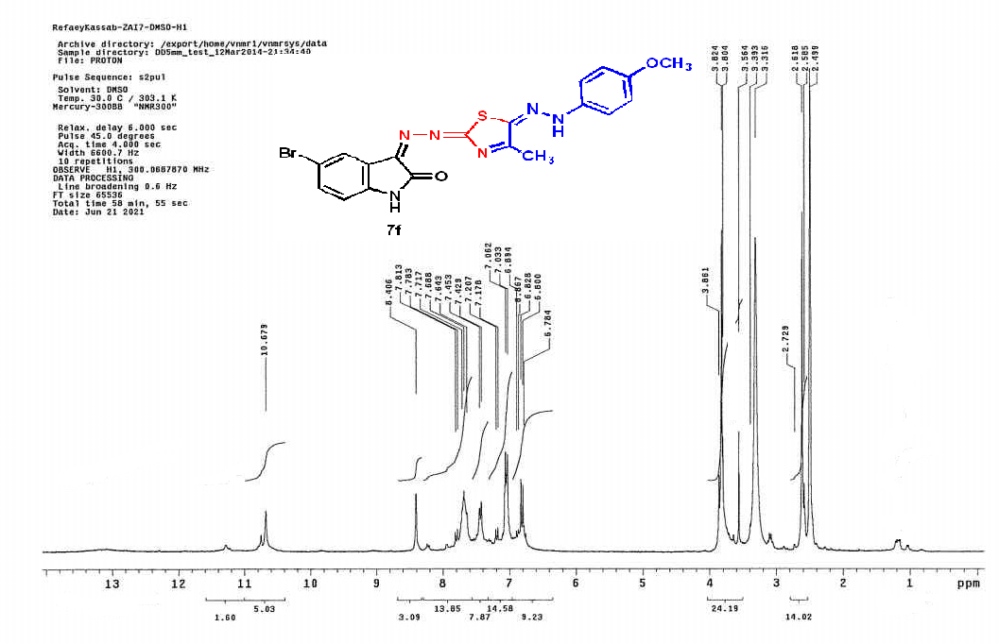
¹H NMR spectrum compound 7f

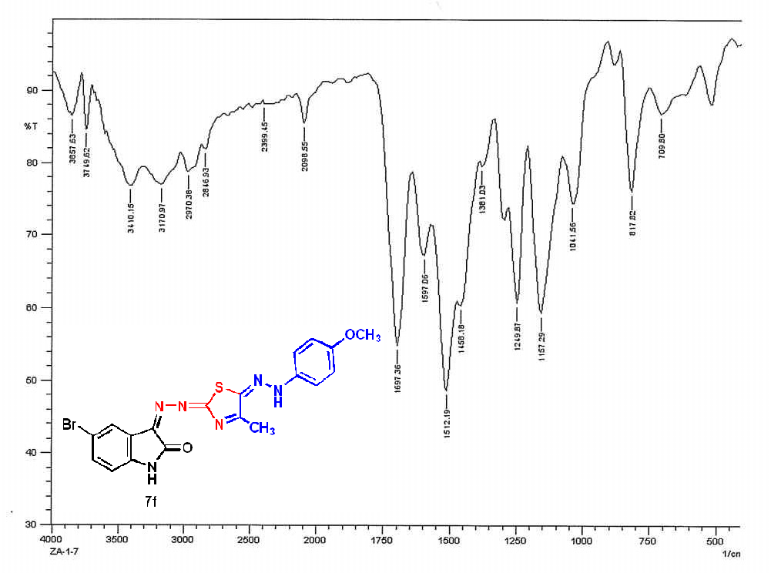
IR spectrum compound 7f
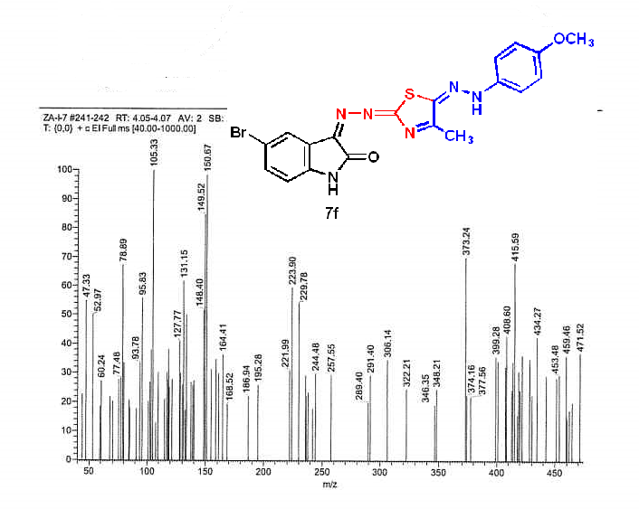
Mass spectrum compound 7f
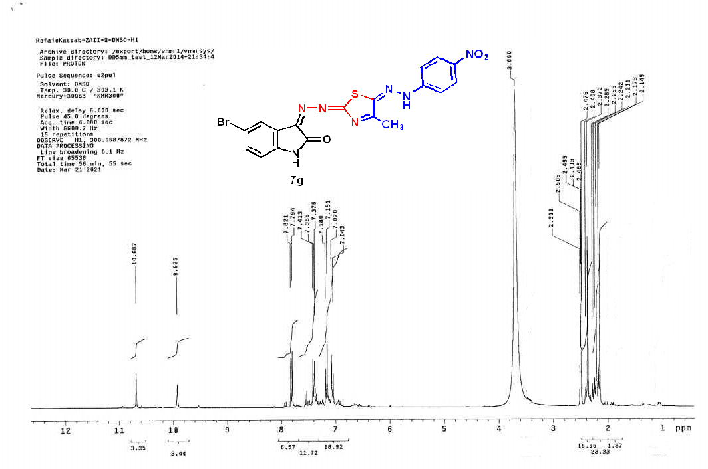
¹H NMR spectrum compound 7g
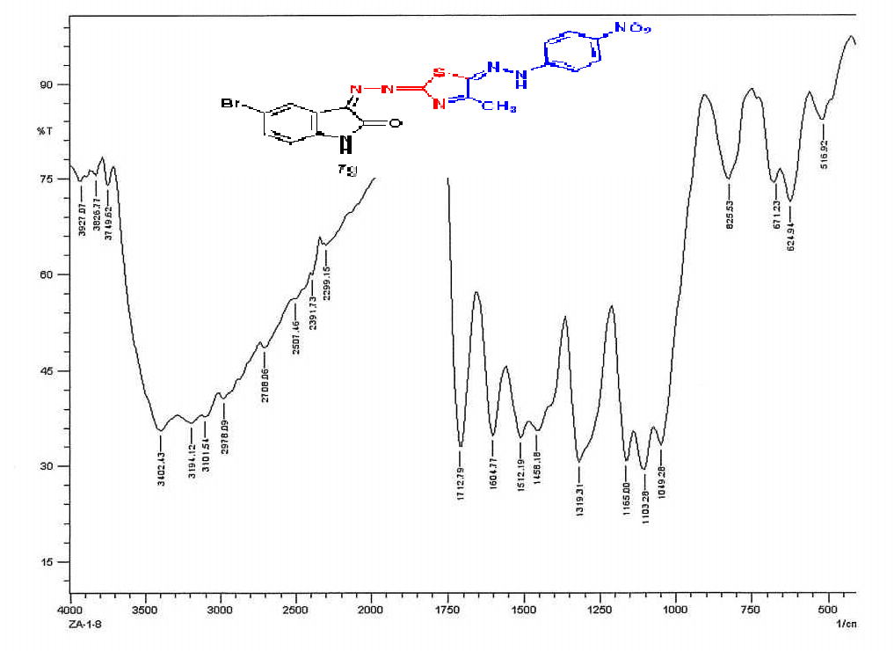
IR spectrum compound 7g
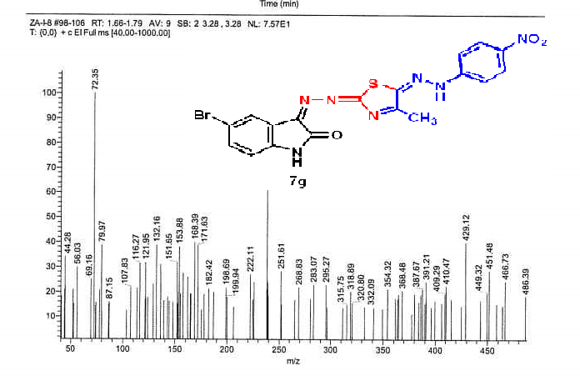
Mass spectrum compound 7g
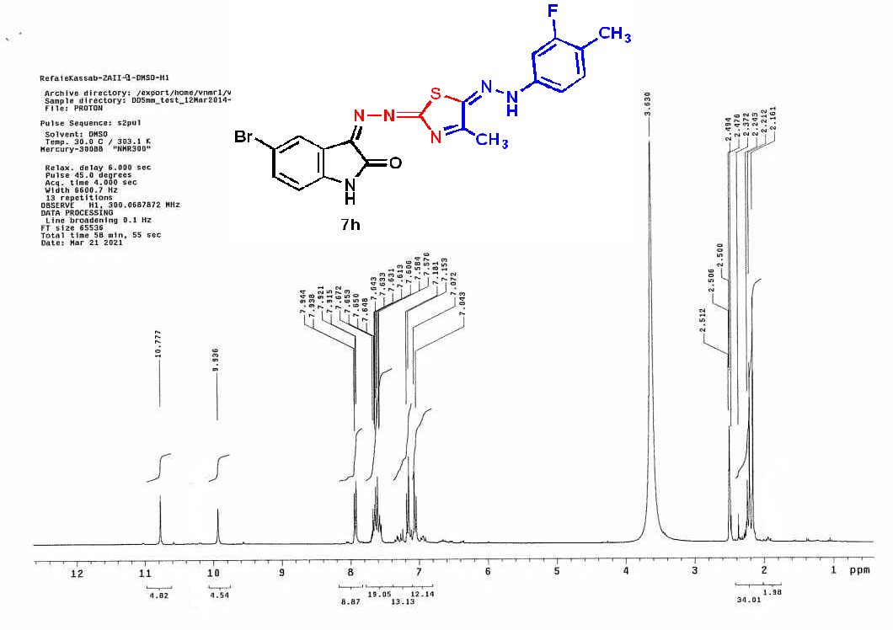
¹H NMR spectrum compound 7h

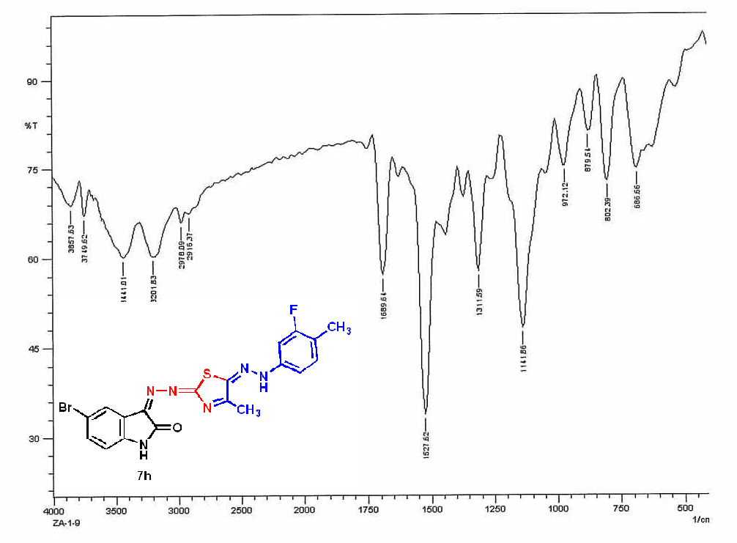
IR spectrum compound 7h
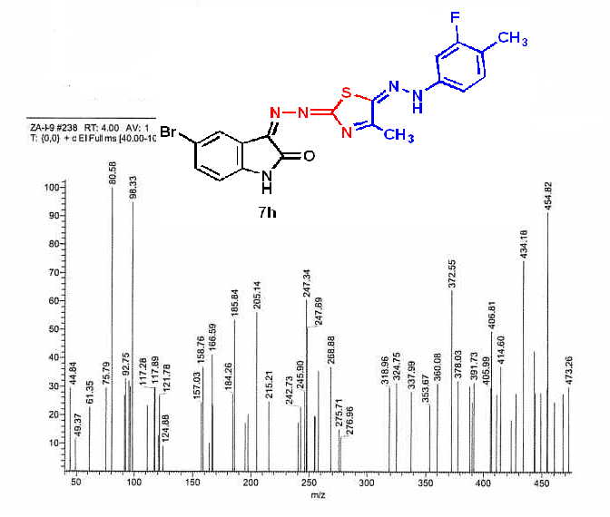
Mass spectrum compound 7h
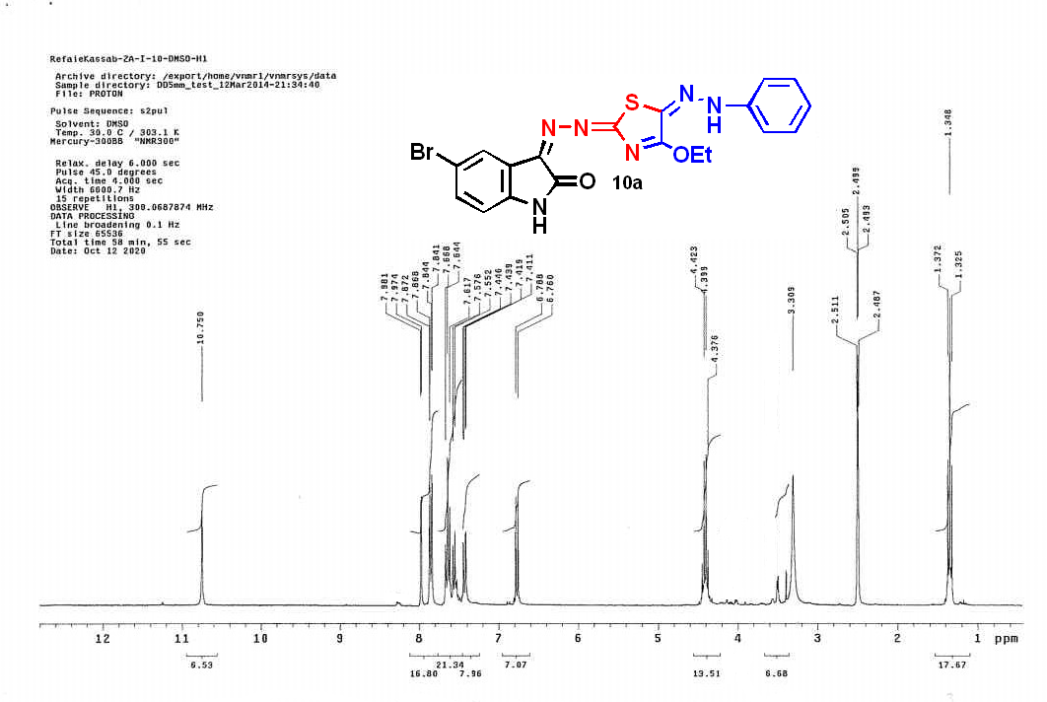
¹H NMR spectrum compound 11a
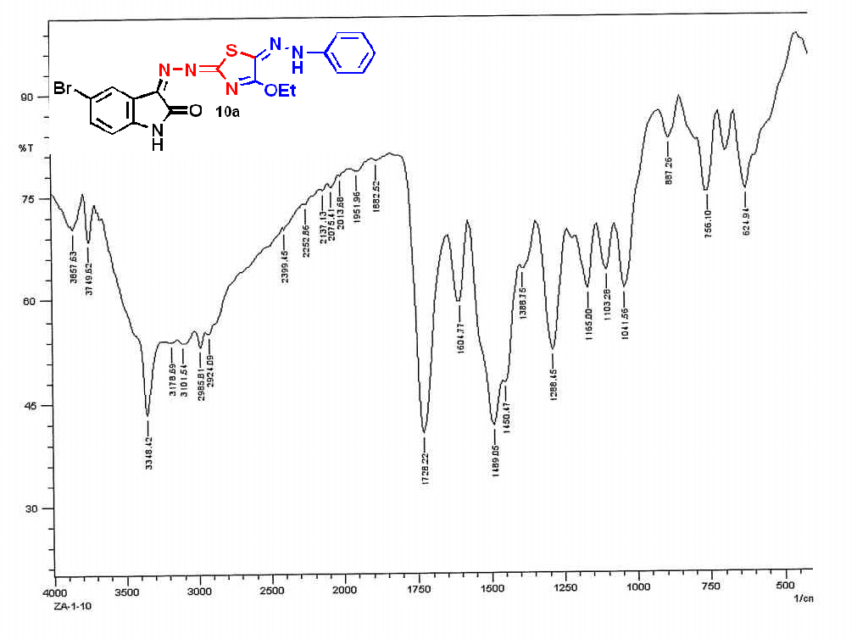
IR spectrum compound 11a
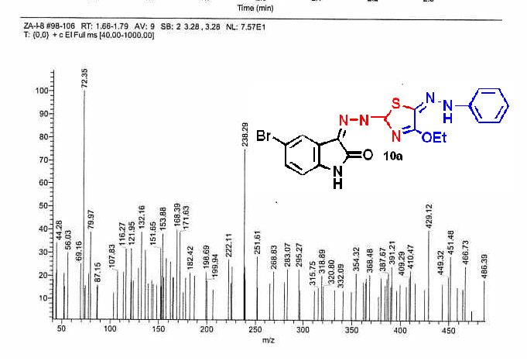
Mass spectrum compound 11a
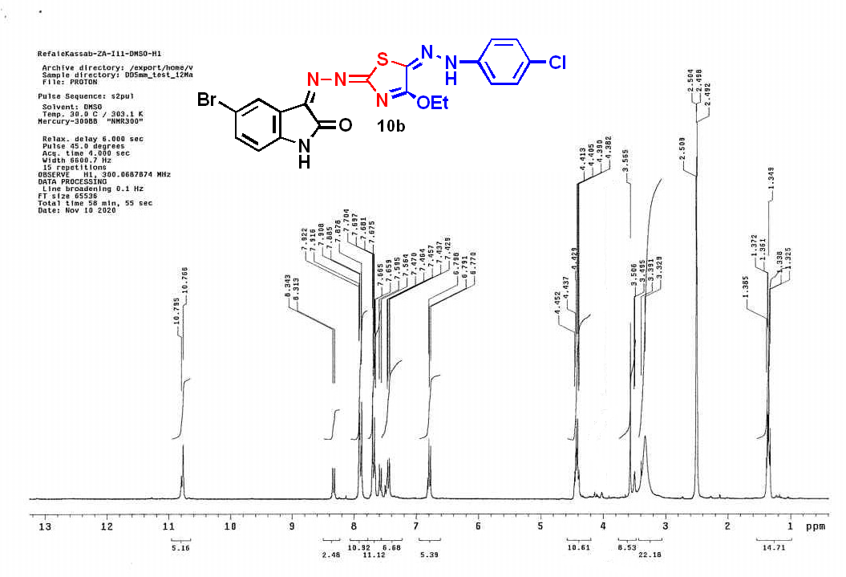
¹H NMR spectrum compound 11b

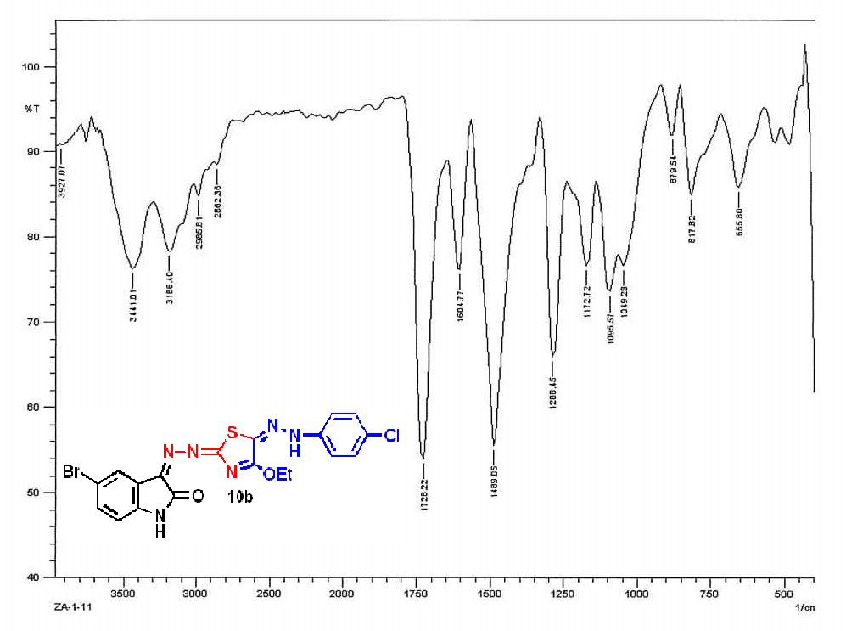
IR spectrum compound 11b
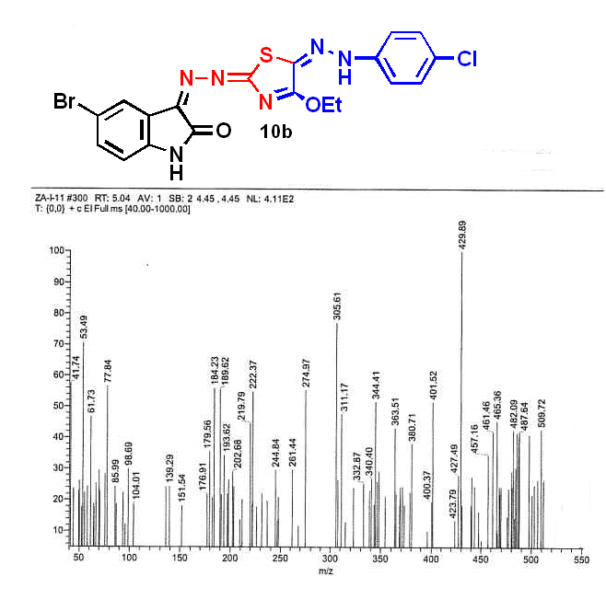
Mass spectrum compound 11b
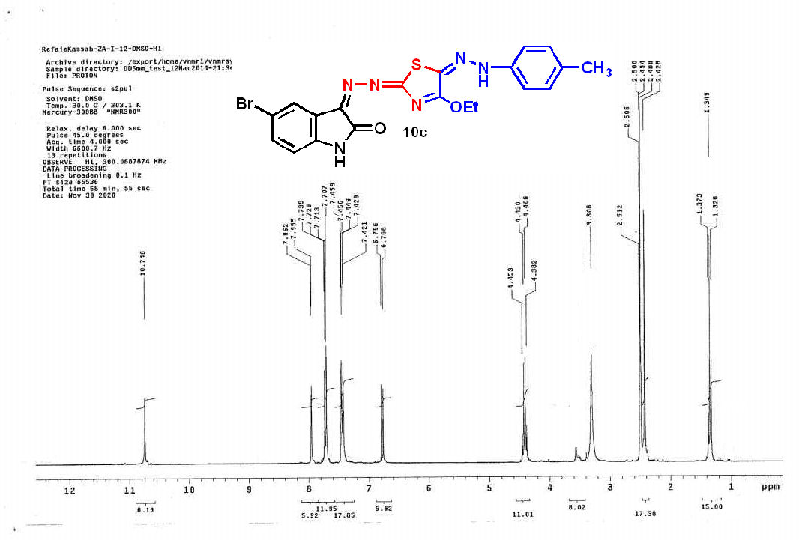
¹H NMR spectrum compound 11c
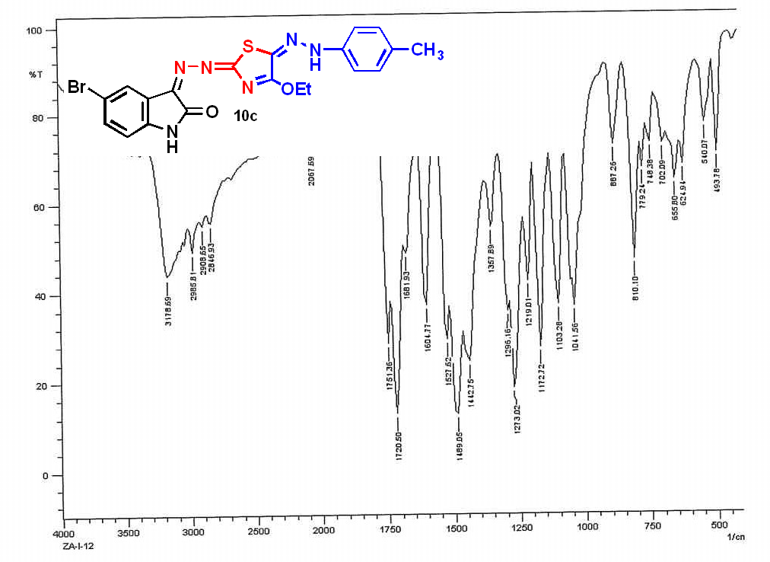
IR spectrum compound 11c

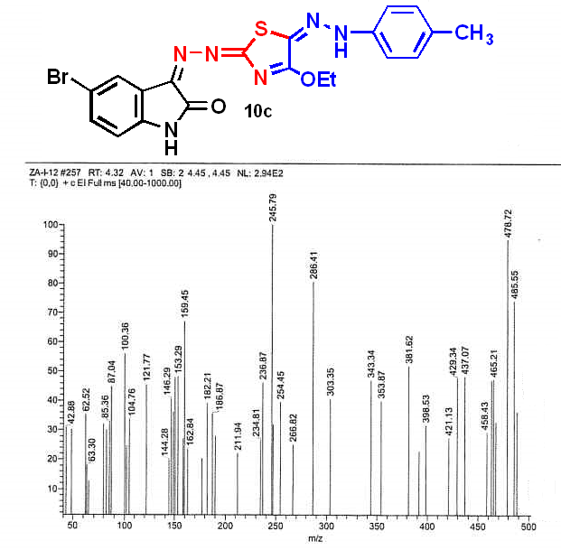
Mass spectrum compound 11c
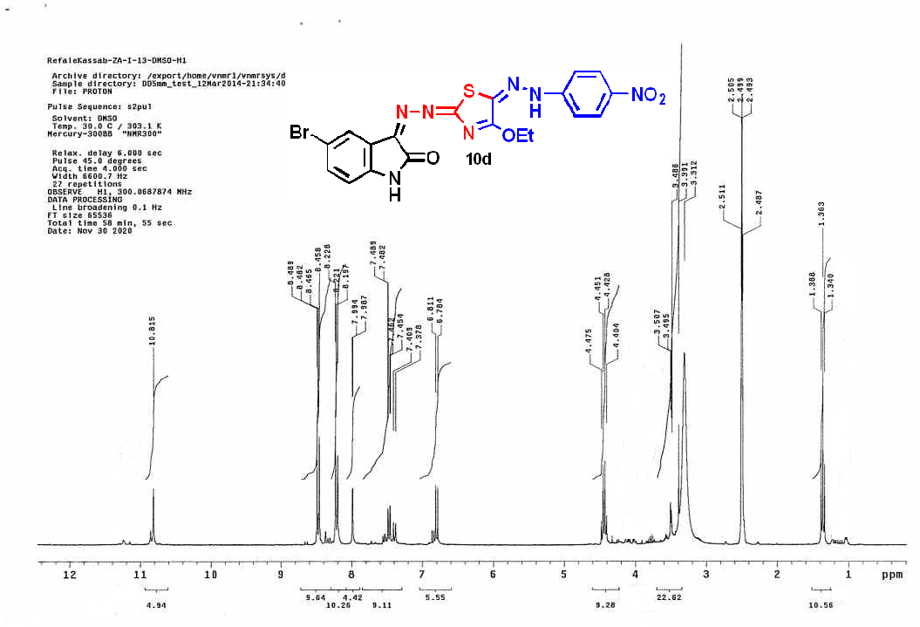
¹H NMR spectrum compound 11d

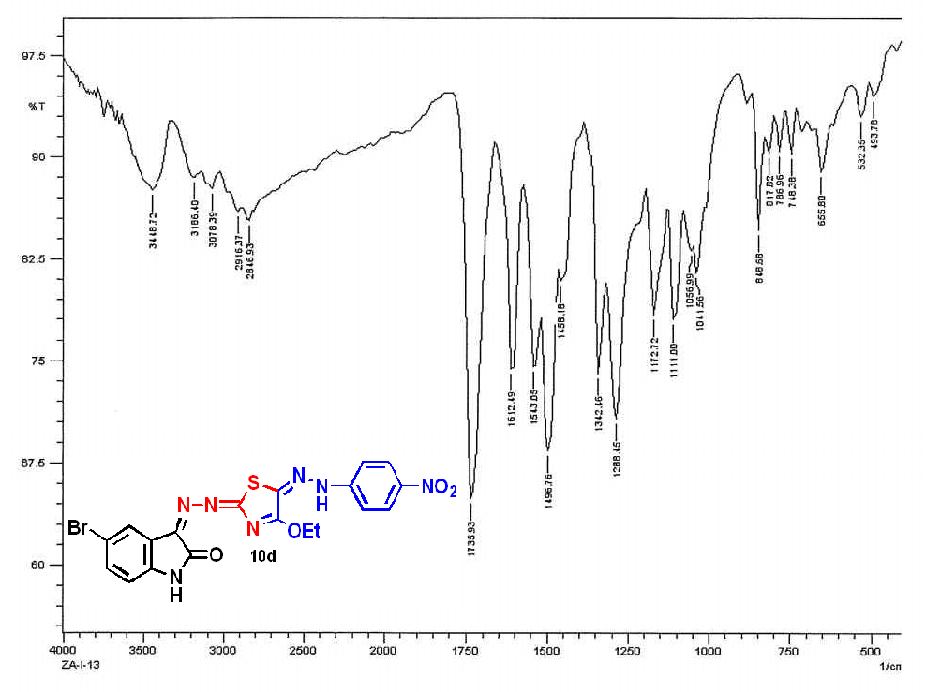
IR spectrum compound 11d
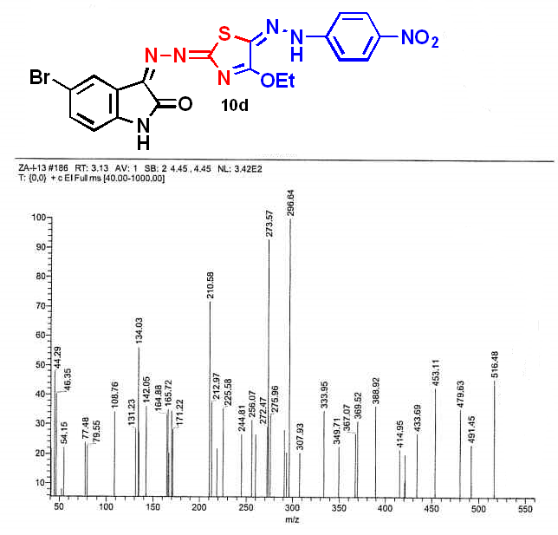
Mass spectrum compound 11d
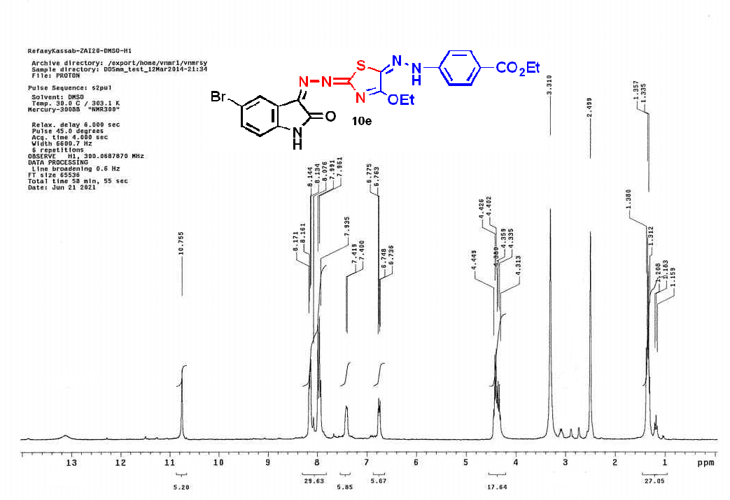
¹H NMR spectrum compound 11e
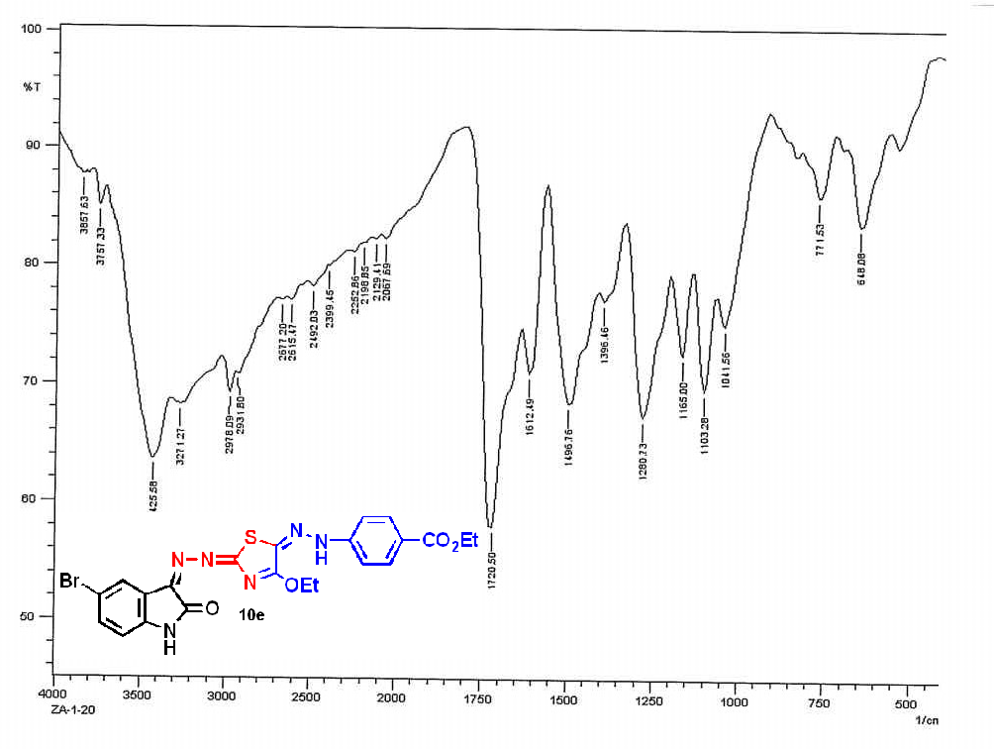
IR spectrum compound 11e
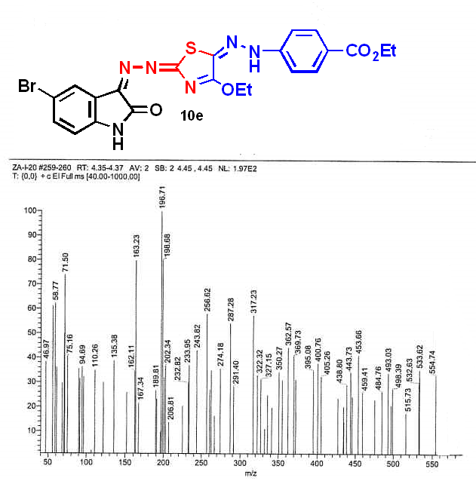
Mass spectrum compound 11e
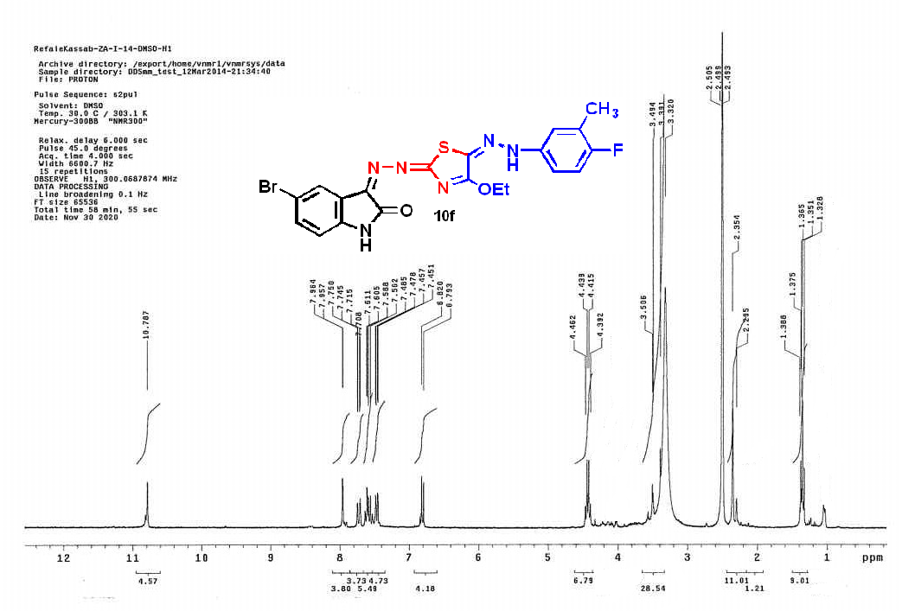
¹H NMR spectrum compound 11f
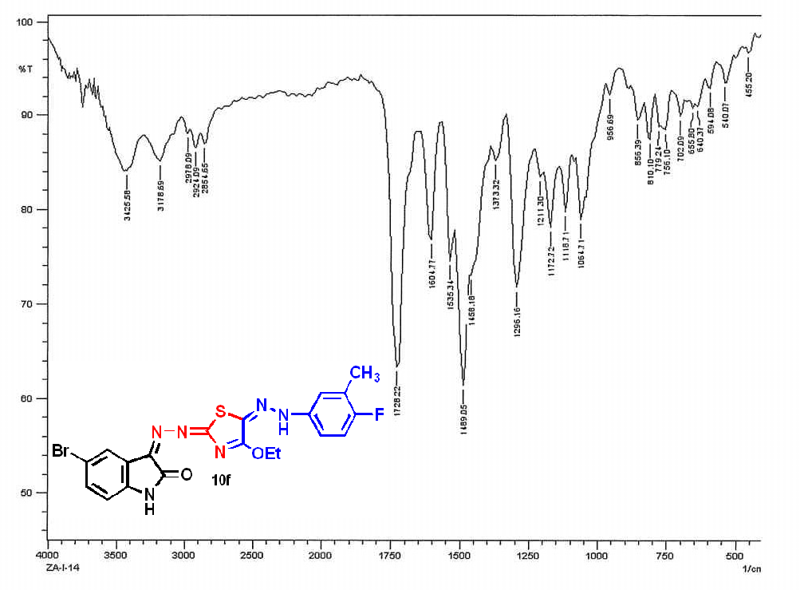
IR spectrum compound 11f
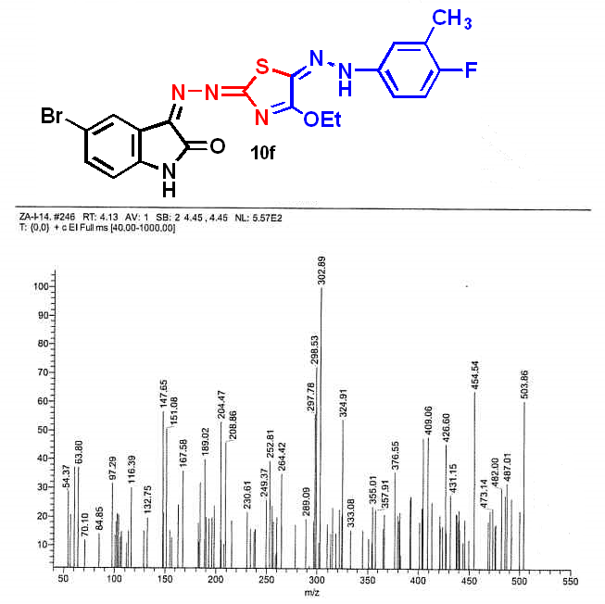
Mass spectrum compound 11f
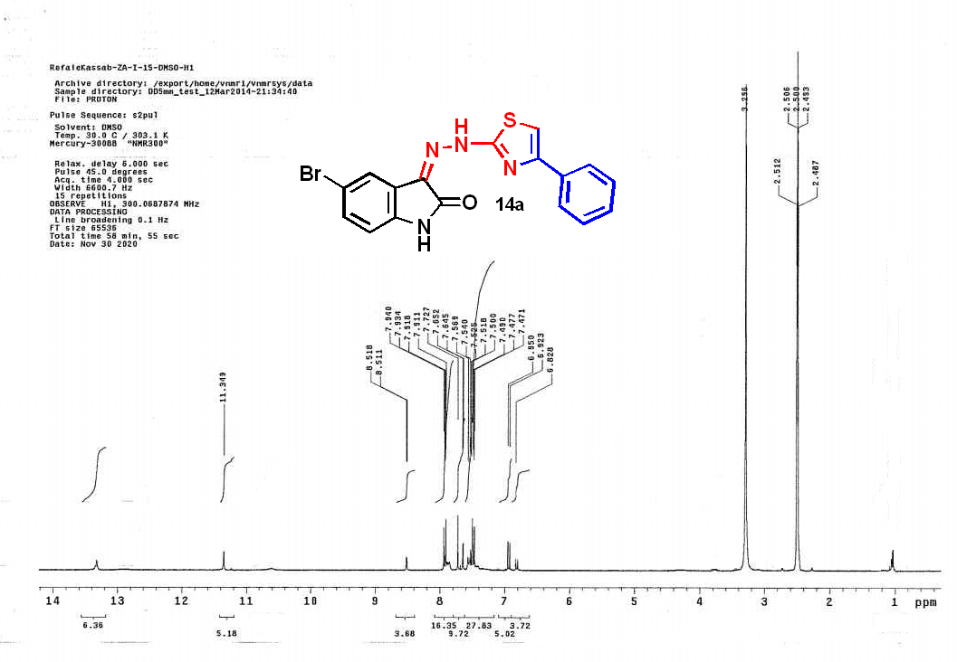
¹H NMR spectrum compound 14a
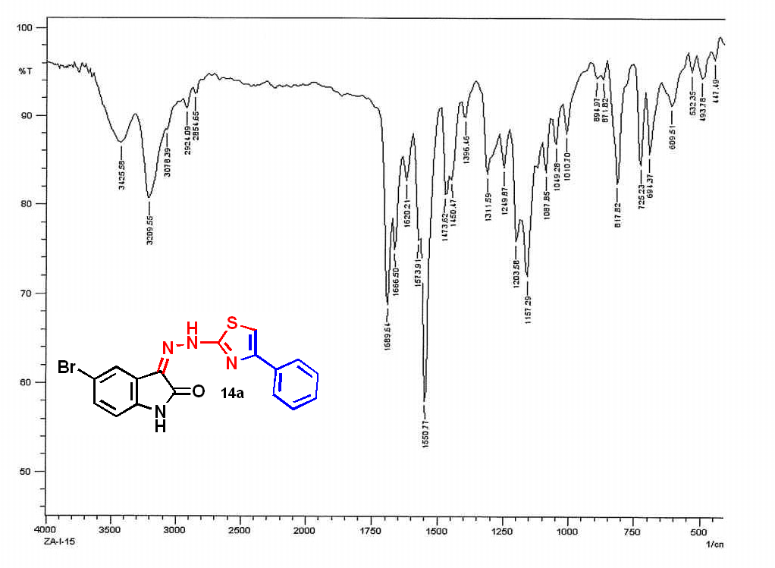
IR spectrum compound 14a
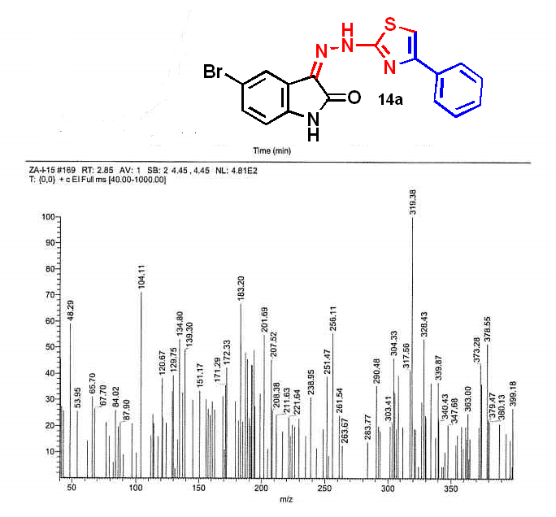
Mass spectrum compound 14a
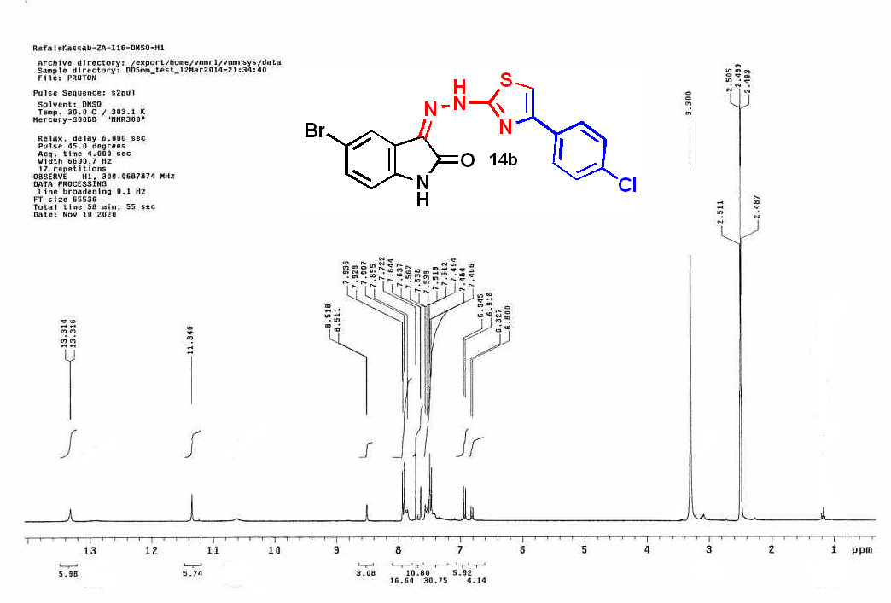
¹H NMR spectrum compound 14b
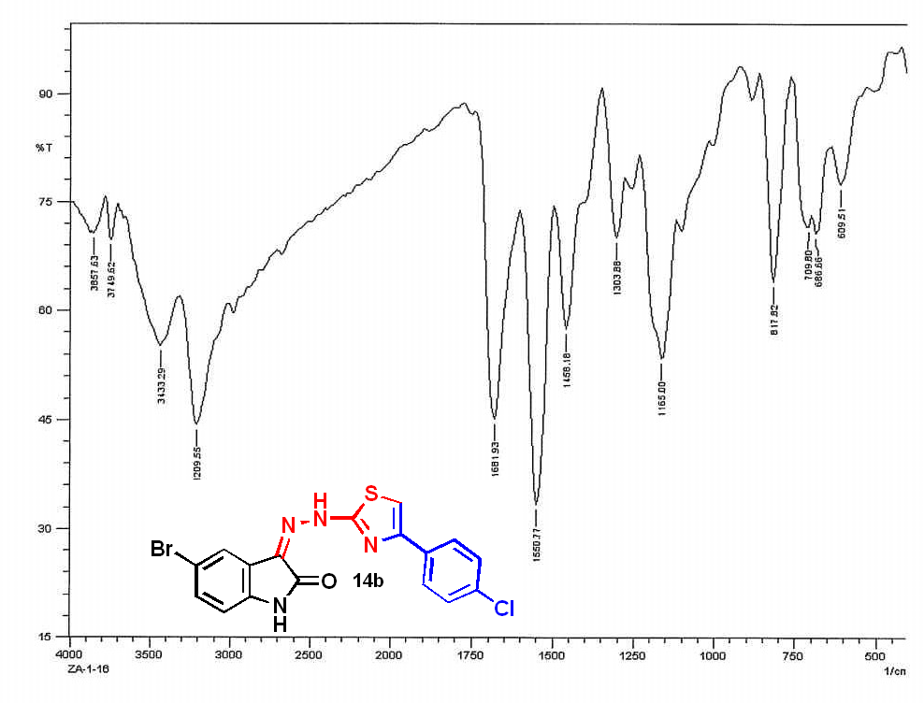
IR spectrum compound 14b
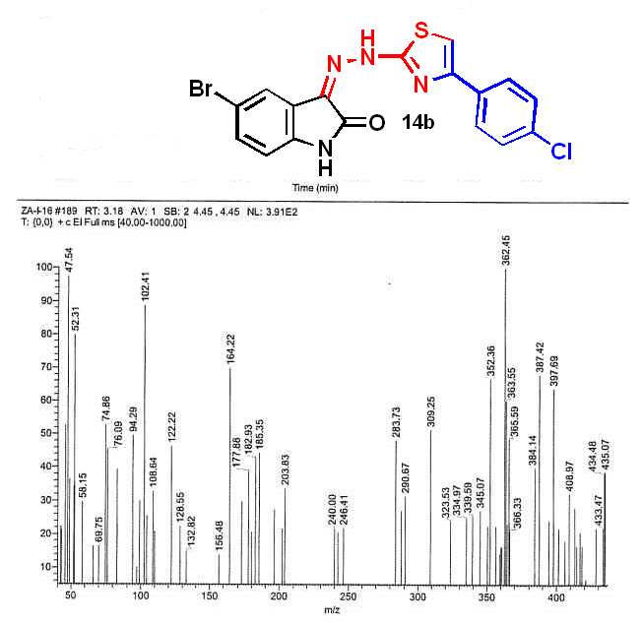
Mass spectrum compound 14b
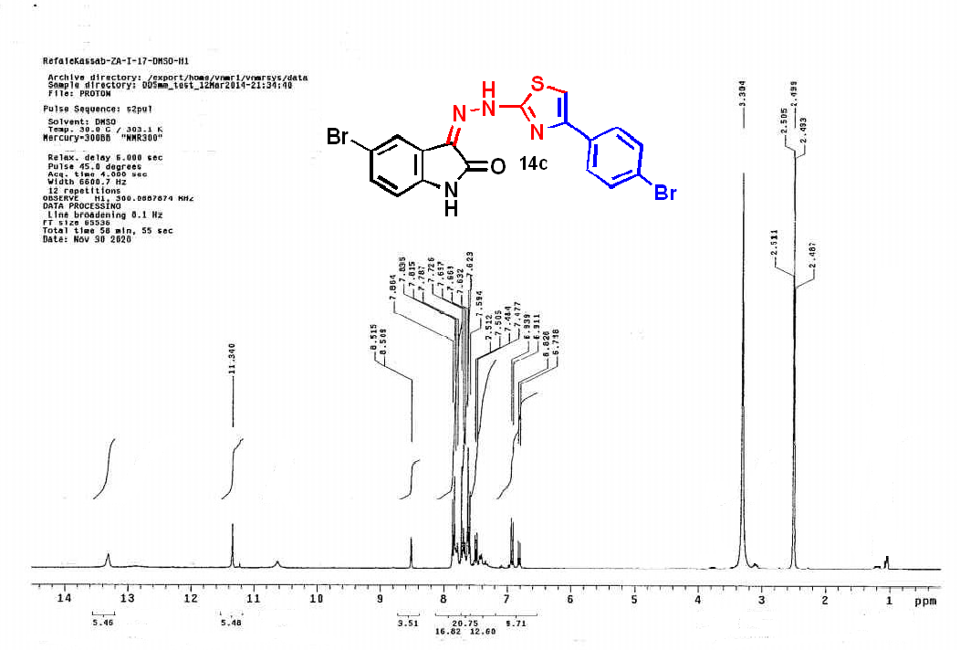
¹H NMR spectrum compound 14c
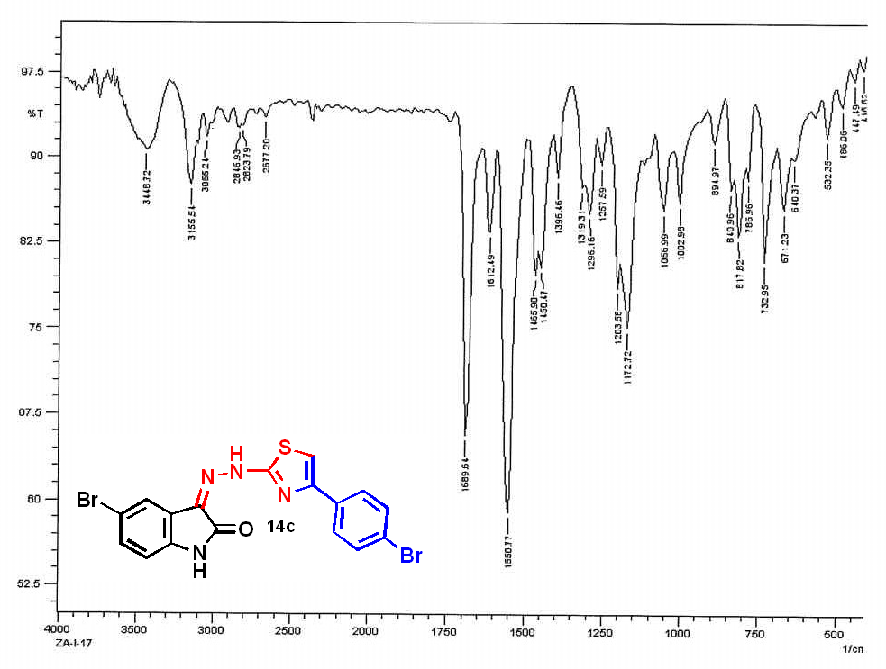
IR spectrum compound 14c
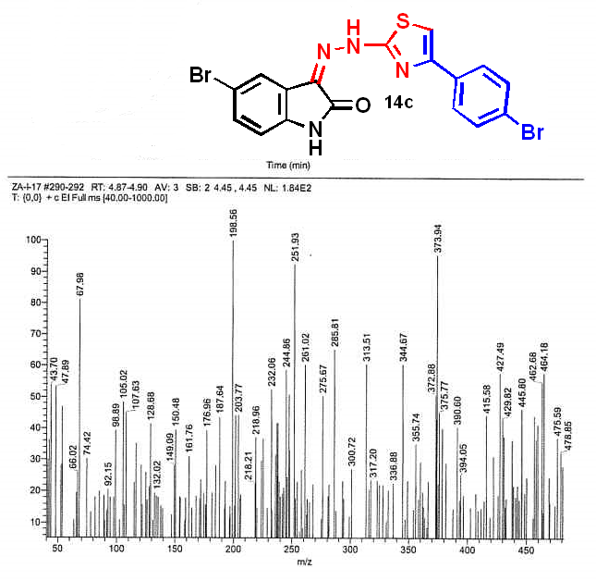
Mass spectrum compound 14c
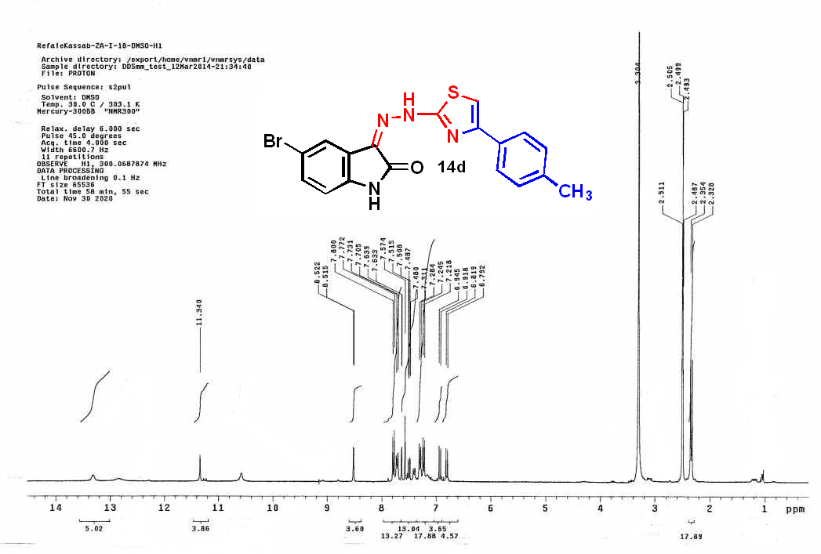
¹H NMR spectrum compound 14d
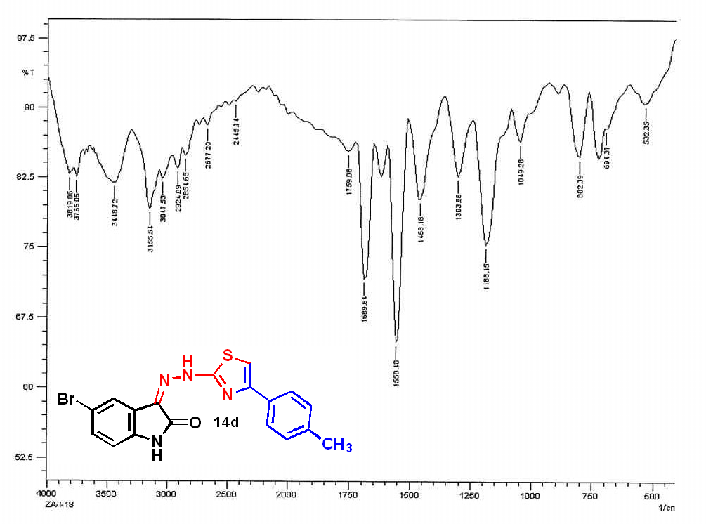
IR spectrum compound 14d
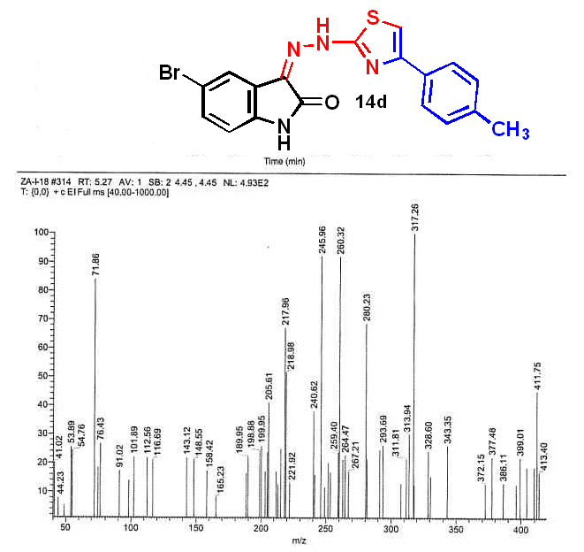
Mass spectrum compound 14d
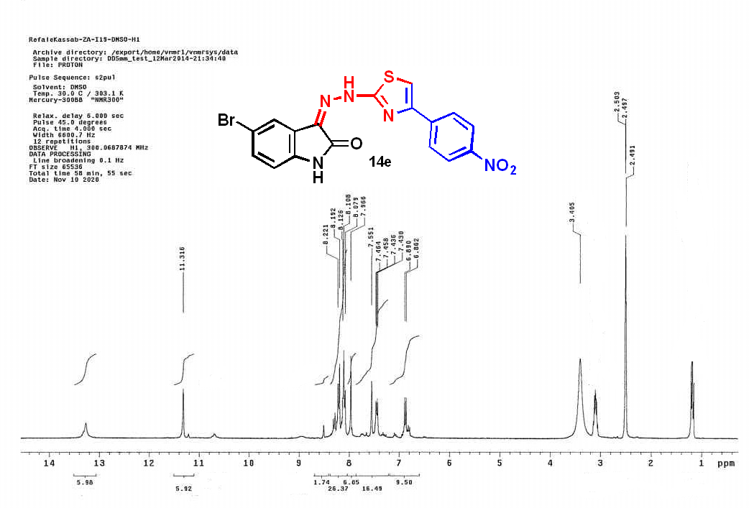
¹H NMR spectrum compound 14e
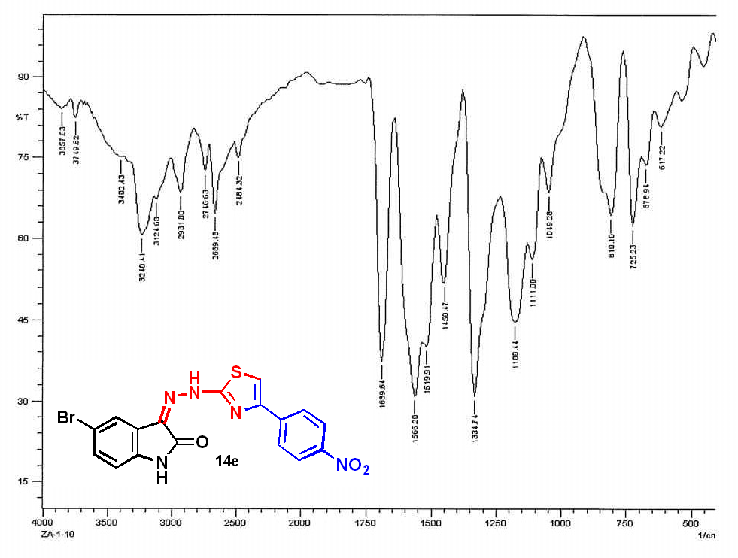
IR spectrum compound 14e
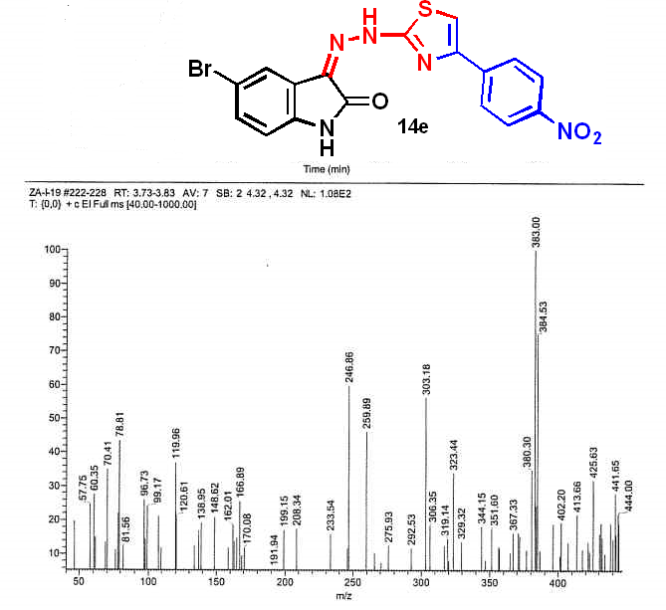
Mass spectrum compound 14e

