Supplementary Data

Table 1. Primary antibodies used for immunocytochemistry staining.
Antigen | Primary Antibody | company | dilution
C(proSP-c) | Polyclonal antibody Rabbit | AB3786-Millpore | 1:1000-1:2000
B(proSP-B) | Polyclonal antibody Rabbit | AB3430-Millpore | 1:4000-1:8000
GBDH | Goat polyclonal IgG | sc-9890 Santa Cruz | 1:50-1:500
HNF-3Î | Goat polyclonal IgG | sc-6554 Santa Cruz | 1:50-1:500
Anti-TTF | Rabbit monoclonal IgG | AB76013-Abcam | 1:100-1:1000
Oct4 | Anti-Oct4** | Applied StemCell, Inc. | As described in company protocol
Sox2 | Anti-Sox2** | Applied StemCell, Inc. | As described in company protocol
Nanog | Anti-Nanog** | Applied StemCell, Inc. | As described in company protocol
SSEA-4 | Anti-SSEA-4* | Applied StemCell, Inc. | As described in company protocol
TRA-1-81 | Anti-TRA-1-81* | Applied StemCell, Inc. | As described in company protocol
TRA-1-60 | Anti-TRA-1-60* | Applied StemCell, Inc. | As described in company protocol
The secondary antibodies used were *goat anti-mouse (Alexa Fluor 594), **goat anti-rabbit (Alexa Fluor 594). A human ESCs/IPSCs characterization kit (Applied StemCell, Inc.) was used for procedures involving these antibodies.

Supplimntary Figure 1. Effect of cell number on absorbance at 490 nm. Human IPSCs were cultured in 96-well plates (50,000 cell per well) and inubated at 37 °C. MTS regaent was added and absorbence at 490 nm was recored using an ELISA reder. The y-axis indicates cell number and the x-axis indicates the OD value. Each point represents a mean of three replicates. The assay was performed according to the kit’s instructions.

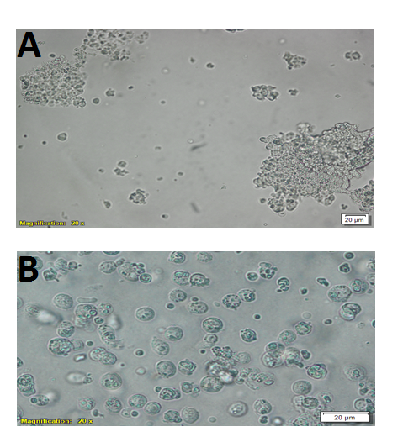
Supplementary Figure 2. Comparison of the passaging of human IPSCs as clusters vs. single cells. (A) Human IPSCs after dissociation without the enzymes formed large aggregates or clumps; (B) human IPSCs after dissociation in the presence of 10 µM Y-27632. Scale for images A and B: 20 μm.

E
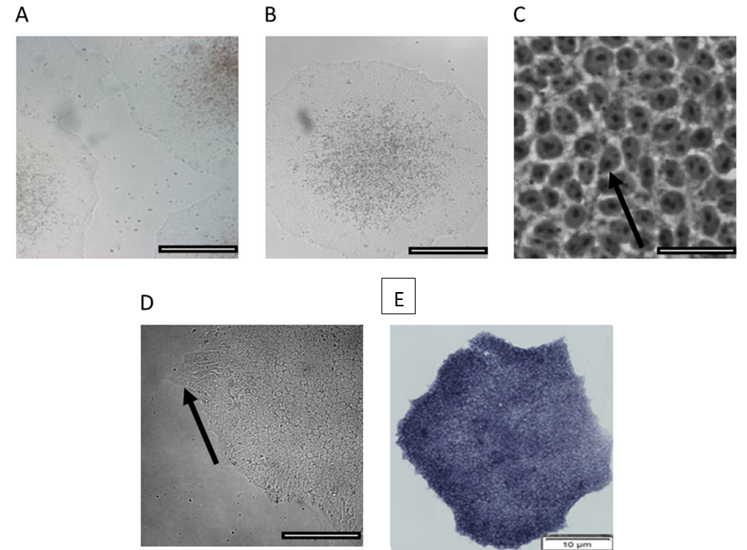

Supplementary Figure 3. Morphology of human induced pluripotent cell line IMR-90 cultured on Corning Matrigel matrix in mTeSR™1 medium under hypoxic condition and ROCK inhibitor. A) The cells on day 5 of culture maintenance showing human IPSC colonies covering a large area of the well. B) The morphology of the human IPSC colony was dense and flat with smooth edges. C) The human IPSCs were condensed, with high nucleus/cytoplasm ratios and prominent nucleoli, as indicated by the arrows. D) An undifferentiated human IPSC colony that has begun to spontaneously differentiate around the edges, as indicated by the arrows. E). Human IPSCs that stained positive for alkaline phosphatase activity. Scales for the images in A, B, and D: 200 μm. Scales for the image in E: 10 μm. Scales for the image in C: 20 μm.

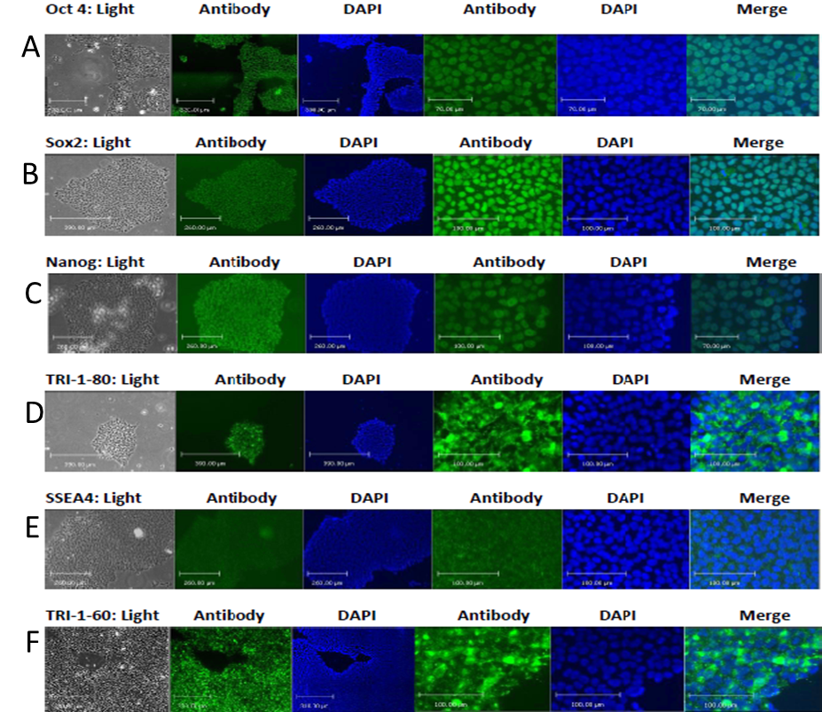

Supplementary Figure 4. Immunocytochemistry staining of pluripotency-associated nuclear and surface proteins in human IPSCs under ROCK/Hypoxia condition. Immunofluorescent staining of confluent human IPSCs at day 5 after culture revealed the expression of pluripotency-associated nuclear markers (A) Oct4 (Alexa Fluor® 488-FITC-green), (B) Sox2 (Alexa Fluor® 488-FITC-green), and (C) Nanog (Alexa Fluor® 488-FITC-green) and the expression of pluripotency surface markers (D) TRA-1-81 (Alexa Fluor® 488-FITC-green), (E) SSEA4 (Alexa Fluor® 488-FITC-green), and (F) TRA-1-60 (Alexa Fluor® 488-FITC-green). The first column shows the bright field images. The second column shows the expression of the nuclear or surface markers in green, as indicated in the legend. The third column shows nuclear counter staining with DAPI. The sixth column shows the composite images. Images were captured at 10× or 40×. The scales for the images are 100 or 200 μm magnification, as indicated in the figures and under the appropriate fluorescent filters.

Supplementary Figure 5. Flow cytometric analysis of pluripotency markers over five passages under ROCK/Hypoxia condition. The percentage of double-positive cells stained with internal protein Nanog-PE and cell surface protein SSEA4-APC from passages 34–39.

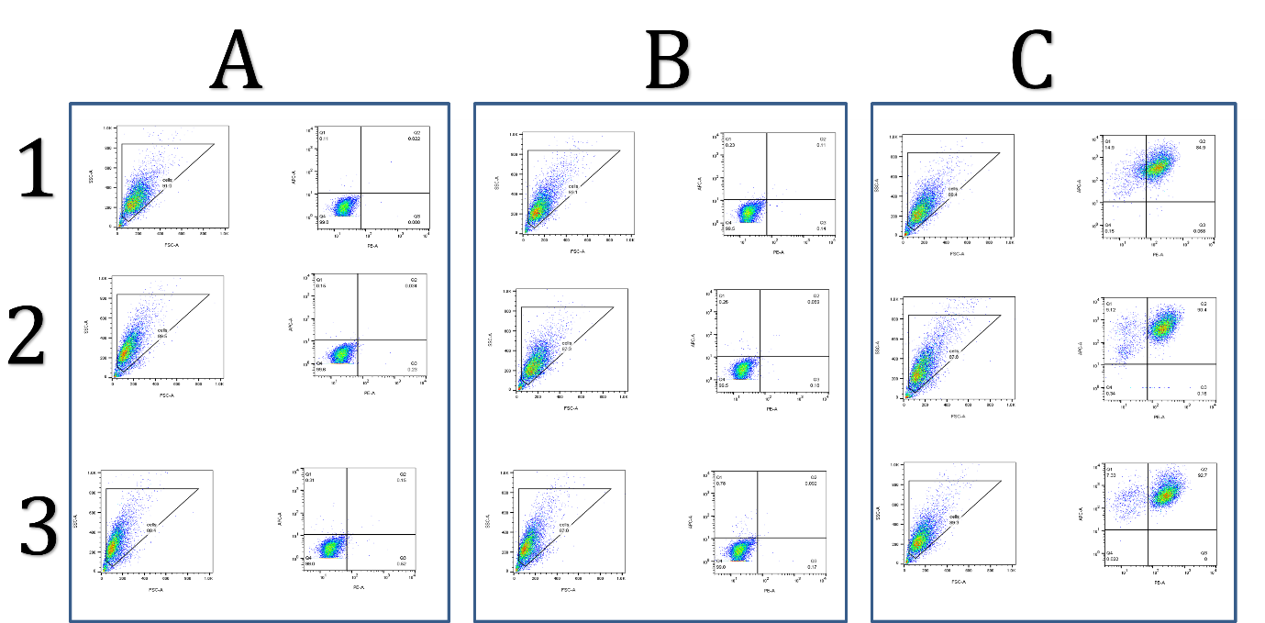

Supplimntary Figure 6. Flow cytometry analysis profile of the cultured human IPS cells at passage 34: (A) Flow cytometry plots of unstained human iPS cells; (B) flow cytometry plots of the isotope control; (C) the plot shows the percentage of double positive cells stained with internal protein Nanog-PE and cell surface protein SSEA4-APC.

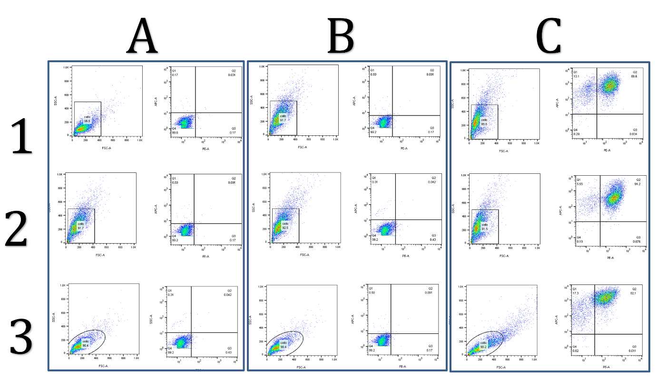

Supplementary Figure 7. Flow cytometry analysis profile of the cultured human IPS cells at passage 39: (A) Flow cytometry plots of unstained human IPSCs; (B) flow cytometry plots of the isotope control; (C) The plot shows the percentage of double positive cells stained with internal protein Nanog-PE and cell surface protein SSEA4-APC

