Supplementary data
ORIGINAL RESEARCH
Jin Cao et al
One-step fabrication of multifunctional PLGA-HMME-DTX@MnO₂ nanoparticles for enhanced chemo-sonodynamic antitumor treatment
Jin Cao^{1,#}, Mingxue Zheng^{1.#}, Zhenyan Sun¹, Zhiye Li¹, Xueyong Qi^{1,*}, Song Shen^{1,*}

¹School of Pharmacy, Jiangsu University, 301 Xuefu Road, 212013, Zhenjiang, Jiangsu, P.R.China

#These authors contributed equally to this work.
*Correspondence: Song Shen; Xueyong Qi
School of Pharmacy, Jiangsu University, 301 Xuefu Road, 212013, Zhenjiang, Jiangsu, P.R.China
Tel +86-0511-88795939
Email jsda.shensong@163.com; qixyemail@163.com

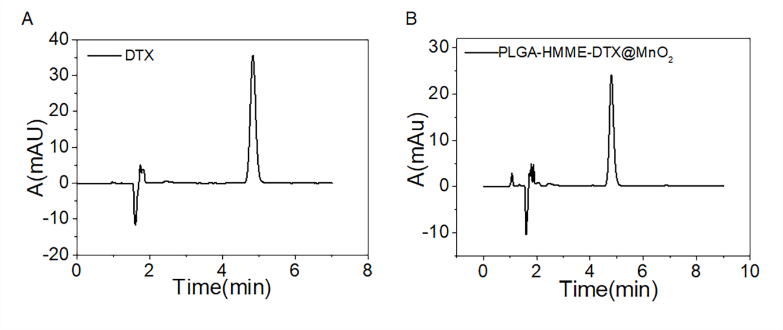
Figure S1. Chromatogram for DTX by HPLC. A) free DTX. B) DTX in PLGA-HMME-DTX@MnO₂.

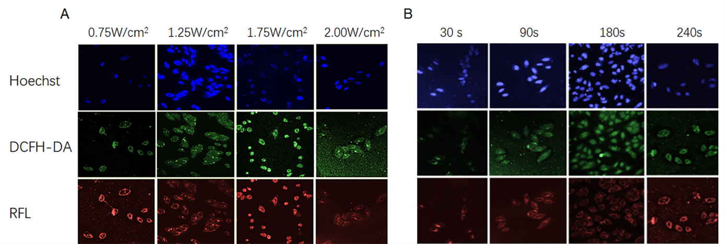
Figure S2. Cellular ROS generation in MCF-7 cells under different ultrasonic power (A), and with various duration (B).

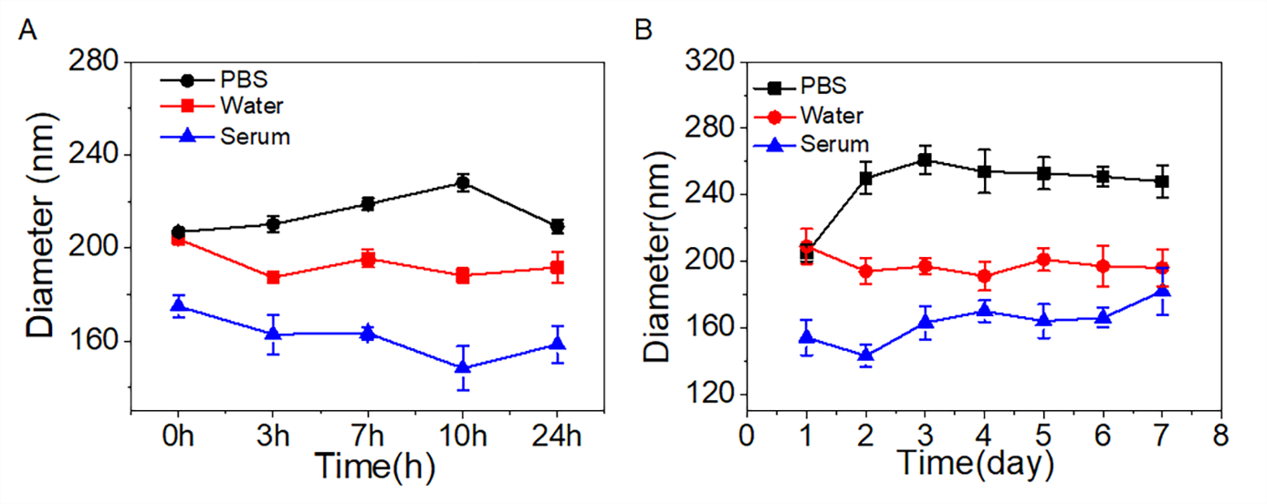
Figure S3. Particle size stability of PHD@MnO₂ nanoparticles in different media. A) within 24 hours. B) within 7 days.

Table S1. Body weights of mice in different groups
Group | Control | US | HMME+US | PH+US | PHD | PHD+US | PHD@MnO₂+US
y 0 | 24.62±1.44 | 24.94±1.22 | 25.14±1.83 | 24.52±1.74 | 23.66±1.42 | 24.72±1.61 | 23.06±2.67
Day 3 | 26.4±1.82 | 26.04±1.62 | 26.26±1.94 | 26.42±1.17 | 25.22±2.14 | 25.66±1.70 | 25.84±2.79
Day 6 | 28.14±1.38 | 27.98±2.11 | 27.12±1.39 | 27.24±1.36 | 27.38±1.81 | 26.46±2.12 | 29.06±2.54
Day 9 | 28.58±1.00 | 28.62±1.29 | 25.98±1.46 | 28.923±2.55 | 28.34±2.48 | 27.78±1.99 | 31.06±2.60
Day 12 | 28.92±1.75 | 28.26±2.40 | 25.5±1.78 | 29.38±1.95 | 30.24±2.21 | 29.94±3.62 | 33.94±1.52
Day 15 | 29.04±1.22 | 30.02±1.72 | 29.06±1.00 | 31.7±2.70 | 31.68±1.68 | 33.88±2.73 | 35.28±1.48

Table S2. Tumor volumes of mice in different groups
Group | Control | US | HMME+US | PH+US | PHD | PHD+US | PHD@MnO₂+US
Day 0 | 172.6±99.2 | 161.6±74.5 | 121.6±37.3 | 208±103.7 | 153.4±129.5 | 132.1±81.3 | 91.7±32.9
Day 3 | 618.7±117.1 | 457.7±121.3 | 166.3±30.5 | 351.6±115 | 325.4±131.4 | 232.4±111.6 | 101.1±38.2
Day 6 | 689.8±238.2 | 592.2±214.7 | 228.5±190.5 | 490.2±277 | 401.4±292.6 | 247.4±95.4 | 120±40.2
Day 9 | 812±258.7 | 718.2±377.8 | 289±28.4 | 539±252.9 | 544.8±339.4 | 498.1±263 | 251.8±150.7
Day 12 | 1080.3±719.8 | 833.4±82.9 | 399.4±128.2 | 681.6±254.4 | 796.6±423.2 | 587.2±273.2 | 214±171
Day 15 | 1895±483.5 | 1759±332.5 | 439.8±178.5 | 800.6±355.9 | 844.2±348.2 | 733.6±328.3 | 232.6±166.2

