Characterization of patients with chronic obstructive pulmonary disease initiating single-inhaler long-acting muscarinic antagonist/long-acting β₂-agonist dual therapy in a primary care setting in England
Gema Requena,¹ Victoria Banks,² Alexandrosz Czira,¹ Robert Wood,² Theo Tritton,² Rosie Wild,² Chris Compton,¹ Maria Duarte,¹ Afisi S. Ismaila^{3,4}
¹Value Evidence and Outcomes, Epidemiology, GlaxoSmithKline, R&D Global Medical, Brentford, Middlesex, UK; ²Real-world Evidence, Adelphi Real World, Bollington, Cheshire, UK; ³Value Evidence and Outcomes, GlaxoSmithKline, Collegeville, PA, USA; ⁴Department of Health Research Methods, Evidence and Impact, McMaster University, Hamilton, ON, Canada
Correspondence: Gema Requena
Address: Epidemiology, Value Evidence and Outcomes, R&D Global Medical, GlaxoSmithKline, Brentford, Middlesex, UK
Tel: +44 20 80476893
Email: gema.x.requena@gsk.com

Supplementary Materials
Supplementary Figure 1. Respiratory therapies prescribed during the baseline period (non-triple users cohort)
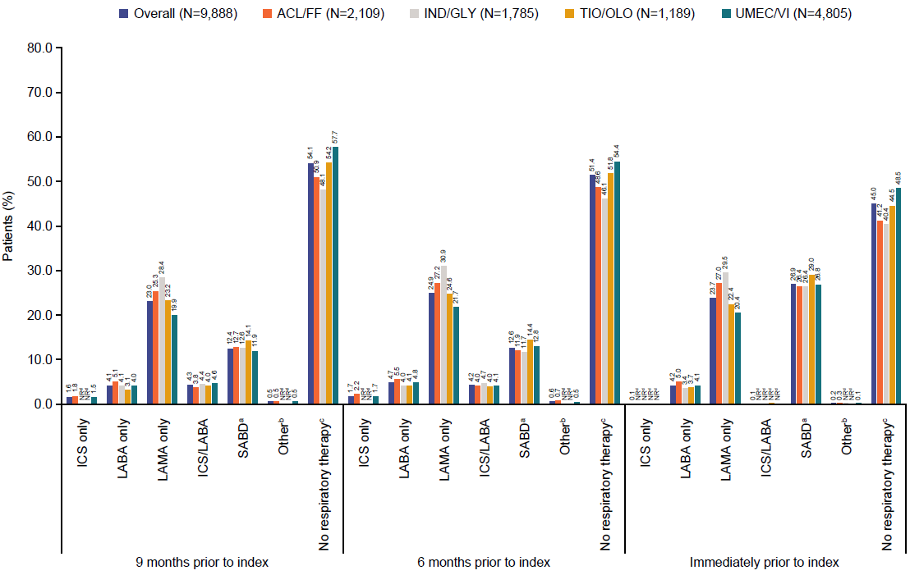
ªIncluded treatment with SABA, SAMA or SABA/SAMA fixed and open combinations; ^{b}included phosphodiesterase-4 inhibitors, methylxanthines, and treatment combinations not reflected elsewhere; ^{c}no ICS, LABA, LAMA, ICS/LABA, SABD or Other category use;
^{d}Results based on small numbers of patients (n<5) were suppressed, as well as the next-smallest value to protect primary suppression.
ACL, aclidinium; FF, formoterol fumarate; GLY, glycopyrronium; ICS, inhaled corticosteroid; IND, indacaterol; LABA, long-acting β₂-agonist; LAMA, long-acting muscarinic antagonist; NR, not reported; OLO, olodaterol; SABA, short-acting β₂-agonist; SABD, short-acting bronchodilator; SAMA, short-acting muscarinic antagonist; TIO, tiotropium bromide; UMEC, umeclidinium; VI, vilanterol.
Supplementary Figure 2. Mean number of respiratory therapies prescribed during the baseline period (non-triple users cohort)
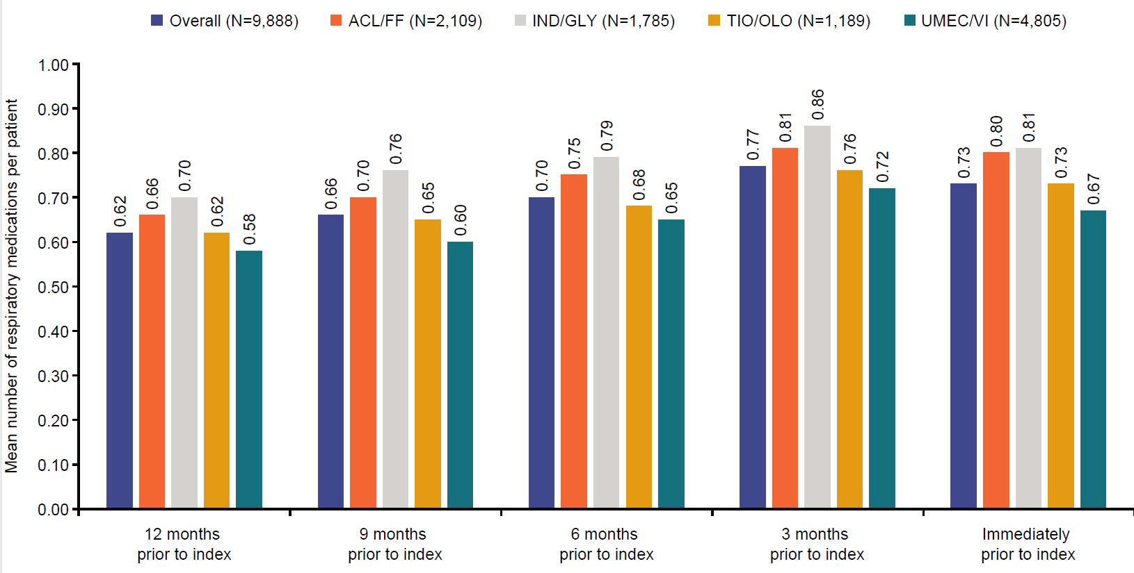
ACL, aclidinium; FF, formoterol fumarate; GLY, glycopyrronium; IND, indacaterol; OLO, olodaterol; TIO, tiotropium bromide; UMEC, umeclidinium; VI, vilanterol.
Supplementary Figure 3. All-cause HCRU during the baseline period (non-triple users cohort)
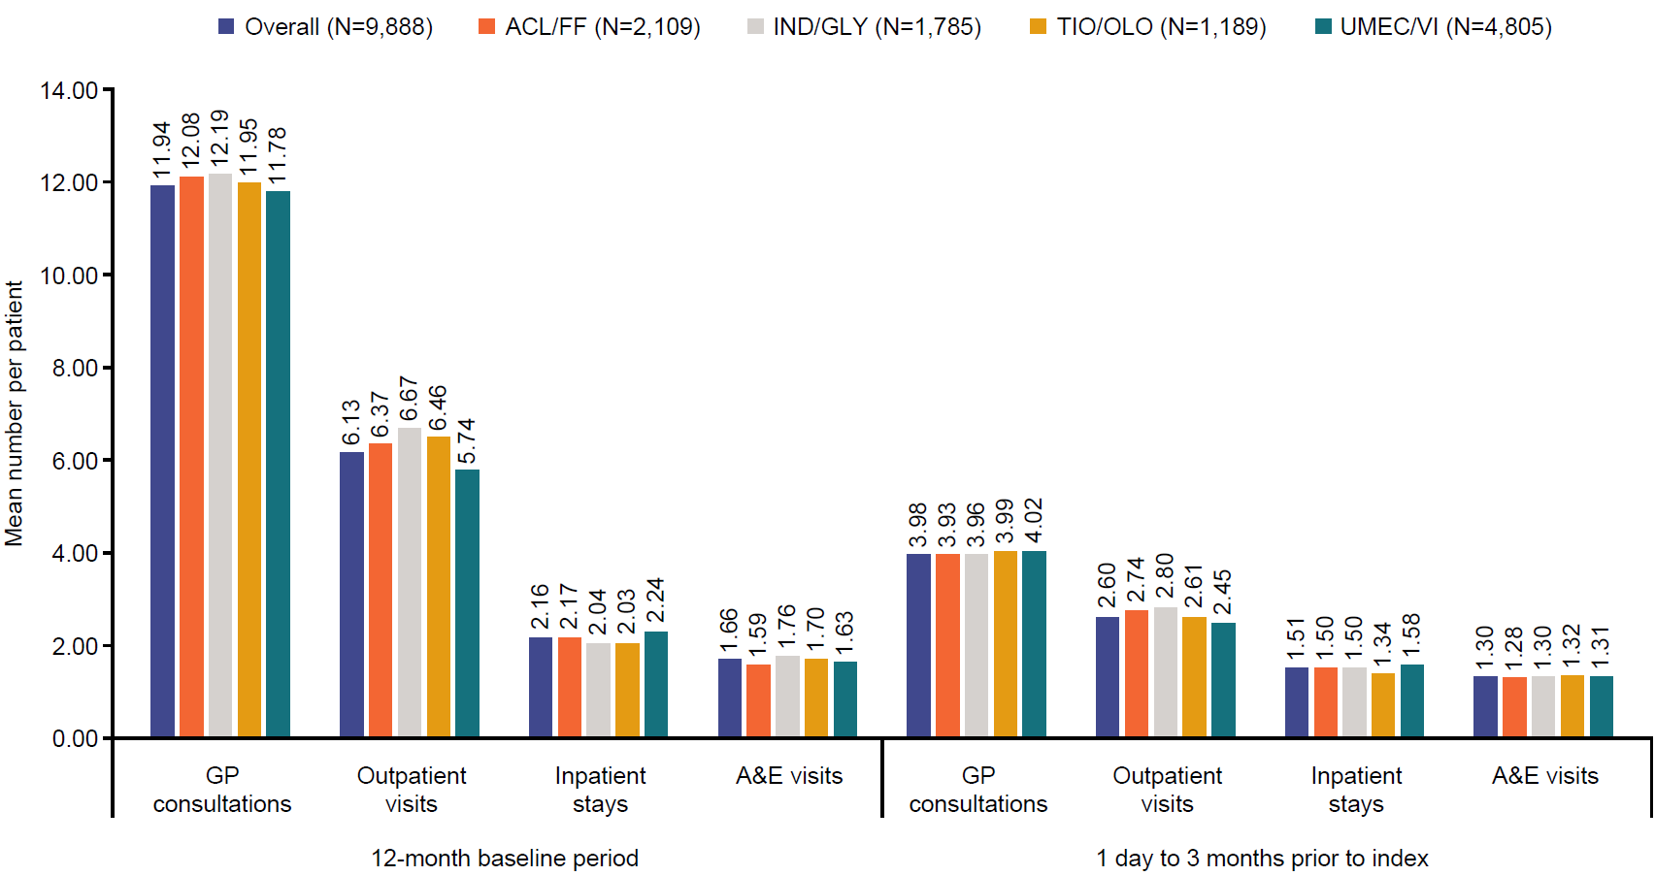
A&E, accident and emergency, ACL, aclidinium; FF, formoterol fumarate; GLY, glycopyrronium; GP, general practitioner; IND, indacaterol; OLO, olodaterol; TIO, tiotropium bromide; UMEC, umeclidinium; VI, vilanterol.
Supplementary Figure 4. All-cause costs during the baseline period (non-triple users cohort)
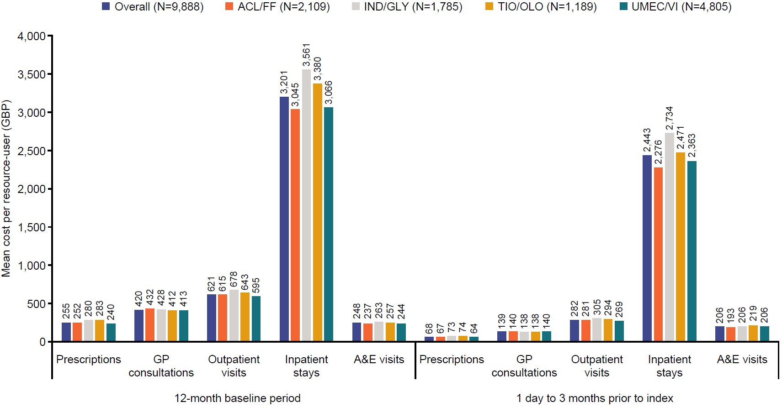
A&E, accident and emergency; ACL, aclidinium; FF, formoterol fumarate; GBP, British pound sterling; GLY, glycopyrronium; GP, general practitioner; IND, indacaterol; OLO, olodaterol; TIO, tiotropium bromide; UMEC, umeclidinium; VI, vilanterol.
Supplementary Table 1. CPRD diagnostic codes for COPD used in this study
Medical code ID | Term
909711000006111 | RFC COPD
909721000006115 | RFC Emphysema
1882421000006113 | 1 COPD exacerbation in past year
1882441000006118 | 2 COPD exacerbations in past year
1882431000006111 | ≥3 COPD exacerbations in past year
424365019 | Acute infective exacerbation of chronic obstructive airways disease
2010061000006113 | Acute non-infective exacerbation of COPD
1823851000006119 | COPD confirmed
11932331000006115 | COPD GOLD group A
11932341000006113 | COPD GOLD group B
11932351000006110 | COPD GOLD group C
11932361000006112 | COPD GOLD group D
977891000006112 | COPD A&E attendance since last visit
977901000006111 | Emergency COPD admission since last appointment
299001000000116 | COPD disturbs sleep
299031000000110 | COPD does not disturb sleep
998281000006115 | Multiple COPD emergency hospital admissions
475431013 | COPD
555471000006114 | Chronic obstructive airways disease
990641000006110 | COPD NOS
285100019 | Emphysematous bronchitis
640491000006111 | Emphysema
301460019 | Chronic bullous emphysema
301468014 | Chronic bullous emphysema NOS
301477019 | Emphysema NOS
457168017 | Mild COPD
457169013 | Moderate COPD
457171013 | Severe COPD
516801000000112 | Very severe COPD
216596014 | End stage chronic obstructive airways disease
301539010 | Other specified chronic obstructive airways disease
301545019 | Chronic obstructive airways disease NOS
1222335015 | COPD NOS
885311000006116 | COPD NOS
301572010 | Chronic emphysema due to chemical fumes
851261000006116 | Chronic bronchitis, acute exacerbation
2160051010 | Admit COPD emergency
990651000006112 | Chronic airway obstruction NOS
105519017 | Chronic bronchitis
508561017 | Simple chronic bronchitis
508562012 | Chronic catarrhal bronchitis
301444018 | Simple chronic bronchitis NOS
123588010 | Mucopurulent chronic bronchitis
885281000006118 | Mucopurulent chronic bronchitis
506053014 | Purulent chronic bronchitis
139979010 | Fetid chronic bronchitis
301448015 | Mucopurulent chronic bronchitis NOS
285104011 | Obstructive chronic bronchitis
301451010 | Chronic wheezy bronchitis
301453013 | AECOPD
301455018 | Obstructive chronic bronchitis NOS
301456017 | Mixed simple and mucopurulent chronic bronchitis
301457014 | Other chronic bronchitis
87480013 | Chronic tracheobronchitis
301458016 | Other chronic bronchitis NOS
301459012 | Chronic bronchitis NOS
301463017 | Segmental bullous emphysema
301464011 | Zonal bullous emphysema
27096010 | Giant bullous emphysema
396108018 | Bullous emphysema with collapse
9337016 | Panlobular emphysema
113497011 | Centrilobular emphysema
301469018 | Other emphysema
301470017 | Acute vesicular emphysema
396109014 | Atrophic (senile) emphysema
1230190015 | MacLeod's unilateral emphysema
396110016 | Other emphysema NOS
161781000006116 | Sawyer – Jones syndrome
1222334016 | Other specified COPD
555461000006119 | COPD with acute lower respiratory infection
553211000006119 | COPD with acute exacerbation, unspecified
885301000006119 | Chronic airway obstruction NOS
301835010 | [X]Other emphysema
301836011 | [X]Other specified COPD
1763751000006117 | GP out of hours notified of COPD care plan
A&E, accident and emergency; AECOPD, acute exacerbation of COPD; COPD, chronic obstructive pulmonary disease; GOLD, Global Initiative for Chronic Obstructive Lung Disease; GP, general practitioner; NOS, nitric oxide synthase; RFC, residual functional capacity

Supplementary Table 2. Baseline demographics and clinical characteristics by cohort and by index LAMA/LABA treatment for incident users and IMT users cohort
 | Incident users |  |  |  | IMT users
 | ACL/FF (N=2,344) | IND/GLY (N=1,999) | TIO/OLO (N=1,333) | UMEC/VI (N=5,315) | ACL/FF (N=558) | IND/GLY (N=392) | TIO/OLO (N=358) | UMEC/VI (N=1,655)
Age at index, years, mean (SD) | 69.4 (10.3) | 69.4 (10.2) | 69.6 (10.3) | 69.6 (10.6) | 68.8 (10.1) | 69.4 (10.5) | 69.4 (10.5) | 68.3 (10.8)
Female, n (%) | 979 (41.8) | 926 (46.3) | 638 (47.9) | 2,335 (43.9) | 219 (39.3) | 169 (43.1) | 164 (45.8) | 723 (43.7)
Region, n (%)  North East  North West  Yorkshire & The Humber  East Midlands  West Midlands  East of England  South West  South Central  London  South East Coast | 60 (2.6)  266 (11.4)  88 (3.8)  70 (3.0)  602 (25.7)  55 (2.4)  508 (21.7)  239 (10.2)  278 (11.9)  178 (7.6) | 270 (13.5)  460 (23.0)  122 (6.1)  16 (0.8)  146 (7.3)  90 (4.5)  376 (18.8)  86 (4.3)  238 (11.9)  195 (9.8) | 141 (10.6)  349 (26.2)  87 (6.5)  13 (1.0)  71 (5.3)  41 (3.1)  253 (19.0)  251 (18.8)  60 (4.5)  67 (5.0) | 112 (2.1)  996 (18.7)  541 (10.2)  57 (1.1)  957 (18.0)  176 (3.3)  1,271 (23.9)  630 (11.9)  307 (5.8)  268 (5.0) | 10 (1.8)  58 (10.4)  34 (6.1)  10 (1.8)  161 (28.9)  12 (2.2)  111 (19.9)  40 (7.2)  85 (15.2)  37 (6.6) | 53 (13.5)  90 (23.0)  37 (9.4)  NRª  NRª  23 (5.9)  75 (19.1)  21 (5.4)  39 (10.0)  35 (8.9) | 58 (16.2)  73 (20.4)  28 (7.8)  NRª  15 (4.2)  NRª  71 (19.8)  80 (22.4)  12 (3.4)  13 (3.6) | 16 (1.0)  287 (17.3)  245 (14.8)  15 (0.9)  239 (14.4)  53 (3.2)  444 (26.8)  194 (11.7)  75 (4.5)  87 (5.3)
BMI, kg/m^{2b}  n  mean (SD) | 2,044  27.8 (6.6) | 1,776  27.6 (6.9) | 1,203  27.5 (6.5) | 4,645  27.7 (6.6) | 460  27.7 (6.3) | 325  27.4 (7.3) | 310  27.1 (6.9) | 1,364  27.4 (6.9)
FEV₁ % predicted^{c}  n  mean (SD) | 1,893  60.2 (17.7) | 1,522  60.7 (17.6) | 1,078  61.1 (17.7) | 4,155  60.5 (17.5) | 436  58.9 (18.0) | 276  58.9 (17.4) | 281  61.1 (16.6) | 1,297  59.2 (17.8)
FEV₁/FVC ratio^{c}  n  mean (SD) | 1,738  58.4 (13.1) | 1,489  59.1 (13.3) | 1,014  59.0 (12.7) | 4,108  58.8 (12.7) | 431  57.9 (12.1) | 279  59.2 (13.6) | 277  57.5 (12.1) | 1,320  57.5 (11.6)
Smoking status, n (%)^{b}  Current smoker  Former smoker  Non-smoker  Unknown | 915 (39.0)  1,211 (51.7)  56 (2.4)  162 (6.9) | 886 (44.3)  929 (46.5)  41 (2.1)  143 (7.2) | 554 (41.6)  629 (47.2)  39 (2.9)  111 (8.3) | 2,159 (40.6)  2,611 (49.1)  103 (1.9)  442 (8.3) | 233 (41.8)  273 (48.9)  8 (1.4)  44 (7.9) | 192 (49.0)  175 (44.6)  5 (1.3)  20 (5.1) | 162 (45.3)  158 (44.1)  6 (1.7)  32 (8.9) | 748 (45.2)  754 (45.6)  31 (1.9)  122 (7.4)
mMRC Dyspnea scale score, n (%)^{c}  1^{d}  2  3  4  5e  Unknown | 269 (11.5)  905 (38.6)  508 (21.7)  195 (8.3)  26 (1.1)  441 (18.8) | 238 (11.9)  654 (32.7)  567 (28.4)  199 (10.0)  27 (1.4)  314 (15.7) | 144 (10.8)  488 (36.6)  316 (23.7)  115 (8.6)  19 (1.4)  251 (18.8) | 641 (12.1)  1970 (37.1)  1125 (21.2)  358 (6.7)  32 (0.6)  1,189 (22.4) | 65 (11.7)  151 (27.1)  65 (11.7)  NRª  NRª  253 (45.3) | 49 (12.5)  94 (24.0)  64 (16.3)  23 (5.9)  6 (1.5)  156 (39.8) | 38 (10.6)  78 (21.8)  61 (17.0)  NRª  NRª  156 (43.6) | 191 (11.5)  444 (26.8)  199 (12.0)  NRª  NRª  767 (46.3)
Comorbidities, mean (SD) | 1.77 (1.43) | 1.88 (1.44) | 1.86 (1.46) | 1.79 (1.45) | 1.67 (1.38) | 1.75 (1.43) | 1.81 (1.37) | 1.67 (1.45)
Comorbidities^{f}, n (%)  Depression  Anxiety  GERD  Acute myocardial infarction  Congestive heart failure  Stroke  Bronchiectasis  Dementia/cognitive impairment  Rheumatoid/osteoarthritis | 920 (39.3)  615 (26.2)  522 (22.3)  261 (11.1)  273 (11.7)  247 (10.5)  66 (2.8)  264 (11.3)  980 (41.8) | 864 (43.2)  562 (28.1)  488 (24.4)  253 (12.7)  246 (12.3)  249 (12.5)  59 (3.0)  208 (10.4)  824 (41.2) | 562 (42.2)  368 (27.6)  303 (22.7)  163 (12.2)  165 (12.4)  184 (13.8)  44 (3.3)  141 (10.6)  548 (41.1) | 2,223 (41.8)  1,370 (25.8)  1,197 (22.5)  640 (12.0)  650 (12.2)  691 (13.0)  152 (2.9)  504 (9.5)  2,095 (39.4) | 204 (36.6)  133 (23.8)  119 (21.3)  55 (9.9)  54 (9.7)  58 (10.4)  11 (2.0)  62 (11.1)  237 (42.5) | 160 (40.8)  98 (25.0)  82 (20.9)  44 (11.2)  50 (12.8)  43 (11.0)  8 (2.0)  42 (10.7)  160 (40.8) | 147 (41.1)  94 (26.3)  76 (21.2)  41 (11.5)  41 (11.5)  50 (14.0)  10 (2.8)  42 (11.7)  148 (41.3) | 676 (40.9)  403 (24.4)  329 (19.9)  186 (11.2)  182 (11.0)  205 (12.4)  39 (2.4)  132 (8.0)  618 (37.3)
Current asthma diagnosis^{g}, n (%) | 352 (15.0) | 278 (13.9) | 183 (13.7) | 676 (12.7) | 62 (11.1) | 37 (9.4) | 30 (8.4) | 145 (8.8)
GOLD 2019 group^{h}, n (%)  A  B  C  D | 826 (46.8)  500 (25.9)  251 (13.0)  355 (18.4) | 575 (33.5)  533 (31.0)  228 (13.3)  383 (22.3) | 458 (41.3)  301 (27.1)  127 (11.5)  223 (20.1) | 1,852 (43.8)  1,016 (24.0)  564 (13.3)  797 (18.9) | 147 (46.2)  64 (20.1)  58 (18.2)  49 (15.4) | 86 (34.8)  64 (25.9)  40 (16.2)  57 (23.1) | 91 (41.0)  57 (25.7)  18 (8.1)  56 (25.2) | 454 (48.1)  169 (17.9)  141 (15.0)  180 (19.1)
Moderate-to-severe AECOPDs^{i}  Patients with AECOPD, n (%)  Mean (SD)  Moderate AECOPDs^{i}  Patients with AECOPD, n (%)  Mean (SD)  Severe AECOPDs^{i}  Patients with AECOPD, n (%)  Mean (SD) | 732 (31.2)  0.4 (0.8)  619 (26.4)  0.4 (0.7)  140 (6.0)  0.7 (0.3) | 702 (35.1)  0.5 (0.8)  549 (27.5)  0.4 (0.7)  210 (10.5)  0.1 (0.4) | 425 (31.2)  0.4 (0.8)  330 (24.8)  0.3 (0.7)  127 (9.5)  0.1 (0.4) | 1,662 (31.3)  0.4 (0.7)  1,361 (25.6)  0.3 (0.7)  404 (7.6)  0.1 (0.3) | 164 (29.4)  0.4 (0.7)  138 (24.7)  0.3 (0.7)  28 (5.0)  0.1 (0.2) | 138 (35.2)  0.5 (0.7)  107 (27.3)  0.3 (0.6)  40 (10.2)  0.1 (0.4) | 113 (31.6)  0.4 (0.8)  84 (23.5)  0.3 (0.7)  38 (10.6)  0.1 (0.4) | 494 (29.9)  0.4 (0.7)  410 (24.8)  0.3 (0.6)  105 (6.3)  0.1 (0.3)
Blood eosinophil count^{j}, cells/µL  n  Mean (SD) | 1,299  0.2 (0.2) | 1,159  0.2 (0.1) | 760  0.2 (0.2) | 2,958  0.2 (0.2) | 309  0.2 (0.1) | 241  0.2 (0.1) | 220  0.2 (0.2) | 941  0.2 (0.2)
ªResults based on small numbers of patients (n<5) were suppressed, as well as the next-smallest value to protect primary suppression.
^{b}most recent score/status at any time in a patient’s history prior to and including index; ^{c}most recent score in the 24 months prior to index; ^{d}not troubled by breathlessness except on strenuous exercise; ^{e}too breathless to leave the house; ^{f}present, prior to and including index; ^{g}in the 24 months prior to and including index; ^{hi}a composite measure of COPD severity using AECOPD events in the prior 12 months and the most recent MRC measurement in the 24 months prior to and including the index date (A: ≤1 moderate exacerbation in 12 months and MRC 1–2, B: ≤1 moderate exacerbation in 12 months and MRC ≥3, C: ≥2 moderate/severe OR ≥1 severe exacerbation in 12 months and MRC 1–2, D: ≥2 moderate/severe OR ≥1 severe exacerbation in 12 months and MRC ≥3); ^{i}in the 12 months to prior and including index date; ^{j}most recent measurement in the 12 months prior to and including index.
ACL, aclidinium; AECOPD, acute exacerbations of COPD; BMI, body mass index; COPD, chronic obstructive pulmonary disorder; FEV₁, forced expiratory volume; FF, formoterol fumarate; FVC, forced vital capacity; GERD, gastroesophageal reflux disease; GOLD, Global Initiative for Chronic Obstructive Lung Disease; GLY, glycopyrronium; IMT, initial maintenance therapy; IND, indacaterol; MRC, Medical Research Council; NR, not reported; OLO, olodaterol; SD, standard deviation; TIO, tiotropium bromide; UMEC, umeclidinium; VI, vilanterol.
Supplementary Table 3. Proportion of patients with all-cause HCRU during the baseline period (non-triple users cohort)
 | Overall (N=9,888) | ACL/FF (N=2,109) | IND/GLY (N=1,785) | TIO/OLO (N=1,189) | UMEC/VI (N=4,805)
12-month baseline period
Prescriptions, n (%) | 9,707 (98.5) | 2,069 (98.3) | 1,759 (98.71) | 1,167 (98.7) | 4,712 (98.5)
GP consultations, n (%) | 9,822 (99.3) | 2,099 (99.5) | 1,769 (99.10) | 1,184 (99.6) | 4,770 (99.3)
Outpatient visits, n (%) | 6,691 (67.7) | 1,425 (67.6) | 1,264 (70.81) | 811  (68.2) | 3,191 (66.4)
Inpatient stays, n (%) | 3,389 (34.3) | 695  (33.0) | 675 (37.82) | 439  (36.9) | 1,580 (32.9)
A&E visits, n (%) | 2,836 (28.7) | 524  (24.9) | 610 (34.2) | 374  (31.5) | 1,328 (27.6)
1 day to ≤3 months prior to index
Prescriptions, n (%) | 9,318 (94.6) | 1,989 (94.5) | 1,697 (95.2) | 1,121 (94.8) | 4,511 (94.3)
GP consultations, n (%) | 8,801 (89.0) | 1,882 (89.2) | 1,594 (89.3) | 1,070 (90.0) | 4,255 (88.6)
Outpatient visits, n (%) | 4,375 (44.3) | 936  (44.4) | 843  (47.2) | 531  (44.7) | 2,065 (43.0)
Inpatient stays, n (%) | 1,452 (14.7) | 268  (12.7) | 321  (18.0) | 190  (16.0) | 673  (14.0)
A&E visits, n (%) | 1,234 (12.5) | 213  (10.1) | 292  (16.4) | 159  (13.4) | 570  (11.9)
A&E, accident and emergency; ACL, aclidinium; FF, formoterol fumarate; IND, indacaterol; GLY, glycopyrronium; GP, general practitioner; HCRU, healthcare resource use; OLO, olodaterol; TIO, tiotropium bromide; UMEC, umeclidinium; VI, vilanterol.

Supplementary Table 4. Cumulative length of inpatient stays during the baseline period (non-triple users cohort)
 | Overall (n=9,888) | ACL/FF (n=2,109) | IND/GLY (n=1,785) | TIO/OLO (n=1,189) | UMEC/VI (n=4,805)
12-month baseline period
Cumulative length of COPD-related inpatient stays, days, mean (SD) | n=2,117 | n=406 | n=465 | n=280 | n=966
 | 5.37 (11.26) | 4.04 (8.17) | 6.03 (11.27) | 6.06 (12.62) | 5.4  (11.9)
Cumulative length of all-cause inpatient stays, days, mean (SD) | n=3,389 | n=695 | n=675 | n=439 | n=1,580
 | 4.92 (12.65) | 3.83 (9.34) | 5.73 (12.88) | 5.69 (13.94) | 4.84 (13.38)
1 day to ≤3 months prior to index
Cumulative length of COPD-related inpatient stays, days, mean (SD) | n=1,008 | n=174 | n=248 | n=133 | n=453
 | 4.84 (8.30) | 3.79 (7.20) | 5.27 (8.43) | 5.53 (8.23) | 4.81 (8.61)
Cumulative length of all-cause inpatient stays, days, mean (SD) | n=1,452 | n=268 | n=321 | n=190 | n=673
 | 3.95 (7.62) | 3.14 (6.53) | 4.62 (8.01) | 4.41 (7.53) | 3.82 (7.82)
ACL, aclidinium; COPD, chronic obstructive pulmonary disorder; FF, formoterol fumarate; IND, indacaterol; GLY, glycopyrronium; OLO, olodaterol; SD, standard deviation; TIO, tiotropium bromide; UMEC, umeclidinium; VI, vilanterol.

