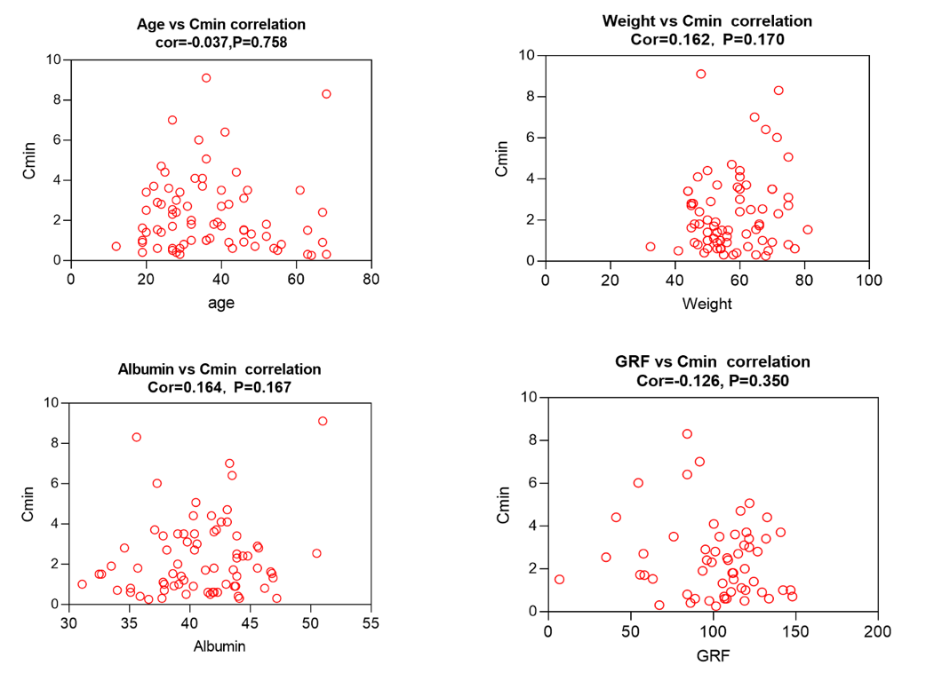
Supplementary Figure 1. Correlation between Serum trough concentration (Cmin) and age, weight, albumin, eGFR

