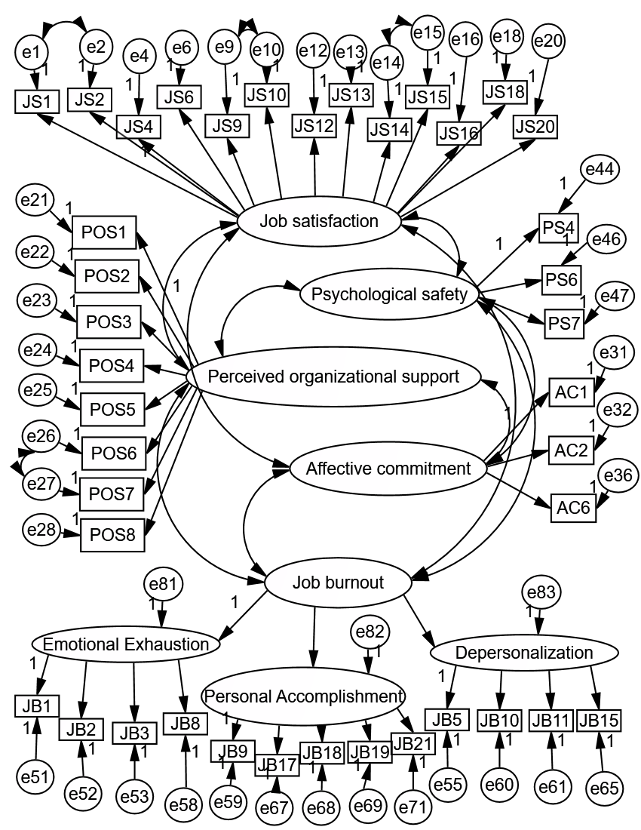

Supplementary Figure 1 Validity test of the adopted scales.
Abbreviations: JS, job satisfaction; POS, perceived organizational support; PS, psychological safety; AC, affective commitment; JB, job burnout.

In multiple-group analysis, we examined whether the mediation model held separately for doctors and nurses group (n = 198, 74.16%) and for medical technicians and administrative staff group (n = 69, 25.84%). Mediation analysis of these two groups was conducted with SPSS PROCESS macro, where gender, age, and annual income were included as control variables. Results (see Supplementary Tables 1 and 2) showed that the mediating effect of job satisfaction in the relationship between psychological safety and affective commitment was significant in both two groups. However, the mediating effect of job burnout and the direct effect of psychological safety were only significant in the group of doctors and nurses.

Supplementary Table 1 Testing the mediating effect of job satisfaction and job burnout between psychological safety and affective commitment among doctors and nurses
 | Model 1  (DV: Job satisfaction) |  |  |  | Model 2  (DV: Job burnout) |  |  |  | Model 3  (DV: Affective commitment) |  |  |  | Model 4  (DV: Affective commitment)
Independent variables | B | SE | 95% CI |  | B | SE | 95% CI |  | B | SE | 95% CI |  | B | SE | 95% CI
Constant | 1.763*** | 0.290 | 1.191~2.335 |  | 4.740*** | 0.054 | 3.847~5.633 |  | 2.512*** | 0.520 | 1.487~3.537 |  | 1.711** | 0.616 | 0.495~2.927
Gender | 0.085 | 0.086 | -0.083~0.254 |  | -0.065 | 0.134 | -0.329~0.198 |  | 0.172 | 0.153 | -0.130~0.475 |  | 0.075 | 0.117 | -0.156~0.305
Age | 0.000 | 0.007 | -0.013~0.013 |  | 0.005 | 0.010 | -0.015~0.026 |  | -0.003 | 0.012 | -0.026~0.021 |  | -0.002 | 0.009 | -0.020~0.016
Annual income | -0.025 | 0.084 | -0.191~0.141 |  | 0.017 | 0.132 | -0.242~0.276 |  | 0.044 | 0.151 | -0.254~0.342 |  | 0.072 | 0.115 | -0.155~0.298
Psychological safety | 0.406*** | 0.035 | 0.338~0.474 |  | -0.367*** | 0.054 | -0.474~-0.261 |  | 0.611*** | 0.062 | 0.489~0.734 |  | 0.137* | 0.062 | 0.015~0.258
Job burnout | ⎯ |  |  |  | ⎯ |  |  |  | ⎯ |  |  |  | -0.199** | 0.072 | -0.341~-0.056
Job satisfaction | ⎯ |  |  |  | ⎯ |  |  |  | ⎯ |  |  |  | 0.989*** | 0.113 | 0.767~1.212
R² | 0.418 |  |  |  | 0.194 |  |  |  | 0.337 |  |  |  | 0.621
F | 34.626 |  |  |  | 11.646 |  |  |  | 24.536 |  |  |  | 52.243

Notes: n = 198. DV = dependent variable. Gender: 0 = female, 1 = male. Annual income: 0 = annual income above 100,000 yuan, 1 = annual income equal or below 100,000 yuan. *p < 0.05, **p < 0.01, ***p < 0.001.
Supplementary Table 2 Testing the mediating effect of job satisfaction and job burnout between psychological safety and affective commitment among medical technicians and administrative staff
 | Model 1  (DV: Job satisfaction) |  |  |  | Model 2  (DV: Job burnout) |  |  |  | Model 3  (DV: Affective commitment) |  |  |  | Model 4  (DV: Affective commitment)
Independent variables | B | SE | 95% CI |  | B | SE | 95% CI |  | B | SE | 95% CI |  | B | SE | 95% CI
Constant | 2.032*** | 0.483 | 1.067~2.996 |  | 4.545*** | 0.702 | 3.141~5.948 |  | 3.063*** | 0.860 | 1.345~4.782 |  | 1.834 | 1.020 | -0.204~3.873
Gender | 0.086 | 0.140 | -0.194~0.365 |  | -0.238 | 0.204 | -0.645~0.169 |  | -0.085 | 0.249 | -0.583~0.413 |  | -0.238 | 0.163 | -0.564~0.087
Age | 0.014 | 0.011 | -0.007~0.036 |  | -0.007 | 0.015 | -0.038~0.024 |  | 0.026 | 0.019 | -0.012~0.064 |  | 0.008 | 0.012 | -0.017~0.033
Annual income | -0.217 | 0.136 | -0.489~0.055 |  | 0.285 | 0.198 | -0.110~0.680 |  | -0.557* | 0.242 | -1.041~-0.074 |  | -0.244 | 0.160 | -0.563~0.076
Psychological safety | 2.032*** | 0.483 | 1.067~2.996 |  | -0.269*** | 0.076 | -0.410~-0.118 |  | 0.436*** | 0.093 | 0.251~0.622 |  | 0.029 | 0.074 | -0.119~0.177
Job burnout | ⎯ |  |  |  | ⎯ |  |  |  | ⎯ |  |  |  | -0.237 | 0.126 | -0.489~0.015
Job satisfaction | ⎯ |  |  |  | ⎯ |  |  |  | ⎯ |  |  |  | 1.135*** | 0.183 | 0.768~1.501
R² | 0.377 |  |  |  | 0.211 |  |  |  | 0.309 |  |  |  | 0.721
F | 9.700 |  |  |  | 4.283 |  |  |  | 7.162 |  |  |  | 26.679
Notes: n = 69. DV = dependent variable. Gender: 0 = female, 1 = male. Annual income: 0 = annual income above 100,000 yuan, 1 = annual income equal or below 100,000 yuan. *p < 0.05, ***p < 0.001.

