Supplementary material
Final updated tapentadol popPK model
Table S1. Parameter estimates
Parameter | Estimate | %RSE | [95% CI from bootstrapª]  (shrinkage %)
CL (L/h) | 93.7 | 8.8 | [78.05-110.83]
V (L) | 414 | 7.8 | [351.96-479.17]
Ka (h⁻¹) | 2.2 | 12.8 | [1.68-3.16]
F | 0.344 | 8.5 | [0.29-0.41]
TLAG (h) | 0.266 | 0.7 | [0.26-0.29]
PMA50 (weeks) | 34.4 | 17.2 | [23.89-48.61]
HILL exponent | 1 FIXED | - | -
KAGE-F (weeks ⁻¹) | 0.117 | 19.5 | [0.06-1.66]
Exponent WT on CL | 0.75 FIXED | - | -
Exponent WT on V | 1 FIXED | - | -
IIV CL (ω2) | 0.0931 | 20.7 | (15.8)
IIV V (ω2) | 0.13 | 29.1 | (21.9)
IIV Ka (ω2) | 1.94 | 27.2 | (27.1)
Cov CL-V | 0.0873 | 27.3 | -
Proportional error (σ) | 32.2 | 14.1 | (20.6)
Additive error (ng/mL) | 0.486 | 46.5 | (20.1)
Abbreviations: CI, confidence interval; CL, clearance; Cov, covariance; F, oral bioavailability; HILL, hill coefficient for tapentadol clearance maturation function; IIV, inter-individual variability; Ka, first-order absorption rate constant; KAGE-F, rate constant of age effect on F; ω2, variance; PMA50, postmenstrual age at 50% of full maturation; RSE, relative standard error (derived from the covariance matrix of the estimates as reported by NONMEM®); σ, standard deviation (given as % coefficient of variation); TLAG, absorption lag-time; V, volume of distribution; WT, total bodyweight
Notes: Estimates of CL and V relate to a reference weight of 70 kg. ª Bootstrap analysis was based on 1000 replicates of resampling datasets.

Figure S1. Prediction-corrected visual predictive check plots
A. Linear scale
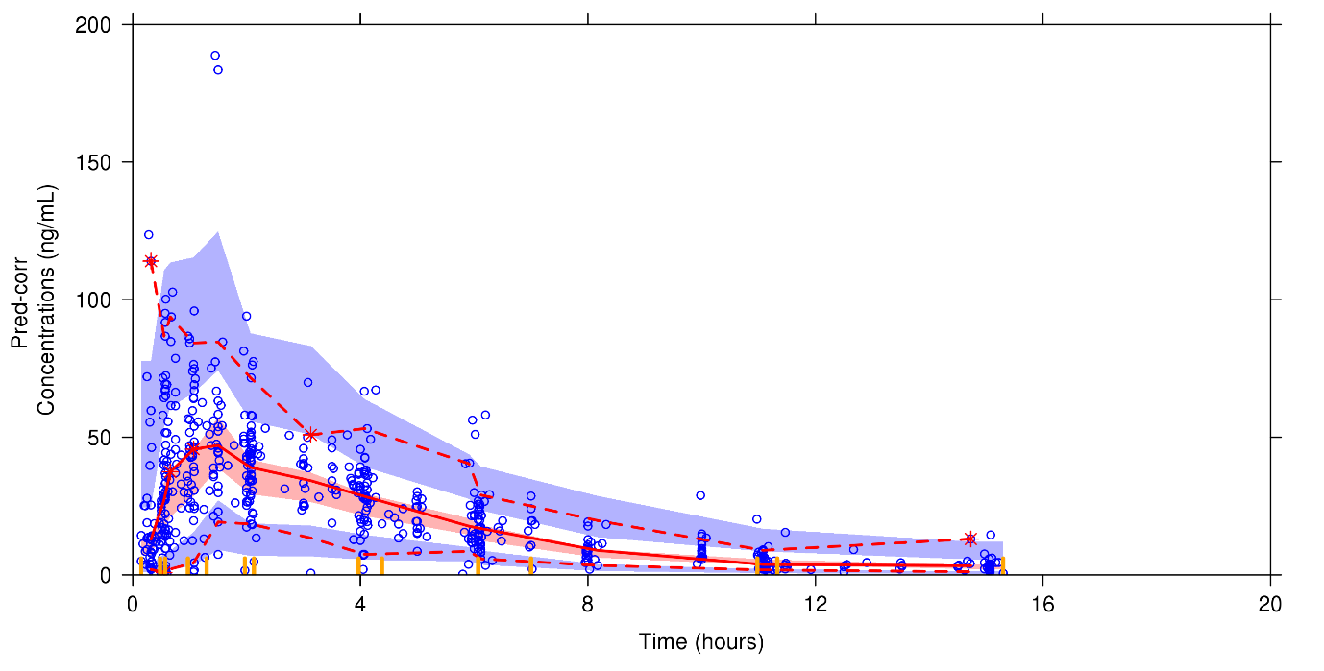
B. Semi-log scale
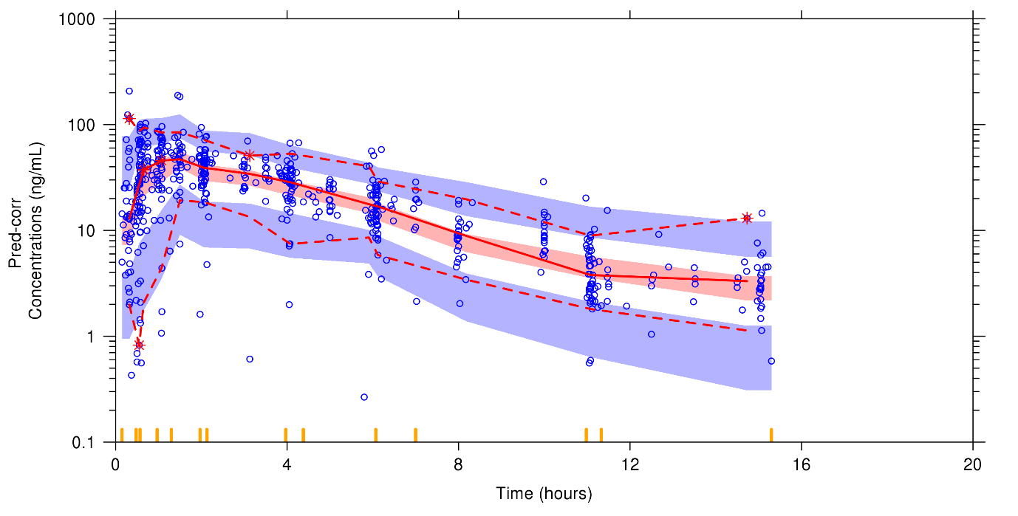

Abbreviation: Pred-corr, prediction-corrected

Joint tapentadol parent-metabolite model
Table S2. Parameter estimates
Parameter | Estimate | RSE % | [95% CI from bootstrapª]  (shrinkage %)
CL (L/h) | 115 | 7.8 | [93.14-139.35]
V (L) | 456 | 6.8 | [378.86-529.21]
Ka (h⁻¹) | 1.61 | 17.6 | [1.23-2.18]
F | 0.409 | 6.3 | [0.34-0.47]
TLAG (h) | 0.246 | 0.8 | [0.24-0.28]
PMA50 (wks) | 62.9 | 21.6 | [40.59-93.81]
HILL exponent | 1 FIXED | - | -
KAGE-F (wks ⁻¹) | 0.117 FIXED | - | -
Exponent WT on CL | 0.75 FIXED | - | -
Exponent WT on V | 1 FIXED | - | -
FMG | 0.55 FIXED | - | -
CLG | 10.5 | 2.5 | [9.97-10.88]
VG | 28.1 | 5.9 | [24.34-31.75]
FMS | 0.15 FIXED | - | -
CLS | 30.9 | 9.7 | [26.07-37.53]
VS | 16.8 | 27.7 | [8.14-24.56]
PMA50M | 41.4 | 4.2 | [37.22-44.36]
HillM | 5.43 | 21.9 | [3.36-9.09]
IIV CL (ω2) | 0.0984 | 24.9 | (13.6)
IIV V (ω2) | 0.165 | 24.2 | (14.5)
IIV Ka (ω2) | 1.55 | 20.4 | (22.1)
Cov CL-V | 0.109 | 27.2 | -
IIV CLG (ω2) | 0.0192 | 34.7 | (39)
IIV CLS (ω2) | 0.155 | 33 | (44.4)
Proportional error – tapentadol (σ) | 34.9 | 14.6 | (14.8)
Proportional error – tapentadol-O-glucuronide (σ) | 38.4 | 9.5 | (8.3)
Proportional error – tapentadol-O-sulfate (σ) | 36.3 | 26.7 | (16)
Abbreviations: CI, confidence interval; CL, clearance; CLG, glucuronide clearance; CLS, sulfate clearance; Cov, covariance; F, tapentadol oral bioavailability; FMG, fraction of tapentadol converted to the glucuronide metabolite; FMS, fraction of tapentadol converted to the sulfate metabolite; Hill, hill coefficient for tapentadol clearance maturation function; HillM, hill coefficient for metabolite clearance maturation function; IIV, inter-individual variability; Ka, first-order absorption rate constant; KAGE-F, rate constant of age effect on F; ω2, variance; PMA50, postmenstrual age at 50% of full maturation of tapentadol clearance; PMA50M, postmenstrual age at 50% of full maturation of metabolite clearance; RSE, relative standard error (derived from the covariance matrix of the estimates as reported by NONMEM®); σ, standard deviation (given as % coefficient of variation); TLAG, absorption lag-time; V, volume of distribution; VG, glucuronide volume of distribution; VS, sulfate volume of distribution; wks, weeks; WT, total bodyweight
Notes: Estimates of CL and V relate to a reference weight of 70 kg. ª Bootstrap analysis was based on 1000 replicates of resampling datasets.

Figure S2. Prediction-corrected visual predictive checks, stratified per analyte. Results are presented on semi-log scale.
A. Tapentadol
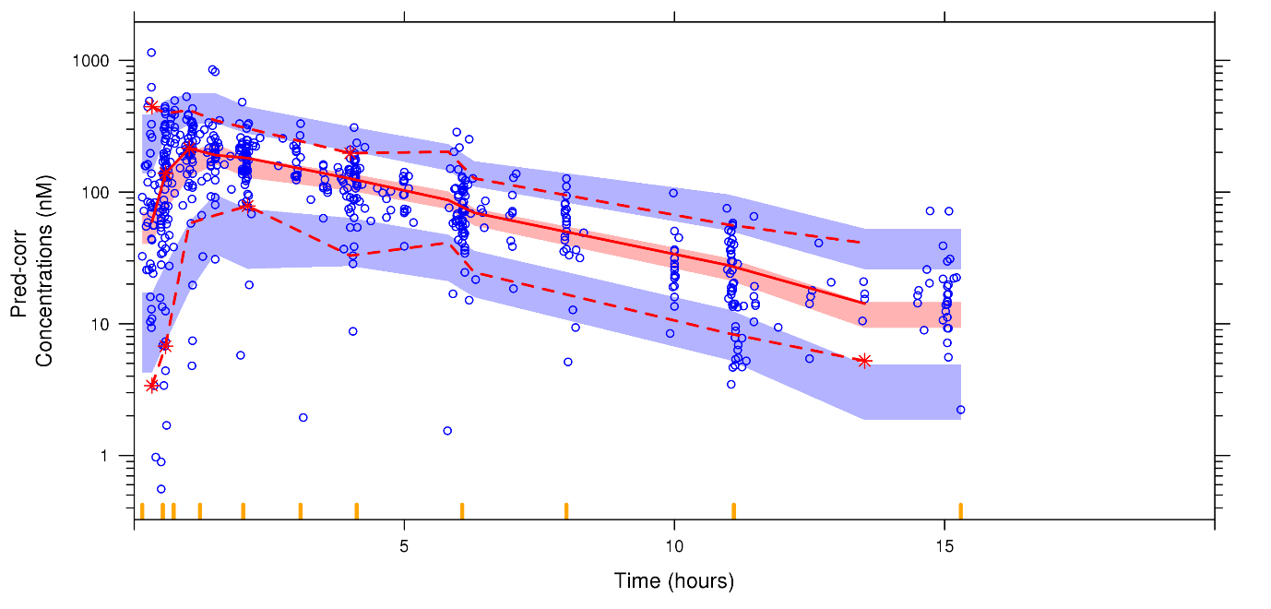

B. Tapentadol-O-glucuronide
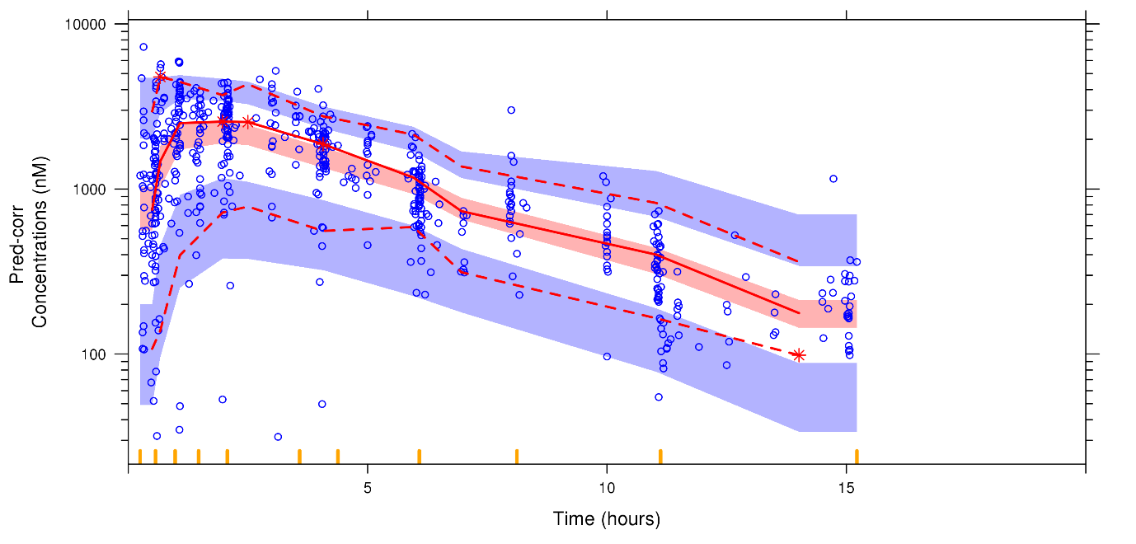
C. Tapentadol-O-sulfate 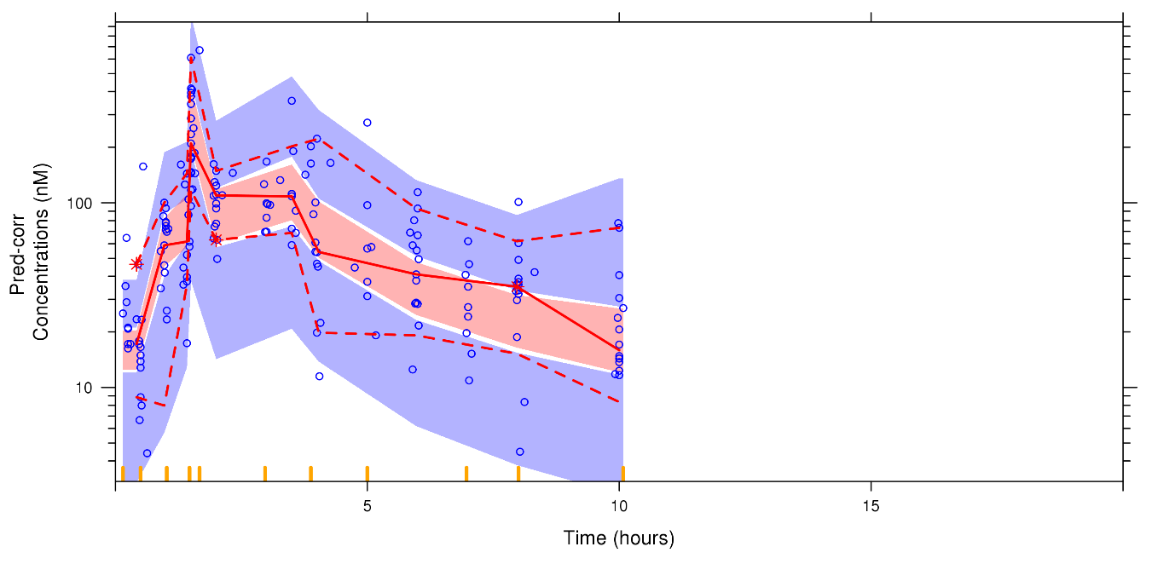
Abbreviation: Pred-corr, prediction-corrected

