Supplementary material
Figure S1: Mechanistic model diagram of the occurrence and development of MTM-HCC
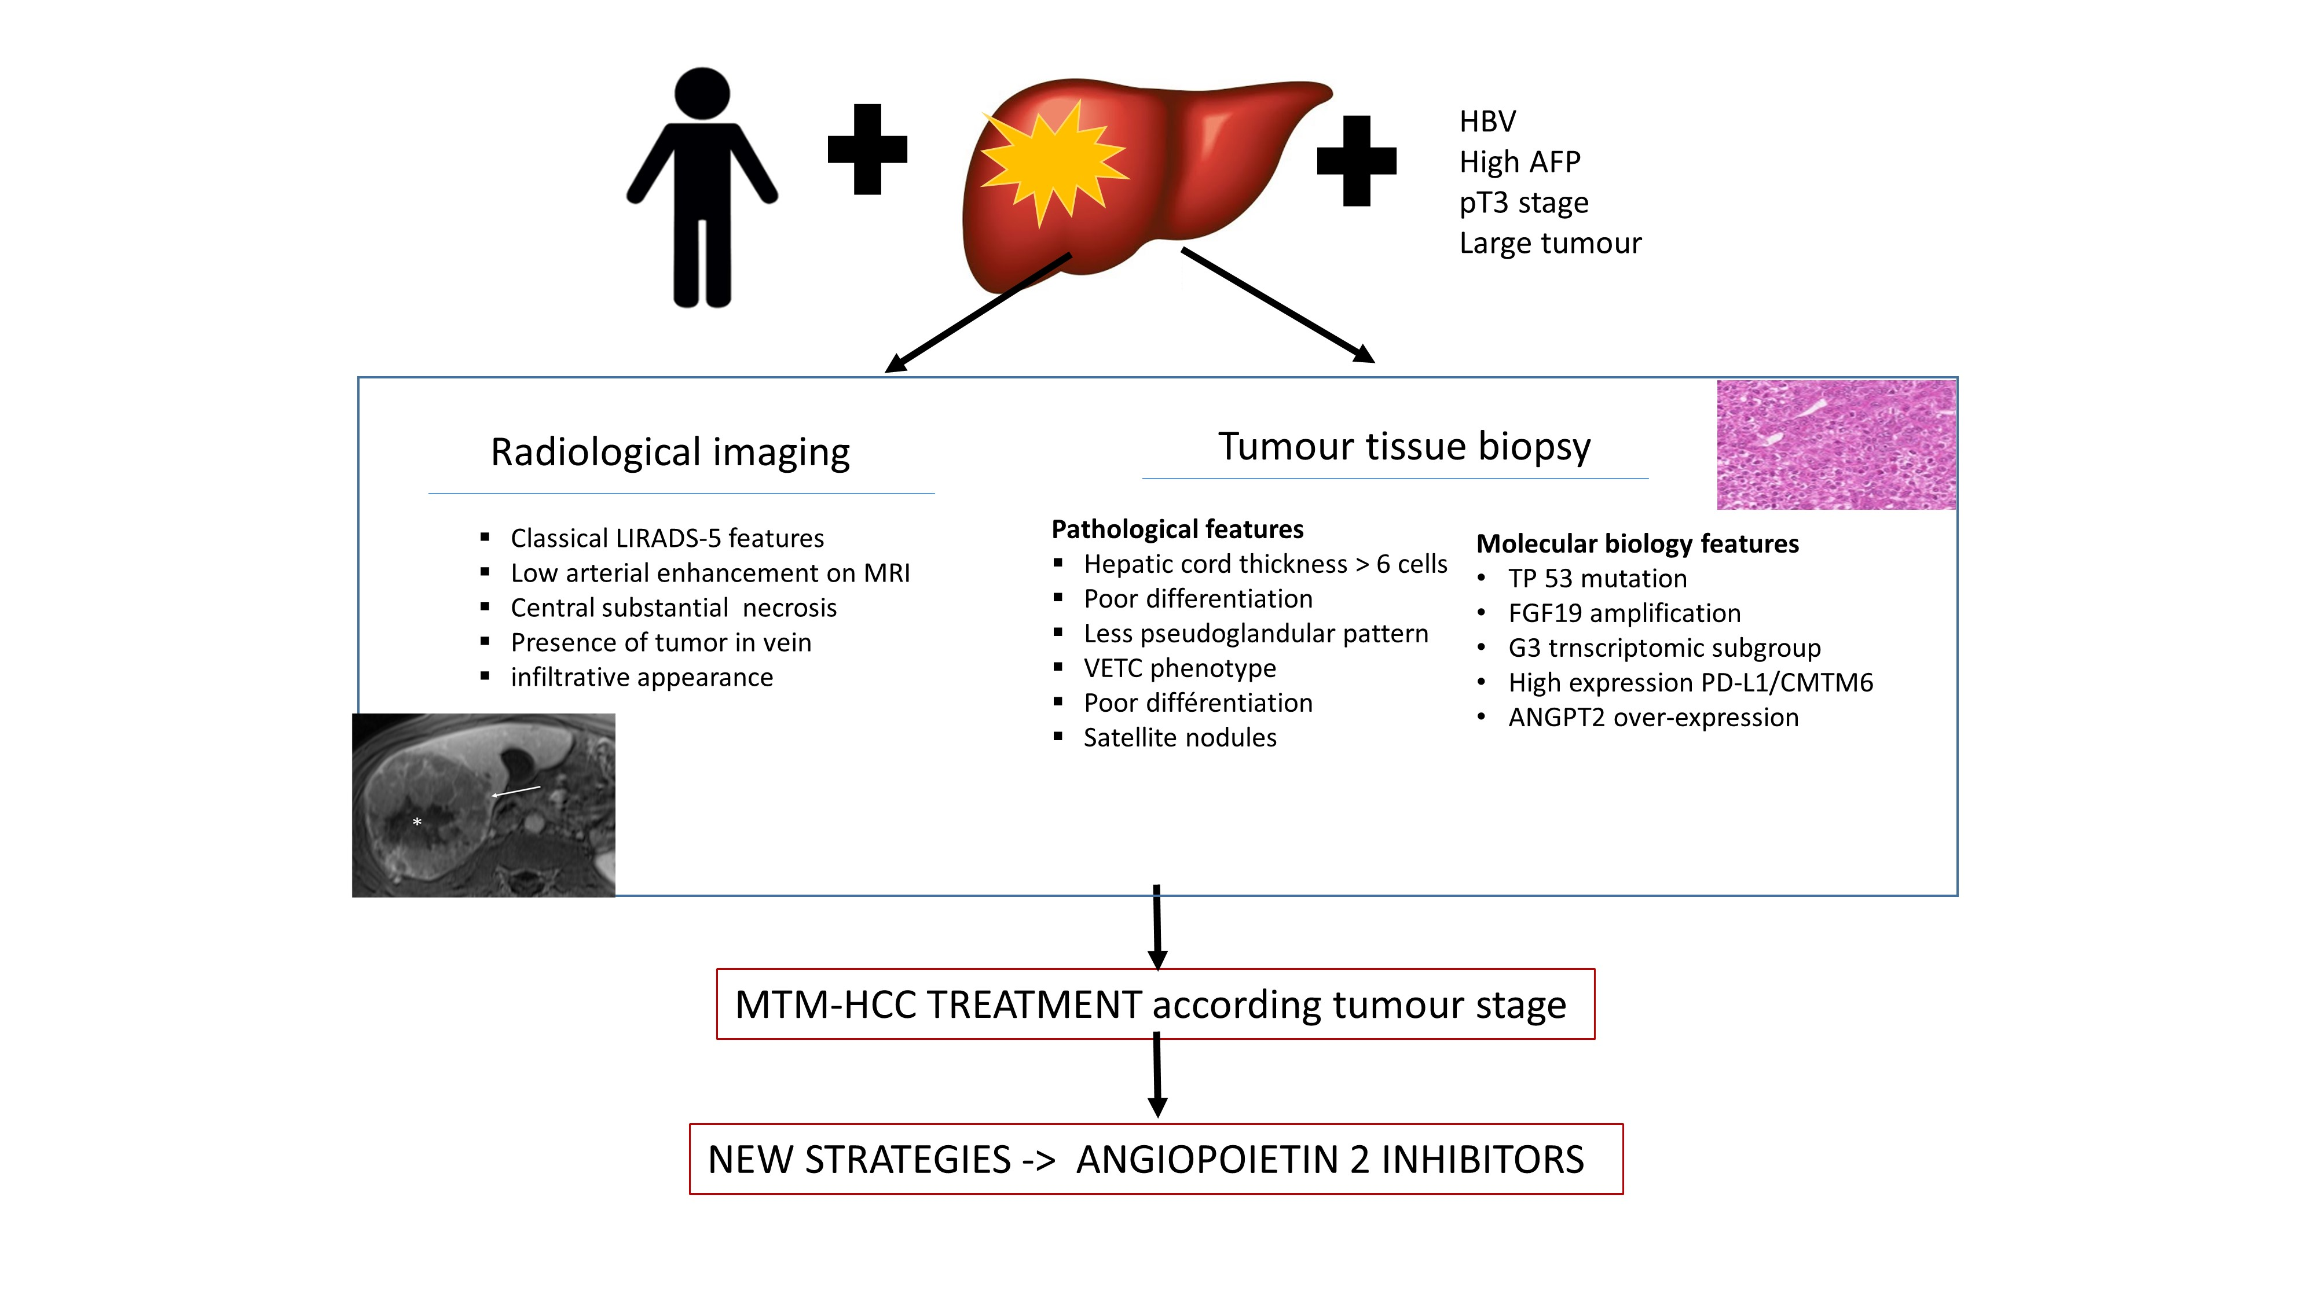

Abbreviations: HBV, hepatitis B; AFP: alpha-fetoprotein; LIRADS, Liver Imaging Reporting and Data System; MRI, Magnetic Resonance Imaging; VETC, vessels that encapsulated tumour clusters; PD-1, checkpoint-blockade immunotherapy targeting programmed cell death protein 1; CMTM6, chemokine-like factor-like (CKLF) MARVEL transmembrane domain-containing 6; ANGPT2, angiopoietin.

