Methods
Western blot
Equal amounts of protein were separated by SDS–PAGE and transferred to nitrocellulose membranes. Membranes were blocked with 5% skim milk powder for 1 hour, followed by incubation with primary antibodies in 5% skim milk-TBS-T at 4 °C overnight with gentle shaking. Primary antibodies against STAT1 (14994, CST, dilution 1:2000), phospho-STAT1 (Tyr701) (9167, CST, dilution 1:2000), STAT3 (D3Z2G) (12640, CST, dilution 1:2000), phospho-STAT3 (Tyr705) (9145, CST, dilution 1:2000), and GAPDH (D16H11) (5174, CST, dilution 1:2000) were used. After three washes with TBS-T, the membrane was incubated with horseradish peroxidase-conjugated anti-rabbit secondary antibody (7074, CST, 1:2 000) in 5% skim milk-TBS-T. The respective proteins were visualized by using a chemiluminescence assay (Thermo Scientific, USA).

Supplementary Figure
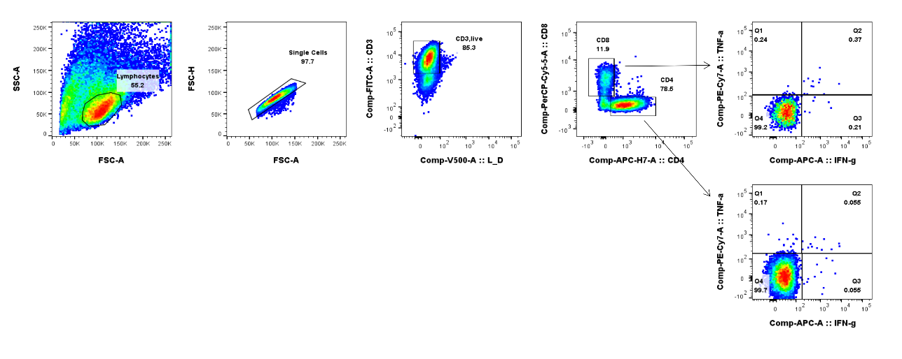
Supplementary Figure 1: Gating strategy for flow cytometry
PBMCs were stimulated for overnight or expanded for 10 days after stimulation with M1₅₈₋₆₆ peptide or heat-killed T. marneffei and then were immuno-stained for surface and intracellular. Live CD3+ cells were gated from singlets derived from lymphocytes. Thereafter, CD4+ and CD8+ T cells were gated and responsive T cells were identified as cells expressing IFNγand TNF. The gating strategy was applied to generation of data at Figure1-3.

