Supporting information
Construction highly loading natural active substances nanoplatform and application in synergistic tumor therapy

Contents:
Section 1. Design and Synthesis of HMPB NPs
Section 2. Photothermal Performance of HMPB NPs
Section 3. Loading and Release Behavior of PC B2 in HMPB NPs
Section 4. In Vitro Synergistic Therapeutic Efficacy
Section 5. In Vivo Synergistic Therapeutic Efficacy

Section 1 Design and Synthesis of HMPB NPs

Figure. S1. XRD spectra of MPB NPs and HMPB NPs.

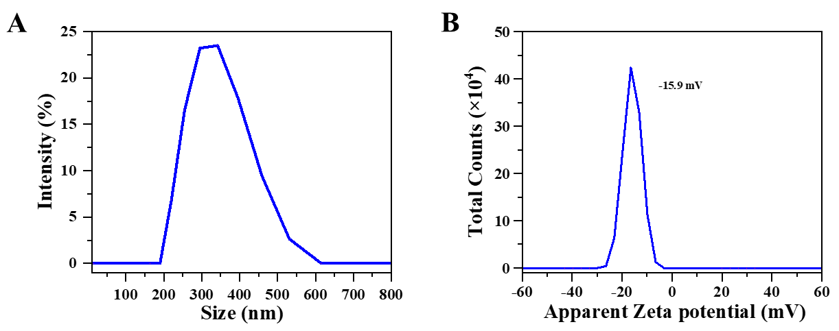
Figure. S2. A) Size distribution of HMPB NPs measured by DLS. B) Zeta potentials of HMPB NPs.

Section 2 Photothermal Performance of HMPB NPs

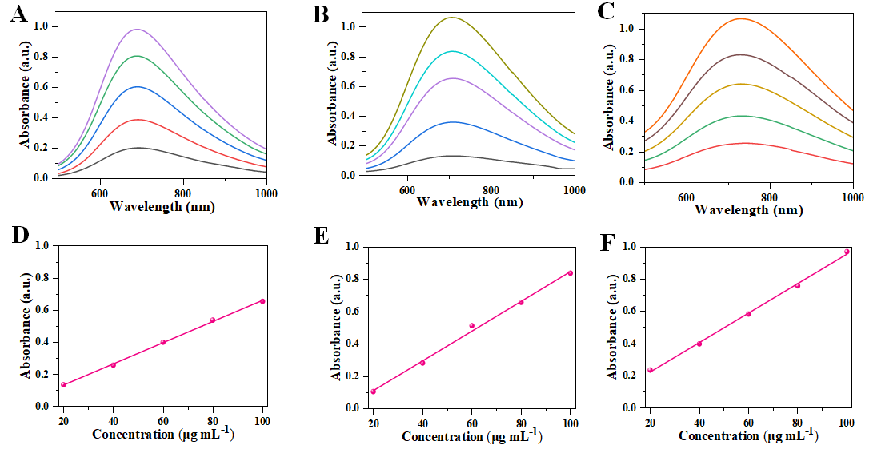

Figure. S3. A), B), and C) UV-visible absorption spectroscopy of PB NPs, MPB NPs, and HMPB NPs at different concentrations (20, 40, 60, 80, 100μg mL⁻¹). D), E), and F) The mass extinction coefficient of PB NPs, MPB NPs and HMPB NPs at 808 nm.

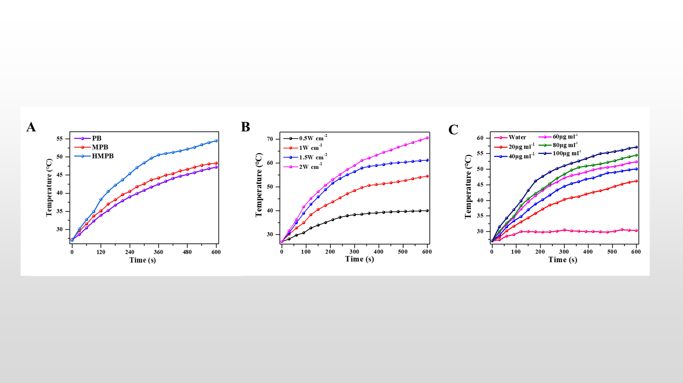

Figure. S4. A) Temperature-rise curves of PB NPs (purple), MPB NPs (red), and HMPB NPs (blue) within 10 min under irradiation of 808 nm NIR laser (1W cm⁻²). B) Temperature change curves of various power densities (0.5, 1, 1.5, 2 W cm⁻²) of HMPB NPs within 10 min under irradiation of 808 nm laser. C) Temperature change curves of solutions containing different concentrations of HMPB (20, 40, 60, 80, 100μg mL⁻¹) within 10 min under irradiation of 808 nm laser.

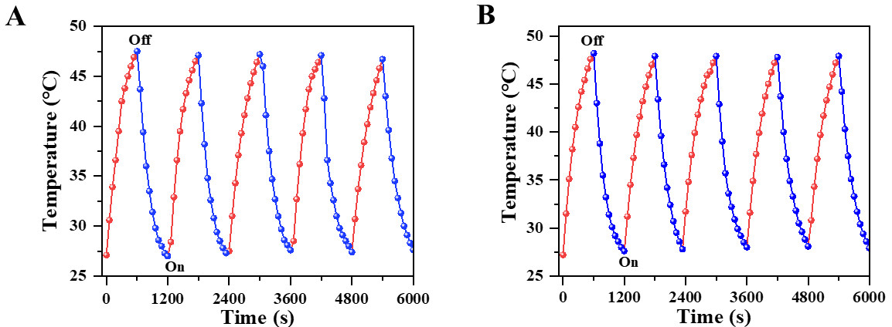
Figure. S5. A) and B) Recycling heating curves of the solution containing PB NPs and MPB NPs for 5 on/off cycles of the 808 nm laser irradiation (1 W cm ⁻²).

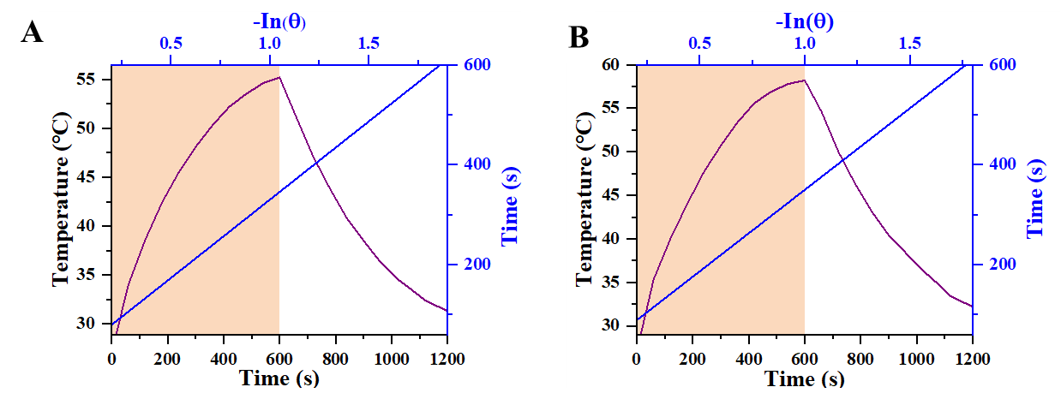

Figure. S6. A) and B) Calculated photothermal-conversion efficiency of PB NPs and MPB NPs at 808 nm (1.5W cm-²). Purple line: temperature change curves of the solution under 808 nm laser irradiation for 10 min, and then the laser was turned off. Blueline: time constant (τs) for the heat transfer from the system obtained by applying the linear time data from the cooling period (A:R²=0.99944, B: R²=0.9994).

Section 3 Loading and Release Behavior of PC B2 in HMPB NPs

Figure. S7. The corresponding pore size distribution of HMPB.

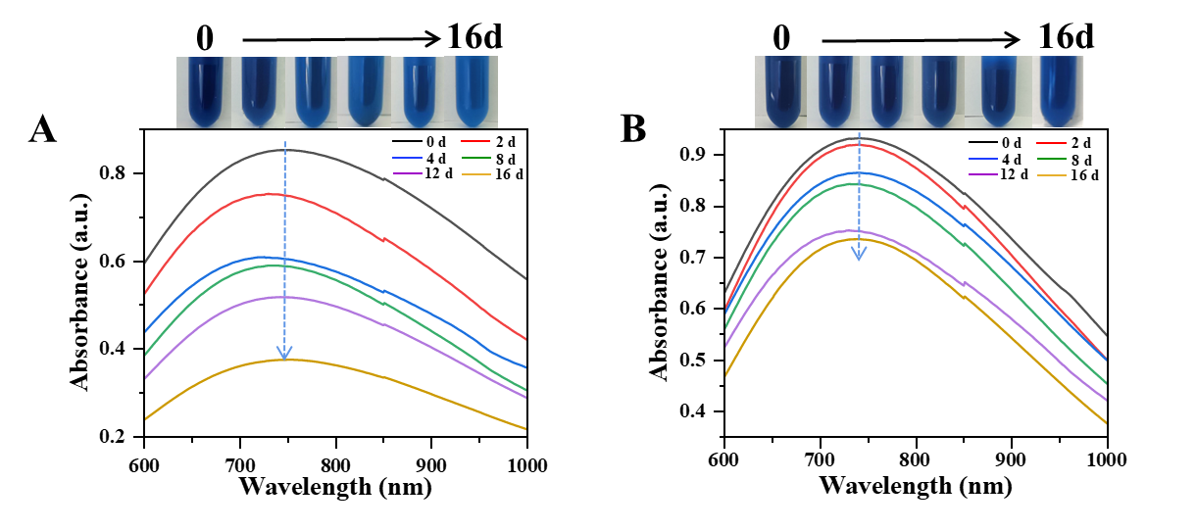
Figure. S8. Estimation of HMPB NPs biodegradability. A) and B) UV-visible absorption spectra of HMPB in the range of 600–1000 nm after immersing in PBS of different pH (5.0, 7.2).

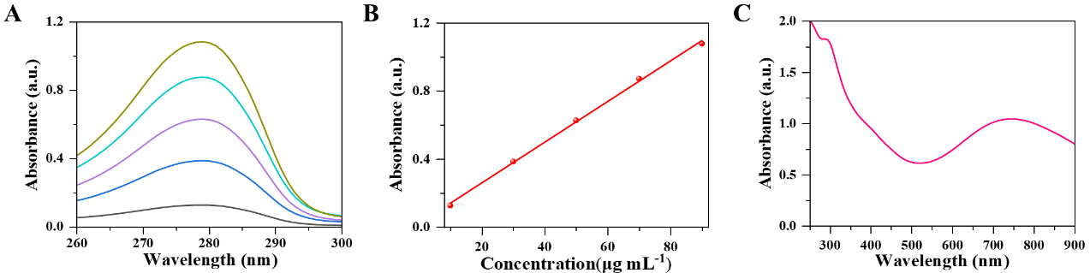

Figure. S9. A) and B) UV-Visible absorption spectra of PC B2 at different concentrations and standard curves. C) UV-visible absorption spectra of HMPB-PC B2.

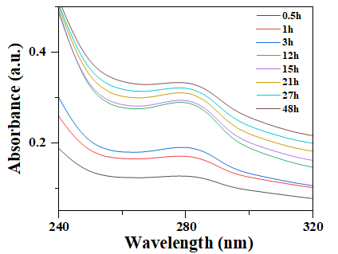
Figure. S10. UV-visible absorption spectra of PC B2 released in vitro from HMPB-PC B2 at pH 5.0.

Section 4 In Vitro Synergistic Therapeutic Efficacy
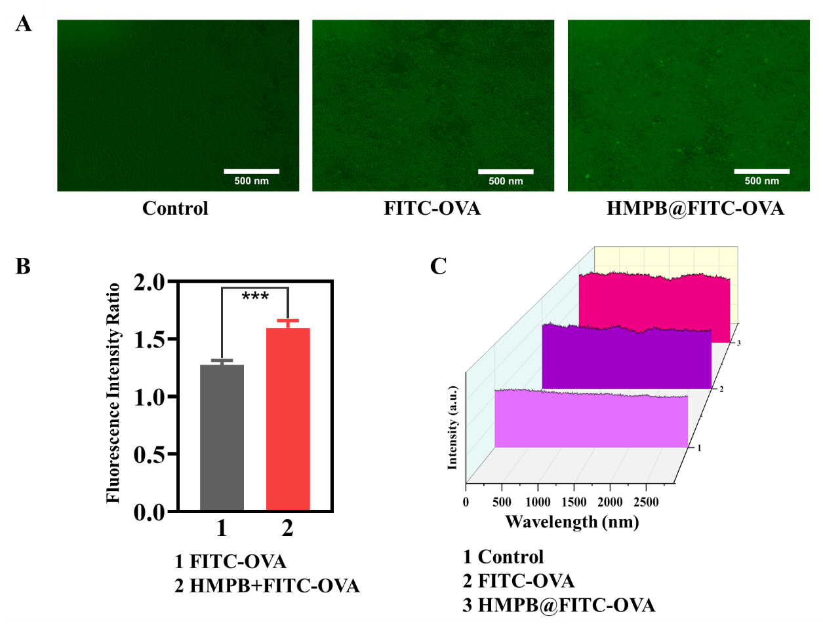
Figure. S11. A) Fluorescence Microscope images of HeLa cells after co-incubated with FITC-labeled HMPB NPs (100 µg mL⁻¹) for 12 h. B) Fluorescence quantitative analysis of the FITC/Control fluorescence intensity ratio in the two treatment groups. C) Waterfall plot of the relative FITC fluorescence intensity in different groups (***p < 0.005).

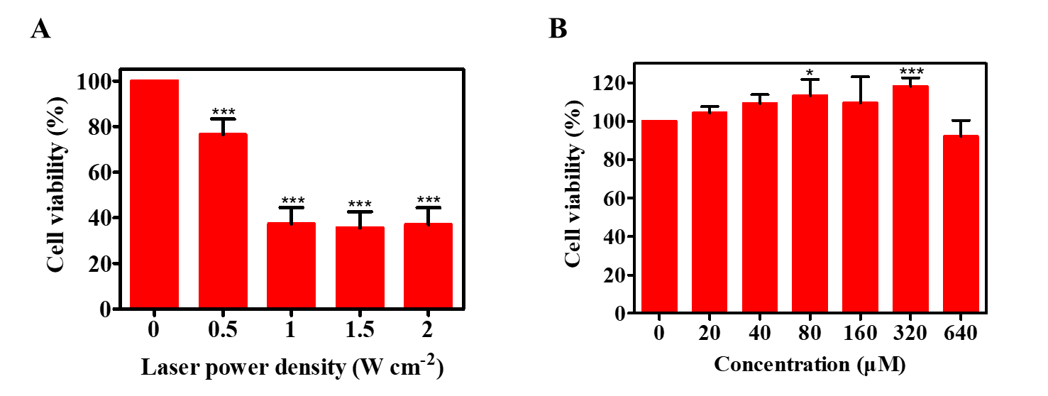
Figure. S12. A) Relative cell viabilities of Hela cells under at the various power densities (0.5, 1, 1.5, 2 W cm⁻²) with HMPB NPs (100 μg mL⁻¹). B) Relative cell viabilities of 293T cells after being under different concentration of PC B2 (*p < 0.05 and ***p < 0.005).
Section 5 In Vivo Synergistic Therapeutic Efficacy
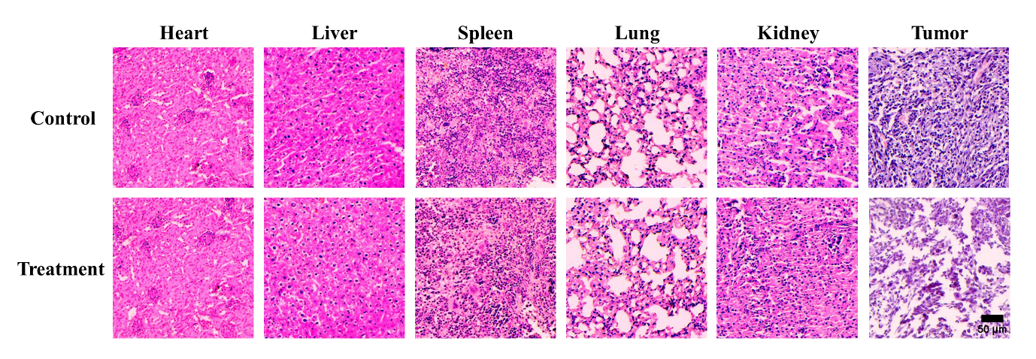

Figure. S13. HE-stained images of main organs and tumors of tumor-bearing mice with various treatment.

Figure. S14. ALT and AST index of the control and treatment groups.

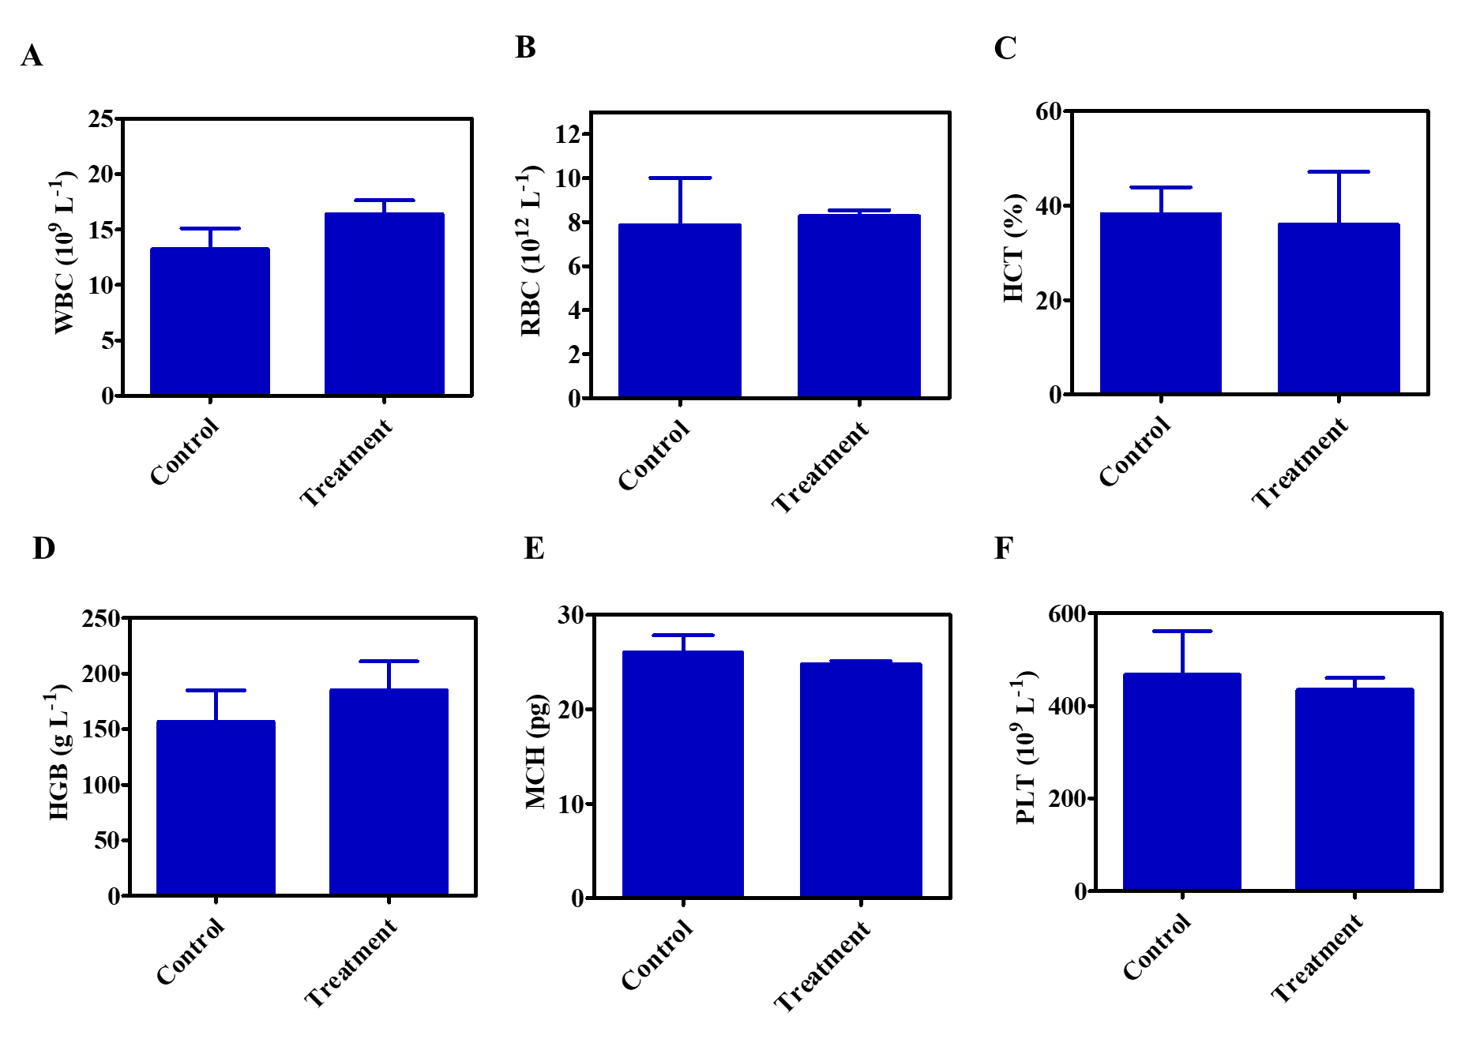
Figure. S15. In vivo biocompatibility evaluation of HMPB@PC B2 nanoplatform. A-F). The haematological data of Hela-bearing balb/c nude mice after 14 days of varied treatments.

