Supplementary material

ORIGINAL RESEARCH
Igaz et al
Functionalized mesoporous silica nanoparticles for drug-delivery to multidrug-resistant cancer cells
Nóra Igaz¹
Péter Bélteky²
Dávid Kovács^{1,3}
Csaba Papp⁴
Andrea Rónavári²
Diána Szabó⁵
Attila Gácser⁴
Zoltán Kónya^{2;6*}
Mónika Kiricsi^{1*}

¹Department of Biochemistry and Molecular Biology, University of Szeged, Szeged, Hungary; ²Department of Applied and Environmental Chemistry, University of Szeged, Szeged, Hungary;
³Institut de Pharmacologie Moléculaire et Cellulaire, Université Côte d'Azur, Inserm, CNRS, Valbonne, France;
⁴HCEMM-USZ Fungal Pathogens Research Group, Department of Microbiology, University of Szeged, Szeged, Hungary;
⁵Department of Oto-Rhino-Laryngology and Head & Neck Surgery, Szeged, Hungary;
⁶Eötvös Loránd Research Network, Reaction Kinetics and Surface Chemistry Research Group, Szeged, Hungary
*Corresponding authors:
Mónika Kiricsi, PhD, Department of Biochemistry and Molecular Biology, University of Szeged, Közép fasor 52. H-6726, Szeged, Hungary. Phone number: +36 (62) 544-887 E-mail: kiricsim@bio.u-szeged.hu
Zoltán Kónya, PhD, DSc, Department of Applied and Environmental Chemistry, University of Szeged, Rerrich square 1. H-6720 Szeged, Hungary
Phone number: +36 (62) 544620 E-mail: konya@chem.u-szeged.hu

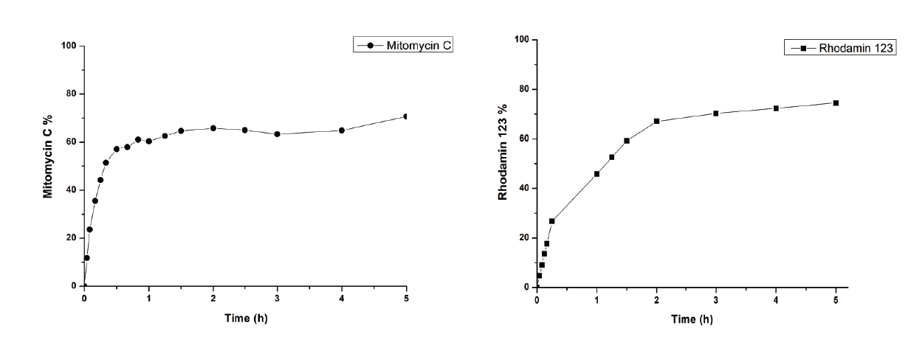
Supplementary File. In vitro drug release profiles of RhoB@MMC@MSNs and RhoB@Rho123@MSNs.

