Supplemental contents to:
Indocyanine green retention test as a predictor of postoperative complications in patients with hepatitis B virus-related hepatocellular carcinoma

Rong-yun Mai M.D., Tao Bai M.D., Xiao-ling Luo PH.D., Guo-bin Wu M.D.

Table of Contents

Supplementary Table 1. Postoperative complications 2
Supplementary Table 2. The discriminative performance of the ICG-R15 and others scoring systems in predicting postoperative major complications in the included patients. 3
Supplementary Table 3. The discriminative performance of the ICG-R15 and others scoring systems in predicting severe PHLF in the included patients.. 5
Supplementary Table 4. Incidence of ICG-R15 for predicting postoperative complications 7
Supplementary Figure 1. Relationship between the incidence of postoperative major complications based upon risk group stratification assessed using the ICG-R15 in the HBV-related HCC patients subgroups. . 8
Supplementary Figure 2. Relationship between the incidence of severe PHLF based upon risk group stratification assessed using the ICG-R15 in the HBV-related HCC patients subgroups.. . 9

Supplementary Table 1. Postoperative complications
Complications | No. of patients, n (%)
Overall morbidity | 199 (56.2)
Pulmonary infection | 8 (2.3)
Pleural effusion or ascites | 115 (32.5)
Postoperative abdominal bleeding | 3 (0.8)
Biliary leakage | 7 (2.0)
Wound infection | 8 (2.3)
Gastrointestinal bleeding | 3 (0.8)
Intestinal obstruction | 2 (0.6)
Intra-abdominal abscess | 3 (0.8)
Cardiopulmonary failure | 2 (0.6)
Renal dysfunction | 2 (0.6)
Posthepatectomy liver failure | 109 (30.8)
Grade A | 52 (14.7)
Grade B | 53 (15.0)
Grade C | 4 (1.1)
Minor morbidity | 41 (11.6)
Fever | 38 (10.7)
Electrolyte disturbance | 41 (11.6)
Dindo–Clavien grade
Grade I | 106 (12.9)
Grade II | 61 (17.2)
Grade IIIa | 21 (5.9)
Grade IIIb | 6 (1.7)
Grade IVa | 1 (0.3)
Grade IVb | 2 (0.6)
Grade V | 2 (0.6)

Supplementary Table 2. The discriminative performance of the ICG-R15 and others scoring systems in predicting postoperative major complications in the included patients.
 | Models | AUC | 95% c.i. | P value
Total (n = 354)
 | Child-Pugh score | 0.619 | 0.515 - 0.723 | 0.027
 | MELD score | 0.617 | 0.516 - 0.721 | 0.029
 | ALBI score | 0.666 | 0.561 - 0.771 | 0.002
 | ICG-R15,% | 0.789 | 0.707 - 0.872 | <0.001
Presence of cirrhosis(n = 213)
 | Child-Pugh score | 0.586 | 0.460 - 0.712 | 0.188
 | MELD score | 0.679 | 0.569 - 0.790 | 0.006
 | ALBI score | 0.593 | 0.454 - 0.731 | 0.151
 | ICG-R15,% | 0.767 | 0.669 - 0.866 | <0.001
Absence of cirrhosis (n = 141)
 | Child-Pugh score | 0.673 | 0.488 - 0.857 | 0.069
 | MELD score | 0.463 | 0.275 - 0.651 | 0.697
 | ALBI score | 0.808 | 0.685 - 0.931 | 0.001
 | ICG-R15,% | 0.820 | 0.657 - 0.982 | 0.001
Major resection (n = 235)
 | Child-Pugh score | 0.618 | 0.508 - 0.728 | 0.043
 | MELD score | 0.587 | 0.468 - 0.706 | 0.134
 | ALBI score | 0.665 | 0.554 - 0.777 | 0.005
 | ICG-R15,% | 0.793 | 0.708 - 0.878 | <0.001
Minor resection (n = 119)
 | Child-Pugh score | 0.513 | 0.204 - 0.822 | 0.93
 | MELD score | 0.715 | 0.484 - 0.946 | 0.144
 | ALBI score | 0.574 | 0.253 - 0.895 | 0.616
 | ICG-R15,% | 0.689 | 0.384 - 0.995 | 0.2
Blood loss ≥ 400 ml (n = 124)
 | Child-Pugh score | 0.541 | 0.404 - 0.677 | 0.580
 | MELD score | 0.638 | 0.497 - 0.779 | 0.062
 | ALBI score | 0.615 | 0.471 - 0.760 | 0.119
 | ICG-R15,% | 0.809 | 0.715 - 0.903 | <0.001
Blood loss < 400 ml (n = 230)
 | Child-Pugh score | 0.664 | 0.503 - 0.824 | 0.040
 | MELD score | 0.548 | 0.391 - 0.705 | 0.548
 | ALBI score | 0.700 | 0.551 - 0.849 | 0.012
 | ICG-R15,% | 0.743 | 0.597 - 0.890 | 0.002
Presence of blood transfusion (n = 98)
 | Child-Pugh score | 0.588 | 0.376 - 0.800 | 0.440
 | MELD score | 0.682 | 0.477 - 0.887 | 0.110
 | ALBI score | 0.609 | 0.374 - 0.845 | 0.338
 | ICG-R15,% | 0.763 | 0.569 - 0.957 | 0.021
Absence of blood transfusion (n = 256)
 | Child-Pugh score | 0.629 | 0.509 - 0.748 | 0.034
 | MELD score | 0.604 | 0.485 - 0.722 | 0.089
 | ALBI score | 0.683 | 0.565 - 0.800 | 0.003
 | ICG-R15,% | 0.796 | 0.705 - 0.887 | <0.001
BCLC-0 or -A stage (n = 217)
 | Child-Pugh score | 0.627 | 0.488 - 0.766 | 0.082
 | MELD score | 0.604 | 0.456 - 0.751 | 0.157
 | ALBI score | 0.662 | 0.512 - 0.812 | 0.027
 | ICG-R15,% | 0.853 | 0.770 - 0.935 | 0.000
BCLC-B or -C stage (n = 137)
 | Child-Pugh score | 0.608 | 0.450 - 0.765 | 0.173
 | MELD score | 0.644 | 0.500 - 0.787 | 0.070
 | ALBI score | 0.678 | 0.534 - 0.822 | 0.025
 | ICG-R15,% | 0.716 | 0.579 - 0.853 | 0.006
Note: Boldface indicates the AUC value of ICG-R15 for predicting postoperative major complications.
Abbreviations: c.i., confidence interval; MELD, model for end-stage liver disease; ALBI , albumin-bilirubin; ICG‐R15, indocyanine green retention test at 15 minutes; BCLC, Barcelona Clinic Liver Cancer.

Supplementary Table 3. The discriminative performance of the ICG-R15 and others scoring systems in predicting severe PHLF in the included patients.
 | Models | AUC | 95% c.i. | P value
Total (n = 354)
 | Child-Pugh score | 0.641 | 0.564 - 0.718 | <0.001
 | MELD score | 0.604 | 0.518 - 0.690 | 0.013
 | ALBI score | 0.691 | 0.612 - 0.769 | <0.001
 | ICG-R15,% | 0.823 | 0.775 - 0.871 | <0.001
Presence of cirrhosis(n = 213)
 | Child-Pugh score | 0.614 | 0.514 - 0.705 | 0.019
 | MELD score | 0.598 | 0.500 - 0.696 | 0.044
 | ALBI score | 0.678 | 0.587 - 0.768 | <0.001
 | ICG-R15,% | 0.800 | 0.737 - 0.8620 | <0.001
Absence of cirrhosis (n = 141)
 | Child-Pugh score | 0.687 | 0.533 - 0.842 | 0.032
 | MELD score | 0.587 | 0.391 - 0.782 | 0.322
 | ALBI score | 0.691 | 0.510 - 0.871 | 0.029
 | ICG-R15,% | 0.873 | 0.805 - 0.942 | <0.001
Major resection (n = 235)
 | Child-Pugh score | 0.607 | 0.522 - 0.692 | 0.021
 | MELD score | 0.561 | 0.465 - 0.658 | 0.184
 | ALBI score | 0.637 | 0.548 - 0.725 | 0.003
 | ICG-R15,% | 0.775 | 0.714 - 0.835 | <0.001
Minor resection (n = 119)
 | Child-Pugh score | 0.742 | 0.543 - 0.941 | 0.032
 | MELD score | 0.758 | 0.564 - 0.952 | 0.023
 | ALBI score | 0.920 | 0.856 - 0.983 | <0.001
 | ICG-R15,% | 0.984 | 0.962 - 1.000 | <0.001
Blood loss ≥ 400 ml (n = 124)
 | Child-Pugh score | 0.546 | 0.427 - 0.666 | 0.483
 | MELD score | 0.599 | 0.467 - 0.732 | 0.131
 | ALBI score | 0.582 | 0.448 - 0.715 | 0.215
 | ICG-R15,% | 0.765 | 0.677 - 0.853 | 0.000
Blood loss < 400 ml (n = 230)
 | Child-Pugh score | 0.692 | 0.592 - 0.793 | <0.001
 | MELD score | 0.591 | 0.478 - 0.705 | 0.093
 | ALBI score | 0.755 | 0.665 - 0.846 | <0.001
 | ICG-R15,% | 0.850 | 0.791 - 0.908 | <0.001
Presence of blood transfusion (n = 98)
 | Child-Pugh score | 0.568 | 0.421 - 0.714 | 0.371
 | MELD score | 0.659 | 0.497 - 0.821 | 0.036
 | ALBI score | 0.692 | 0.548 - 0.836 | 0.011
 | ICG-R15,% | 0.844 | 0.760 - 0.929 | <0.001
Absence of blood transfusion (n = 256)
 | Child-Pugh score | 0.672 | 0.583 - 0.762 | 0.001
 | MELD score | 0.578 | 0. 476 - 0.680 | 0.121
 | ALBI score | 0.691 | 0.597 - 0.784 | <0.001
 | ICG-R15,% | 0.818 | 0.760 - 0.875 | <0.001
BCLC-0 or -A stage (n = 217)
 | Child-Pugh score | 0.523 | 0.399 - 0.646 | 0.728
 | MELD score | 0.628 | 0.500 - 0.757 | 0.049
 | ALBI score | 0.621 | 0.496 - 0.747 | 0.062
 | ICG-R15,% | 0.798 | 0.722 - 0.875 | <0.001
BCLC-B or -C stage (n = 137)
 | Child-Pugh score | 0.727 | 0.636 - 0.818 | <0.001
 | MELD score | 0.587 | 0.470 - 0.703 | 0.114
 | ALBI score | 0.745 | 0.649 - 0.842 | <0.001
 | ICG-R15,% | 0.834 | 0.770 - 0.898 | 0.000
Note: Boldface indicates the AUC value of ICG-R15 for predicting severe PHLF.
Abbreviations: c.i., confidence interval; MELD, model for end-stage liver disease; ALBI , albumin-bilirubin; ICG‐R15, indocyanine green retention test at 15 minutes; BCLC, Barcelona Clinic Liver Cancer.

Supplementary Table 4. Incidence of ICG-R15 for predicting postoperative complications
 |  | ICG-R15 (n = 354)
 | Complications | Low risk | Intermediate risk | High risk | P value
Total (n = 354) | No. of patients, n | 185 | 116 | 53
 | Major complications, n (%) | 4 (2.2) | 13 (11.2) | 15 (28.3) | <0.001
 | Severe PHLF, n (%) | 8 (2.7) | 30 (25.9) | 22 (41.5) | <0.001
Presence of cirrhosis(n = 213) | No. of patients, n | 104 | 74 | 35
 | Major complications, n (%) | 3 (2.9) | 10 (13.5) | 9 (25.7) | <0.001
 | Severe PHLF, n (%) | 5 (4.8) | 24 (32.4) | 16 (45.7) | <0.001
Absence of cirrhosis (n = 141) | No. of patients, n | 81 | 42 | 18
 | Major complications, n (%) | 1 (1.2) | 3 (7.1) | 6 (33.3) | <0.001
 | Severe PHLF, n (%) | 0 (0) | 6 (14.3) | 6 (33.3) | <0.001
Major resection (n = 235) | No. of patients, n | 109 | 85 | 41
 | Major complications, n (%) | 2 (7.1) | 13 (15.3) | 13 (31.7) | <0.001
 | Severe PHLF, n (%) | 5 (4.6) | 29 (34.1) | 16 (39.0) | <0.001
Minor resection (n = 119) | No. of patients, n | 76 | 31 | 12
 | Major complications, n (%) | 2 (2.6) | 0 (0) | 2 (16.7) | <0.001
 | Severe PHLF, n (%) | 0 (0) | 1 (3.2) | 6 (50.0) | <0.001
Blood loss ≥ 400 ml (n = 124) | No. of patients, n | 54 | 44 | 26
 | Major complications, n (%) | 1 (1.9) | 8 (18.2) | 9 (34.6) | <0.001
 | Severe PHLF, n (%) | 1 (1.9) | 14 (31.8) | 9 (34.6) | <0.001
Blood loss < 400 ml (n = 230) | No. of patients, n | 131 | 72 | 27
 | Major complications, n (%) | 3 (2.3) | 5 (6.9) | 6 (22.2) | <0.001
 | Severe PHLF, n (%) | 4 (3.1) | 16 (22.2) | 13 (48.1) | <0.001
Presence of blood transfusion (n = 98) | No. of patients, n | 58 | 28 | 12
 | Major complications, n (%) | 1 (1.7) | 4 (14.3) | 2 (16.7) | <0.001
 | Severe PHLF, n (%) | 3 (5.2) | 8 (28.6) | 7 (58.3) | <0.001
Absence of blood transfusion (n = 256) | No. of patients, n | 127 | 88 | 41
 | Major complications, n (%) | 3 (2.4) | 9 (10.2) | 13 (31.7) | <0.001
 | Severe PHLF, n (%) | 2 (1.6) | 22 (25) | 15 (36.6) | <0.001
BCLC-0 or -A stage (n = 217) | No. of patients, n | 111 | 73 | 33
 | Major complications, n (%) | 1 (0.9) | 6 (8.2) | 10 (30.3) | <0.001
 | Severe PHLF, n (%) | 3 (2.7) | 16 (21.9) | 14 (42.4) | <0.001
BCLC-B or -C stage (n = 137) | No. of patients, n | 74 | 43 | 20
 | Major complications, n (%) | 3 (4.1) | 7 (16.3) | 5 (25) | <0.001
 | Severe PHLF, n (%) | 2 (2.7) | 14 (32.6) | 8 (40) | <0.001
Abbreviations: ICG‐R15, indocyanine green retention test at 15 minutes; BCLC, Barcelona Clinic Liver Cancer; PHLF, posthepatectomy liver failure.

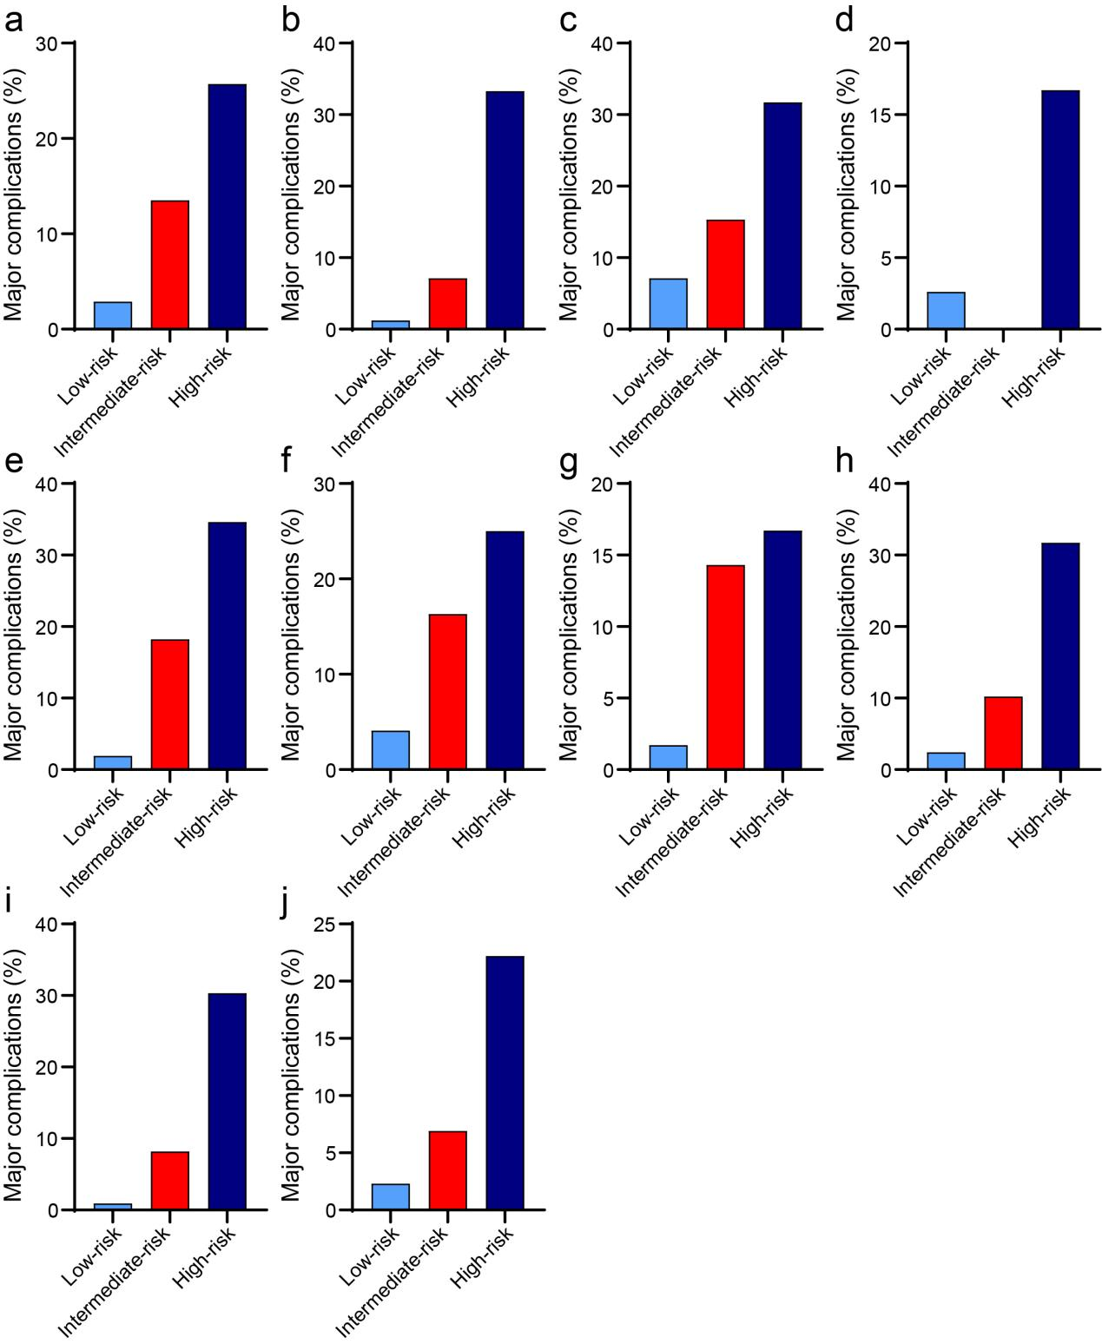
Supplementary Figure 1. Relationship between the incidence of postoperative major complications based upon risk group stratification assessed using the ICG-R15 in the HBV-related HCC patients subgroups. Subgroups include (a) cirrhosis, (b) no cirrhosis, (c) major hepatectomy, (d) minor hepatectomy, (e) blood loss≥400 ml, (f) blood loss < 400 ml, (g) blood transfusion, (h) no blood transfusion, (i) BCLC-0 or -A stage, and (j) BCLC-B or -C stage. ICG‐R15, indocyanine green retention test at 15 minutes; MELD, model for end‐stage liver disease; ALBI, albumin-bilirubin; ROC, receiver operating characteristic; PHLF, posthepatectomy liver failure; BCLC, Barcelona Clinical Liver Cancer; HBV, hepatitis B virus; HCC, hepatocellular carcinoma.

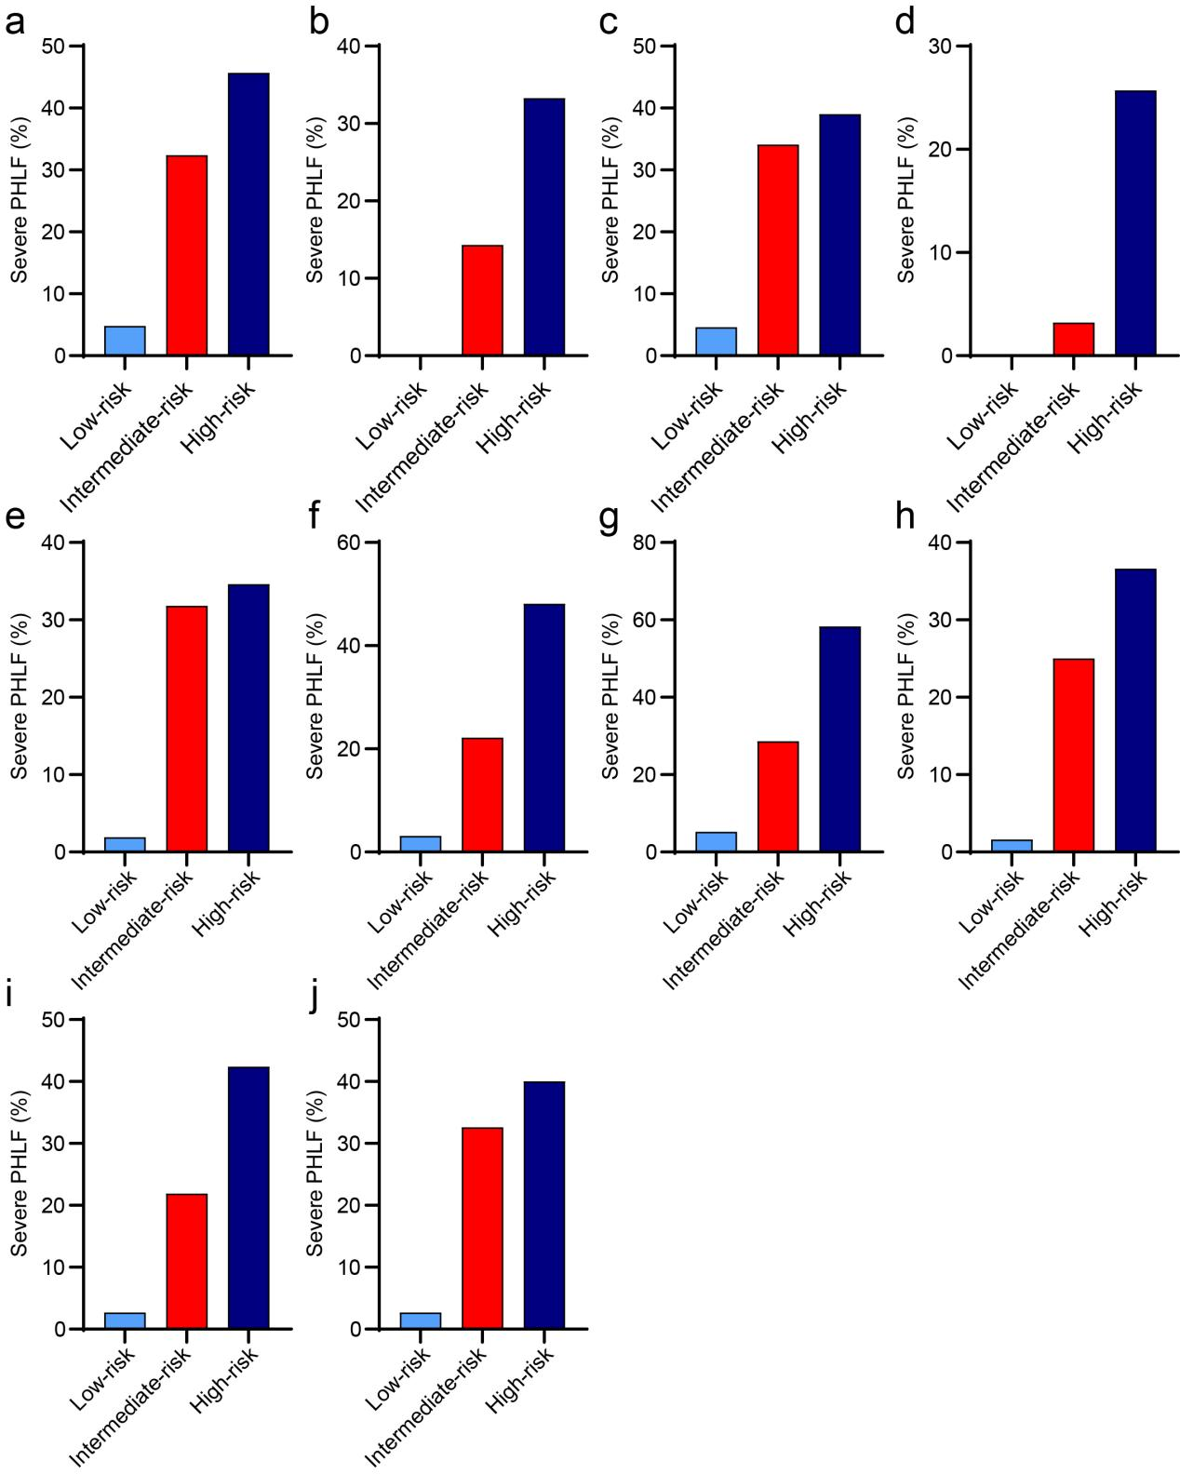
Supplementary Figure 2. Relationship between the incidence of severe PHLF based upon risk group stratification assessed using the ICG-R15 in the HBV-related HCC patients subgroups. Subgroups include (a) cirrhosis, (b) no cirrhosis, (c) major hepatectomy, (d) minor hepatectomy, (e) blood loss≥400 ml, (f) blood loss < 400 ml, (g) blood transfusion, (h) no blood transfusion, (i) BCLC-0 or -A stage, and (j) BCLC-B or -C stage. ICG‐R15, indocyanine green retention test at 15 minutes; MELD, model for end‐stage liver disease; ALBI, albumin-bilirubin; ROC, receiver operating characteristic; PHLF, posthepatectomy liver failure; BCLC, Barcelona Clinical Liver Cancer; HBV, hepatitis B virus; HCC, hepatocellular carcinoma.

