Supplementary Material

ORIGINAL RESEARCH
Yao et al

THSD7B Mutation Induces Platinum Resistance in Small Cell Lung Cancer Patients
Zifu Yao ^{1,2,*} ; Anqi Lin^{1,*} ; Yonglin Yi^{1,*} ; Weitao Shen¹ ; Jian Zhang¹ ; Peng Luo¹
¹Department of Oncology, Zhujiang Hospital, Southern Medical University, Guangzhou, 510282, Guangdong, People's Republic of China; ²The First Clinical Medical School, Nanfang Hospital, Southern Medical University, Guangzhou, 510515, Guangdong, People's Republic of China
*These authors have contributed equally to this work

Correspondence:
Jian Zhang
Email:zhangjian@i.smu.edu.cn
Peng Luo
Email:luopeng@smu.edu.cn

A
Zhujiang Cohort
 | Overall  (N=39) | THSD7B-MUT  (N=6) | THSD7B-WT  (N=33) | P
Gender |  |  |  | 1
Female | 5 (12.8%) | 1 (16.7%) | 4 (12.1%) | 1
Male | 34 (87.2%) | 5 (83.3%) | 29 (87.9%) | 1
Age |  |  |  | 0.213
Mean(SD) | 62.8 (9.40) | 58.0 (9.87) | 63.8 (9.20) | 0.213
Median[Min,Max] | 63.0 [46.0,89.0] | 62.0 [46.0,68.0] | 63.5 [49.0,89.0] | 0.213
Missing | 10 (25.6%) | 1 (16.7%) | 9 (27.3%) | 0.213
Smoking |  |  |  | 0.956
Non-smoker | 9 (23.1%) | 1 (16.7%) | 8 (24.2%) | 0.956
Smoker | 20 (51.3%) | 4 (66.7%) | 16 (48.5%) | 0.956
Missing | 10 (25.6%) | 1 (16.7%) | 9 (27.3%) | 0.956

B
George et al Cohort¹
 | Overall  (N=101) | THSD7B-MUT  (N=15) | THSD7B-WT  (N=86) | P
Gender |  |  |  | 0.244
Female | 37(36.6%) | 8 (53.3%) | 29 (33.7%) | 0.244
Male | 64 (63.4%) | 7 (46.7%) | 57 (66.3%) | 0.244
Age |  |  |  | 0.963
Mean(SD) | 64.7 (9.35) | 64.6 (13.0) | 64.7 (8.65) | 0.963
Median[Min,Max] | 65.0 [33.0,83.0] | 64.0 [33.0,83.0] | 65.0 [44.0,83.0] | 0.963
UICC stage |  |  |  | 0.669
I | 34 (33.7%) | 6 (40.0%) | 28 (32.6%) | 0.669
II | 21 (20.8%) | 2 (13.3%) | 19 (22.1%) | 0.669
III | 27 (26.7%) | 3 (20.0%) | 24 (27.9%) | 0.669
IV | 19 (18.8%) | 4 (26.7%) | 15 (17.4%) | 0.669
Smoking |  |  |  | 0.6
Non-smoker | 2 (2.0%) | 1 (6.7%) | 1 (1.2%) | 0.6
Smoker | 92 (91.1%) | 11 (73.3%) | 81 (94.2%) | 0.6
Missing | 7 (6.9%) | 3 (20.0%) | 4 (4.7%) | 0.6

Supplementary Table 1. Comparison of clinical information between THSD7B-MUT and THSD7B-WT patients.
- Zhujiang Cohort. (B) George et al Cohort¹.
Abbreviations: THSD7B-MUT: THSD7B mutant group; THSD7B-WT: THSD7B wild-type group

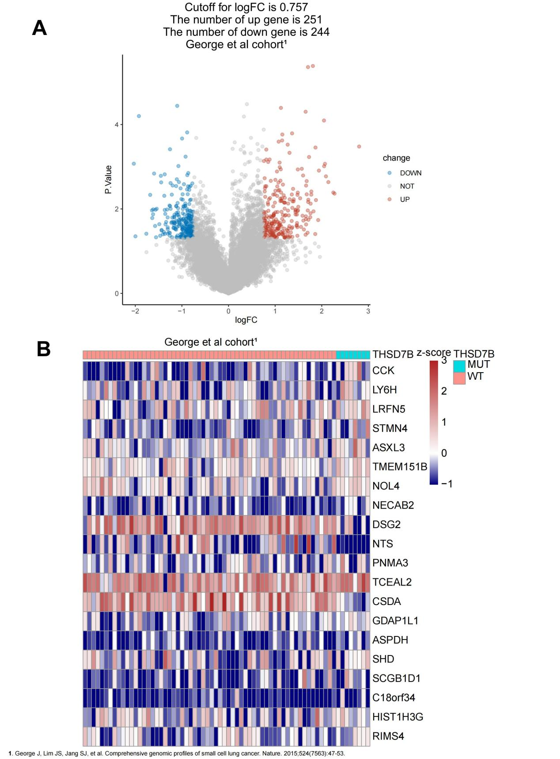

Supplementary Figure 1. Differentially expressed genes (DEGs) between the THSD7B-MUT and THSD7B-WT in the George et al cohort¹.
- The volcano map showed significant DEGs between the two groups (P<0.05). A total of 251 genes were up-regulated, and 244 genes were down-regulated, with logFC=0.757. (B) The heat map shows the expression of the top 20 DEGs (z-score).
Abbreviations: THSD7B-MUT: THSD7B mutant group; THSD7B-WT: THSD7B wild-type group

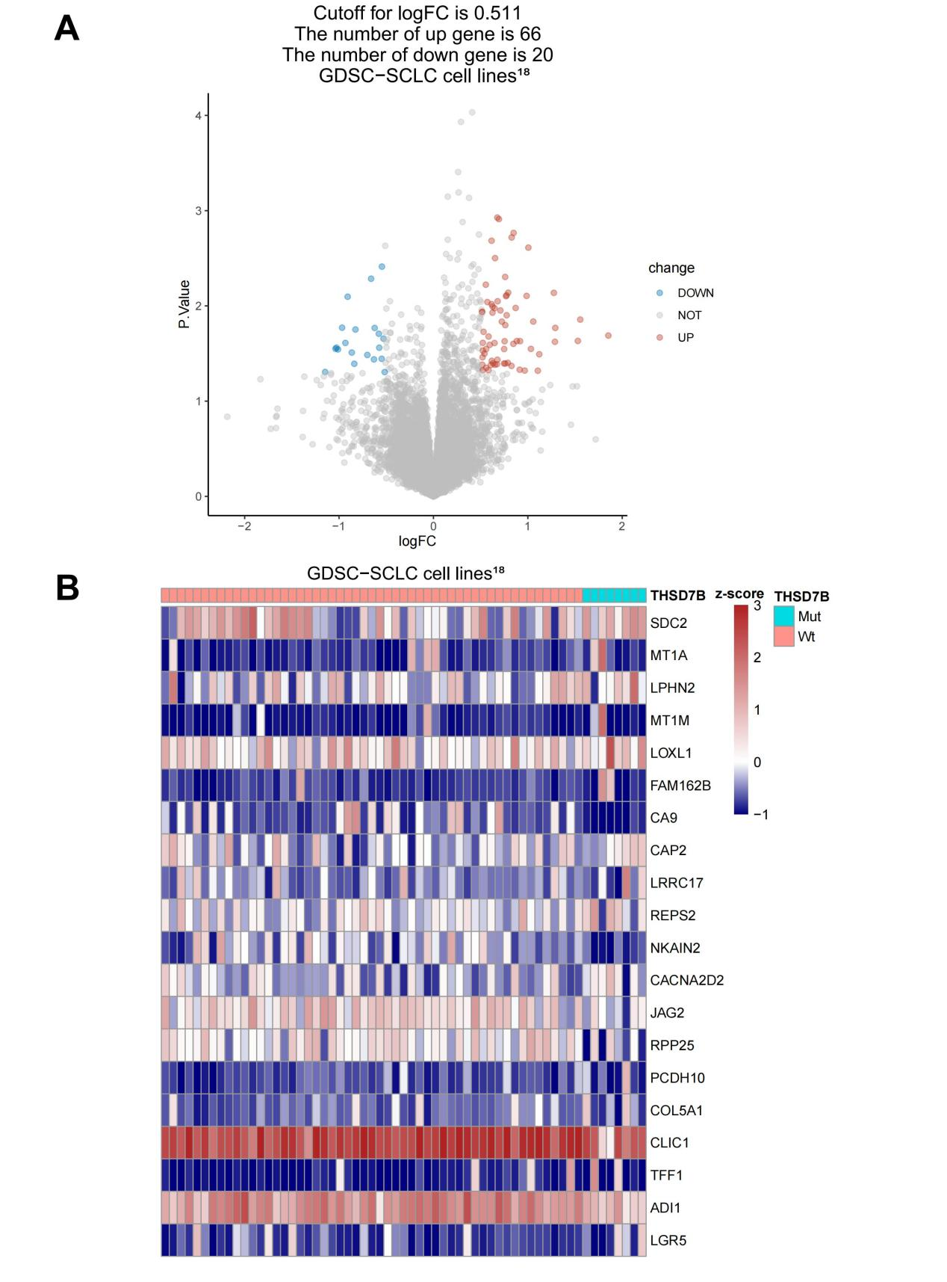
Supplementary Figure 2. Differentially expressed genes (DEGs) between the THSD7B-MUT and THSD7B-WT in GDSC-SCLC cell lines¹⁸.
- The volcano map showed significant DEGs between the two groups (P<0.05). A total of 60 genes were up-regulated, and 22 genes were down-regulated, with logFC=0.511. (B) The heat map shows the expression of the top 20 DEGs (z-score).
Abbreviation: GDSC: Genomics of Drug Sensitivity in Cancer; SCLC: small cell lung cancer

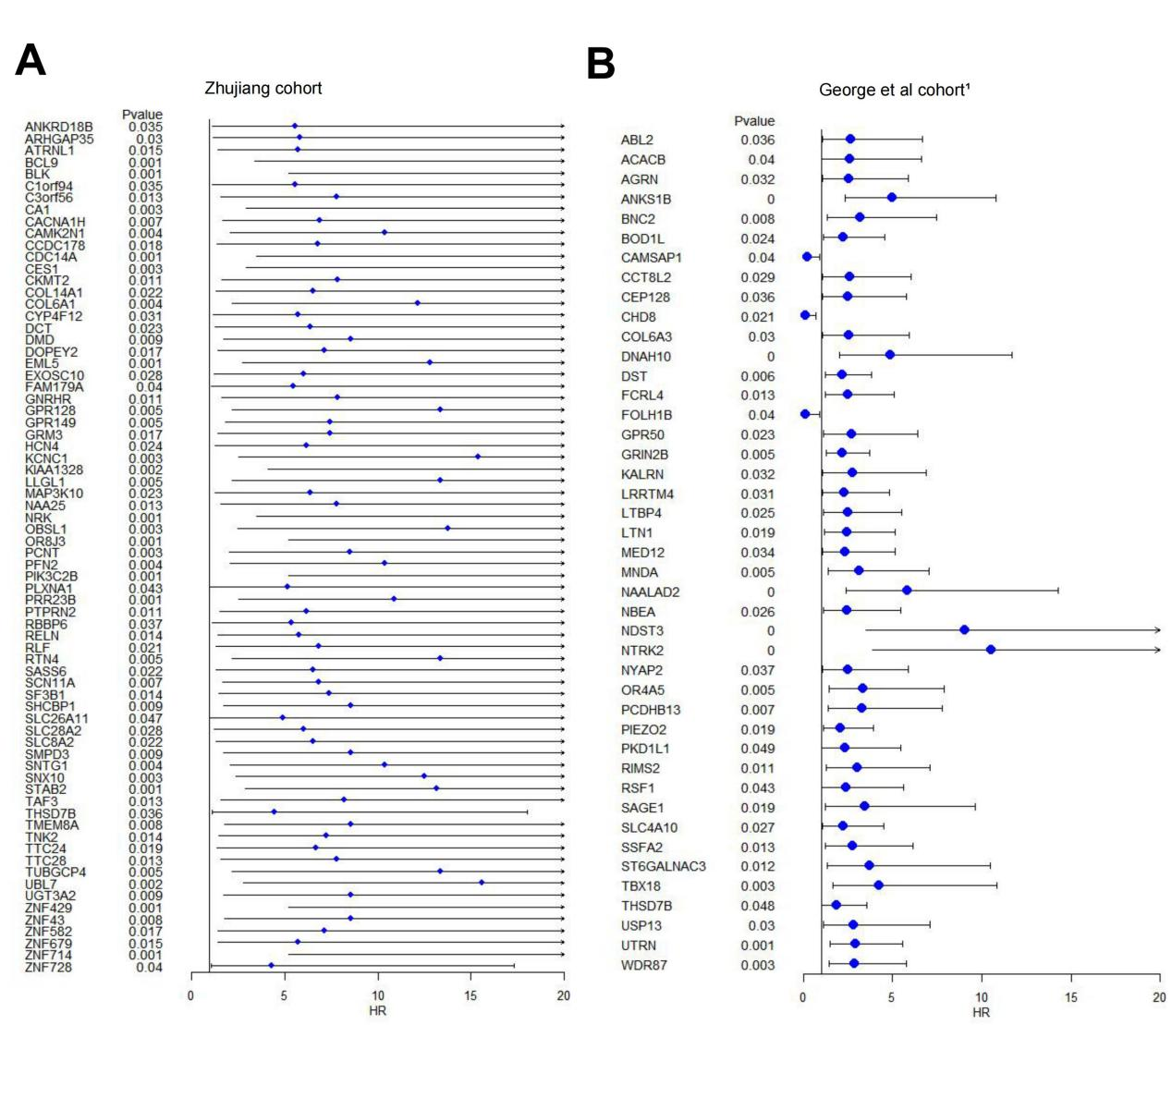
Supplementary Figure 3. Univariate cox proportional hazard regression model of mutant genes significantly related to OS in SCLC patients treated with platinum.
- & (B) There are 71 mutant genes and 42 mutant genes that are significantly related to the OS of platinum-resistant patients in the Zhujiang cohort and George et al cohort¹, respectively. The mutation frequency was more than 5%, and the significance was P<0.05.
Abbreviation: OS: overall survival; SCLC: small cell lung cancer

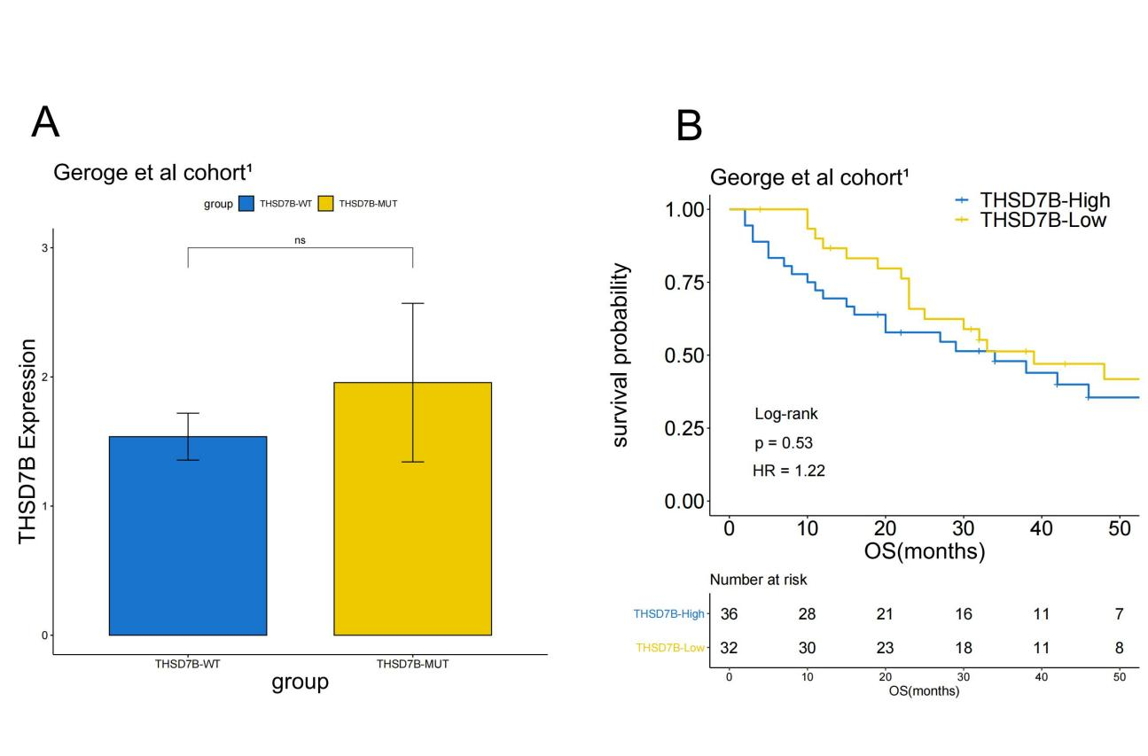
Supplementary Figure 4. The relationship of THSD7B expression, THSD7B mutation and the OS of patients in George et al cohort¹. (A) There was no significant relationship between THSD7B expression and THSD7B mutation (Wilcox test, P>0.05). (B) There was no significant relationship between THSD7B expression and the OS of SCLC patients (Kaplan-Meier test, P=0.53).
Abbreviation: OS: overall survival; SCLC: small cell lung cancer

