Supporting Information

1.Materials and methods
1.1 Characterization of the Biological Target Magnetic NPs
The biological target magnetic NPs were constructed by the ligation of PFH@CL/Fe₃O₄ nanoparticles and B. bifidum by electrostatic adsorption. The PFH@CL/Fe₃O₄ NPs (1 mg/mL) and B. bifidum ((1×10⁶ CFU/mL) were mixed at the ratio of 10:1. Afterwards, the mixture incubated at room temperature for 5 min. The resulting B. bifidum-NP bioconjugates were centrifuged and washed with PBS for three times to remove unreacted NPs. The surface morphology of B. bifidum + PFH@CL/Fe₃O₄ NPs were imaged with TEM, and the hydrodynamic diameter of the B. bifidum + PFH@CL//Fe₃O₄ NPs were determined by DLS.
1.2 In vitro Synergistic effect for HIFU therapy
For HIFU in vitro ablation effect, fresh beef liver of 10 cm × 8 cm × 8 cm was degassed for 45min. Degassed bovine livers were divided into five different concentration groups (0.1, 0.5, 1.0, 2.5, 5.0mg/ml). Then, 200 μL of each solution was injected directly into the liver with a 1mL syringe. After all bovine livers were ablated by HIFU with a power of 120W for 5s, the coagulation volume (V) of liver tissue was calculated as follows:
V(mm³) = π /6 × length × width × depth
1.3 Hemolysis test
Different concentrations of PFH@CL/Fe₃O₄ NPs (0.1, 0.5, 1.0, 2.5 and 5.0mg/mL) were mixed with blood samples collected from female BALB/c mice at 37 °C for 4h. The hemolysis rate was measured using 0.1mL supernatants after a rotation at 1200 rpm for 8 min, the absorbance was measured at 540 nm. RBCs in deionized water and PBS were acted as the positive and negative control group respectively. The hemolysis rate was calculated by the equation:
Hemolysis rate (%) = (OD_{540sample}-OD_{540negative})/(OD_{540positive}-OD_{540negative}) ×100%

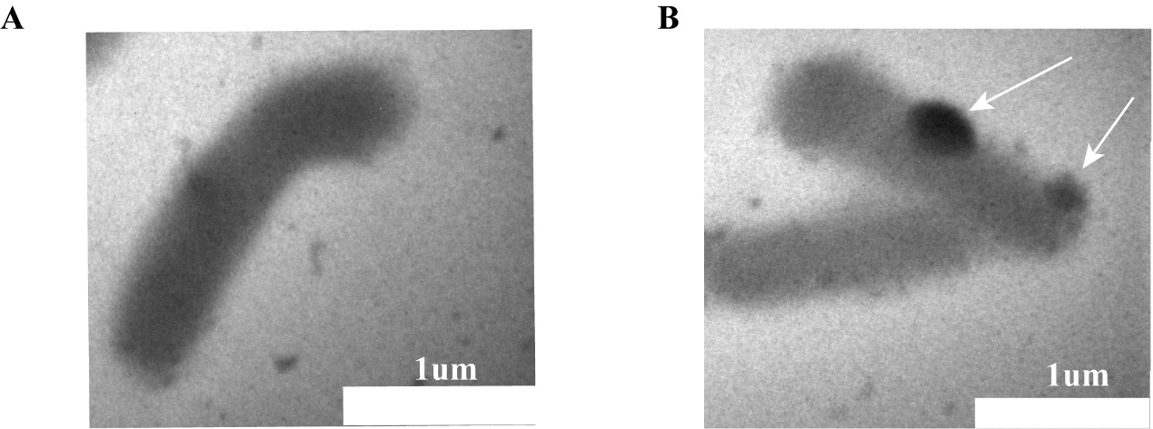
Figure S1. Synthesis of PFH@CL/ Fe₃O₄ NPs + B. bifidum (A)The TEM images of naked B. bifidumand (B) The TEM images of B. bifidum + PFH@CL/Fe₃O₄ NPs. White arrow shows the NPs. Scale bar, 1 μm.
Abbreviations: Fe₃O₄, Superparamagnetic Iron Oxide; PFH, perfluorohexanes; CL, cationic liposome; NPs, nanoparticles; TEM, transmission electron microscopy.

Figure S2. Hydrodynamic diameter of PFH@CL/Fe₃O₄ NPs + B. bifidum (A)The Particle size distribution of B. bifidum. (B) The Particle size distribution of B. bifidum + PFH@CL/Fe₃O₄ NPs.
Abbreviations: Fe₃O₄, Superparamagnetic Iron Oxide; PFH, perfluorohexanes; CL, cationic liposome; NPs, nanoparticles.

Figure S3. Evaluation of synergistic effect of PFH@CL/Fe₃O₄ NPs for HIFU ablation in vitro. (A) HIFU ablation of In vitro bovine liver with different concentrations of NPs (B) Coagulative necrosis volume of different concentration NPs (n=3).
Abbreviations: HIFU, High intensity focused ultrasound; Fe₃O₄, Superparamagnetic Iron Oxide; PFH, perfluorohexanes; CL, cationic liposome; NPs, nanoparticles.

Figure S4. Hemolysis result of PFH@CL/Fe₃O₄ NPs with different concentrations (n=3).
Abbreviations: Fe₃O₄, Superparamagnetic Iron Oxide; PFH, perfluorohexanes; CL, cationic liposome; NPs, nanoparticles; DDH₂O, double distilled water.

