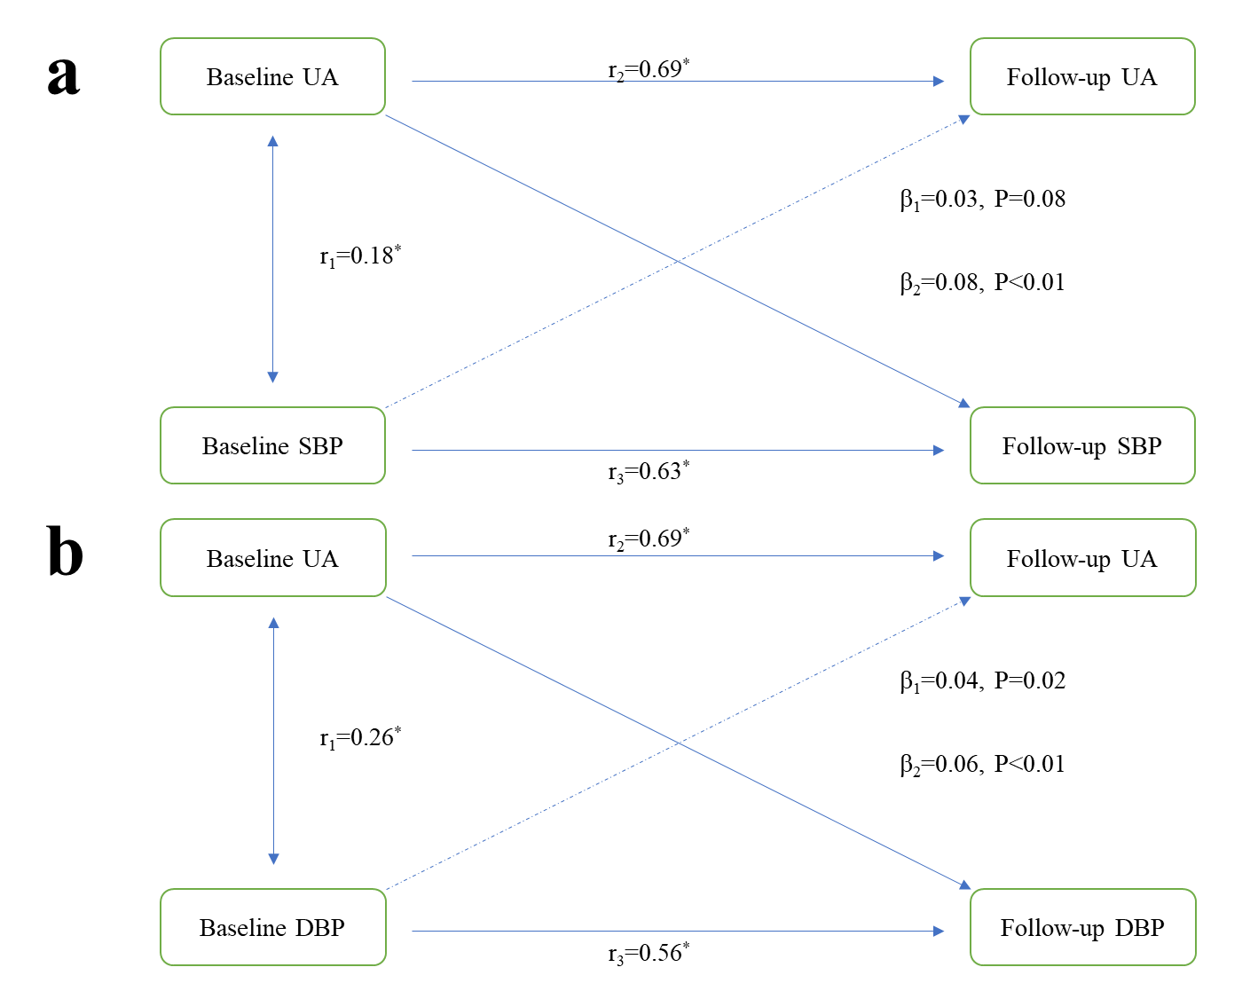
Supplementary Figure 1. An illustration of the cross-lagged panel analysis models for the temporal associations of SBP (a) and DBP (b) with serum UA, adjusting for age, sex, education level, cigarette smoking, alcohol consumption, low-density lipoprotein, high-density lipoprotein, and fasting glucose. All values were standardized with Z-transformation. β1 and β2 indicate cross-lagged path coefficients. r1 indicates a synchronous correlation. r2 and r3 indicate tracking correlations. UA: uric acid, SBP: systolic blood pressure, DBP: diastolic blood pressure, *P < 0.05.

