Online Supplement
Longitudinal Associations Between Sleep Habits, Screen Time and Overweight, Obesity in Preschool Children
Myrtha E. Reyna, MScª, Arpita Parmar, MScª, Diana L. Lefebvre PhD^{b}, Meghan B. Azad, PhD^{c,d,f}, Allan B. Becker, MD^{c,d}, Stuart E. Turvey, MBBS, PhDe, Theo J. Moraes, MD, PhDª, Wendy Lou, PhD^{g}, Padmaja Subbarao MD, MSc^{ag}, Malcolm R. Sears, MB, ChB^{b}, Piushkumar J. Mandhane, MD, PhD^{h}, Indra Narang*, MBBCh, MD^{ag}
*Corresponding author

METHODS
Overweight and obesity classification
The WHO provides guidelines for both clinical and epidemiological use on classification of growth indicators based on BMI z-scores, that are considered differently for children under five years of age and at/over five years of age ^{1–3}. In this study WHO guidelines by age group were applied as follows: At three -years of age children with a BMIz < -1.96 were classified as wasted, , ≥ -1.96 to ≤ 1.96 as normal, >1.96 as overweight, and >3 as obese. The cut-offs for children at or over five years of age was considered as < -1.96 as wasted, ≥ -1.96 to ≤ 1.04 as normal, > 1.04 as overweight and > 1.96 as obese.

Questionnaire data
Sleep data
The child's bedtime and waketime were obtained by open-ended questions restricted to numeric input phrased as "On weekdays, what is your child's usual bedtime? (Please use a 24-hour clock)". The respondent was provided with blank spaces in the format "_ _:_ _". Screen time data was collected by the question " On weekdays, on average, how many hours per day does your child sit and watch TV/DVDs, use a computer/tablet/ipod/iphone, or play video games?". The respondent was provided with blank spaces in the format "_ _ hours". Usual naptime was similarly obtained by the question "How long does your child nap per 24 hour period?", with the open ended answer provided in minutes as "_ _ minutes".

Caloric Intake
Daily caloric intake was calculated by cross-correlating a parent-reported food frequency questionnaire (FFQ) of 115 food items with a nutrient matrix based on the US Department of Agriculture (USDA) database. The nutrient composition of each of the foods listed in the FFQ was obtained, and individual energy intake was calculated as the sum of the product of frequency of consumption and kcal of each food item, based on portion sizes listed in the FFQ.

RESULTS
Stratification by 5-year exposures
A sensitivity analysis was performed to explore whether associations observed between overweight/obesity and 3-year exposures were modified by five-years duration of nocturnal sleep and screen time. This analysis consisted in seven adjusted GEE models stratified by each exposure group at five-years. Children with increased screen time at three years, but decreased at 5 years were at higher associated risk of overweight/obesity (OR 1.6 95% CI 1.09,2.35). All other results were not significant (eTable 4). Trajectory analysis or other clustering methods in a population with balanced sample sizes for all exposure and outcome groups may be better suited to explore the role of consistently shorter or longer sleep and screen time in early life.

REFERENCES
1. de Onis M. Development of a WHO growth reference for school-aged children and adolescents. Bull World Health Organ. 2007;85(09):660-667. doi:10.2471/BLT.07.043497
2. Merdedes de Onis. Length/Height-for-Age, Weight-for-Age, Weight-for-Length, Weight-for-Height and Body Mass Index-for-Age; Methods and Development. WHO Press; 2006.
3. Carsley S, Pope EI, Anderson LN, Tremblay MS, Tu K, Birken CS. Temporal trends in severe obesity prevalence in children and youth from primary care electronic medical records in Ontario: a repeated cross-sectional study. CMAJ Open. 2019;7(2):E351-E359. doi:10.9778/cmajo.20180174

TABLES AND FIGURES
eTable 1. Characteristics of children included in this analysis compared to children excluded due to missing sleep data at 3 years or BMI-z data at 3 or 5 years.
eTable 2. Bedtime and overweight/obese status longitudinal analysis from GEE adjusted models for interaction between bedtime and sex, as well as stratified by sex.
eTable 3. Cross-sectional sleep and overweight/obese cross-sectional analysis. Results from unadjusted and adjusted logistic regression models. Nocturnal sleep group 3 (>11 hrs) used as reference group.
eTable 4. Longitudinal sleep and overweight/obese status analysis stratified by exposure status at 5 years.
eFigure 1. Consort diagram of CHILD Cohort Study participants with available sleep and BMI-z data at 3 and 5 years

eTable 1. Characteristics of children included in this analysis compared to children excluded due to missing sleep data at 3 years or BMI-z data at 3 or 5 years.
 | Included in Analysis (N=2185) | Excluded  (N=882) | P
Male sex (%) | 1159 (53.0) | 448 (50.8) | 0.276
Caucasian ethnicity (%) | 1403 (64.7) | 531 (62.7) | 0.318
Birthweight (kg) | 3.45 (0.48) | 3.45 (0.49) | 0.916
Maternal BMI | 25.17 (5.68) | 26.14 (6.57) | <0.001
Maternal Perceived Stress Score |  |  | 0.04
Low | 1194 (56.6) | 225 (50.9)
Medium | 544 (25.8) | 119 (26.9)
High | 372 (17.6) | 98 (22.2)
Breastfeeding status at 6 months |  |  | <0.001
Exclusive | 405 (18.8) | 137 (17.2)
Partial | 1298 (60.3) | 418 (52.5)
None | 448 (20.8) | 241 (30.3)
Age 3 Years
Age (years) | 3.07 (0.16) | 3.13 (0.24) | <0.001
Weight (kg) | 15.02 (1.89) | 15.43 (1.93) | <0.001
Height (cm) | 95.89 (4.02) | 96.58 (3.97) | <0.001
BMI-z | 0.56 (1.00) | 0.70 (1.02) | 0.003
Daily Caloric Intake | 1454.59  [1150.80, 1756.55] | 1386.89  [1139.02, 1691.25] | 0.06
BMI-z classification* |  |  | 0.17
Wasted | 19 ( 0.9) | 3 ( 0.6)
Normal | 2021 (92.5) | 464 (90.1)
Overweight | 121 ( 5.5) | 41 ( 8.0)
Obese | 24 ( 1.1) | 7 ( 1.4)
Age 5 Years
Age (years) | 5.08 (0.19) | 5.16 (0.27) | <0.001
Weight (kg) | 19.45 (2.81) | 19.84 (3.08) | 0.008
Height (cm) | 110.65 (4.80) | 111.27 (4.83) | 0.013
BMI-z | 0.34 (0.97) | 0.40 (1.05) | 0.265
Daily Caloric Intake (Kcal) | 1425.94  [1188.40, 1706.34] | 1344.39  [1096.38, 1625.57] | 0.001
BMI-z classification⁺ |  |  | 0.14
Wasted | 16 ( 0.7) | 5 ( 1.1)
Normal | 1751 (80.1) | 345 (75.3)
Overweight | 293 (13.4) | 75 (16.4)
Obese | 125 ( 5.7) | - 7.2)
Continuous data presented as mean (SD) or median [IQR] and tested by t-test or Wilcoxon rank-test as appropriate. Categorical data presented as N (%) and tested by Chi-square test.
*WHO Classifications at three years: <-1.96 wasted, ≥ -1.96 to ≤ 1.96 normal, >1.96 to ≤ 3 overweight and >3 obese.
⁺WHO Classifications at five years: <-1.96 wasted, ≥ -1.96 to ≤ 1.04 normal, >1.04 to ≤ 1.96 overweight and >1.96 obese.
eTable 2. Bedtime and overweight/obese status longitudinal analysis from GEE adjusted models for interaction between bedtime and sex, as well as stratified by sex.
Sleep variable at 3 years | Interaction term |  | Boys only |  | Girls Only
Sleep variable at 3 years | OR (95%CI) | P | OR (95%CI) | P | OR (95%CI) | P
Bedtime > 9PM | 2.36 (1.19,4.7) | 0.01 | 0.75 (0.44,1.27) | 0.28 | 1.83 (1.16,2.9)* | 0.009

eTable 3. Cross-sectional sleep and overweight/obese cross-sectional analysis. Results from unadjusted and adjusted logistic regression models. Nocturnal sleep group 3 (>11 hrs) used as reference group.
Outcome | Sleep variable | Unadjusted  OR (95%CI) | Adjusted  OR (95%CI)
3 years (Overweight/  Obesity) | Nocturnal sleep group 1 (≤10.5 hrs) | 1.00 (0.65, 1.53) | 1.01 (0.60, 1.69)
3 years (Overweight/  Obesity) | Nocturnal sleep group 2 (>10.5 – 11 hrs) | 1.32 (0.87, 2.02) | 1.34 (0.81, 2.22)
3 years (Overweight/  Obesity) | Bedtime > 9PM | 1.06 (0.66, 1.69) | 1.13 (0.66, 1.94)
3 years (Overweight/  Obesity) | Screen time (>1hr/day) | 1.91 (1.36, 2.68)* | 1.68 (1.10, 2.57)*
5 years (Overweight/  Obesity) | Nocturnal sleep group 1 (≤10.5 hrs) | 1.71 (1.27, 2.31)* | 1.97 (1.39, 2.78)*
5 years (Overweight/  Obesity) | Nocturnal sleep group 2 (>10.5 – 11 hrs) | 1.45 (1.07, 1.97)* | 1.77 (1.25, 2.51)*
5 years (Overweight/  Obesity) | Bedtime > 9PM | 0.73 (0.45, 1.19) | 0.80 (0.46, 1.39)
5 years (Overweight/  Obesity) | Screen time (>1hr /day) | 1.46 (1.16, 1.85)* | 1.22 (0.93, 1.60)
*p-value≤0.05
Logistic GEE models adjusted for sex, birthweight (grams), breastfeeding status, maternal education, daily caloric intake, maternal perceived stress score, 5 years’ physical activity, and maternal BMI.

eTable 4. Longitudinal sleep and overweight/obese status analysis stratified by exposure status at 5 years.
Strata at 5Y | 3 years NSD | N/Total | Adjusted  OR (95%CI) | P
Long NSD  (>11 hrs) | >11 hrs | 343/622 | Ref | -
Long NSD  (>11 hrs) | ≤10.5 hrs | 98/1090 | 1.39 (0.69, 2.79) | 0.35
Long NSD  (>11 hrs) | >10.5 – 11 hrs | 181/1090 | 1.66 (0.91, 3.03) | 0.10
Medium NSD  (>10.5 – 11 hrs) | >11 hrs | 196/703 | Ref | -
Medium NSD  (>10.5 – 11 hrs) | ≤10.5 hrs | 242/703 | 1.10 (0.63, 1.93) | 0.73
Medium NSD  (>10.5 – 11 hrs) | >10.5 – 11 hrs | 265/703 | 1.24 (0.75, 2.05) | 0.40
Short NSD  (≤10.5 hrs) | >11 hrs | 83/696 | Ref | -
Short NSD  (≤10.5 hrs) | ≤10.5 hrs | 436/696 | 0.90 (0.47, 1.75) | 0.76
Short NSD  (≤10.5 hrs) | >10.5 – 11 hrs | 177/696 | 0.66 (0.31, 1.42) | 0.28
Early Bedtime  (≤ 9PM) | ≤ 9PM | 1709/1898 | Ref | -
Early Bedtime  (≤ 9PM) | > 9PM | 189/1898 | 1.34 (0.90, 1.98) | 0.15
Late Bedtime  (>9PM) | ≤ 9PM | 51/151 | Ref | -
Late Bedtime  (>9PM) | > 9PM | 100/151 | 0.69 (0.23, 2.06) | 0.51
Screen Time >1hr/day | ≤1hr/day | 263/857 | Ref | -
Screen Time >1hr/day | >1hr/day | 594/857 | 1.12 (0.76, 1.66) | 0.56
Screen Time ≤1hr/day | ≤1hr/day | 946/1186 | Ref | -
Screen Time ≤1hr/day | >1hr/day | 240/1186 | 1.60 (1.09, 2.35) | 0.02

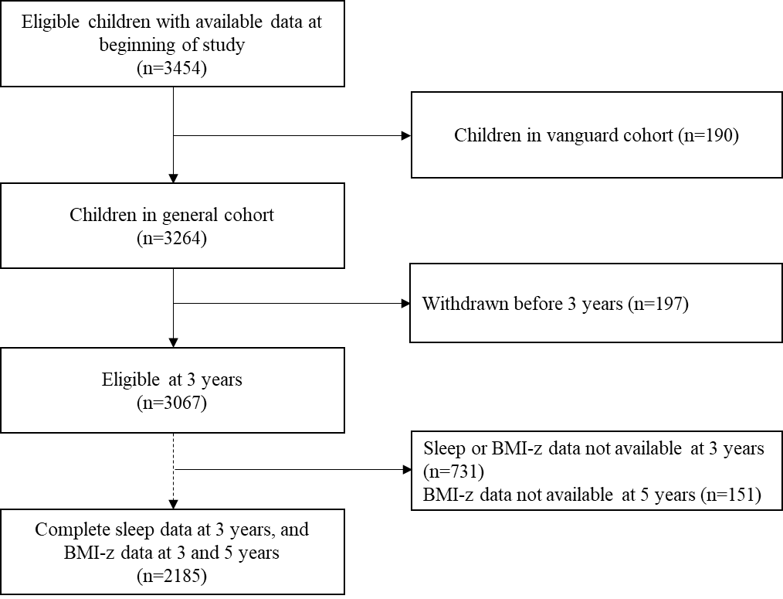

eFigure 1. Consort diagram of CHILD Cohort Study participants included in study.

