Supporting Information

A Ternary Synergistic eNOS Gene Delivery System Based on Calcium Ion and L-arginine for Accelerating Angiogenesis by Maximizing NO production

Materials
peNOS (plasmids coding endothelial nitric oxide synthase (eNOS)) was obtained from Sangon Biotech Co., Ltd. (Shanghai, China). pEGFP (plasmids coding enhanced green fluorescent protein) was purchased from Beyotime Biotechnology Co., Ltd. (Shanghai, China). Human umbilical vein endothelial cells (HUVECs) (PCS-100-013) were obtained from American Type Culture Collection (ATCC, Manassas, VA). Dulbecco’s modified Eagle medium (DMEM) with high glucose, fetal bovine serum (FBS) and Griess Reagent Kit for Nitrite Determination Molecular Probes® were bought from Thermo Fisher Scientific Co., Ltd. (Shanghai, China). Phosphate buffered saline (PBS, 1×, pH7.2-7.4, 10mM, cell culture), penicillin/streptomycin stock solution (100×), trypsin-EDTA solution (0.25%) and Cell Counting Kit-8 (CCK-8) agent were purchased from Solarbio Technology Co., Ltd. (Beijing, China). Label IT® Nucleic Acid Labeling Kit, Cy®5 was purchased from Mirus Bio LLC Gamma Biosciences Company. LysoTracker Green and Hoechst 33342 were obtained from Invitrogen Biotechnology Co., Ltd. (Shanghai, China). Transwell (24-well, 8 μm) and BD Biocoat 356234 Matrigel was obtained from Corning Inc. Chemicals were purchased from Sigma Aldrich (St. Louis, MO). Monoclonal antibodies against CD31 (anti-CD31) and monoclonal antibodies against F4/80 (anti-F4/80) were purchased from Abcam (Shanghai, China). BALB/c (male, 7 weeks, 20 g) were purchased from Chinese Academy of Medical Science & Peking Union Medical College Institute of Biomedical Engineering.
Agarose gel electrophoresis
Agarose gel electrophoresis was carried out to assess the loading capability of gene carriers for plasmids DNA (pDNA). Firstly, nanocomplexes with various weight radios of CaCl₂ and pDNA were prepared and incubated at room temperature for 30 min. Then, the freshly prepared nanocomplexes (10 μL) were mixed with 2 μL DNA loading buffer (6×). After solidification, adding gene complexes into 0.8% agarose gel containing 6 μL GoldView and conducting electrophoresis in 1× TAE buffer at 120 V for 25 min. Finally, the binding ability of these gene carrier with pDNA were observed on a UV illuminator
Quantitative real-time polymerase chain reaction (PCR) assay
To observe the expression of eNOS on HUVECs treated with different nanoparticles, the mRNA level for eNOS was measured by PCR assay. PBS-treated HUVECs were used as control. HUVECs were seeded in 6-well plate and transfected with different gene complexes loaded with peNOS for 24 h. Total RNA was isolated from the cell suspension using a RNA easy tissue mini kit (Qiagene GmbH, Germany) according to the manufacturer's protocol. Then, the RNA was reverse-transcribed into cDNA, which was further used to complete realtime fluorescence quantitative PCR assay on 7500 Real-Time PCR System. The expression of house-keeping gene GAPDH was used as an internal control. The forward and reverse primers for GAPDH were ‘TTCTTTTTCACCTACACGCTCA’ and ‘TGTAGATAACAGGGTTCAGCGA’, respectively. The forward and reverse primers for the eNOS gene were ‘AGGCATCACCAGGAAGAAGA’ and ‘GGCCAGTCTCAGAGCCATAC’, respectively.

Histopathological analysis
The gastrocnemius muscles of the left legs were collected after 14 days of ischemia, and then washed with PBS three times and fixed with 4% PFA for 24 h. Subsequently, the muscles were dehydrated by gradient alcohol and transparent by xylene. Paraffin was used for fixing and encapsulation. The fixed tissues were cut into 4.5 µm thickness and middle parts of the stented aorta and mounted on 3-aminopropyltriethoxysilane-coated slides. The slides were dewaxed to water and stained with hematoxylin and eosin (H&E). Immunostaining for monoclonal antibodies against CD31 (anti-CD31) and monoclonal antibodies against F4/80 (anti-F4/80) was performed to evaluating vascular regeneration and inflammation. The tissue sections were performed microwave antigenic repair after dewaxing to water. Afterwards, these sections were blocked with goat serum for 1 h at the room temperature. Slides were incubated with primary antibodies (anti-31 and anti-F4/80, respectively) overnight at 4 °C and then with secondary antibodies for 2 h at room temperature. Then, DAPI was used to stain nucleus. The slides were imaged with a fluorescence microscope. The vascular regeneration was characterized by surface microvessel density. The microvessel density was calculated by the numbers of CD-31-positive vessels in five randomly taken images and reported as vessels/mm². The inflammatory level was reflected by the volume of F4/80-positive cells in all cells.

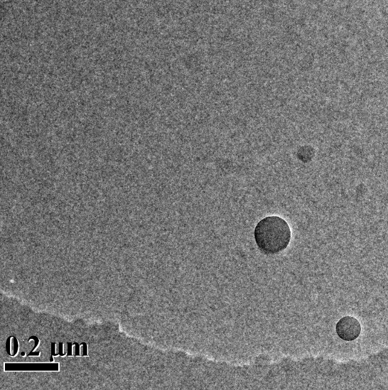
Figure S1. The morphology of R(L)-CaP/peNOS nanoparticles detecting by transmission electron microscope (TEM).

