Development of Paeonol Liposomes: Design, Optimization, in vitro and in vivo Evaluation
Table S1 Design factor level of Box-Behnken response surface method
 | Level
 | -1 | 0 | 1
A | 4:1 | 6:1 | 8:1
B | 2.0 | 3.0 | 4.0
C | 6.0 | 6.5 | 7.0

Table S2 Experimental arrangement and results of Box-Behnken response surface method
Run | A (w/w) | B (mg/mL) | C | EE (%)
1  2  3  4  5  6  7  8  9  10  11  12  13  14  15  16  17 | 0  0  0  0  0  0  0  0  -1  -1  -1  -1  1  1  1  1  0 | 1  0  -1  1  -1  0  0  0  0  -1  0  1  0  -1  0  1  0 | 1  0  -1  -1  1  0  0  0  -1  0  1  0  1  0  -1  0  0 | 84.34  89.75  85.62  83.01  83.48  90.17  89.84  89.62  86.99  82.40  84.30  82.88  85.12  84.15  83.50  80.13  89.46

Table S3 Results of variance analysis
Source | Sum of Squares | df | Mean Square | F-value | P-value
Model | 156.81 | 9 | 17.42 | 117.11 | <0.0001 | significant
A | 1.68 | 1 | 1.68 | 11.32 | 0.0120
B | 3.50 | 1 | 3.50 | 23.51 | 0.0019
C | 0.4418 | 1 | 0.4418 | 2.97 | 0.1285
AB | 5.06 | 1 | 5.06 | 34.03 | 0.0006
AC | 4.64 | 1 | 4.64 | 31.21 | 0.0008
BC | 3.01 | 1 | 3.01 | 20.23 | 0.0028
A² | 44.65 | 1 | 44.65 | 300.12 | <0.0001
B² | 71.52 | 1 | 71.52 | 480.73 | <0.0001
C² | 9.91 | 1 | 9.91 | 66.60 | <0.0001
Residual | 1.04 | 7 | 0.1488
Lack of Fit | 0.7576 | 3 | 0.2525 | 3.56 | 0.1259 | not significant
Pure Error | 0.2839 | 4 | 0.0710
Cor Total | 157.85 | 16
 | R²=0.9934 |  |  | R²adj=0.9849

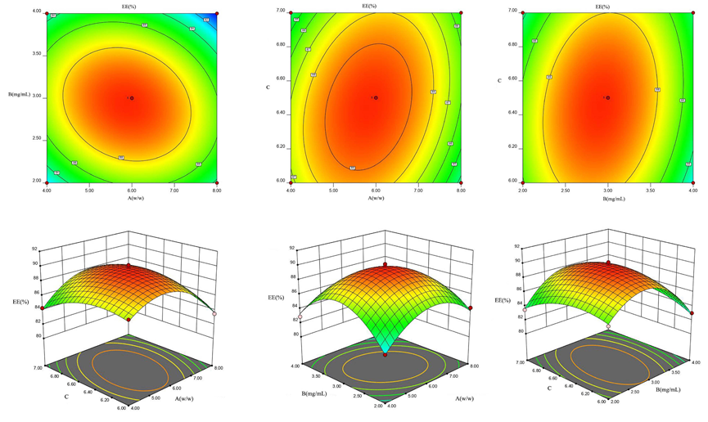
Figure S1 Contour map and 3D effect surface map of the interaction of various factors

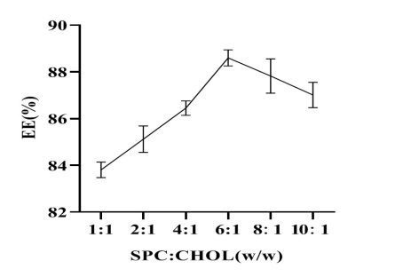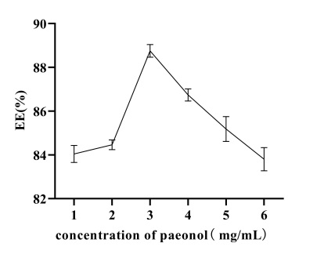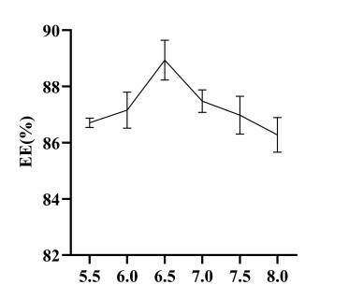

Figure S2 Single factor experiment results

paeonol vs Pae-Lips | p
PBS | 0.00131749
SGF | 0.025252673
SIF | 0.001058
Table S4 The p-values for the comparison of the in vitro release of paeonol and Pae-Lips in PBS, SGF and SIF

Table S5 The p-values for the comparison of the pharmacokinetic parameters of paeonol and Pae-Lips
paeonol vs Pae-Lips | p
t_{1/2} | 0.010579157
C_{max} | < 0.0001
AUC_{(0-t)} | < 0.0001
AUC_{(0-∞)} | < 0.0001
MRT_{(0-t)} | 0.002699777
CL | < 0.0001

Table S6 The p-values for the comparison of the Papp values of different concentrations of paeonol and Pae-Lips at different intestines
paeonol vs Pae-Lips (Papp) | p
ileum at low concentrations | 0.020121217
colon at low concentrations | 0.009766212
ileum at middle concentrations | 0.028241684
colon at middle concentrations | 0.01171972
colon at high concentrations | 0.009061318

Table S7 The p-values for the comparison of the Ka values of different concentrations of paeonol and Pae-Lips at different intestines
paeonol vs Pae-Lips (Ka) | p
ileum at low concentrations | 0.00012168
colon at low concentrations | 0.000981901
ileum at middle concentrations | 0.016767625
colon at middle concentrations | 0.000424527
colon at high concentrations | 0.093786136

Table S8 The p-values for the comparison of the Papp values of paeonol and paeonol + Ver at different intestines
paeonol vs paeonol + Ver (Papp) | p
duodenum | < 0.0001
jejunum | < 0.0001
ileum | < 0.0001
colon | < 0.0001

Table S9 The p-values for the comparison of the Papp values of paeonol and paeonol + Indo at different intestines

paeonol vs pae + Indo (Papp) | p
duodenum | < 0.0001
jejunum | < 0.0001
ileum | < 0.0001
colon | < 0.0001
Table S10 The p-values for the comparison of the Papp values of paeonol and paeonol + Res at different intestines
paeonol vs pae + Res (Papp) | p
duodenum | < 0.0001
jejunum | < 0.0001
ileum | < 0.0001
colon | < 0.0001

Table S11 The p-values for the comparison of the Papp values of different concentrations of paeonol and Pae-Lips at different transport directions
paeonol vs Pae-Lips (Papp) | p
AP-BL at low concentrations | 0.00483293
BL-AP at low concentrations | 0.042986757
AP-BL at middle concentrations | 0.020660862
BL-AP at middle concentrations | 0.035494661
AP-BL at high concentrations | 0.021300889
BL-AP at high concentrations | 0.048770998

Table S12 The p-values for the comparison of the Papp values of paeonol and paeonol + different inhibitors at different transport directions
paeonol vs paeonol + Ver (Papp) | p
AP-BL | 0.00010647
BL-AP | 0.044709263
paeonol vs paeonol + Indo (Papp)
AP-BL | < 0.0001
BL-AP | 0.045528371
paeonol vs paeonol + Res (Papp)
AP-BL | 0.001907208
BL-AP | 0.030162744

Table S13 The p-values for the comparison of the NO, IL-6, IL-10 and TNF-α levels of paeonol and Pae-Lips (middle and high concentrations)
paeonol vs Pae-Lips | NO | IL-6 | IL-10 | TNF-α
Pae-Lips-M | 0.016934113 | 0.025361182 | 0.035434639 | 0.034594663
Pae-Lips-H | 0.000213854 | 0.005114275 | 0.025423585 | 0.008275968

Table S14 The p-values for the comparison of the NF-κB and p38 levels of paeonol and Pae-Lips (middle and high concentrations)
paeonol vs Pae-Lips | NF-κB | p38
Pae-Lips-M | 0.030774547 | 0.00085561
Pae-Lips-H | 0.000905125 | <0.0001

