Supplementary materials

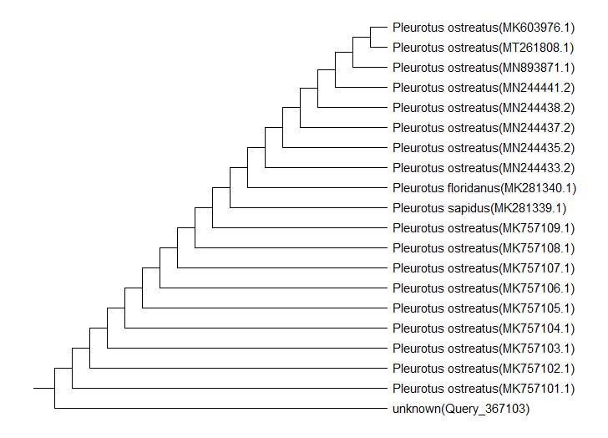
Figure S1. The phylogenetic tree based on partial sequencing of ITS1 and ITS4 ribosomal RNA gene showing relationship neighbor-joining between identified mushroom species P. ostreatus and other closely related sequences on NCBI GenBank reference database

Figure S2. The phylogenetic tree based on partial sequencing of ITS1 and ITS4 ribosomal RNA gene showing relationship neighbor-joining between identified mushroom species L. edodes and other closely related sequences on NCBI GenBank reference database

Figure S3. The phylogenetic tree based on partial sequencing of ITS1 and ITS4 ribosomal RNA gene showing relationship neighbor-joining between identified mushroom species A. bisporus and other closely related sequences on NCBI GenBank reference database

Docking Results:
- lead
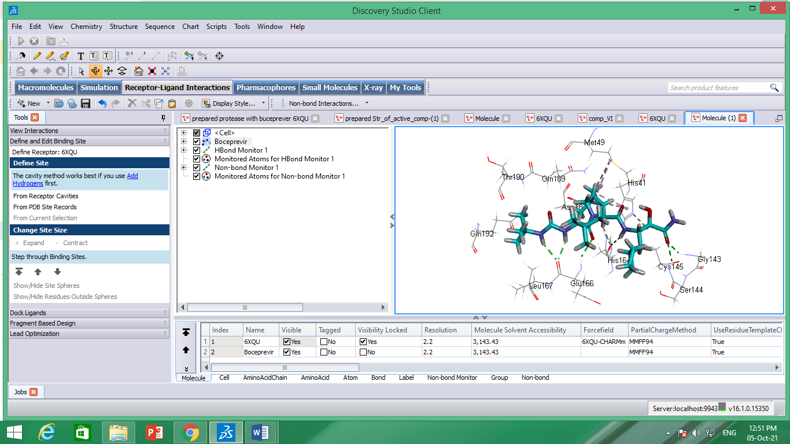
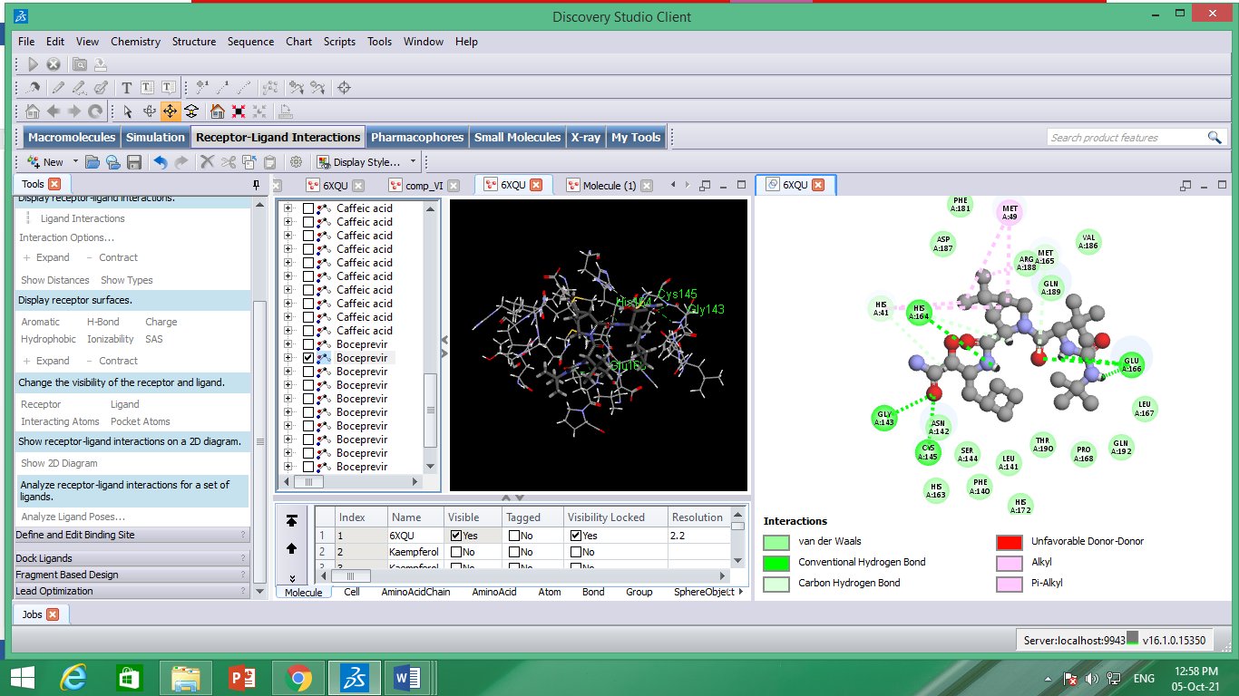

2-kaempeferol
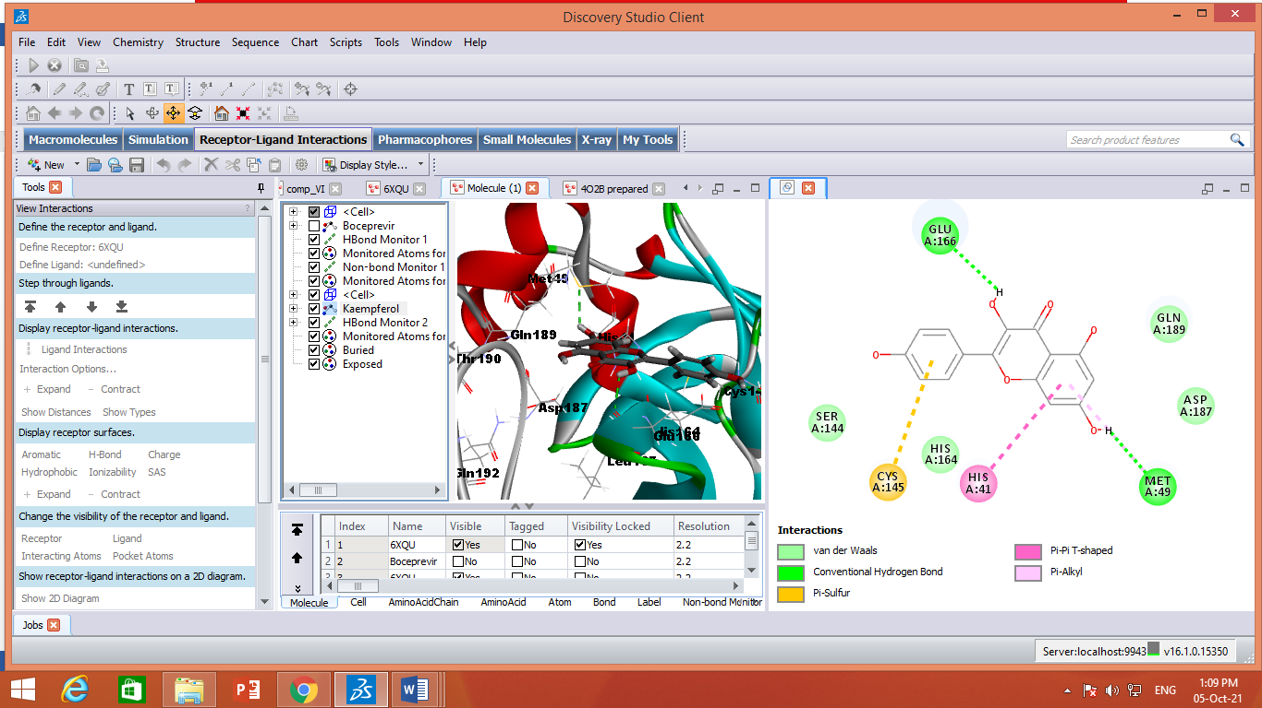

2-Quercetin
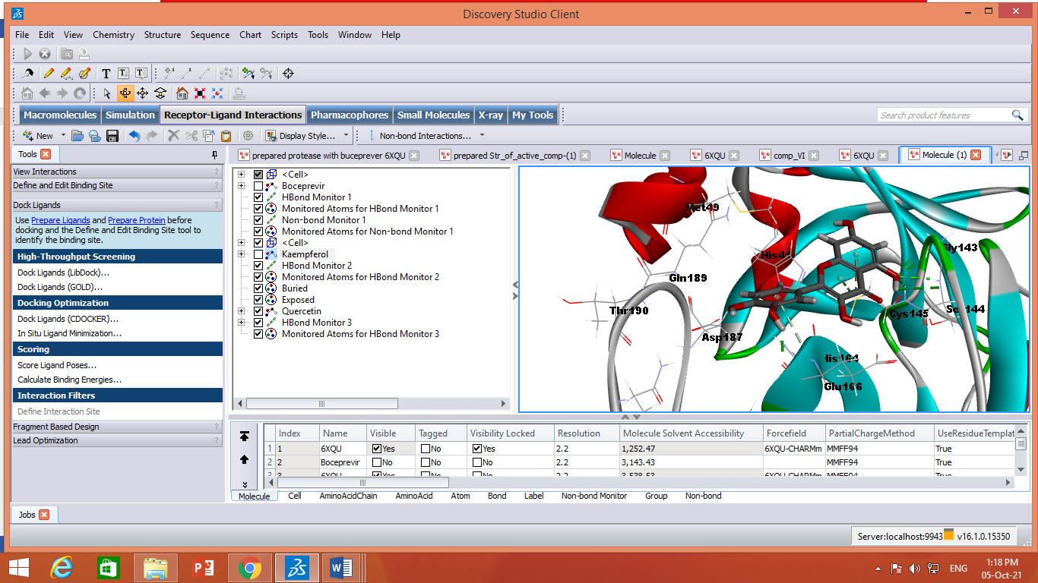

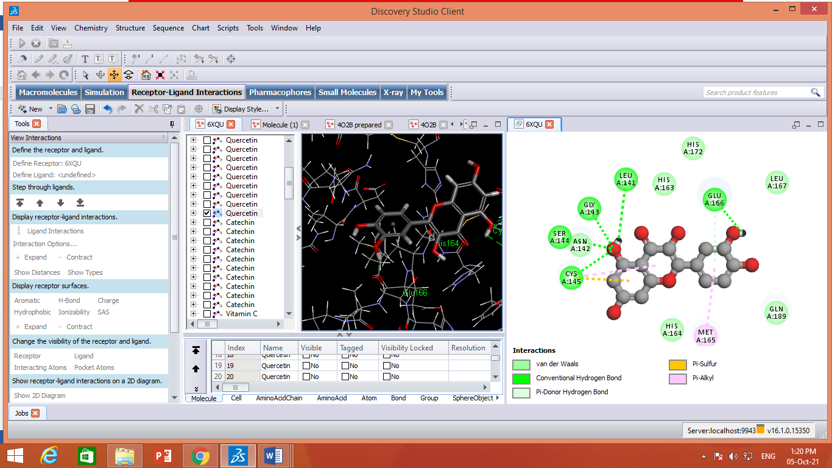

3-Vitamin C
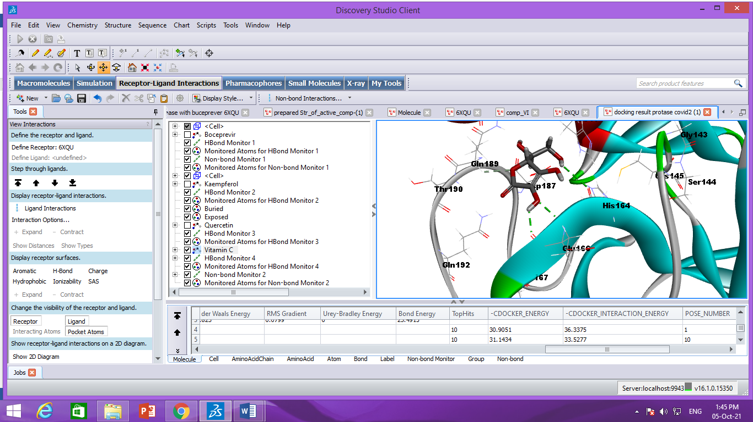

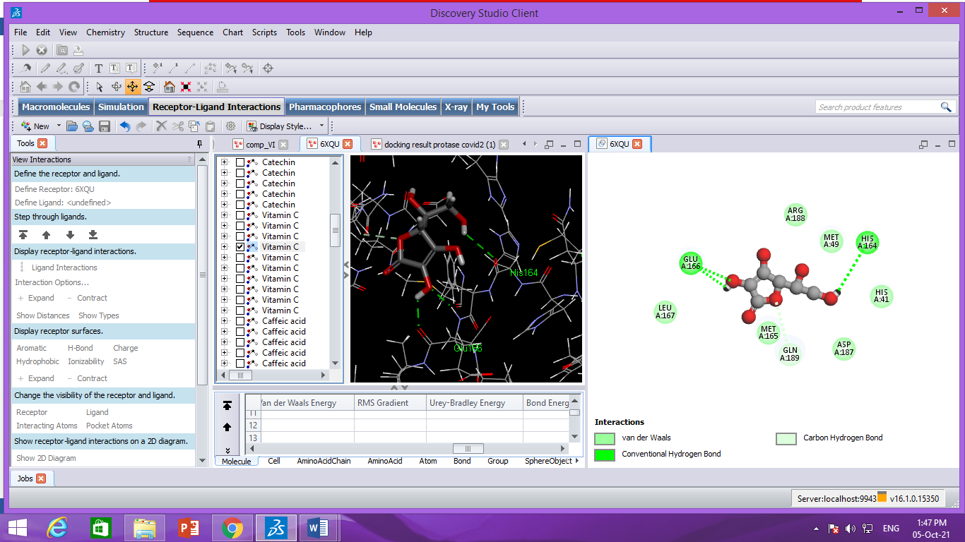

4-Catechin
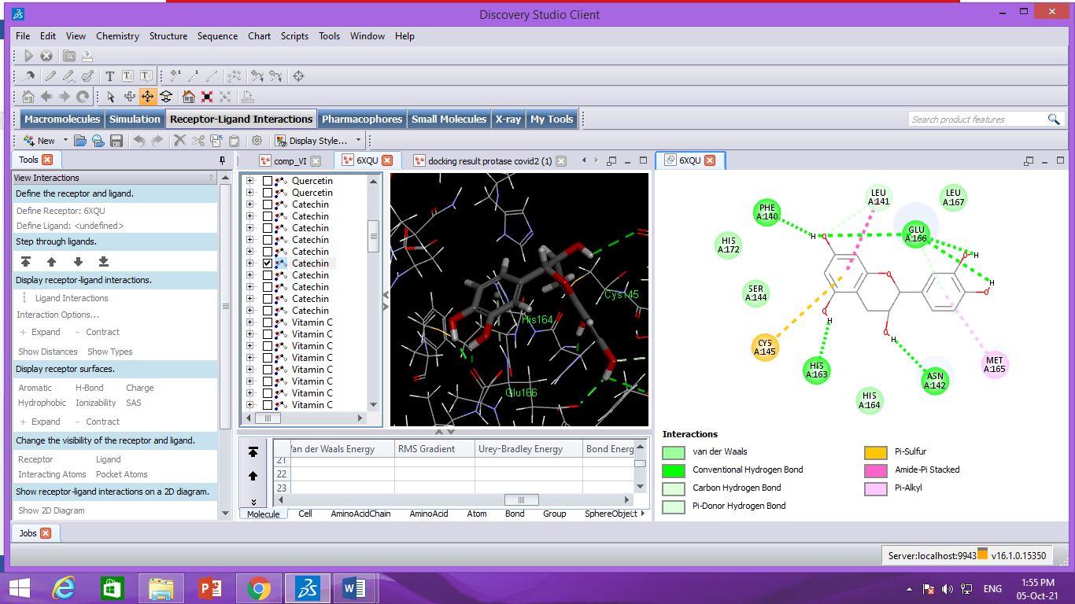

5-Cafeic acid
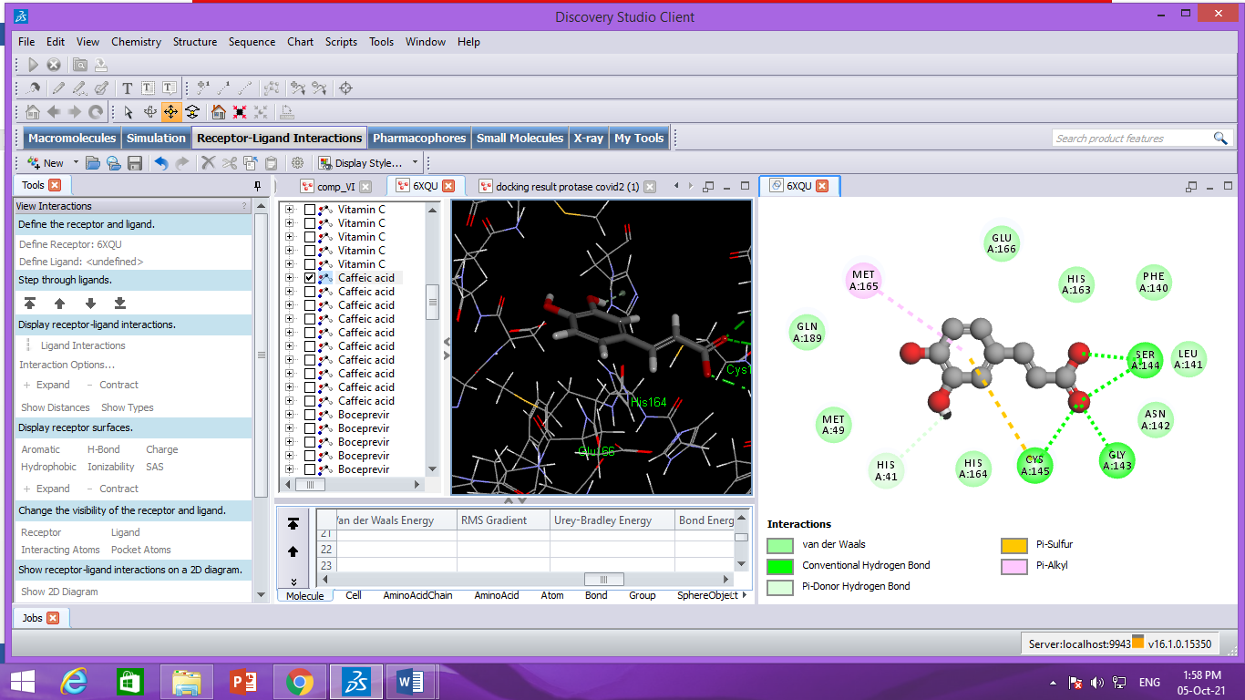

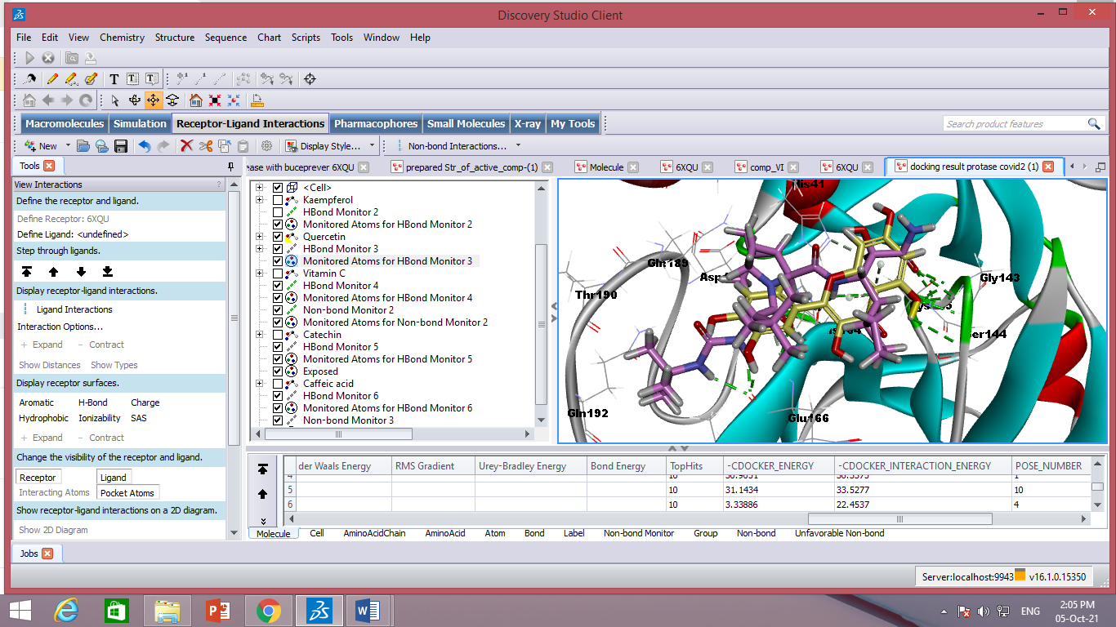

2Y9X after ZDOCK
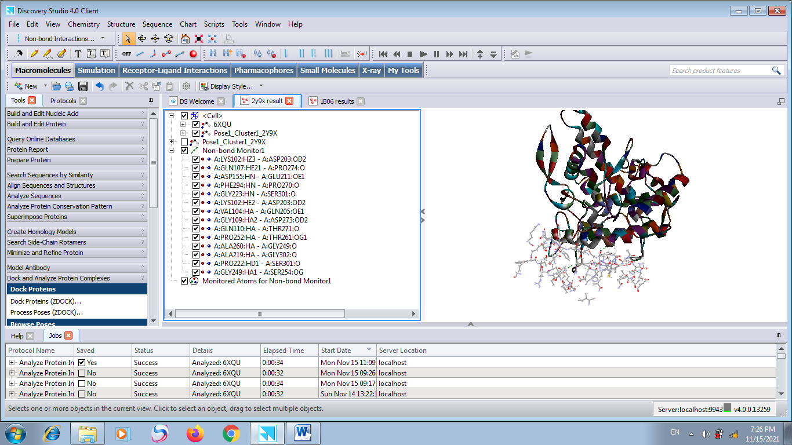

1BO6
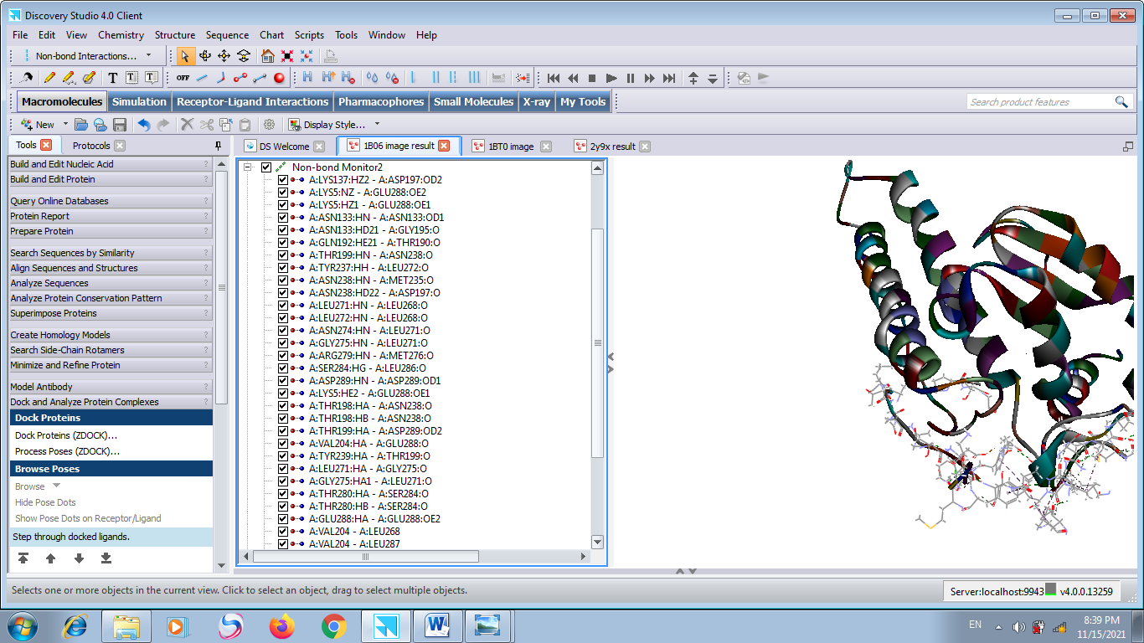

1DGG
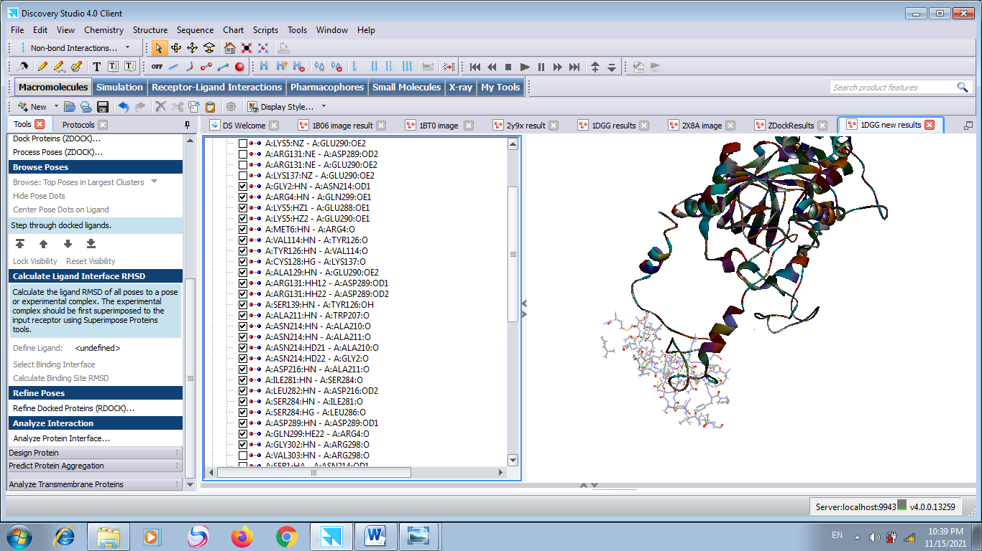

Analyze Protein Interface Results:
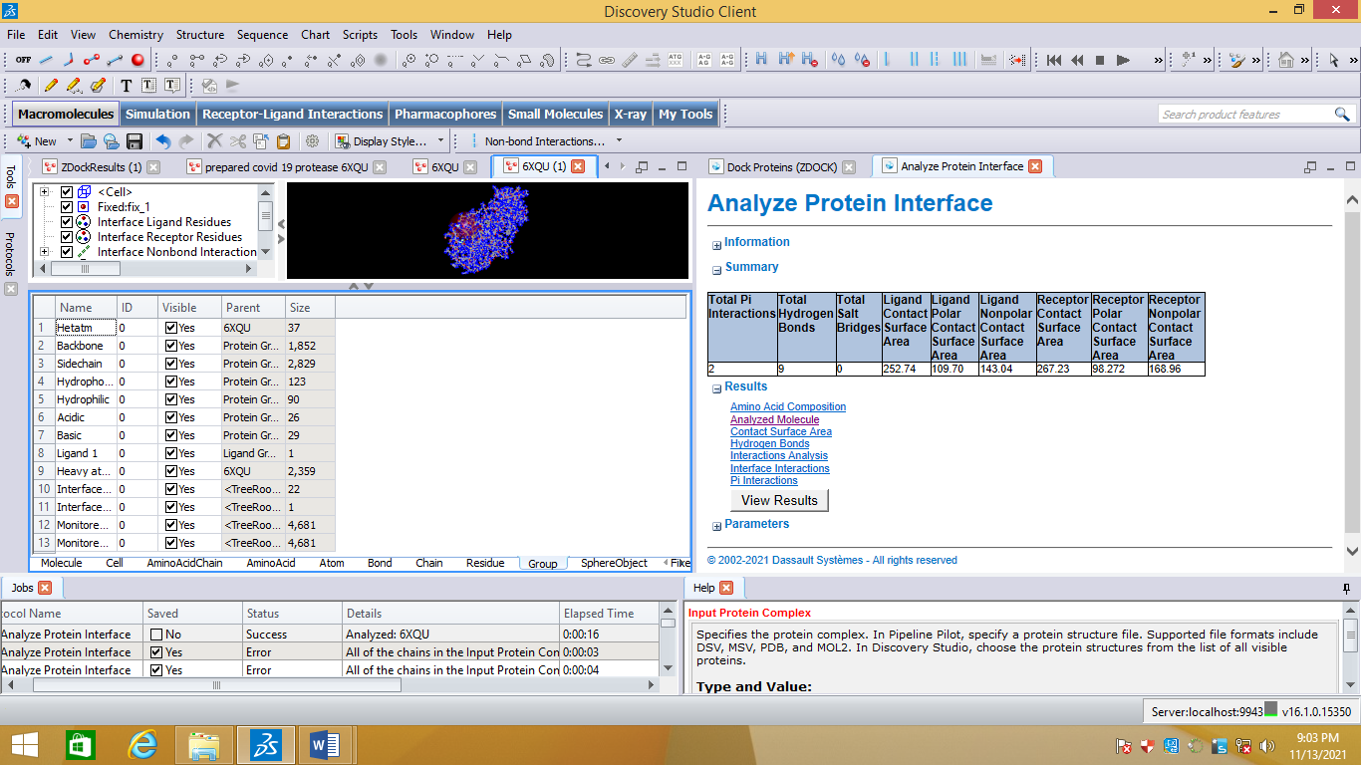
Description:
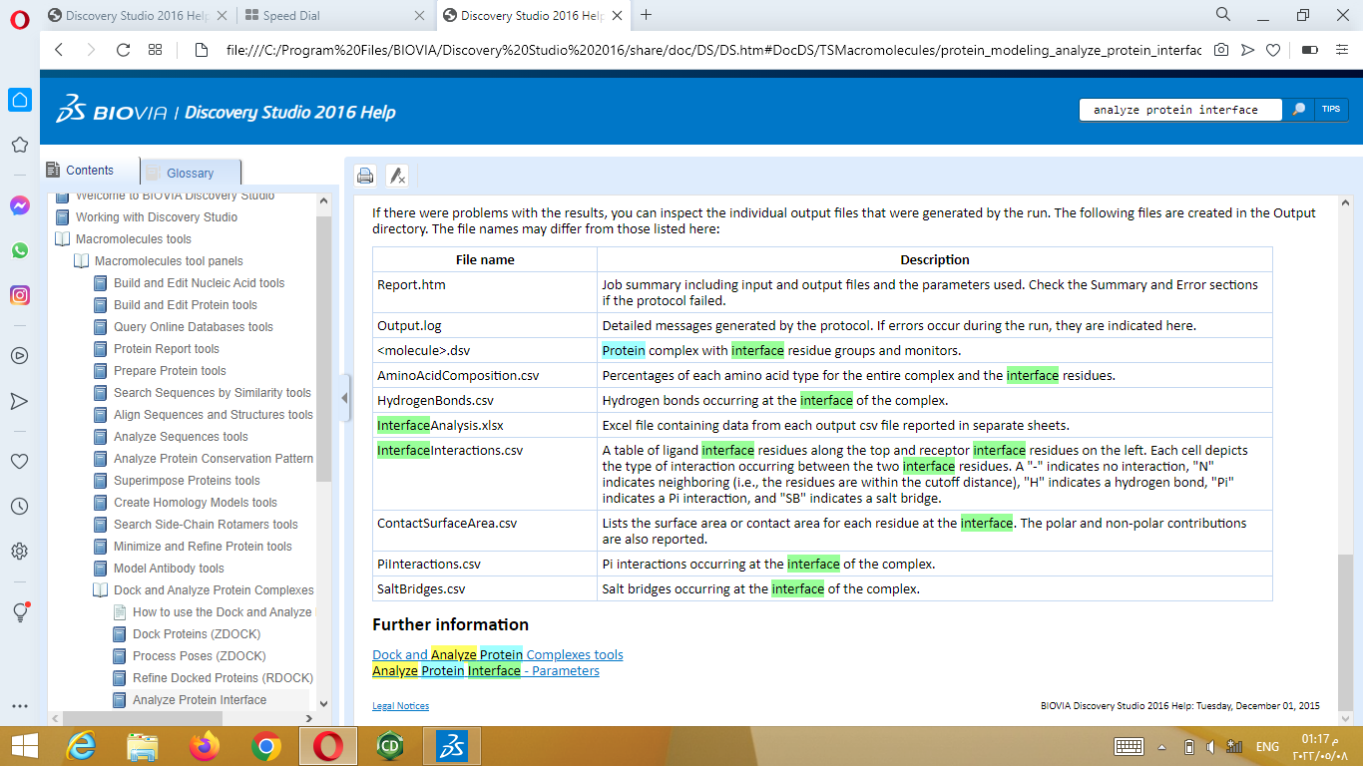

Figure S4. Screenshot samples of the uncropped results of the Molecular Dynamics Simulation analysis.

