Supplementary material
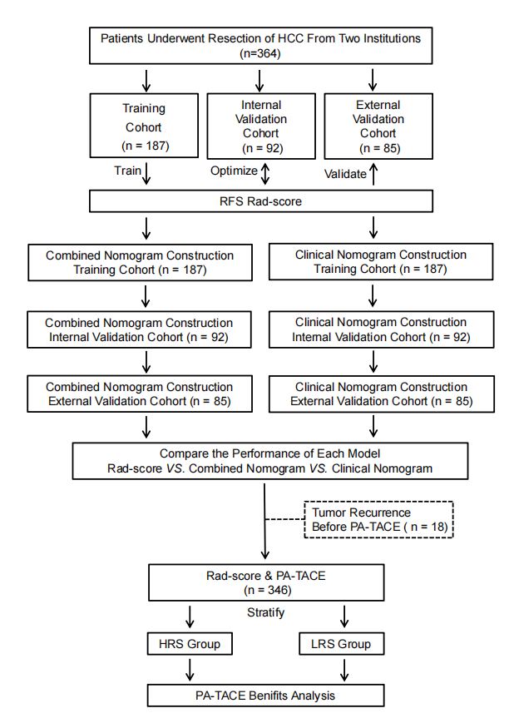
Figure S1: Study design.
Abbreviations: HCC, hepatocellular carcinoma; RFS, recurrence-free survival; Rad-score, radiomics score; PA-TACE, postoperative adjuvant transcatheter arterial chemoembolization; LRS, low radiomics score; HRS, high radiomics score.

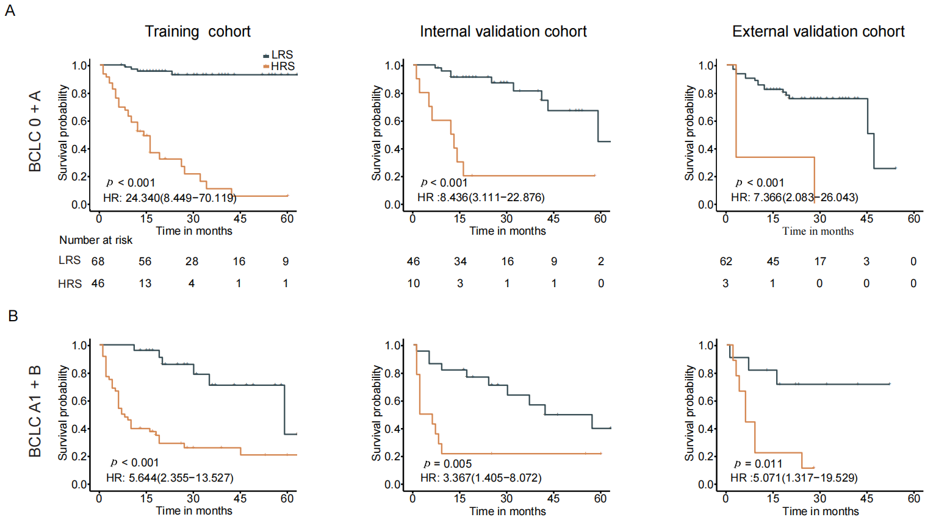
Figure S2: Kaplan-Meier RFS curves among HCC patient subgroups in the training, the internal and external validation cohorts. (A) BCLC 0 and A; (B) BCLC A1 and B.
Abbreviations: LRS, low radiomics score; HRS, high radiomics score; HR, hazard ratio; BCLC, Barcelona Clinic Liver Cancer; HCC, hepatocellular carcinoma; RFS, recurrence-free survival.

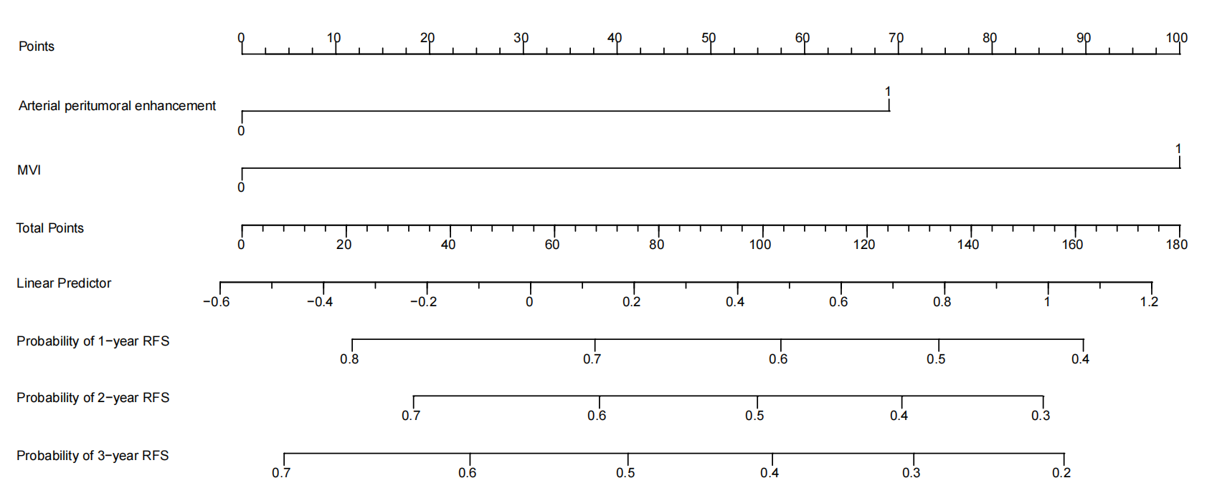

Figure S3: The Clinical nomogram to estimate RFS.
Abbreviations: RFS, recurrence-free survival; MVI, microvascular invasion.

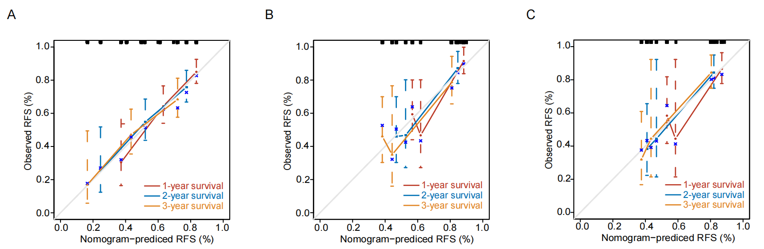
Figure S4: The calibration curves for the clinical nomogram. (A) the training cohort; (B) the internal validation cohort; (C) the external validation cohort.
Abbreviations: RFS, recurrence-free survival.

Table S1: CT protocols of the two institutions
Parameters | Institution I |  |  | Institution II
 | Sir Run Run Shaw Hospital, Zhejiang University School of Medicine |  |  | The First Affiliated Hospital of Wenzhou Medical University
CT version | 64-slice spiral CT  (GE LightSpeedVCT, Waukesha,  Wisconsin, USA) | 40-slice spiral CT  (Siemens SOMATOM Definition AS 40, Forchheim, Germany) | 96-slice spiral CT (Siemens Sensation16,  Forchheim, Germany) | 256-slice spiral CT  (Philips Healthcare, The Netherlands) | 16-slice spiral CT (Toshiba Medical Systems, Tokyo, Japan)
CT tube voltage (kVp) | 120 | 120 | 120 | 120 | 120
CT tube current (mAs) | 180 | 260 | 260 | 220 | 150
CT rotation time (s) | 0.5 | 0.5 | 0.5 | 0.6 | 0.5
Bolus-tracking threshold (aorta) (HU) | 100 | 100 | 100 | 200 | 100
Image matrix | 512×512 | 512×512 | 512×512 | 512×512 | 512×512
pixel spacing (mm) | 0.70 | 0.81 | 0.70 | 0.51 | 0.70
Slice thickness(mm) | 7 | 5 | 5 | 5 | 5
Reconstruction interval (mm) | 7 | 5 | 5 | 5 | 5

Table S2: Imaging features selected for the construction of radiomics model
Phase | Region | Features number | Features selected
Pre-contrast phase | Tumor | 13 | (1) original glszm Zone Entropy;  (2) original ngtdm Coarseness;  (3) wavelet-HHH-glcm Cluster Shade;  (4) wavelet-HHL-glszm-Gray Level Non-Uniformity;  (5) wavelet-HHL-glszm Size Zone Non-Uniformity;  (6) wavelet-HLL-first order Mean;  (7) wavelet-HLL-glcm Cluster Tendency;  (8) wavelet-HLL-glcm Imc1;  (9) wavelet-LHL-glrlm Long Run Emphasis;  (10) wavelet-LHL-glszm Zone Entropy;  (11) wavelet-LLH-gldm Large Dependence Low Gray Level Emphasis;  (12) wavelet-LLL-glcm Cluster Prominence;  (13) wavelet-LLL-glcm Cluster Shade
Pre-contrast phase | Peritumor | 12 | (1) original shape Surface Volume Ratio;  (2) wavelet-HHH-glcm Cluster Shade;  (3) wavelet-HHL-glszm Size Zone Non-Uniformity;  (4) wavelet-HLL-first order 10 Percentile;  (5) wavelet-HLL-first order Uniformity;  (6) wavelet-HLL-glcm Sum Entropy;  (7) wavelet-HLL-glszm Zone Percentage;  (8) wavelet-LLH-first order Minimum;  (9) wavelet-LLH-glcm Correlation;  (10) wavelet-LLH-gldm Large Dependence Low Gray Level Emphasis;  (11) wavelet-LLL-first order Skewness;  (12) wavelet-LLL-glcm Cluster Prominence
Arterial phase | Tumor | 11 | (1) original glszm Low Gray Level Zone Emphasis;  (2) original glszm Zone Entropy;  (3) original ngtdm Contrast;  (4) wavelet-HHL-glszm Gray Level Non-Uniformity;  (5) wavelet-HLL-first order Mean;  (6) wavelet-HLL-first order Median;  (7) wavelet-HLL-glcm Cluster Tendency;  (8) wavelet-HLL-glcm Imc1;  (9) wavelet-LHL-glszm Zone Entropy;  (10) wavelet-LLH-gldm Small Dependence Low Gray Level Emphasis;  (11) wavelet-LLL-ngtdm Busyness
Arterial phase | Peritumor | 9 | (1) original first order Median;  (2) original glszm Large Area Low Gray Level Emphasis;  (3) original shape Surface Volume Ratio;  (4) wavelet-HHL-glszm Size Zone Non-Uniformity;  (5) wavelet-HLL-glcm Sum Entropy;  (6) wavelet-LLH-glcm Joint Average;  (7) wavelet-LLH-glcm Sum Average;  (8) wavelet-LLH-gldm Small Dependence Low Gray Level Emphasis;  (9) wavelet-LLL-gldm Small Dependence Low Gray Level Emphasis
Portal venous phase | Tumor | 22 | (1) original first order Skewness;  (2) original glszm GrayLevelNonUniformityNormalized;  (3) wavelet-HHH-glcm Cluster Shade;  (4) wavelet-HHH-glszm Zone Percentage;  (5) wavelet-HHH-ngtdm Busyness;  (6) wavelet-HHL-glszm Size Zone Non-Uniformity;  (7) wavelet-HLH-glcm Maximum Probability;  (8) wavelet-HLL-first order Mean;  (9) wavelet-HLL-first order Median;  (10) wavelet-HLL-glrlm Gray Level Variance;  (11) wavelet-HLL-ngtdm Strength;  (12) wavelet-LHH-first order Median;  (13) wavelet-LHH-glcm Imc1;  (14) wavelet-LHH-glszm Small Area Low Gray Level Emphasis;  (15) wavelet-LHL-glcm Idn;  (16) wavelet-LHL-glcm Maximum Probability;  (17) wavelet-LHL-gldm Small Dependence Low Gray Level Emphasis;  (18) wavelet-LHL-glszm Gray Level Variance;  (19) wavelet-LLH-glcm Difference Entropy;  (20) wavelet-LLL-first order Skewness;  (21) wavelet-LLL-glszm Large Area Low Gray Level Emphasis;  (22) wavelet-LLL-glszm Zone Percentage
Portal venous phase | Peritumor | 14 | (1) original gldm Small Dependence Low Gray Level Emphasis;  (2) original ngtdm Coarseness;  (3) original shape Surface Volume Ratio;  (4) wavelet-HHH-glcm Cluster Shade;  (5) wavelet-HHH-glszm Zone Percentage;  (6) wavelet-HHL-glszm Size Zone Non-Uniformity;  (7) wavelet-HLL-first order Entropy;  (8) wavelet-LHH-glcm Cluster Prominence;  (9) wavelet-LHH-glcm Difference Entropy;  (10) wavelet-LHH-glszm Small Area Low Gray Level Emphasis;  (11) wavelet-LHL-glcm Maximum Probability;  (12) wavelet-LLL-glcm Cluster Prominence;  (13) wavelet-LLL-glszm Large Area Low Gray Level Emphasis;  (14) wavelet-LLL-glszm Zone Percentage

Table S3: Univariate Cox regression analysis of predictors of recurrence in the training cohort
Characteristics | P | HR
Age, years | 0.191 | 0.99(0.97-1.01)
Gender (male, female) | 0.831 | 0.93(0.46-1.86)
Liver cirrhosis (no, yes) | 0.576 | 1.15(0.71-1.86)
Etiology (Unknown/Other, HBV) | 0.391 | 1.27(0.74-2.17)
AFP, ng/mL (≤200, >200) | 0.377 | 1.23(0.78-1.93)
ALT, U/mL (≤50, >50) | 0.201 | 1.35(0.85-2.14)
AST, U/mL (≤40, >40) | 0.626 | 1.12(0.71-1.75)
ALB, g/L (≤36, >36) | 0.956 | 0.99(0.58-1.67)
GGT, U/L (≤45, >45) | 0.201 | 0.75(0.48-1.17)
TB, µmol/L (≤19, >19) | 0.79 | 0.94(0.6-1.48)
CB, µmol/L (≤6.8, >6.8) | 0.386 | 0.79(0.46-1.35)
PLT, ×10⁹/L (≤100, >100) | 0.138 | 0.7(0.44-1.12)
PT, seconds (≤13, >13) | 0.972 | 0.99(0.6-1.63)
INR (≤1, >1) | 0.269 | 1.4(0.77-2.54)
Child-Pugh grade (A, B or C) | 0.677 | 1.14(0.62-2.11)
ALBI grade (1, 2 or 3) | 0.800 | 1.06(0.68-1.66)
BCLC classification | 0.003
0 | NA | Reference
A | 0.221 | 1.73(0.72-4.17)
A1 or B | 0.009 | 3.13(1.32-7.41)
MVI (Negative, Positive) | <0.001 | 2.88(1.82-4.56)
Edmondson grade | 0.174
I | NA | Reference
II | 0.257 | 1.37(0.79-2.38)
III/IV | 0.057 | 1.81(0.98-3.32)
Tumor number (Solitary, Multiple) | 0.067 | 1.99(0.95-4.15)
Tumor size, cm (≤5.0, >5.0) | 0.003 | 1.94(1.24-3.03)
Tumor growth pattern  (intrahepatic growth, extrahepatic growth) | 0.191 | 1.46(0.83-2.57)
Tumor margin (smooth, non–smooth) | 0.481 | 1.18(0.74-1.89)
Capsule appearance (incomplete, complete) | 0.346 | 0.75(0.41-1.36)
Intratumor hemorrhage (Absent, Present) | 0.096 | 1.69(0.91-3.13)
Intratumoral necrosis (Absent, Present) | 0.182 | 1.37(0.86-2.16)
Arterial peritumoral enhancement  (Absent, Present) | 0.001 | 2.22(1.38-3.59)
Radiogenomic venous invasion  (Negative, Positive) | 0.043 | 1.59(1.01-2.48)
Rad-score | <0.001 | 2.72(2.28-3.25)

Abbreviations: HR, hazard ratio; AFP, alpha-fetoprotein; ALT, alanine aminotransferase; AST, aspartate aminotransferase; ALB, albumin; GGT, glutamyl transpeptidase; TB, total bilirubin; CB; conjugated bilirubin; PLT, platelet count; PT, prothrombin time; INR, international normalized ratio; ALBI, albumin-bilirubin; BCLC, Barcelona Clinic Liver Cancer; MVI, microvascular invasion; Rad-score, radiomics score.

Table S4: Univariate and multivariate Cox regression analysis of predictors of recurrence in the training cohort
Characteristics | Univariate Cox Regression Analysis |  | Multivariate Cox Regression Analysis
Characteristics |  |  | Clinical Model |  | Combined Model
Characteristics | HR | P | HR | P | HR | P
MVI  (Negative, Positive) | 2.88(1.82-4.56) | <0.001 | 2.65(1.66-4.23) | <0.001 | 2.25(1.39-3.63) | <0.001
Arterial peritumoral enhancement  (Absent, Present) | 2.22(1.38-3.59) | 0.001 | 1.96(1.20-3.20) | 0.007
Radiogenomic venous invasion  (Negative, Positive) | 1.59(1.01-2.48) | 0.043
Tumor size, cm  (≤5.0, >5.0) | 1.94(1.24-3.03) | 0.003
BCLC classification | NA | 0.003
0 | Reference | NA
A | 1.73(0.72-4.17) | 0.221
A1 or B | 3.13(1.32-7.41) | 0.009
Rad-score | 2.72(2.28-3.25) | <0.001 | NA | NA | 2.88(2.35-3.53) | <0.001

Abbreviations: HR, hazard ratio; MVI, microvascular invasion; BCLC, Barcelona Clinic Liver Cancer; Rad-score, radiomics score.

