Supplementary Table S1. Characteristics of study participants by the baseline anti-hyperglycemic drug adherence ª
 |  | No Medication ª  (n=1,129, 52.4%) | Adherent ª  (n= 928, 43.1%) | Non-adherent ª (n=98, 4.5%) | Total  (n=2,155, 100%)
 |  | Mean (SD), % | Mean (SD), % | Mean (SD), % | Mean (SD), %
Mean_PDC *ª
% |  | - | 95.0 (5.3) | 72.0 (9.0) | 92.8 (8.9)
Age at diagnosis
years |  | 59.3 (9.6) | 60.2 (8.9) | 57.9 (8.7) | 59.6 (9.3)
Sex
Female |  | 52.1 | 49.6 | 51.0 | 51.0
Male |  | 47.9 | 50.4 | 49.0 | 49.0
Ethnicity
Caucasian |  | 87.3 | 87.7 | 79.6 | 87.1
Other |  | 12.6 | 12.2 | 20.4 | 12.8
missing |  | 0.1 | 0.1 | 0 | 0.1
Rural/urban
Rural |  | 25.7 | 28.2 | 35.7 | 27.2
Urban |  | 74.3 | 71.8 | 64.3 | 72.8
Education level
High school or less |  | 34.2 | 38.0 | 38.8 | 36.1
Some post-secondary |  | 47.3 | 46.7 | 51.0 | 47.2
Post-secondary |  | 18.5 | 15.3 | 10.2 | 16.7
BMI category *
Normal/under weight |  | 8.4 | 4.3 | 6.1 | 6.5
Overweight |  | 27.9 | 26.3 | 25.5 | 27.1
Obese |  | 62.7 | 68.5 | 67.4 | 65.4
missing |  | 1.0 | 0.9 | 1.0 | 0.9
Current smoking status
No |  | 36.4 | 35.8 | 33.7 | 36.0
Yes |  | 63.6 | 64.2 | 66.3 | 64.0
Physically active ^{b}
No |  | 52.5 | 51.9 | 53.0 | 52.3
Yes |  | 35.0 | 32.5 | 28.6 | 33.6
missing |  | 12.5 | 15.5 | 18.4 | 14.1
Diet quality (HEI score)
Average |  | 52.3 (10.0) | 51.9 (9.7) | 52.7 (9.4) | 52.2 (9.8)
Lowest tertile |  | 35.3 | 34.0 | 29.6 | 34.5
Medium tertile |  | 28.2 | 27.5 | 26.5 | 27.8
Highest tertile |  | 24.5 | 23.3 | 25.5 | 24.0
missing |  | 12.1 | 15.2 | 18.4 | 13.7
Hospitalizations in 1st year *
average |  | 0.3 (0.8) | 0.4 (0.9) | 0.6 (1.1) | 0.4 (0.9)
ED visits in 1st year *
average |  | 0.8 (1.8) | 1.0 (2.4) | 4.9 (28.5) | 1.1 (6.4)
GP visits in 1st year *
average |  | 9.6 (10.7) | 9.7 (8.2) | 12.8 (13.2) | 9.8 (9.8)
Comorbid conditions ^{c} *
0 |  | 12.8 | 8.0 | 5.1 | 10.4
1 |  | 27.9 | 26.7 | 29.6 | 27.5
2+ |  | 59.3 | 65.3 | 65.3 | 62.2

a. anti-hyperglycemic drug adherence is based on proportion of days covered (PDC) categories (no medications, adherent: PDC>=80%, non-adherent: PDC <80%) in the first year of diagnosis;
b. Categories (Yes/No) were created by whether or not accumulating at least 210min moderate- to vigorous- intensity recreational physical activities per week in the past 12 months;
c. numbers of Elixhauser comorbidities (diabetes excluded) within the first year of diagnosis
* Statistically significant different (p<0.05) across groups.
Abbreviations: BMI=body mass index; ED=emergency department; HEI=Healthy Eating Index; GP = General Practitioner;
Supplementary Table S2. Rate of healthcare utilization in the subsequent 36 or 60 months by anti-hyperglycemic drug adherence †
 | No medication |  |  | Adherent |  |  | Non-adherent
 | Rate of healthcare utilization in the subsequent 36 months
n=1,773 | Freq. | P-Y | IR | Freq. | P-Y | IR | Freq. | P-Y | IR
All hosp | 2,361 | 13707.4 | 0.172* | 2,751 | 15007.1 | 0.183 | 342 | 1416.3 | 0.241**
DM hosp | 19 | 13707.4 | 0.001* | 66 | 15007.1 | 0.004 | 44 | 1416.3 | 0.031**
ACS hosp | 237 | 13707.4 | 0.017* | 389 | 15007.1 | 0.026 | 65 | 1416.3 | 0.046**
ED visits | 9,424 | 13707.4 | 0.688* | 11,608 | 15007.1 | 0.774 | 1,509 | 1416.3 | 1.065**
GP visits | 101,266 | 13707.4 | 7.388* | 123,416 | 15007.1 | 8.224 | 12,494 | 1416.3 | 8.822**
 | Rate of healthcare utilization in the subsequent 60 months
n=1,477 | Freq. | P-Y | IR | Freq. | P-Y | IR | Freq. | P-Y | IR
All hosp | 2,894 | 16672.5 | 0.174* | 2,994 | 16084.4 | 0.186 | 368 | 1542.6 | 0.239**
DM hosp | 31 | 16672.5 | 0.002* | 69 | 16084.4 | 0.004 | 50 | 1542.6 | 0.032**
ACS hosp | 283 | 16672.5 | 0.017* | 428 | 16084.4 | 0.027 | 77 | 1542.6 | 0.050**
ED visits | 11,238 | 16672.5 | 0.674* | 12,162 | 16084.4 | 0.756 | 1,520 | 1542.6 | 0.985**
GP visits | 123,302 | 16672.5 | 7.396* | 133,624 | 16084.4 | 8.308 | 13,160 | 1542.6 | 8.531**

* Statistically significant (p<0.05) difference between patients with no anti-hyperglycemic medication (reference group) vs. adherent or non-adherent patients;
** Statistically significant (p<0.05) difference between adherent vs. non-adherent patients;
† Patients were grouped based on whether or not they were taking anti-hyperglycemic medication and by adherence levels (via proportion of days covered [PDC] categories, adherent: PDC>=0.8, non-adherent: PDC <0.8); due to the time-varying nature of drug adherence, patient’s data was segmented by every 36 or 60 months. Frequency was computed as the accumulated number of healthcare utilization events of each drug adherence category over the total follow-up of 15 years for all segments; person-year (P-Y) is the accumulated person-years of each drug adherence category over the total follow-up of 15 years for all segments.
Abbreviations: P-Y=person-years; IRR=incidence rate ratio; DM=diabetes; ACS=ambulatory care sensitive conditions; ED=Emergency Department; GP=General Practitioner

Supplementary Figure S1. Study design and variable measurement timeline.

March 2018
Incidence*
(index date)
ATP enrollment
Year_i + 12 months
X
Year_i (i=1…15)

Time-varying Exposure: drug adherence in the past 12 months of Year_i;

Time-varying covariates:
# hosp, ED, GP visits & comorbidities in the past 12 months of Year_i;

Baseline covariates:
Socio-demographics, BMI, lifestyle factors, social and environmental factors
Outcomes: all-cause hosp., diabetes-specific and ACS hospitalization, ED, GP visits in the subsequent 12, 36 or 60 months.

Supplementary Figure S1 Legend: ATP participants with incidence of diabetes were followed up from the date of diagnosis (index date) to March 31, 2018 (or until death). Anti-hyperglycemic medication adherence was computed in a 12-months timeframe for any of each year (Year_i) after diagnosis and the rate of healthcare utilization was assessed for the subsequent 12 months (or 36 and 60 months).
* Only incident cases of diabetes were included in the study; cases were identified as incident if the index date was at least 6 months after enrollment in ATP.
Abbreviations: ACS=ambulatory care sensitive conditions; ATP=Alberta’s Tomorrow Project; BMI=body mass index; ED=Emergency Department; GP=General Practitioner

Supplementary Figure S2. The association between anti-hyperglycemic medication adherence and subsequent all-cause hospitalization: results from progressive adjustment of covariates in the regression model.
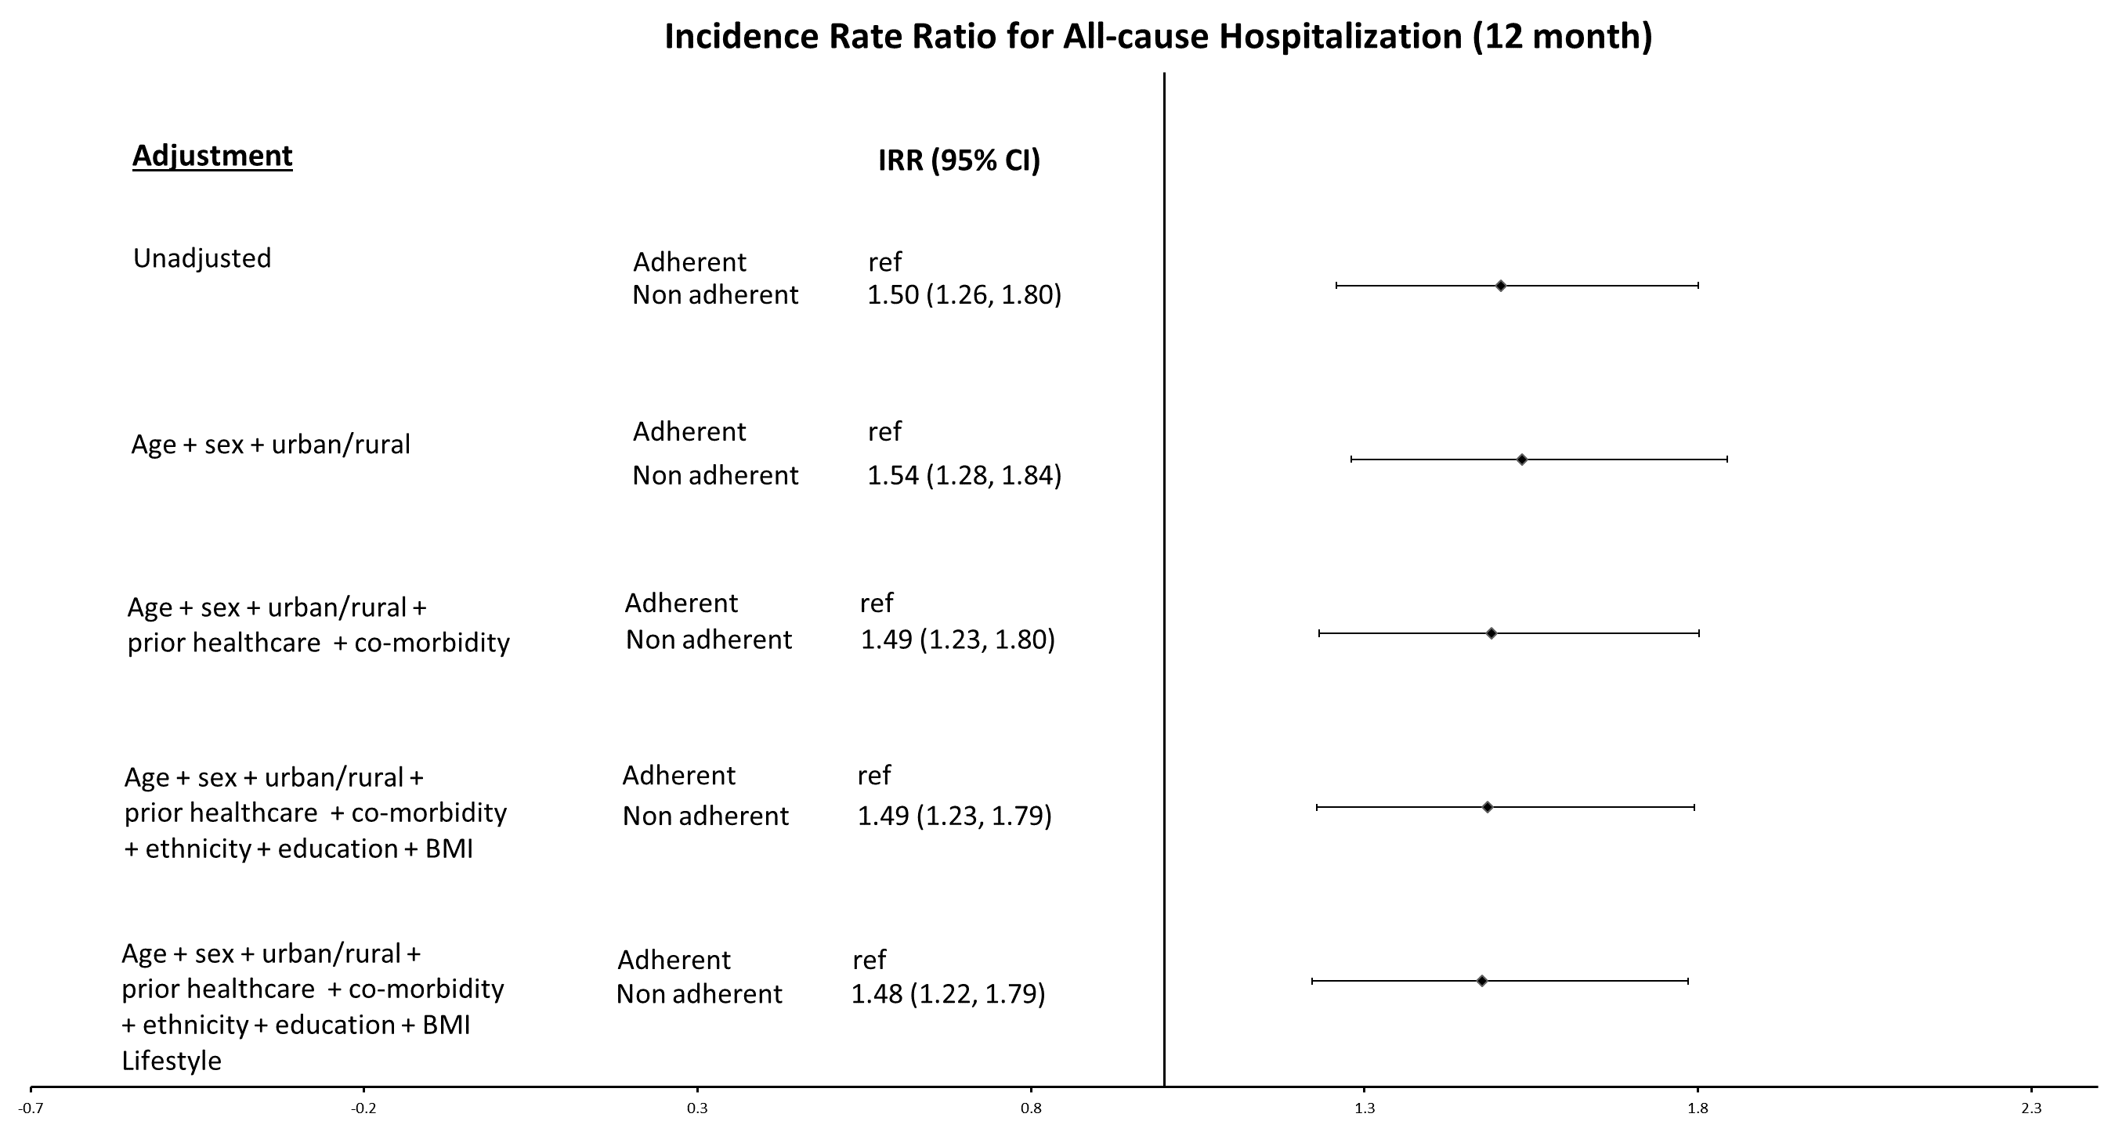

Supplementary Figure S2 Legend: In multivariate regression analyses, the incidence rate ratios (IRR) were compared between unadjusted model (no covariates were controlled for) and models where a series of covariates, including basic socio-demographic factors (age, sex and living in urban vs. rural areas), standard baseline clinical information (healthcare utilization in prior year and comorbidities) and those difficult-to-capture characteristics (ethnicity, education attainment, body mass index [BMI] and lifestyle factors), were progressively adjusted.

