SUPPLEMENTARY TABLE 1 TTF and OS in patient subgroups who received a starting afatinib dose of 40 mg
 | Median TTF  (months, 95% CI) | Median OS  (months, 95% CI)
All patients (n=147) | 30.6 (25.1–36.4) | 45.2 (41.7–NR)
Mutation type
Del19 (n=95) | 33.0 (27.7–40.3) | 63.5 (42.3–71.1)
L858R (n=52) | 25.3 (19.8–32.3) | 39.1 (29.3–NR)
Brain metastases present
No (n=121) | 31.2 (25.8–36.5) | 45.2 (41.7–71.1)
Yes (n=24) | 22.6 (17.9–NR) | 26.4 (19.1–NR)
ECOG PS
<2 (n=116) | 31.3 (25.8–38.2) | 63.5 (41.8–NR)
≥2 (n=10) | 32.3 (8.0–NR) | 33.1 (17.1–NR)
Abbreviations: CI, confidence interval; ECOG PS, Eastern Cooperative Oncology Group performance status; NR, not reached; OS, overall survival; TTF, time-to-treatment failure.

SUPPLEMENTARY TABLE 2 List of institutional review boards/ethics committees that approved the GioTag and UpSwinG studies
GioTag
Ethikkommission der Stadt Wien
Ethikkommission Land OÖ
Ethikkommission für das Land Niederösterreich
Health Research Ethics Board of Alberta Cancer Committee
Medizinische Ethik-Kommission der Fakultät VI Medizin und Gesundheitswissenschaften
Helsinki Committee of Meir Medical Center
Helsinki Committee of Soroka University Medical Center
Helsinki Committee of Rambam Health Care Campus
Comitato Etico Unico Regionale del Friuli Venezia Giulia
Comitato Etico Area Vasta nord-ovest
Comitato Etico Fondazione Pascale, IRCCS, Istituto Nazionale dei Tumori
Comitato Etico, A.O.R.N. Dei Colli Plesso Monaldi
Comitato Etico Lazio 1, A.O. San Camillo Forlanini
Comitato etico ASL Lecce
Comitato Etico, Provincia di Brescia, ASST degli Spedali civili di Brescia
Comitato Etico per la sperimentazione clinica, Dell’Istituto Oncologico Veneto (IOV)
Comitato etico per la Sperimentazione Clinica (CESC) delle Province di Verona e Rovigo con sede presso AOUI di Verona Servizio di Farmacia dell'Ospedale Borgo Trento
Ethics committee of Kansai Medical University
Wakayama Medical University Independent Ethics Committee
Kanazawa University Medical Ethics Review Committee
Niigata Cancer Center Hospital Ethics Committee
Hokkaido University Hospital Ethical Committee
Kanagawa Cancer Center Research Ethics Review Comittee
Kyushu Cancer Center Ethic Committee
National Healthcare Group Pte Ltd - Domain Specific Review Board - Domain B1
Komisija RS za medicinsko etiko
CEIC Hospital Universitari Germans Trias i Pujol
CEIC Hospital U. Severo Ochoa
CEIm Hospital Universitario Puerta de Hierro Majadahonda
CEIC Hospital Clínico San Carlos
Comité Ético de Investigación Clínica de Aragón
FISEBI Unidad de gestión de Ensayos Clinicos
Instituto de Investigación Sanitaria y Biomédica de Alicante
Comité Etico de la Investigación con Medicamentos de las Áreas de Salud de León y El Bierzo
Institution Review Board of Chi Mei Medical Center
Research Ethics Committee C National Taiwan University Hospital
Institution Review Board I&II Taichung Veterans General Hospital
Institution Review Board Kaohsiung Medical University Chung-Ho Memorial Hospital
Institution Review Board Taipei Veterans General Hospital
Research Ethics Committee China Medical University& Hospital
Institution Review Board Chang Gung Medical Foundation
Advarra
Institutional Review Board University of Nebraska Medical Center
Biomedical Research Alliance of New York (BRANY)
UpSwinG
Ethics Committee of the City of Vienna
Ethikkommission des Landes Oberösterreich
Aerztekammer Berlin
Comitato Etico Lazio 1
Comitato Etico Interaziendale AOU Città della Salute e della Scienza di Torino
Istituto Nazionale Tumori Fondazione G. Pascale
Comitato Etico Area Vasta Nord Ovest
Comitato Etico di Area Vasta Centro
Comitato Etico della Provincia Monza Brianza
Comitato Etico Indipendente dell'IRCCS Centro di Riferimento Oncologico di Aviano (PN)
Comitato Etico Humanitas
IRB of Ajou University Hospital
IRB of Samsung Medical Center
IRB of Jeonbuk national university hospital
IRB of Pusan National University Hospital
IRB of Chonnam National University Hwasun Hospital
IRB of Gachon University Gil Medical Center
IRB of Inje University Haeundae Paik Hospital
IRB of Asan Medical Center
IRB of Kyung Hee University Hospital
IRB of Chungnam National University Hospital
IRB of Severance Hospital, Yonsei University Health System
IRB of Kyungpook National University Chilgok Hospital
IRB of Pusan National University Yangsan Hospital
CEIC Hospital Universitari Germans Trias i Pujol
Agencia Española del Medicamento y Productos Sanitarios (Spain)
CEIC Hospital Universitari Germans Trias i Pujol
CEIC HOSPITAL la Paz
CEIC Fundación Hospital Alcorcón
Hospital Universitario Fundacion Jimenez Diaz
CEIC Complejo Hospitalario de Jaen
National Taiwan University Hospital, Research Ethics Committee
China Medical University Hospital, Institutional Review Board
Kaohsiung Medical University Chung-Ho Memorial Hospital, Institutional Review Board
Taipei Veterans General Hospital, Institutional Review Board
Chang Gung Medical Foundation, Institutional Review Board
Taichung Veterans General Hospital, Institutional Review Board
NHS Health Research Authority
Wales Research Ethics Committee 6

SUPPLEMENTARY FIGURE 1 TTF (A) and OS (B) in Asian patients receiving sequential afatinib (starting dose 40 mg) and osimertinib (n=147).
Abbreviations: CI, confidence interval; OS, overall survival; TTF, time-to-treatment failure.
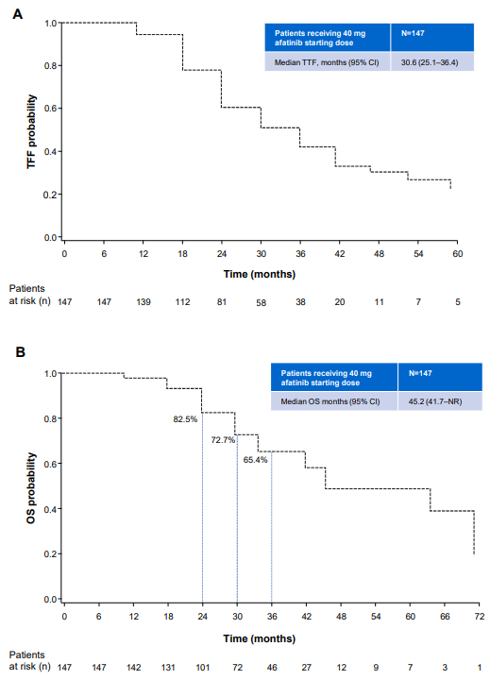

SUPPLEMENTARY FIGURE 2 TTF (A) and OS (B) in Asian patients with a Del19 EGFR mutation receiving sequential afatinib (starting dose 40 mg) and osimertinib (n=95).
Abbreviations: CI, confidence interval; EGFR, epidermal growth factor receptor; OS, overall survival; TTF, time-to-treatment failure.

