Supplement

Supplement Table 1. Descriptive Statistics of SAMS for NeuroGerAdh (N = 910) 2
Supplement Table 2. Descriptive Statistics of SAMS for NTX (N = 418) 3
Supplement Table 3. Descriptive Statistics of SAMS for Pain (N = 260) 4
Supplement Table 4. Descriptive Statistics of SAMS for Gerland et al. (N = 160) 5
Supplement Table 5. Weights matrix 6
Supplement Table 6. Edge betweenness centrality 7
Supplement Table 7 A-C. Confirmatory Factor Analysis with different item compositions 8
Supplement Figure 1. Boxplots for age in the 4 study cohorts 11
Supplement Figure 2. Simple correlation network 12
Supplement Figure 3. Strength stability for entire cohort network based on 1,000 case-drop bootstraps 13
Supplement Figure 4. Bootstrapped 95% confidence intervals of edge weights for entire cohort network 14
Supplement Figure 5. Centrality difference test, based on 1,000 parametric bootstrap samples for entire cohort network 15
Supplement Figure 6. Bootstrapped difference tests (α = 0.05) between edge-weights that were non-zero in the estimated network for entire cohort 16
Supplementary Figure 7 A-D. Separate Network Analyses for each dataset 17

Supplement Table 1. Descriptive Statistics of SAMS for NeuroGerAdh (N = 910)

 | Missing | Mean | Std. Deviation | Skewness
SAMS1 | 5 | 0.452 | 0.954 | 2.320
SAMS2 | 6 | 0.525 | 1.134 | 2.174
SAMS3 | 9 | 0.280 | 0.807 | 3.398
SAMS4 | 5 | 0.235 | 0.714 | 3.861
SAMS5 | 11 | 0.512 | 1.065 | 2.151
SAMS6 | 6 | 0.633 | 0.746 | 1.194
SAMS7 | 8 | 0.800 | 1.299 | 1.562
SAMS8 | 13 | 0.330 | 0.873 | 2.963
SAMS9 | 11 | 0.305 | 0.803 | 3.086
SAMS10 | 9 | 0.051 | 0.397 | 8.778
SAMS11 | 8 | 0.287 | 0.815 | 3.323
SAMS12 | 13 | 0.276 | 0.797 | 3.384
SAMS13 | 16 | 0.188 | 0.658 | 4.251
SAMS14 | 46 | 0.324 | 0.765 | 3.110
SAMS15 | 84 | 0.355 | 0.776 | 2.689
SAMS16 | 45 | 0.471 | 0.834 | 2.185
SAMS17 | 20 | 0.170 | 0.641 | 4.632
SAMS18 | 65 | 0.252 | 0.652 | 3.308

Supplement Table 2. Descriptive Statistics of SAMS for NTX (N = 418)

 | Missing | Mean | Std. Deviation | Skewness
SAMS1 | 0 | 0.280 | 0.588 | 2.898
SAMS2 | 0 | 0.100 | 0.372 | 4.773
SAMS3 | 0 | 0.081 | 0.370 | 6.341
SAMS4 | 0 | 0.041 | 0.198 | 4.668
SAMS5 | 0 | 0.144 | 0.531 | 4.585
SAMS6 | 0 | 0.239 | 0.449 | 1.542
SAMS7 | 0 | 0.701 | 1.229 | 1.848
SAMS8 | 0 | 0.067 | 0.454 | 7.973
SAMS9 | 0 | 0.065 | 0.307 | 5.112
SAMS10 | 0 | 0.007 | 0.085 | 11.719
SAMS11 | 0 | 0.091 | 0.423 | 6.674
SAMS12 | 0 | 0.091 | 0.450 | 6.404
SAMS13 | 0 | 0.057 | 0.296 | 7.741
SAMS14 | 0 | 0.199 | 0.542 | 3.915
SAMS15 | 0 | 0.158 | 0.522 | 4.451
SAMS16 | 0 | 0.263 | 0.610 | 3.230
SAMS17 | 0 | 0.067 | 0.404 | 7.743
SAMS18 | 0 | 0.206 | 0.510 | 3.013

Supplement Table 3. Descriptive Statistics of SAMS for Pain (N = 260)

 | Missing | Mean | Std. Deviation | Skewness
SAMS1 | 0 | 0.142 | 0.519 | 4.859
SAMS2 | 0 | 0.212 | 0.701 | 3.878
SAMS3 | 0 | 0.119 | 0.502 | 5.016
SAMS4 | 0 | 0.408 | 0.960 | 2.797
SAMS5 | 0 | 0.204 | 0.658 | 4.097
SAMS6 | 0 | 0.615 | 0.765 | 1.301
SAMS7 | 0 | 1.185 | 1.443 | 0.948
SAMS8 | 0 | 1.004 | 1.426 | 1.192
SAMS9 | 0 | 0.877 | 1.274 | 1.431
SAMS10 | 0 | 0.054 | 0.379 | 9.128
SAMS11 | 0 | 0.685 | 1.208 | 1.738
SAMS12 | 0 | 0.781 | 1.218 | 1.589
SAMS13 | 0 | 0.385 | 0.904 | 2.673
SAMS14 | 0 | 0.515 | 1.053 | 2.332
SAMS15 | 0 | 0.354 | 0.794 | 2.491
SAMS16 | 0 | 0.619 | 1.050 | 1.862
SAMS17 | 0 | 0.300 | 0.826 | 3.207
SAMS18 | 0 | 0.346 | 0.694 | 2.343

Supplement Table 4. Descriptive Statistics of SAMS for Gerland et al. (N = 160)

 | Missing | Mean | Std. Deviation | Skewness
SAMS1 | 2 | 0.152 | 0.494 | 4.166
SAMS2 | 1 | 0.113 | 0.421 | 4.845
SAMS3 | 1 | 0.107 | 0.430 | 5.931
SAMS4 | 1 | 0.075 | 0.265 | 3.245
SAMS5 | 3 | 0.115 | 0.438 | 4.748
SAMS6 | 0 | 0.506 | 0.604 | 0.756
SAMS7 | 4 | 0.910 | 1.425 | 1.366
SAMS8 | 0 | 0.206 | 0.664 | 4.303
SAMS9 | 2 | 0.234 | 0.669 | 3.691
SAMS10 | 0 | 0.044 | 0.361 | 9.532
SAMS11 | 2 | 0.171 | 0.650 | 4.744
SAMS12 | 6 | 0.201 | 0.680 | 4.148
SAMS13 | 0 | 0.181 | 0.690 | 4.627
SAMS14 | 20 | 0.386 | 0.862 | 2.928
SAMS15 | 53 | 0.234 | 0.667 | 3.388
SAMS16 | 28 | 0.500 | 0.929 | 2.148
SAMS17 | 4 | 0.160 | 0.596 | 4.574
SAMS18 | 33 | 0.299 | 0.568 | 1.767

Supplement Table 5. Weights matrix

SAMS Item | 1 | 2 | 3 | 4 | 5 | 6 | 7 | 8 | 9 | 10 | 11 | 12 | 13 | 14 | 15 | 16 | 17 | 18
1 | 0.000 | 0.240 | 0.158 | 0.000 | 0.230 | 0.045 | 0.000 | 0.000 | 0.000 | 0.059 | 0.000 | 0.000 | 0.000 | 0.000 | 0.000 | 0.000 | 0.000 | 0.000
2 | 0.240 | 0.000 | 0.395 | 0.010 | 0.337 | 0.013 | 0.000 | 0.000 | 0.000 | 0.000 | 0.000 | 0.000 | 0.000 | 0.000 | 0.000 | 0.000 | 0.002 | 0.012
3 | 0.158 | 0.395 | 0.000 | 0.092 | 0.000 | 0.029 | 0.000 | 0.009 | 0.023 | 0.000 | 0.000 | 0.000 | 0.000 | 0.000 | 0.004 | 0.019 | 0.022 | 0.022
4 | 0.000 | 0.010 | 0.092 | 0.000 | 0.147 | 0.096 | 0.000 | 0.140 | 0.078 | 0.000 | 0.097 | 0.004 | 0.009 | 0.000 | 0.025 | 0.000 | 0.000 | 0.000
5 | 0.230 | 0.337 | 0.000 | 0.147 | 0.000 | 0.000 | 0.006 | 0.000 | 0.000 | 0.000 | 0.000 | 0.000 | 0.000 | 0.000 | 0.000 | 0.000 | 0.000 | 0.000
6 | 0.045 | 0.013 | 0.029 | 0.096 | 0.000 | 0.000 | 0.045 | 0.030 | 0.004 | 0.000 | 0.000 | 0.000 | 0.000 | 0.179 | 0.176 | 0.226 | 0.006 | 0.067
7 | 0.000 | 0.000 | 0.000 | 0.000 | 0.006 | 0.045 | 0.000 | 0.127 | 0.000 | 0.026 | 0.000 | 0.000 | 0.024 | 0.025 | 0.024 | 0.042 | 0.003 | 0.002
8 | 0.000 | 0.000 | 0.009 | 0.140 | 0.000 | 0.030 | 0.127 | 0.000 | 0.283 | 0.040 | 0.023 | 0.071 | 0.130 | 0.000 | 0.000 | 0.000 | 0.005 | 0.000
9 | 0.000 | 0.000 | 0.023 | 0.078 | 0.000 | 0.004 | 0.000 | 0.283 | 0.000 | 0.058 | 0.043 | 0.286 | 0.000 | 0.073 | 0.000 | 0.005 | 0.056 | 0.065
10 | 0.059 | 0.000 | 0.000 | 0.000 | 0.000 | 0.000 | 0.026 | 0.040 | 0.058 | 0.000 | 0.051 | 0.000 | 0.176 | 0.023 | 0.058 | 0.020 | 0.097 | 0.080
11 | 0.000 | 0.000 | 0.000 | 0.097 | 0.000 | 0.000 | 0.000 | 0.023 | 0.043 | 0.051 | 0.000 | 0.449 | 0.194 | 0.016 | 0.000 | 0.034 | 0.022 | 0.000
12 | 0.000 | 0.000 | 0.000 | 0.004 | 0.000 | 0.000 | 0.000 | 0.071 | 0.286 | 0.000 | 0.449 | 0.000 | 0.155 | 0.000 | 0.026 | 0.012 | 0.022 | 0.028
13 | 0.000 | 0.000 | 0.000 | 0.009 | 0.000 | 0.000 | 0.024 | 0.130 | 0.000 | 0.176 | 0.194 | 0.155 | 0.000 | 0.000 | 0.064 | 0.005 | 0.329 | 0.000
14 | 0.000 | 0.000 | 0.000 | 0.000 | 0.000 | 0.179 | 0.025 | 0.000 | 0.073 | 0.023 | 0.016 | 0.000 | 0.000 | 0.000 | 0.154 | 0.072 | 0.028 | 0.089
15 | 0.000 | 0.000 | 0.004 | 0.025 | 0.000 | 0.176 | 0.024 | 0.000 | 0.000 | 0.058 | 0.000 | 0.026 | 0.064 | 0.154 | 0.000 | 0.165 | 0.010 | 0.035
16 | 0.000 | 0.000 | 0.019 | 0.000 | 0.000 | 0.226 | 0.042 | 0.000 | 0.005 | 0.020 | 0.034 | 0.012 | 0.005 | 0.072 | 0.165 | 0.000 | 0.054 | 0.051
17 | 0.000 | 0.002 | 0.022 | 0.000 | 0.000 | 0.006 | 0.003 | 0.005 | 0.056 | 0.097 | 0.022 | 0.022 | 0.329 | 0.028 | 0.010 | 0.054 | 0.000 | 0.127
18 | 0.000 | 0.012 | 0.022 | 0.000 | 0.000 | 0.067 | 0.002 | 0.000 | 0.065 | 0.080 | 0.000 | 0.028 | 0.000 | 0.089 | 0.035 | 0.051 | 0.127 | 0.000

Supplement Table 6. Edge betweenness centrality

From | To | Betweenness | From | To | Betweenness
SAMS 4 | SAMS 5 | 35 | SAMS 1 | SAMS 10 | 9
SAMS 4 | SAMS 6 | 27 | SAMS 12 | SAMS 13 | 8
SAMS 4 | SAMS 8 | 27 | SAMS 17 | SAMS 18 | 8
SAMS 13 | SAMS 17 | 19 | SAMS 13 | SAMS 15 | 6
SAMS 8 | SAMS 13 | 17 | SAMS 11 | SAMS 13 | 5
SAMS 2 | SAMS 5 | 14 | SAMS 14 | SAMS 15 | 5
SAMS 7 | SAMS 8 | 14 | SAMS 6 | SAMS 18 | 5
SAMS 9 | SAMS 12 | 13 | SAMS 10 | SAMS 15 | 4
SAMS 8 | SAMS 9 | 13 | SAMS 10 | SAMS 18 | 4
SAMS 3 | SAMS 4 | 12 | SAMS 1 | SAMS 2 | 3
SAMS 1 | SAMS 5 | 12 | SAMS 14 | SAMS 18 | 3
SAMS 4 | SAMS 11 | 12 | SAMS 1 | SAMS 3 | 3
SAMS 6 | SAMS 5 | 12 | SAMS 15 | SAMS 16 | 2
SAMS 6 | SAMS 14 | 11 | SAMS 2 | SAMS 3 | 2
SAMS 9 | SAMS 14 | 10 | SAMS 16 | SAMS 17 | 2
SAMS 10 | SAMS 13 | 10 | SAMS 6 | SAMS 7 | 2
SAMS 11 | SAMS 12 | 10 | SAMS 9 | SAMS 18 | 1
SAMS 6 | SAMS 15 | 10 | SAMS 7 | SAMS 16 | 1
All others = 0

Supplement Table 7 A-C. Confirmatory Factor Analysis with different item compositions
A
CFA A: Item 7 and 4 in the Modification I factor
Factor | Indicator | Estimate | Std. Error | z-value | p | Upper CI | Lower CI
Modification I | SAMS4 | 0.694 | 0.019 | 37.013 | < .001 | 0.657 | 0.731
Modification I | SAMS8 | 0.776 | 0.015 | 51.327 | < .001 | 0.746 | 0.805
Modification I | SAMS9 | 0.828 | 0.014 | 59.153 | < .001 | 0.801 | 0.856
Modification I | SAMS11 | 0.862 | 0.014 | 63.071 | < .001 | 0.835 | 0.889
Modification I | SAMS12 | 0.914 | 0.013 | 68.803 | < .001 | 0.887 | 0.940
Modification I | SAMS7 | 0.419 | 0.017 | 23.943 | < .001 | 0.385 | 0.453
Knowledge | SAMS1 | 0.787 | 0.017 | 45.411 | < .001 | 0.753 | 0.801
Knowledge | SAMS2 | 0.919 | 0.018 | 50.397 | < .001 | 0.883 | 0.690
Knowledge | SAMS3 | 0.875 | 0.020 | 44.606 | < .001 | 0.837 | 0.763
Knowledge | SAMS5 | 0.772 | 0.018 | 41.927 | < .001 | 0.736 | 0.749
Forgetting | SAMS6 | 0.766 | 0.018 | 43.220 | < .001 | 0.731 | 0.801
Forgetting | SAMS14 | 0.651 | 0.020 | 33.231 | < .001 | 0.613 | 0.690
Forgetting | SAMS15 | 0.724 | 0.020 | 35.985 | < .001 | 0.685 | 0.763
Forgetting | SAMS16 | 0.712 | 0.018 | 38.513 | < .001 | 0.676 | 0.749
Modification II | SAMS10 | 0.761 | 0.023 | 33.202 | < .001 | 0.716 | 0.806
Modification II | SAMS13 | 0.906 | 0.019 | 47.504 | < .001 | 0.869 | 0.944
Modification II | SAMS17 | 0.790 | 0.019 | 41.969 | < .001 | 0.753 | 0.827
Modification II | SAMS18 | 0.548 | 0.019 | 28.469 | < .001 | 0.510 | 0.586
Fit Indices |  |  |  | Chi2 Test
Index | CFI | TLI | RMSEA | Model | X2 | Df | p
Value | 0.987 | 0.984 | 0.040 | Baseline | 23328.275 | 153 | < .001
 |  |  |  | Factor | 439.768 | 129 | < .001
Abbreviations: CI, Confidence Interval; CFI, Comparative Fit Index; Df, degrees of freedom; RMSEA, Root Mean Squared Error of Approximation; TLI, Tucker-Lewis-Index

B
CFA B: Item 7 not in the Modification I Factor
Factor | Indicator | Estimate | Std. Error | z-value | p | Upper CI | Lower CI
Modification I | SAMS4 | 0.699 | 0.019 | 36.498 | < .001 | 0.662 | 0.737
Modification I | SAMS8 | 0.774 | 0.015 | 50.464 | < .001 | 0.744 | 0.804
Modification I | SAMS9 | 0.836 | 0.014 | 58.848 | < .001 | 0.808 | 0.864
Modification I | SAMS11 | 0.870 | 0.014 | 62.743 | < .001 | 0.843 | 0.897
Modification I | SAMS12 | 0.917 | 0.013 | 68.224 | < .001 | 0.891 | 0.944
Knowledge | SAMS1 | 0.787 | 0.017 | 45.300 | < .001 | 0.753 | 0.821
Knowledge | SAMS2 | 0.920 | 0.018 | 50.234 | < .001 | 0.884 | 0.956
Knowledge | SAMS3 | 0.872 | 0.020 | 44.365 | < .001 | 0.834 | 0.911
Knowledge | SAMS5 | 0.772 | 0.018 | 41.836 | < .001 | 0.736 | 0.808
Forgetting | SAMS6 | 0.767 | 0.018 | 42.593 | < .001 | 0.732 | 0.802
Forgetting | SAMS14 | 0.650 | 0.020 | 32.756 | < .001 | 0.611 | 0.689
Forgetting | SAMS15 | 0.725 | 0.020 | 35.563 | < .001 | 0.685 | 0.765
Forgetting | SAMS16 | 0.711 | 0.019 | 37.890 | < .001 | 0.674 | 0.748
Modification II | SAMS10 | 0.757 | 0.023 | 32.867 | < .001 | 0.712 | 0.802
Modification II | SAMS13 | 0.909 | 0.019 | 47.242 | < .001 | 0.872 | 0.947
Modification II | SAMS17 | 0.790 | 0.019 | 41.687 | < .001 | 0.753 | 0.827
Modification II | SAMS18 | 0.548 | 0.019 | 28.164 | < .001 | 0.510 | 0.586
Fit Indices |  |  |  | Chi2 Test
 | CFI | TLI | RMSEA | Model | X2 | Df | p
Value | 0.989 | 22711.519 | 0.038 | Baseline | 23328.275 | 138 | < .001
 |  |  |  | Factor | 360.155 | 113 | < .001
Abbreviations: CI, Confidence Interval; CFI, Comparative Fit Index; Df, degrees of freedom; RMSEA, Root Mean Squared Error of Approximation; TLI, Tucker-Lewis-Index

C
CFA C: Item 4 not in the Modification I factor
Factor | Indicator | Estimate | Std. Error | z-value | p | Upper CI | Lower CI
Modification I | SAMS8 | 0.782 | 0.015 | 49.535 | < .001 | 0.751 | 0.813
Modification I | SAMS9 | 0.834 | 0.014 | 57.465 | < .001 | 0.806 | 0.863
Modification I | SAMS11 | 0.867 | 0.014 | 61.288 | < .001 | 0.839 | 0.895
Modification I | SAMS12 | 0.923 | 0.018 | 66.892 | < .001 | 0.896 | 0.951
Modification I | SAMS7 | 0.424 | 0.018 | 22.989 | < .001 | 0.388 | 0.460
Knowledge | SAMS1 | 0.793 | 0.019 | 45.032 | < .001 | 0.758 | 0.827
Knowledge | SAMS2 | 0.921 | 0.020 | 49.615 | < .001 | 0.885 | 0.957
Knowledge | SAMS3 | 0.870 | 0.019 | 43.854 | < .001 | 0.831 | 0.908
Knowledge | SAMS5 | 0.768 | 0.018 | 41.283 | < .001 | 0.732 | 0.805
Forgetting | SAMS6 | 0.753 | 0.020 | 41.542 | < .001 | 0.718 | 0.789
Forgetting | SAMS14 | 0.654 | 0.021 | 32.456 | < .001 | 0.614 | 0.693
Forgetting | SAMS15 | 0.725 | 0.019 | 35.033 | < .001 | 0.684 | 0.766
Forgetting | SAMS16 | 0.724 | 0.023 | 37.853 | < .001 | 0.687 | 0.762
Modification II | SAMS10 | 0.762 | 0.019 | 33.000 | < .001 | 0.717 | 0.807
Modification II | SAMS13 | 0.904 | 0.019 | 46.997 | < .001 | 0.866 | 0.941
Modification II | SAMS17 | 0.792 | 0.020 | 41.516 | < .001 | 0.755 | 0.830
Modification II | SAMS18 | 0.549 | 0.015 | 28.016 | < .001 | 0.510 | 0.587
Fit Indices |  |  |  | Chi2 Test
Index | CFI | TLI | RMSEA | Model | X2 | Df | p
Value | 0.992 | 21752.934 | 0.032 | Baseline | 23328.275 | 136 | < .001
 |  |  |  | Factor | 286.046 | 113 | < .001
Abbreviations: CI, Confidence Interval; CFI, Comparative Fit Index; Df, degrees of freedom; RMSEA, Root Mean Squared Error of Approximation; TLI, Tucker-Lewis-Index

Supplement Figure 1. Boxplots for age in the 4 study cohorts

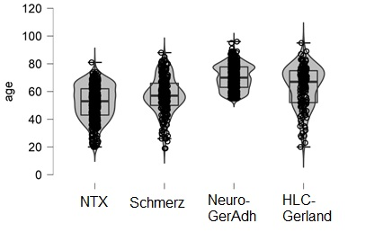

Supplement Figure 2. Simple correlation network
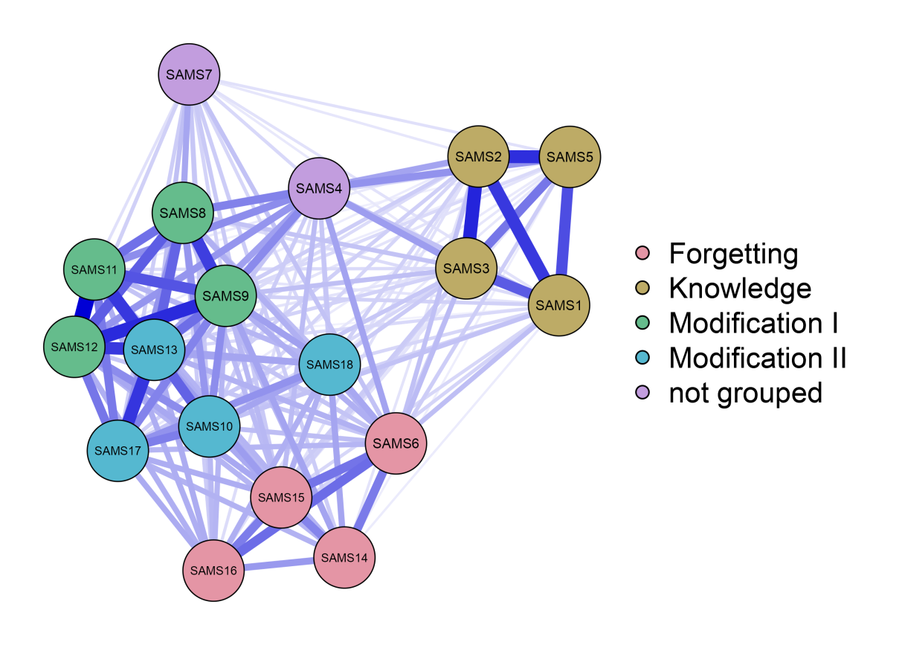
Note: In this network, all significant and non-significant edges are shown.

Supplement Figure 3. Strength stability for entire cohort network based on 1,000 case-drop bootstraps
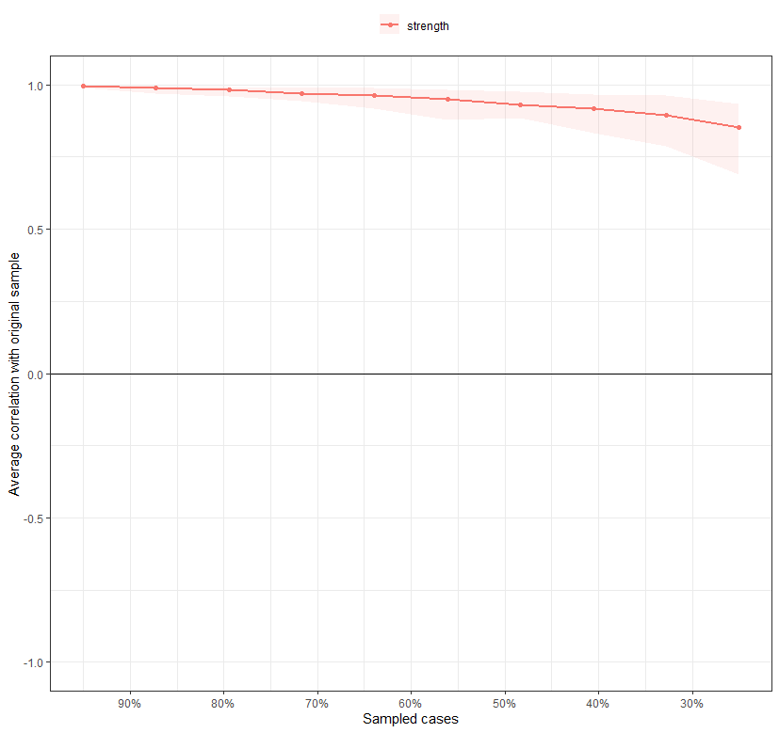
Note: To investigate the stability of the strength centrality index, a case-dropping bootstrap procedure was used (Epskamp, Borsboom, und Fried 2018). This re-estimates strength with an increasingly higher percentage of dropped-out cases. Then the correlation between the original strength index and those from the subsamples were calculated. Also the correlation stability coefficient (CS-coefficient) represents the maximum proportion of cases which can be dropped to maintain a correlation of at least .70 with the original centrality indices. The case-dropping bootstrap procedure shows that CS-Cs of node strength was 0.75.

Supplement Figure 4. Bootstrapped 95% confidence intervals of edge weights for entire cohort network
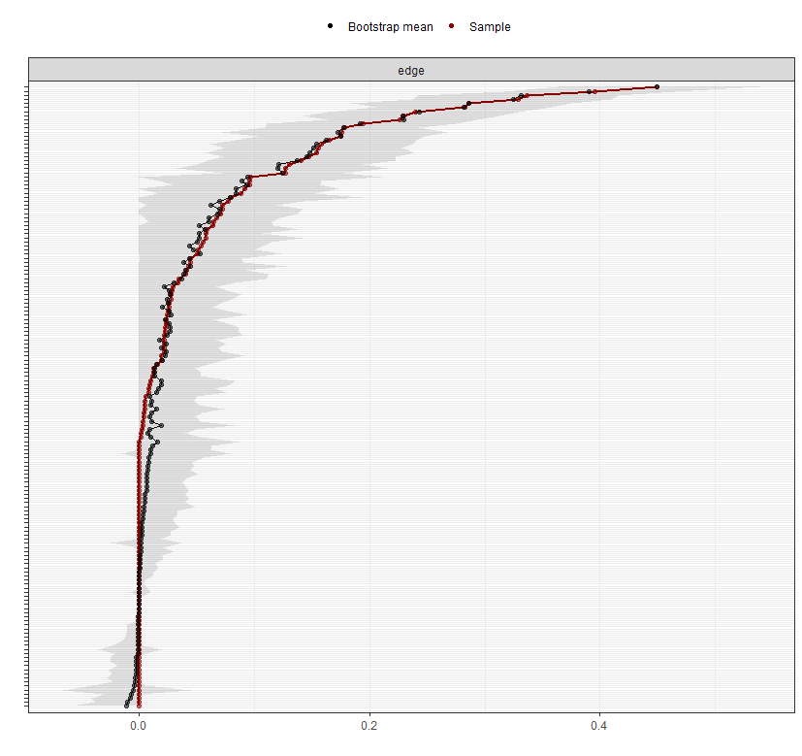
Note: Bootstrapped 95% confidence intervals of edge weights, based on 1,000 nonparametric bootstrap samples: A nonparametric bootstrap method and construction of 95% bootstrapped confidence interval around the regularized edge weight were used to investigate the stability of edge weight parameters. The red dots represent the original sample values. The black dots represent the bootstrap means, and the grey areas represent the 95% bootstrapped confidence interval. The bootstrapped confidence interval is very narrow, suggesting highly stable and interpretable results.

Supplement Figure 5. Centrality difference test, based on 1,000 parametric bootstrap samples for entire cohort network

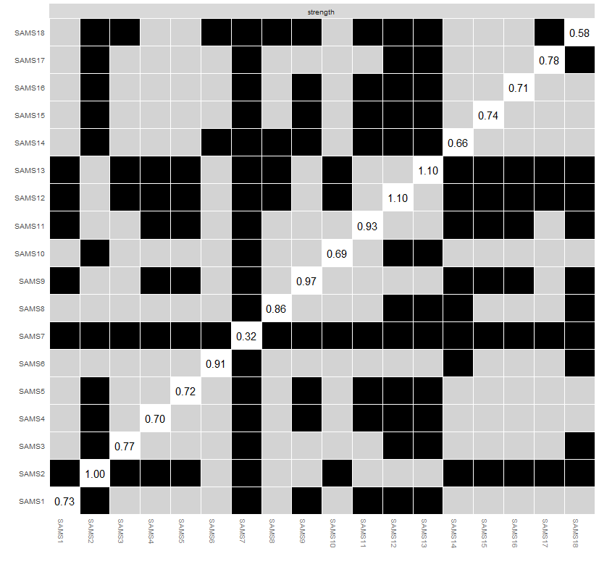
Note: A bootstrap stability difference test (á = 0.05) was used to explore if the nodes were significantly different than each other in terms of strength centrality. Each point on the x and y axes represents a network node. Gray boxes indicate that two nodes do not significantly differ from each other. Black boxes indicate that two nodes significantly differ from each other. The numbers in the diagonal represent the values of the strength centrality measure of the node.

Supplement Figure 6. Bootstrapped difference tests (α = 0.05) between edge-weights that were non-zero in the estimated network for entire cohort

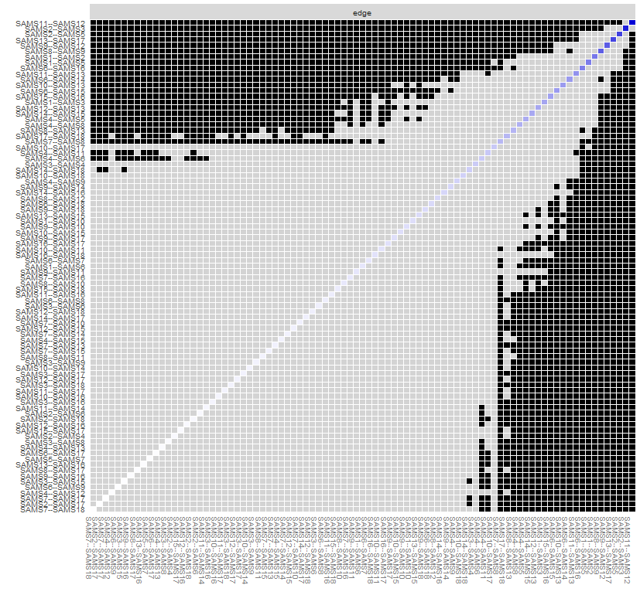
Note: Gray boxes indicate edges that do not differ significantly from one-another. Black boxes represent edges that do differ significantly from one-another. Colored boxes correspond to the color of the edge in the network plot (figure 1 in main text).

Supplementary Figure 7 A-D. Separate Network Analyses for each dataset

